Assignment 4

Realism is one way to study International Relations. By considering the core assumptions of realism on human nature, role of state, war, international institutions, security, interest, economy etc., please explain the cartoon below. What does it say about the system of international affairs?

Hint: Don’t overlook the details! Give attention to the position (territories and resources) of each party while analyzing the cartoon. Also, think about the interests of each party and also the ways and reasons that they communicate to each other.
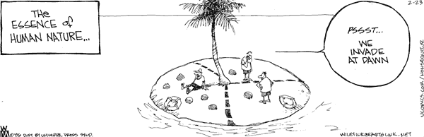

Guidelines:

- Your answer should be no less than 300 words.
- Use double space. Font should be Times New Roman in 12p size.
- You don’t have to use external resources.
- Be prepared to discuss your answer with your classmates.
- Don’t be late!
- Have a nice week!

