NSG 420 - Field Note
Student Name
Adeyemi Jah
Date and Time of Clinical
Tuesday, May 8, 2021
Site's Name and Address & a PHOTO from your phone (not from the internet)
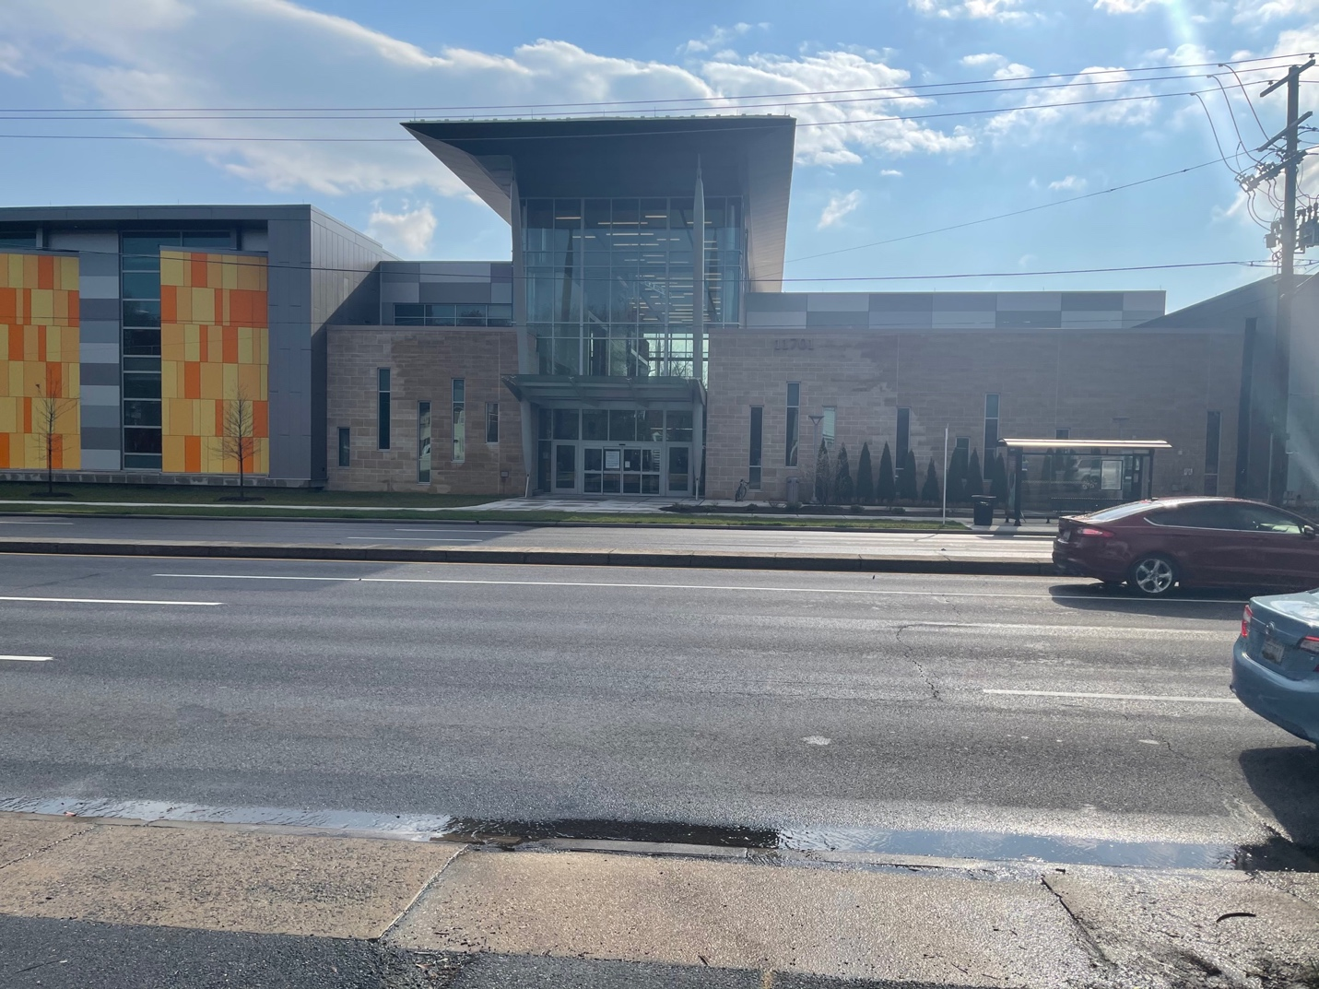

Wheaton Community Center
11701 Georgia Avenue
Silver Spring, MD 20902

Type of Organization (governmental, non-profit, for profit, etc.): Community Center
What is the focus/ mission of this organization? “The mission is to provide high quality, diverse, and accessible programs, services and facilities that enhance the quality of life for all ages, cultures, and abilities”.
When was it established? The center officially opened September 2020 for public use.
What aggregate is served and how many people are served weekly?
Adults and children of all ages and cultures of Montgomery County are welcomed to visit. The site does not specify how many people it services per week.
What did you do while there? (Utilize social distancing, mask wearing and observe how the site functions)
Initially, I went to the front desk to speak with the clerk to find out what services are offered at the center, the hours of operation, and membership questions. The spring classes are just opening this month. They will still adhere to COVID-19 policy of wearing masks and social distancing. The center offers classes like Tai Chi outdoors, Fitness classes, Karate, and virtual yoga classes opened to all ages specific to the class. Next, I went to the gym to walk around the upper-level track to observed who was visiting the center and to get some exercise. I watched the long line of people who were there to obtain the COVID shot.
Do you think this organization fills a deficit for the area or other aggregate and do they have additional, peripheral services? (What need does this organization address? Is there a high rate of poverty or unemployment in the area which explains the need of the foodbank? Use critical thinking skills, there not one correct answer.)
There is not a high poverty or homelessness rate in this area. The main service is to the people of Montgomery County including people in need of assistance of certain services (WIC, Maternal/Child education). The site offers COVID shots to the people who signed up for appointments. On that day, there were a long line for the COVID shot and people were outside directing traffic and showing people where to park and inside directing the lines. Last November, the center was set up for voting in the general election. They also have monthly WIC programs for women and children.
How does this organization compare to one other facility you have visited previously in terms of aggregate population and successfully delivered services? Compare to your previous field note visits or past clinical experience.)
This facility appeared to be well organized and had enough people on staff to check people in for registration and direct the lines. The center is newly built and is clean and maintained.
If you were the Program Manager what changes would you make to the organization? (From your observations, what do you think would make things run smoother? For example: More staff? More resources (food)? Cleaner waiting area? Long lines?)
I would be proud of my staff if I was the Program Manager of the center. The staff appeared to have been trained to handle the long lines and the wait time was very minimal. The site was newly built, clean, and beautifully decorated.
Do you think this organization has enough money to deliver their services? (Explain using critical thinking from your observations.)
The center is funded by Montgomery County therefore, they have an annual budget for each fiscal year for the programs free to the public. They also have some classes offered to the public that have a fee attached.
Explain what is the singularly largest problem that this organization's aggregate must overcome on a daily basis? (Use critical thinking to give a thoughtful answer based on your observations and the facility website.)
In this COVID season, the singular problem is to be able to have the large group of people adhere to the center’s policy of wearing mask within the site as well as social distancing. Even though the numbers of people affected with COVID have decreased, some people are still acquiring the infection. Therefore, in a facility that is set up to service the public, the center still has a responsibility to maintain the safety of the visitors while providing good customer service. The lines were long but because the staff appeared to be thoroughly trained and prepared, the lines went smoothly.

By uploading field note to clinical faculty’s clinical Moodle, I attest to the activity & accuracy of the hours I spent at this clinical site or during the windshield survey activity. Lateness results in a zero grade with all assignments.

Hours of clinical: 3 hours
Total hours of Community Clinical as of date: N/A hours
Student E-Signature: Adeyemi Jah Date: 06/16/2021

