Introduction:
Translation, throughout history, has contributed significantly in the field of knowledge, research and culture interchange. It is not only about the act of transferring the meaning of a word or an utterance to the other language; it is the art of creating, editing and rendering either a written or a spoken utterance to the other language, where it meets and accomplishes the target language standards and systems.Currently, and as Coronavirus is spreading worldwide, countries are facing many challenges not only in the sector of medicine and prevention, but also challenges that are related to other fields such as diseasesawareness and knowledge, economy, education, security, etc. This article discusses the role of translation during such pandemic, and specifically to what extent translation has played role in the United Kingdom (UK) addressing various communities and expats.
Translation and community translation:
Due to spread of Coronavirus worldwide, translation plays a key role in ensuring everyone is able to access services, from healthcare to education to other procedures made by any authority to control the spread of the pandemic.
According to Catford's (1995) definition,"translation is the replacement of textual material in one language (SL) by equivalent textual material in another language (TL)". The Catford's definition reveals that translation is a type of process that could be considered as an activity which is done by translators while utterances and expressions are translated within the same language, rewording and paraphrasing, or from one language into another. Whereas Ghazala (1995), defines translation as it "is generally used to refer to all the process and methods used to convey the meaning of the source language in to the target language".
On the other hand,community translation as explained by Taibi and Ozolins (2016), "discusses the different types of texts produced by public authorities, services and individuals for communities that need to be translated into minority languages, and the socio-cultural issues that surround them". For this, community translation guarantees and ensures that privileges and rights of all communities and foreigners of any country are accessed and for their service. In the UK, the population of non-UK nationals is almost 6.2 million people, which is (9%) of the total population in the UK, and the migrant population is concentrated more in London capital city. For this, the government and concerned authorities must take precautions and necessary procedures to ensure that all communities and expats, especially those who are not native speakers of English, are getting the information and updates in their own languageswith regard to the Coronavirus pandemic as issued by the authorities and government.
The translation role in the United Kingdom (UK) during Coronavirus Covid-19 outbreak:
All countries of the world have not prepared to encounter such outbreak. An outbreak that changed every prospective of life. As Coronavirus spreading and continuously challenging countries to face such pandemic, all countries are struggling to compact the spread of the Virus for its people and citizens, and to finally pass the novel Coronavirus with less losses possible. The UK, for instance, is one of the countries that has been fighting the spread of the Virus, and is taking measure and procedures to control the spread among its nationals and expats, non-UK nationals, who might be not native speakers of English.Translation, in such pandemics or similar conditions, plays asignificant role in any country especially during times when all nationals and non-nationals within a country are needed to take a part and role to compact any relevant crisis.
Online efforts:
The UK government and the governments of each member country (England, Northern Ireland, Scotland and Wales) are providing information online, via the radio, and through the post, and according to the (Mayor of London and London Assembly 2020) official website, information, guidance and awareness messages on Coronavirus Covid-19 for non-UK nationals are provided in the following languages: Arabic, Bengali, Cantonese, Mandarin, French, Gujarati, Polish, Portuguese, Punjabi, Urdu, and Welsh. This has been done to reach and cover various communities living in the UK to inform and update them regarding the pandemic. Moreover, the Government of the UK official website(GOV.UK 2020) published documents on "Covid-19: guidance on social distancing for everyone living in the UK and protecting older people and vulnerable adults" in the following languages: Welsh, Urdu, Punjabi, Portuguese, Polish, Gujarati, French, Traditional Chinese - Cantones, Simplified Chinese – Mandarin, Bengali, and Arabic. Another procedure taken by the Government is to publish the guidance issued by the World Health Organization (WHO) through the country's official websites in some languages including Russian, French, Spanish, Arabic and Chinese.
Radio and television efforts:
In addition, various media channels are also spreading awareness in different languages. The British Broadcasting Company (BBC), for example, is providing live news coverage of Coronavirus in other languages besides English, in whichit is also broadcasted in Vietnamese, Urdu, Turkish, Persian, Hindi, and Hausa.

Initiative groups:
What is more, in London as it covers most foreign communities in England, a community initiative called "Linguist Aid" was launched, and it is a support group of volunteers who speak a different language other than English to provide translations and interpretations for those who are suffering from getting the proper and required information in their own languages as their local communities and groups sites are closed due to the general lockdown.
Challenges:
However, there are some issues and challenges the Government of the UK is facing when it comes to reaching some foreign communities as some of them are unable to meet in certain sites, for example, places of worship or community centers, then there is a worry that the message is not reaching everyone. In this regard, Dr. Huddleson (2020), PhD in Translation and citizen from London (England), believes thatthe UK still has a lot to learn in such toughtimes. Some services have made efforts to ensure documents are available in a range of languages, from Arabic to Pashto. However, the UK’s indigenous languages have been largely overlooked during this crisis. Some information has been made available in Welsh, but for Irish and Scottish Gaelic, there is little to nothing for them. Dr. Huddleson added: "Just recently, the Education Authority admitted to not having prepared documents in Irish for those who attend Irish-medium schools. As an Irish-speaker and as someone who pays taxes in the UK, I am not happy at this disregard for my right to access information in my language".
The other issue is that of literacy. There are many communities in the UK, particularly migrants as well as Irish Travelers, where there are serious issues around literacy. Even if a document is available in a language, it counts for nothing if someone cannot read and understand the text, so the Government should do more and consider such cases in that regard to ensure everyone has access to information.
Conclusion:
In conclusion, translation plays a key role to ease and control the spread of Coronavirus Covid-19 pandemic in any country. The UK, one of the countries worldwide that struggles to handle the Coronavirus crisis, has taken many procedures that serve not only the nationals of the UK, but also the various communities and non-UK nationals who are currently living in the UK. For this, the government through different official websites, such as the “Mayor of London and London Assembly” and “the Government of UK”, has published awareness information and guidance in many languages including Arabic, Chinese, Hindi, Vietnamese, French, Welsh, etc. In addition, there are many efforts of broadcasting information and live news coverage of the novel Coronavirus through the BBC various channels in many other languages other than English such as Arabic, Persian, Turkish, Russian, etc.
However, the Government of UK faces challenges with regard to reaching some communities of non-UK nationals as they struggle due to the city lockdown. Another issue is the literacy of some communities with the UK especially the migrants, and the struggle of ensuring everyone to get the access for the important information regarding the pandemic.

List of references:
- Catford, J. (1995) Alinguistic Theory of Translation. London: Oxford University Press.
- Ghazala, H. (1995) Translation as problems and solutions. Syria: Dar ElkalemElArabi.
- Gov.UK. 2020. Covid-19 guidance. Retrieved from https://www.gov.uk/government/publications/covid-19-guidance-on-social-distancing-and-for-vulnerable-people
- House of Common Library. March 06, 2020. Migration Statistics. Retrieved from https://commonslibrary.parliament.uk/research-briefings/sn06077/
- Mayor of London. 2020. Information on coronavirus (covid-19) for non-UK nationals. Retrieved from https://www.london.gov.uk/what-we-do/eu-londoners-hub/information-coronavirus-covid-19-non-uk-nationals
- Taibi, M. Ozolins, U. (2016) Community Translation. London: Bloomsbury.

Samples:
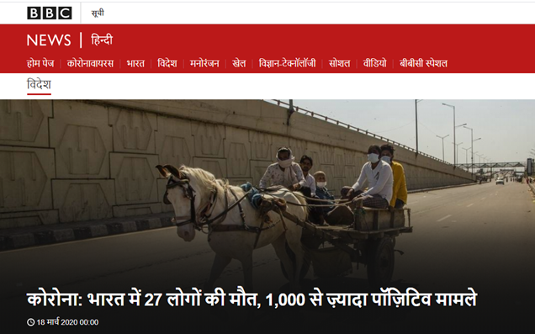
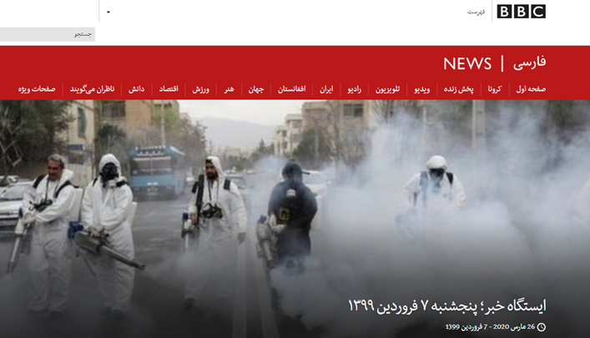
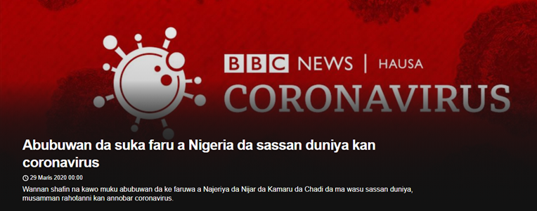

Samples:
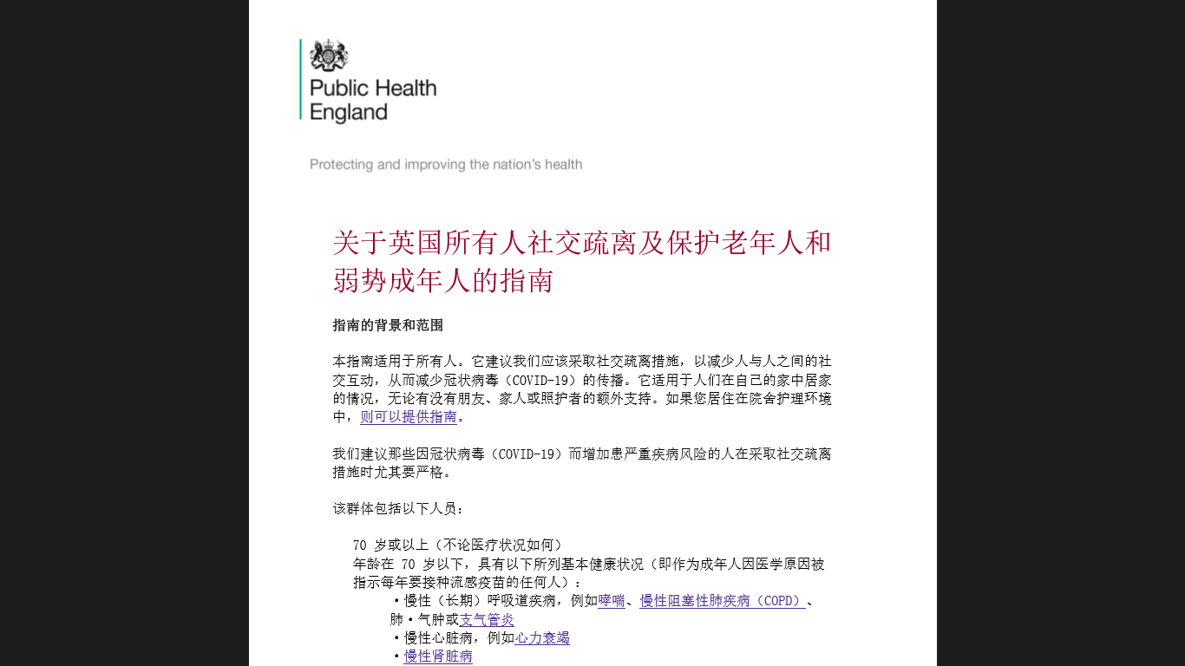

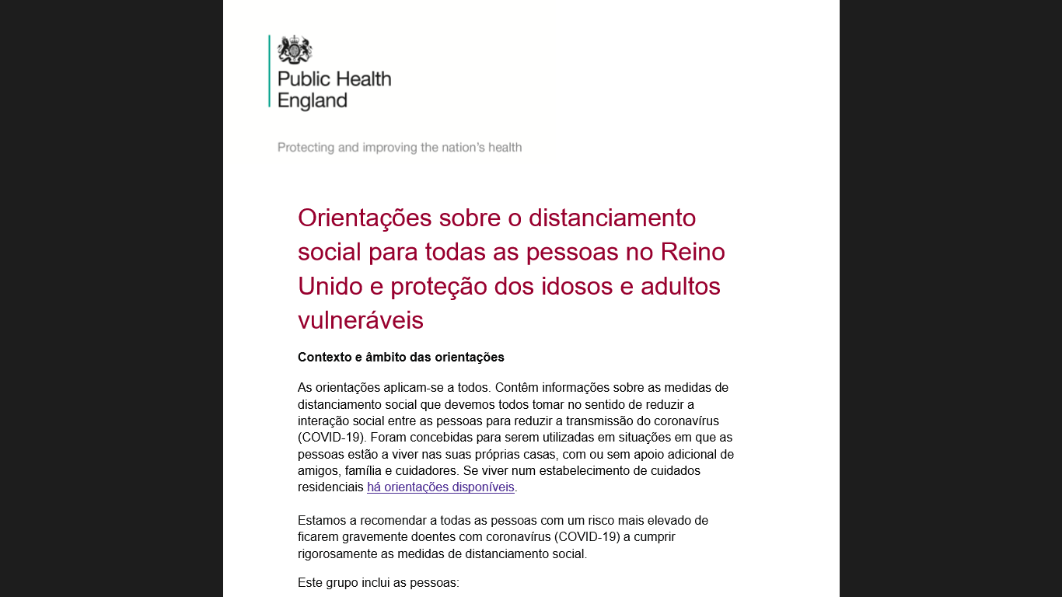

- According to the UK migration statistics 2019.
- The last part of the article will include samples of the efforts done by the UK various authorities.
- Mayor of London (2020) official website.
- An online interview with Dr. Huddleson R. April 25th, 2020.

