Assignment 2: Designing a Network Topology
Bennie Carter
CIS 532: Network Architecture and Analysis
John Dorociak
Monday, May 4, 2020

Depict a graphical topological network design for the 20 employees (Academy, 2014).
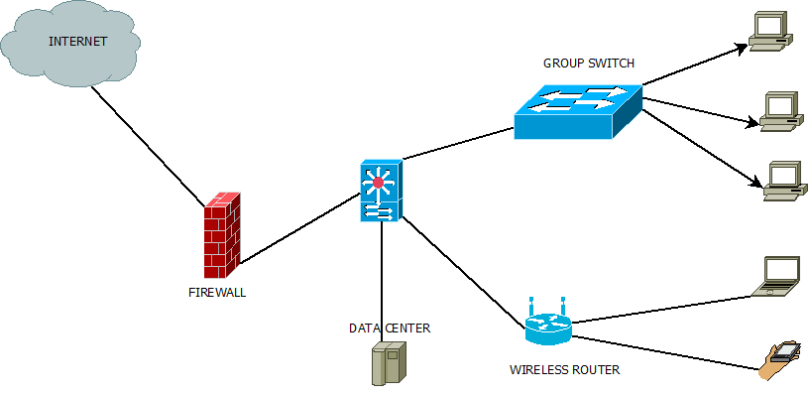
Figure 1: Graphical topological network design for the 20 employees

Depict a graphical topological network design for the 200 employees (Cisco, 2011).

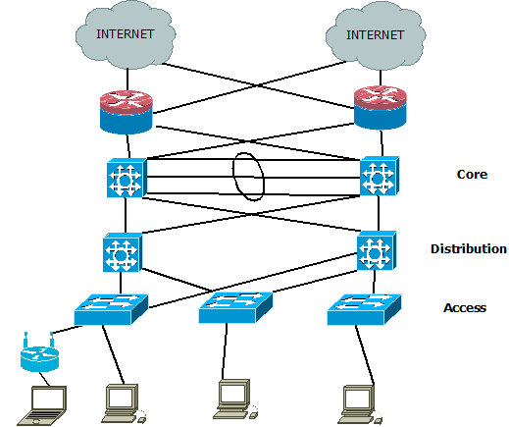
Figure 2: Graphical topological network design for the 200 employees

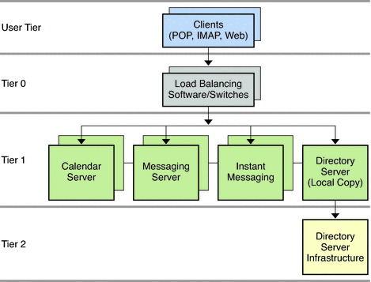
Figure 3: Network Tiers

Depict a graphical model of network topology for future development to 400 employees.

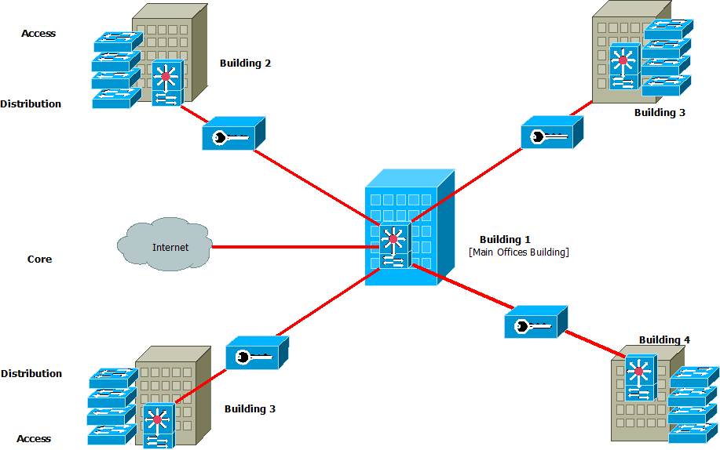
Figure 4: Graphical model of network topology for future development to 400 employees

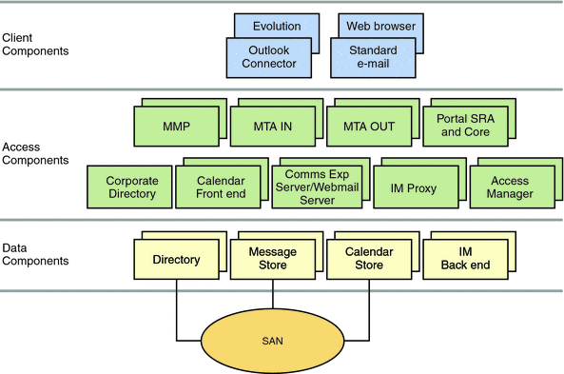
Figure 5: Client, Access and Data Components

Executive Summary
As companies grow and expand their capacities, it is key that security in the networking is incorporated as the network expands allowing for backup servers. The first image displays the pictorial view of the 20 employees in the organization. They are connected to the network using a group switch or a router for the Bring Your Own Devices [BYOD] (Redmon, 2014). Business goes on in the company in the presence of a server and firewall filtering the internet traffic. The current topology which is considered flat, incorporated Pc's and Peer to Peer Servers connection connected using ADSL internet line connectivity making the access very restricted. The switch has allowed workers to keep the growing employees connected. The current design that was upgraded to accommodate the 200 employees supported the installation of essential services to maintain and keep the network secure. Active Directory with DNS, Sign-on, file sharing and DHCP replaces the initial flat topology (Academy, 2014).
(Cisco, 2011) claims that an organization's growth of between 200 and 1000 users is called a medium-size network. A three-tier network model is proposed to counter this high number of employees. It increases the performance of the network at all times, keep the network safe by employing a VPN to enhance security at all times. Working stations are linked with the Access Layer Stackable switches making it cheap to redeploy the existing switches. They will uplink a Distribution layer switch that joins to a dual-core layer redundant switch structure and a touch of mesh topology. For the backups, all buildings will serve as a storage for each building linked using a Virtual local area network that employs a failover services technology called MPLS and Active Directory DFS synch for files, data source failover of web server, management of content and database are always accessible. Part mesh model offer recovery from disaster and no downtime.

References
Academy, C. N. (2014). Hierarchical Network. Cisco Networking Academy Connecting Networks Companion Guide: Hierarchical Network Design, https://www.ciscopress.com/articles/article.asp?p=2202410&seqNum=4.
Cisco. (2011). Redundancy and Fail-Over. Retrieved from Service Control Engine (SCE) Software Configuration Guide, Rel. 3.1,: https://www.cisco.com/en/US/products/ps6134/products_configuration_guide_chapter09186a0080849904.html#wp1047706
Redmon, K. (2014). Cisco bring your own device (BYOD) networking. Cisco Press,.

