Assignment 1: Capabilities Proposal
Bennie Carter
CIS 532: Network Architecture and Analysis
John Dorociak
Monday, April 20, 2020

Prepare an opening statement that specifies your organization's capabilities to manage a deployment of this size
Antotech consulting firm began operations in 2004. We are ready to aid in the complexities of network analysis, upgrades, assessments, and processes for company mergers. We have the experience in merging companies, including Verizon and Vodafone, Spectrum and Bright House, as well as Tech Data with Avnet. Antotech Consulting is prepared in all technical, legal, and financial aspects of the process. Most importantly, we have the resources, licenses, and strategies to implement and complete a merger. We employ individuals who leverage in the assessment and consolidation of IT services.
  - Antotech Consulting Company employs individuals that will be leveraged in the assessment and merger of IT services:
    - We centered on three resources with F5 certifications for load balancing, traffic management, and app security which include; (F5-CA certifications) F5 Certified BIG-IP Administrator (F5 -CA), F5 Certified Technology Specialist (F5 -CTS), and F5 Certified Solutions expert (F5-CSE)
    - Main focus include resources which provide Palo Alto certifications for firewall and cloud (GlobalProtect and PCNSA certifications) PCCSA (Palo Alto Network Certified Cybersecurity Associate), PCNSA (Paolo Alto Network Security Administrator), and PCNSE (Paolo Alto Certified Network Security Engineer)
    - We also ensure resources and attained experience engineer with Cisco network certifications such as CCENT (Cisco Certified Entry Network Technician) CCNP (Cisco Certified Network Professional) R/S, CCNA (Cisco Certified Network Associate), and CCIE (Cisco Certified Network Expert).
    - Our consulting firm also employs resources with Cisco WLAN certification experts such as CCNP-W
    - Two engineers with Cisco CCIE R/S certification
    - Four experienced contractors with Cisco data center certifications (CCNP)
    - Five resources and experienced professionals in Cisco collaboration certifications (CCNP-collaboration).
    - Two engineers with Citrix certifications (CCE-N)
    - Multiple contractors and one experience employee with WAN certifications.
    - And experience employees with Microsoft certifications (MCSE)
  - Antotech Consulting is highly experienced in merging of company network resources
    - Antotech Consulting has conducted seven IT mergers of Fortune 500 companies over the past five years
    - Antotech Consulting has done network analysis of fifteen companies over the past ten years.
    - Antotech Consulting has provided an analysis of firewall
    - Antotech Consulting is highly experienced in using Cisco Stealth watch Enterprise, allowing administrative staff to facilitate a smooth and seamless merger process through the usage of Google Cloud and Microsoft Azure.
    - Antotech Consulting contacts for references are available upon request are; Office 813-808-7178 and email antotech.Consuslting@antotech.com

Graphically depict and effectively promote your company's structured development and services using Visio or its alternative open-source software
Below is a visual breakdown of the company's structure development and services to effectively illustrate Antotech Consulting's capabilities on completed the network implementation for the merge.
- Image one has a business strategy.
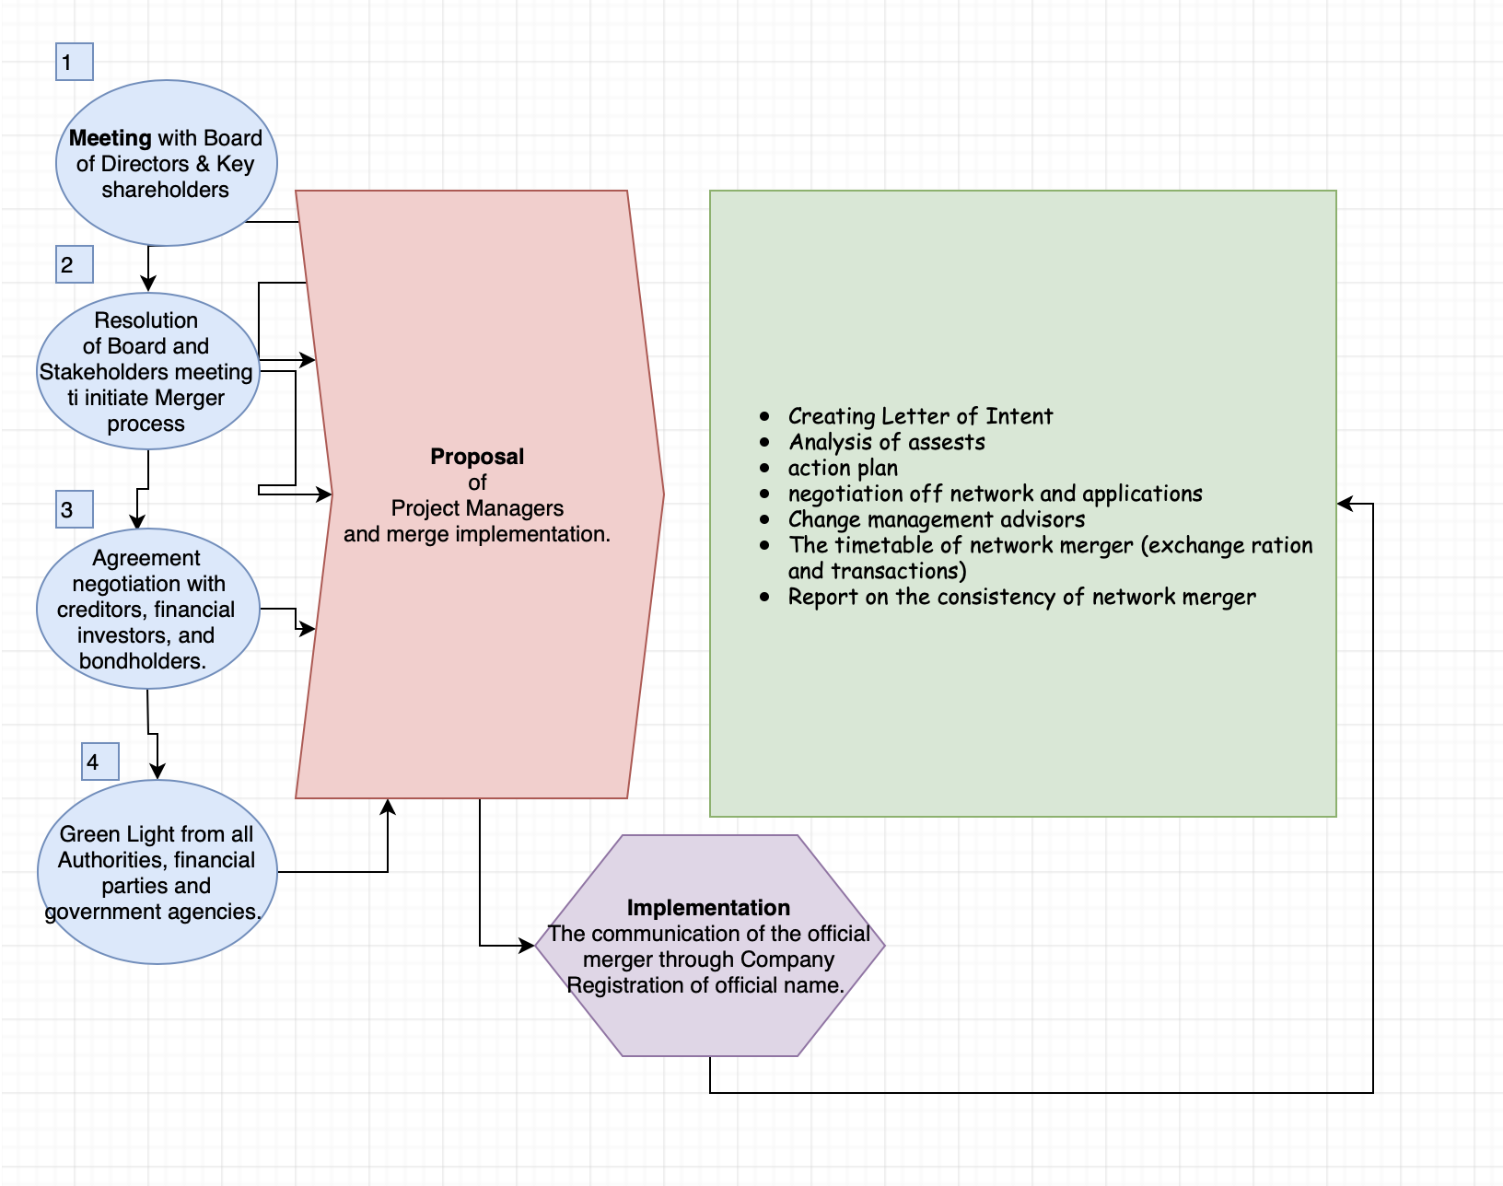
- The second image has the network Implementation strategy
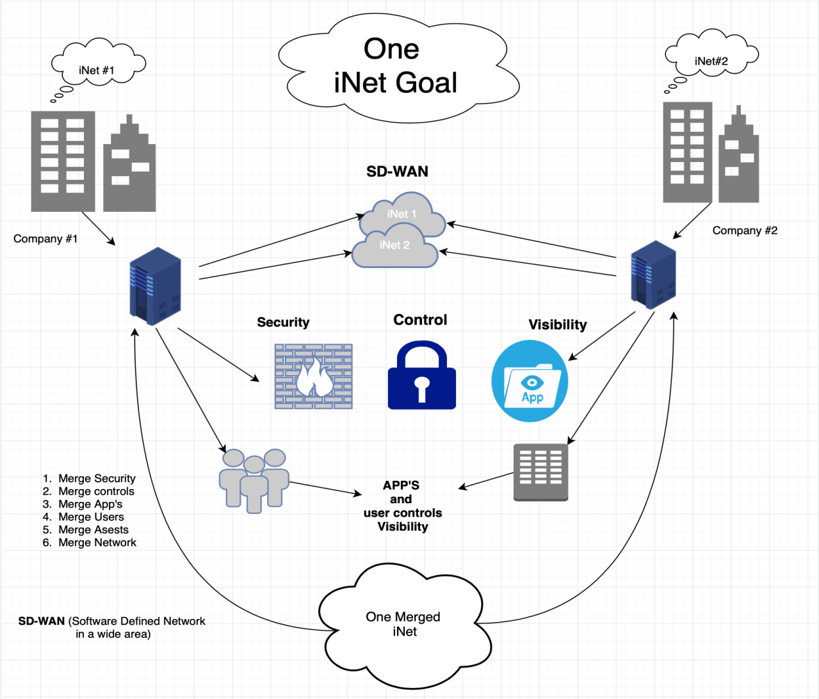

Explain what the client can expect from your services, including past efforts of this size
Antotech Consulting clients may expect efficiency, quality, and urgency with the implementation process. Productivity is imperative since we ensure that installation of systems and services and completed from day one. Our resources and partnership offer a quality of applications, equipment, and technical expertise on the desired services. Strayer Consulting has professional engineers who are trained and experienced to handle a vastly complex network and provide ways to recycle and satisfy and integrate multiple networks into one robust system. Antotech Consulting would help plan the process from both the business and technical perspectives. After assessing an organizational approach to how to handle the merge starting from executives board, stakeholders' insights, and financial institution and benefits. Then the company would process on implementing the technical aspect of the network migration and combining both domains into one where all security, users, equipment, network infrastructure, and all systems that impact the new company's acquisition.
  - Antotech Consulting is positioned to provide outstanding products and services for merger analysis through the following:
- Thoroughly analyze existing network topologies and network functions from the core, distribution and access layers.
- Carefully assess the process of merging network organizations.
- Manage the entire turnkey merger process, from stakeholder meetings to knowledge transfer.

References
Albrecht, K., & Albrecht, K. (2019). The only thing that matters: Bringing the power of the customer into the center of your business. New York: HarperBusiness.
Mancuso, J. (1983). How to prepare and present a business plan. Englewood Cliffs, NJ: Prentice-Hall.
Oyewole, B. (2018). Business Plan Guideline for Small and Medium Scale Enterprises.

