The State of Healthcare in the City of Joshua Tree
Debra Saunders
MHA/599
03/23/2020
Maire Simington

The State of Healthcare in the city of Joshua Tree
The current state of the health care system in the city
While appreciating the massive improvements that the city has been making in its healthcare system, it is notable that there are emerging health issues within the city. One of the most pressing emerging health issues that have changed the health situation in the city is the rise in the number of mental health cases. In the recent past, the city has witnessed an increase in the cases of drug abuse. This development has led to the development of other health complications in the city, such as addiction. Many young people in the city of Joshua Tree are living with addiction, and this has had adverse social, economic, and political impacts on the city (Happen et al., 2012). While substance abuse and addiction are major mental health challenges to many cities in the United States, it is necessary to note that the city has limited mental health facilities and professionals. Notably, mental health is a serious health challenge that requires the establishment of highly trained mental health care providers, including nurses and other healthcare professionals. Additionally, mental health facilities are also unique in many ways. The absence of these healthcare professionals and facilities to handle mental health cases is a massive threat to the city's healthcare system.
A Proposed improved health care service
The proposed healthcare improvement that the city of Joshua Tree needs to make is to introduce a sub-department in the department of health that is dedicated to mental health challenges in the city. The primary reason for having this department created at the local authorities is that the problem exists at the local level, and it is only the local authorities that are based placed to address the challenges. The main role of this sub-department is to have strategies in place to address substance abuse and associated mental health challenges. The treatment of mental health challenges is an incredibly complex process that requires a lot of variables to be established. The creation of this sub-department will not only look at the treatment of mental health complications in the city of Joshua Tree but also consider the most suitable mechanisms to address combat substance abuse rather than focusing only on treatments (Smith et al., 2014). The development of strategies to combat substance abuse is likely to be much more beneficial than the utilization of treatment approaches only.
How would this improve the community?
The introduction of this department is likely to have a significant impact on the health status of the city of Joshua Tree. Like any other society, an increase in mental health cases is likely to have adverse effects on the social and even economic aspects of the city. Mental health illnesses destroy families, especially by occasioning divorce. Many individuals whose partners have mental illnesses are likely to seek a divorce since they may not bear with the situation. Besides, it is notable that the treatment of mental health challenges is costly, and it may drain the little resources that families may have. These resources could have been used to pursue other beneficial economic ventures (Gauffin et al., 2013). Thus, the creation of this sub-department is likely to have very important roles to play in the improvement of the health of the community while at the same time promoting the social and economic aspects of society.
Another potential benefit of this improvement is the enhancement of the fight against substance abuse in the city. It is important to realize that substance abuse is one of the major causes of mental health problems in the city. The creation of this sub-department is likely to lead to the enhancement of the fight against substance abuse in the city. The city is facing significant mental health issues as a result of a tremendous increase in substance abuse. Thus, one of the most important courses of action is to address substance abuse challenges in the city.
Finally, the creation of this development is aimed at facilitating the training and recruitment of sufficient healthcare professionals to handle the increase in the number of people living with mental health challenges. While appreciating the fact that there are some mental health professionals in the City of Joshua Tree, the number is not sufficient. Besides, the sub-department will oversee the establishment of sufficient mental health facilities such as hospitals and other necessary equipment. As indicated earlier, there is a difference between mental health hospitals and other hospitals. It is beneficial to make sure that there are healthcare organizations that are created solely for mental health patients.
Floor plan for the facility
A mental health treatment facility has a unique floor design to allow for the effective achievement of the objectives of the organization;
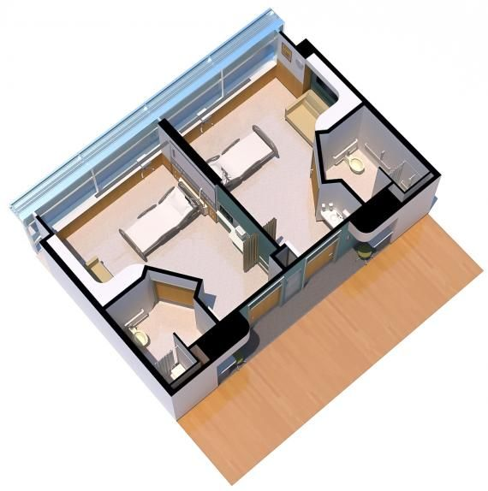
The floor plan above is for a mental health facility. From the floor above, it is notable that there is the creation of sections or units that are aimed at making sure that there is total privacy for each patient as they are being attended to by health practitioners. Many mental illness patients face challenges with self-esteem, and they may not be comfortable being handled among other people. The plan makes sure that the patient and care provider have an environment that allows them to interact appropriately.

References
Gauffin, K., Vinnerljung, B., Fridell, M., Hesse, M., & Hjern, A. (2013). Childhood socioeconomic status, school failure, and drug abuse: A Swedish national cohort study. Addiction, 108(8), 1441-1449.
Happell, B., Scott, D., Platania‐Phung, C., & Nankivell, J. (2012). Should we or shouldn't we? Mental health nurses' views on physical health care of mental health consumers. International Journal of Mental Health Nursing, 21(3), 202-210.
Smith, R. C., Laird-Fick, H., D’Mello, D., Dwamena, F. C., Romain, A., Olson, J., ... & VI, A. H. F. (2014). Addressing mental health issues in primary care: An initial curriculum for medical residents. Patient Education and Counseling, 94(1), 33-42.

