The City of Joshua Tree, California Healthcare
Debra Saunders
MHA/599
03/16/2020
Maire Simington

The City of Joshua Tree, California Healthcare
Demographic Information
Joshua tree is a city in California. The city has a population of 7,657 people. The city has a population density of 193 people per square mile. This is 25% less than the population density of California but it is 113% higher than the national average (World Population Review, 2020).
Image 1: The city of Joshua Tree, California
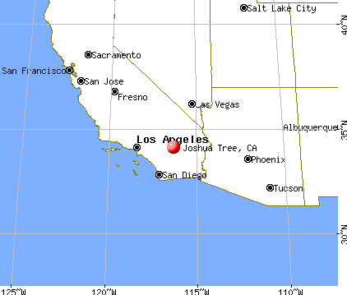
There are several challenges that have contributed to the seemingly low population in the city of Joshua Tree, California. One of the reasons is the relatively high rates of crime in the city. In this city, 1 in 59 people stands a chance of being involved in property crime. Besides, one in 232 people stand a chance of being involved in violent crime. To get a picture of the rates of crime in the city, evidence suggests that the city of Joshua Tree is only safer than 27% of the cities in the United States (Neighborhood Scout, 2020). The interpretation of this data is that the city of Joshua Tree among the cities in the United States with the worst levels of crime. The average age of the residents of the city of Joshua Tree is 41 years. This average age is 15% lower than that of California that is at 36 years. A significant majority of the population speaks English (87%) while 9% speak Spanish (World Population Review, 2020). On racial composition, 80% of the residents of the city of Joshua Tree are white while 1.92% is of Asian descent. African Americans from the minority group at 0.76%. There are more females than males in the city of Joshua Tree. For every 100 women, there are 92 men.
Types and locations of medical services
The city of Joshua Tree has a fairly advanced healthcare system. There are many primary healthcare organizations in the city of Joshua Tree. These healthcare organizations offer primary healthcare to the residents of the city. Primary healthcare providers are also known as primary care physicians. In the city of Joshua Tree, most of the primary care physicians offer outpatient and emergency services. One of the most unique features of the city of Joshua Tree's healthcare is that many of the healthcare professionals operate in freelance without being attached to any healthcare organization. Most of these professionals have small clinics where they offer healthcare services to their clients. Many families in this city identify with their family doctors they often call on them when they are in need of healthcare services. However, there are also many healthcare organizations that provide primary medical services to their clients. One of the most outstanding primary healthcare providers in the Hi-Desert Medical Center. This facility has some of the best medical services in the region. The Family Health Center is another significant medical organization in the region. This organization is equipped with some of the latest medical technologies and that provides it with the capability of addressing a wide range of medical services.
There are referral healthcare facilities in the city of Joshua Tree. These facilities largely handle medical issues that may not be addressed by primary healthcare providers. For example, when patients with adverse health complications are presented to primary healthcare providers but they realize that they are not capable of addressing such challenges. Some of the most prominent referral facilities in the city include Robert E Bush Naval Hospital and FCPP Multispecialty Clinic-Palm Springs. These facilities are equipped to provide effective care services to the clients.
Just like any other region, there are specific healthcare complications that characterize the population of the City of Joshua Tree. Most of the health complications that characterize the population include diabetes, blood pressure, and heart complications. Thus, any attempt to improve the quality of healthcare in the city must consider this uniqueness. One of the weak links in medical care in this region is the inadequacy of preventive interventions. In the recent past, most medical practices have been taking different approaches to healthcare and shifting focus on prevention. While there are many health challenges associated with the lifestyles, it is notable that there is little effort that is being made to improve on this health challenge. Lifestyle changes are likely to play an important role in making sure that the residents of the city of Joshua Tree enjoy good health.
Substance abuse is another healthcare challenge facing the residents of the city. Many of the young people residing in the city use drugs such as alcohol, marijuana, and cocaine. Overindulgence in some of these substances has contributed to the development of mental health challenges on the victims (Lajos & Zoltan, 2014). In response to the mental health challenges facing the residents of the city of Joshua Tree, many mental health facilities have been developed to handle the challenges. Some of them include Mental Health Systems Yucca Valley Center for Change, Mental Health Systems Inc. Indio Center for Change, Ranch Recovery Centers Inc. Hacienda Valdez and Desert Treatment Clinic among others.

References
Lajos, D., & Zoltán, Á. (2014). Comparison of drug abuse at two music festivals and the importance of health education. Procedia-Social and Behavioral Sciences, 116, 3236-3240.
Neighborhood Scout. (2020). Joshua Tree, CA. Crime Rates. Retrieved from https://www.neighborhoodscout.com/ca/joshua-tree/crime
World Population Review. (2020). Joshua Tree, California Population 2020. Retrieved from https://worldpopulationreview.com/us-cities/joshua-tree-ca-population/

