Speech Outline Format and Reference Guide

TITLE OF SPEECH

Name:

Specific Purpose Statement:

Thesis Statement:

Organizational Pattern:

Introduction

I. Attention-Getting Device: Gain the attention of the audience

II. Purpose and Thesis: Inform the audience of the purpose of your speech and state your
thesis

III. Credibility and Relational Connection: Explain why the audience should listen to you
speak on the topic and discuss your personal connection with the audience

IV. Orientation Phase: Familiarize the audience with the topic and define terms if
necessary

V. Impact of the Topic and Speech: Explain how the topic impacts the audience and why
they should listen to the speech

VI. Enumerated preview: Outline your main points

Transition: Lead audience from the introduction to the body

Body

I. First main point as stated in preview in a complete sentence
A. Supporting information for first main point in complete sentence
1. First detail of support for A in complete sentence
2. Second detail of support for A in complete sentence
B. Supporting information for the first main point in complete sentence
1. First detail of support for B in complete sentence
2. Second detail of support for B in complete sentence
C. Supporting information for the first main point in complete sentence
1. First detail for support for C in complete sentence
2. Second detail for support for C in complete sentence
Transition: Lead audience from the first main point to the second main point

II. Second main point as stated in preview in a complete sentence
A. Supporting information for second main point in complete sentence
1. First detail of support for A in complete sentence
2. Second detail of support for A in complete sentence
B. Supporting information for second main point in complete sentence
1. First detail of support for B in complete sentence
2. Second detail of support for B in complete sentence
C. Supporting information for second main point in complete sentence
1. First detail of support for C in complete sentence
2. Second detail of support for C in complete sentence

Transition: Lead audience from the second main point to the third main point

III. Third main point as stated in preview in a complete sentence
A. Supporting information for third main point in complete sentence
1. First detail of support for A in complete sentence
2. Second detail of support for A in complete sentence
B. Supporting information for third main point in complete sentence
1. First detail of support for B in complete sentence
2. Second detail of support for B in complete sentence
C. Supporting information for third main point in complete sentence
1. First detail of support for C in complete sentence
2. Second detail of support for C in complete sentence

Transition: Lead audience from the body to the conclusion

Conclusion

I. Wrap-Up Signal: Signal the beginning of the conclusion

II. Restatement of Thesis: Restate your thesis

III. Summary of Main Points: Provide the audience with a complete summary of your
main points

IV. Audience Motivation: Encourage the audience to incorporate the material you have
provided into their lives or to behave/think in a certain manner

V. Relational Reinforcement: Reinforce the relationship between the audience and the
material and between the audience and yourself

VI. Clicher Statement: Include a memorable line or phrase that will enable you to end
strongly and smoothly

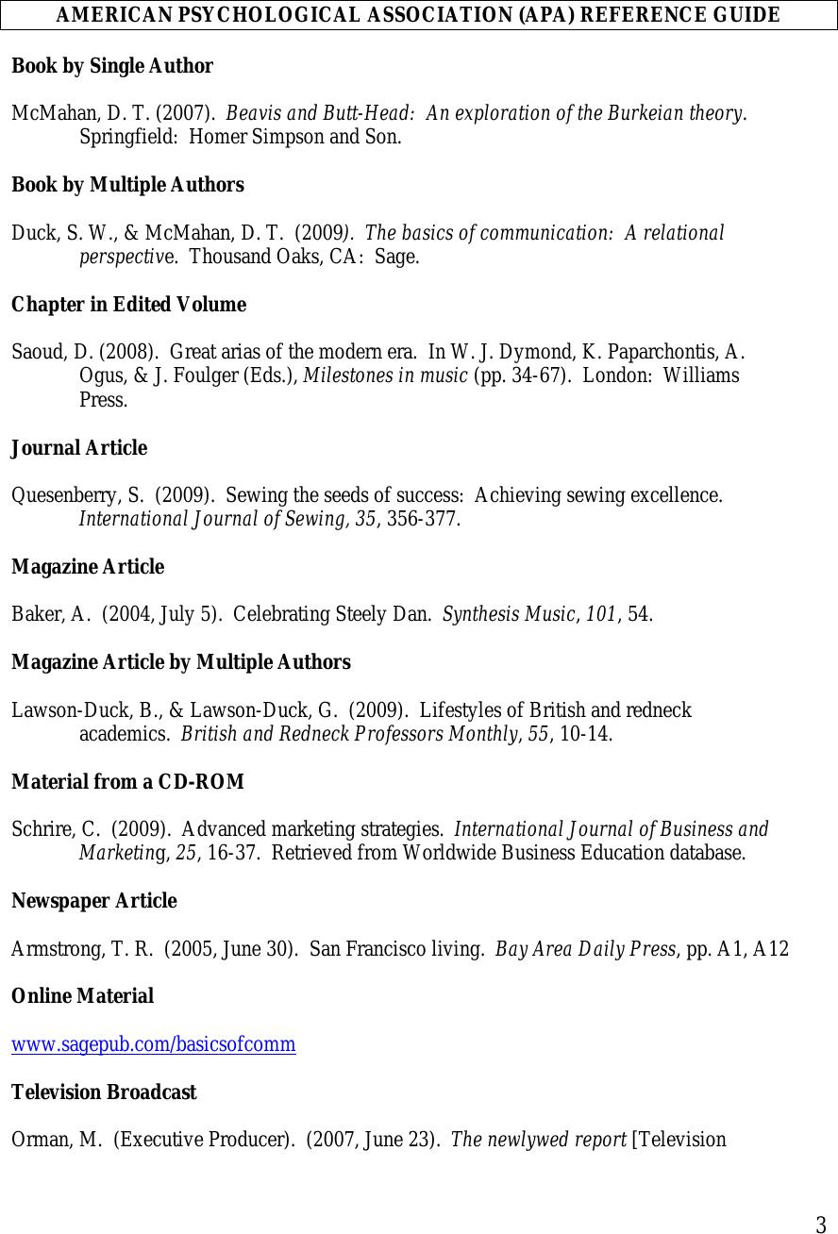

3

AMERICAN PSYCHOLOGICAL ASSOCIATION (APA) REFERENCE GUIDE

Book by Single Author

McMahan, D. T. (2007). Beavis and Butt-Head: An exploration of the Burkeian theory.
Springfield: Homer Simpson and Son.

Book by Multiple Authors

Duck, S. W., & McMahan, D. T. (2009). The basics of communication: A relational
perspective. Thousand Oaks, CA: Sage.

Chapter in Edited Volume

Saoud, D. (2008). Great arias of the modern era. In W. J. Dymond, K. Paparchontis, A.
Ogus, & J. Foulger (Eds.), Milestones in music (pp. 34-67). London: Williams
Press.

Journal Article

Quesenberry, S. (2009). Sewing the seeds of success: Achieving sewing excellence.
International Journal of Sewing, 35, 356-377.

Magazine Article

Baker, A. (2004, July 5). Celebrating Steely Dan. Synthesis Music, 101, 54.

Magazine Article by Multiple Authors

Lawson-Duck, B., & Lawson-Duck, G. (2009). Lifestyles of British and redneck
academics. British and Redneck Professors Monthly, 55, 10-14.

Material from a CD-ROM

Schrire, C. (2009). Advanced marketing strategies. International Journal of Business and
Marketing, 25, 16-37. Retrieved from Worldwide Business Education database.

Newspaper Article

Armstrong, T. R. (2005, June 30). San Francisco living. Bay Area Daily Press, pp. A1, A12

Online Material

www.sagepub.com/basicsofcomm

Television Broadcast

Orman, M. (Executive Producer). (2007, June 23). The newlywed report [Television

Broadcast]. Thousand Oaks, CA: Sage Broadcasting Service.

IN-TEXT CITATION

Direct Quotation of Single Author Work

Deya Saoud (2008) has noted that “selecting the greatest arias of the modern era is a challenge of
epic proportion” (p. 36).

Paraphrase of Single Author Work

Selecting the great arias of the modern era has been viewed as a significant challenge by music
theorists (Saoud, 2008).

Paraphrase of Single Author Work (Author Part of Narrative)

Saoud (2008) discovered selecting great arias of the modern era to be a significant challenge.

Direct Quotation of Multiple Author Work

According to Lawson-Duck and Lawson-Duck (2009), “the lives of British and redneck
academics are filled with adventure, lavish parties, and international intrigue” (p. 10).

Paraphrase of Multiple Author Work

The lives of British and redneck academics are marked by great action and excitement (Lawson-
Duck & Lawson-Duck, 2009).

Paraphrase of Multiple Author Work (Authors Part of Narrative)

Lawson-Duck and Lawson-Duck (2009) found the lives of British and redneck academics to be
marked by great action and excitement.

