Efficient Energy for Hospitals
Debra Saunders
MHA/560
01/21/2020
Doria Chege

Creating energy-efficient hospitals that save money on energy bills to use for critical patient care

STORYBOARD FOR HOSPITAL ENERGY EFFICIENCY
# | Scene | Transition | Script
1 | 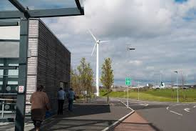 |  | Efficient energy to hospitals definitely saves the management of such hospitals from high energy bills. In the end, the healthcare costs will equally come down as an effect of reduced operation cost.  The video starts by showing the hospital surrounding where wind turbines are mounted. This lasts for 10 seconds after having detailed facts such as the number of turbines, their specifications as well as other details.
2 | 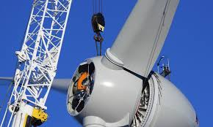 |  | The video zooms in one of the turbines to give viewers a sneak peek of the investment at a close range. The idea is to create seriousness on the efforts being made.
3 | 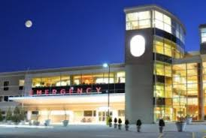 |  | The video then switches to a lateral view of a well-lit emergency section of the hospital. This lasts for 20 seconds. Critical medical interventions can be made smoothly and at many affordable costs.
4 | 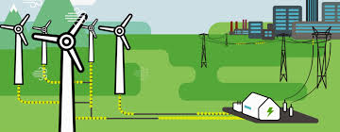 |  | The video concludes as it shows the full landscape of the hospital surrounding. Energy transmission from mechanical to electrical. This scene lasts for 20 seconds.  Will need the input of the hospital operations manager. Will also need donors to come on board. A partnership with a local power supply company will be a worthy collaboration for our course. A local community leader will be a member of our board.

