ETHICAL EXPECTATIONS
Alydia Harrell
ECE 600 Leadership, Innovation, and Social Justice in Early Childhood Education
Instructor: Kathy Hoover
Date: April 2, 2020

The essential focal point of the Code is on the day by day practice with kids and their families in programs for youngsters from birth through 8 years old, for example, new child/baby projects, preschool and prekindergarten programs, kid care focuses, clinic and kid life settings, family kid care homes, kindergartens, and essential classrooms (Coeckelbergh, Pop, Simut, & Peca, 2016). At the point when the issues include little youngsters, these arrangements additionally apply to experts who do not work straightforwardly with kids, including program directors, parent-teachers, early childhood instructors, and authorities with obligation regarding program observing and authorizing.
The beliefs reflect the goals of experts. The principles guide conduct and help specialists in settling moral situations. Both beliefs and standards are proposed to guide experts to those inquiries which, when dependably replied, can give the premise to decision making (National Association for the Education of Young Children, 2011). While the Code provides specific courses to tending to some moral problems, numerous others will require the expert to join the direction of the Code with proficient judgment.
The ideals and standards in this Code present a mutual system of expert duty that avows our promise to the guiding principle of the field (National Association for the Education of Young Children, 2009). The Code freely recognizes the obligations that individuals in the field have accepted, and in this manner, supports moral conduct in their work. Experts who face circumstances with reliable measurements are asked to look for direction in the pertinent pieces of this Code and in the spirit that educates the entirety.
Administrators of projects for small kids are liable for directing all program activities, filling in as pioneers in their projects, and representing the field to the community (Bredekamp, 2017). Youth program executives are called upon to support associations with a wide assortment of customers. They communicate with and have obligations to kids, families, program work force, governing board and supporting organizations, funders, administrative offices, their locale, and the profession.

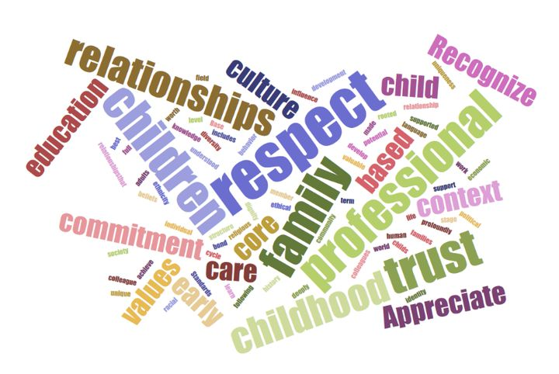

Reference
Bredekamp, S. (2017). Effective practices in early childhood education (3rd ed.). Upper Saddle River, NJ: Pearson Chapter 10: Planning Effective Curriculum
Chapter 16: Putting it All Together in Practice: Making a Difference for Children
Coeckelbergh, M., Pop, C., Simut, R., Peca, A., Pintea, S., David, D., & Vanderborght, B. (2016). A survey of expectations about the role of robots in robot-assisted therapy for children with ASD: Ethical acceptability, trust, sociability, appearance, and attachment. Science and engineering ethics, 22(1), 47-65.
National Association for the Education of Young Children. (2009). NAEYC standards for early childhood professional preparation programs [PDF file]. Retrieved from https://www.naeyc.org/
National Association for the Education of Young Children. (2011). Code of ethical conduct and statement of commitment (Links to an external site.) [PDF file]. Retrieved from https://www.naeyc.org/sites/default/files/globallyshared/downloads/PDFs/resources/position-statements/Supplement%20PS2011.pdf

