1.1 Realize You Are Part of a Noble Profession
Early childhood education has a rich history that has led to an understanding of the importance of initial experiences. From that understanding stems the growth of high-quality programs that benefit millions of children today.
The Legacy of Friedrich Froebel
Early childhood education in the United States can trace its beginnings to the philosophy of Friedrich Froebel, who founded the first German kindergarten in 1840. Froebel’s kindergartens were based on allowing children free-choice activities, creativity, social participation, and motor expression in a welcoming and stimulating environment prepared by the teacher.
In the late 19th century, American children often began working at the age of 10 after completing 3 years of school. Susan Blow, an educator in St. Louis, devoted her life to the education of young children and opened the first public kindergarten in 1873, based in Froebel’s theories, in order to improve children’s lives. Many of the best practices in early education today have roots in these early kindergartens. Play was viewed as a primary means for children’s learning, children were seen as progressing through developmental stages, and the teacher set the environment and stimulating activities to enhance learning. When today’s teachers encourage children to sing songs, build with blocks, express themselves through creative activities, and engage in “free play,” they are employing the educational philosophy and methods developed by Froebel more than two centuries ago (Elkind, 2012; Froebel, 1826/1887; Frost, 2010).
Twentieth-Century Children’s Advocates
Interest in the study of children and awareness of the value of educating their parents in wholesome child-rearing practices began to grow around the beginning of the 20th century. Along with the burgeoning interest in child development came a companion interest in preschool education and child care. This began abroad, where such leaders as Maria Montessori and the McMillan sisters pioneered child care as a means of improving the well-being of children of the poor.
Maria Montessori
In 1907 Maria Montessori, an ardent young reformer-physician, began her Casa dei Bambini (Children’s House). That child care center was originally founded as part of an experiment in refurbishing slum housing in an economically distressed quarter of Rome (Loeffler, 1992). Supporters of that cooperative housing venture found that young children left unattended during the day while their parents were away at work were getting into trouble and destroying the property that people had worked so hard to restore. They therefore wanted to work out some way for the children to be cared for. Under Montessori’s guidance, Children’s House emphasized health, cleanliness, sensory training, individual learning, and the actual manipulation of materials (Elkind, 2012; Hainstock, 1997; Montessori, 1912). Since Montessori believed that individual self-learning comes before other learning can take place, she focused on specially designed, self-correcting materials that the child uses alone. Language experience, the use of imagination, and dramatic play were not recognized as being of much importance (Beatty, 1995).
The McMillan Sisters
In England, too, the pathetic condition of young slum children was being recognized. In 1911 two English sisters, Margaret and Rachel McMillan, founded their open-air nursery school. The McMillans had been interested in socialism and the women’s movement. Through these concerns they came to know the condition of the London poor. They were horrified to discover that many children were running around shoeless in the London slums, suffering from lice, malnutrition, and scabies. Like Children’s House, their school stressed good health, nourishing food, and adequate medical care. Unlike Children’s House, it emphasized the value of outdoor play, sunshine, sandboxes, and regular baths. The McMillans advocated teaching children together in small groups. They stressed building independence and self-esteem. They also believed that young girls had natural gifts for working with children, so they gave them paid, on-the-job training as they worked with the children (Bradburn, 1989; McMillan, 1929).
John Dewey and Progressive Education
In the United States, childhood education witnessed a flowering of interest in the early 1900s as well. Progressive education, one of the most influential movements in the early childhood field still today, was developed at the University of Chicago Laboratory School under the direction of John Dewey at the beginning of the 20th century. Progressive education prevailed in elementary schools, yet many of the practices currently used in preprimary programs grew out of Dewey’s then-radical philosophy of “child-centered education.” Dewey believed that education should stem from the child’s interests and real experiences in the world, help the child think critically, and meet all the child’s needs—physical, social, emotional, and intellectual—to develop into a moral citizen and member of a democratic community (Elkind, 2012; Mooney, 2000). Dewey’s influence on the field of early childhood education can be seen in the similar goals that are espoused in developmentally appropriate practice (DAP), which is discussed later in this chapter.
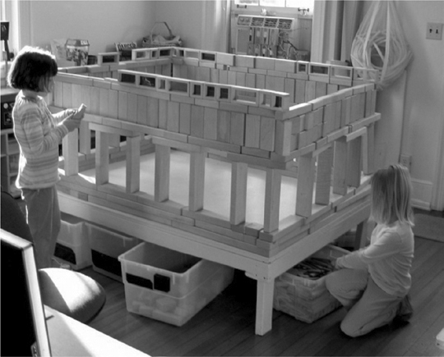
Many early childhood programs today use child-centered, play-based, hands-on teaching practices that stem from the theories of Froebel and Dewey.
Nursery Schools and the Growth of the Early Childhood Teaching Profession
“Nursery” education began to blossom in this country in the early 1920s. A group of women at the University of Chicago began the first parent cooperative nursery school in 1916. In 1919 Harriet Johnson opened the City and County School, which later metamorphosed into Bankstreet College of Education (one of today’s most renowned teacher education facilities and its affiliated School for Children) in New York City. Abigail Eliot began the Ruggles Street Nursery School in Boston in 1921—the same year that Patty Smith Hill founded a laboratory nursery school at Columbia Teachers College (the oldest and largest graduate school of education in the United States today).
As interest in nursery-level education grew, the academic community began to offer training in the field, and professional associations were formed. For example, at the Merrill Palmer School of Motherhood and Home Training (which later became the prestigious Merrill Palmer Institute), a nursery school was provided where students participated in an 8-hour laboratory experience each week. They studied child care management, health, nutrition, and social problems—not very different from what students do, at least in part, today.
The National Association for the Education of Young Children
In 1925 Patty Smith Hill (1942/1992) called a meeting of early leaders in the field to discuss issues of concern in the care of young children. In 1929 the National Association of Nursery Education was founded. That association has continued and is now known as the National Association for the Education of Young Children (NAEYC). It has grown to more than 100,000 members and provides an annual conference attended by 24,000 people (NAEYC, 2010). For over 25 years, NAEYC has developed an accreditation system designed to ensure high-quality standards in early childhood programs. Over 7,000 preprimary centers were NAEYC accredited in 2010. In addition to promoting the educational philosophy of developmentally appropriate practice, the organization provides professional development resources and seminars, publishes books and journals, and is a leading advocate for public policy issues that affect children and families (NAEYC, 2010). Information about NAEYC is included in the Related Organizations and Online Resources section at the end of this chapter.
TEACHER TALK
“The NAEYC national conferences are completely mind-blowing. To be surrounded by tens of thousands of early childhood professionals—attending workshops, making connections, hearing what the researchers and movers and shakers are up to—makes me feel I am part of an important community. I always come away inspired.”
The field of early childhood education has a noble history that has resulted in a proliferation of programs designed with the very best intentions for young children. People who enter the field usually do so out of a genuine sense of caring about children—certainly not for a love of money! (The issue of compensation will be discussed later in this chapter.) Most of us in early childhood education—like John Dewey or Maria Montessori or Patty Smith Hill—want to make a difference in children’s lives and, by doing so, help to create a better society. Nevertheless, these questions have probably crossed every early childhood teacher’s mind: Is all our hard work effective? Can we really make a difference?

