The requirements for the software to be developed are very clear so methodology chosen for the software is Waterfall Model. Steps of waterfall model and how this system will fit into this model are given as follows:
  - Requirements
Requirements of the system are clear and transparent so there will be no change in the requirements at any stage during the development of the system. Delays can ruin the entire system but there are no delays in the system and requirements can be processed as planned. Gathered requirements are
- Task is to develop a system that can track the courses reregistered by the student.
- The new system will compromise of the students and faculty information. It will also contain the information of courses reregistered by students.
- A catalog will be available for the students which consists of description and detail of the courses, each semester time table and an option to add/drop the course.
  - Analysis
Once requirements are gathered, it is necessary that these requirements are analyzed. Not only the requirements but also the stakeholders and feasibility of the project. Before any starting negotiation are to made if necessary, before starting the project.
After analysis and discussions with the stakeholders, following questions raised:
- How much are the expected user for this system and if there is any room of increase in the number provided in coming years?
- If there is a need to support multiple languages?
- What would be the time limit for each course?
- On which scale system will be used?
  - Design
Architecture used for the project will be 3-tier architecture and design of the system will be kept user-centered. Human Computer Interaction rules and regulations for usability will be followed to keep the system usable and easy to use. Design will contain all the finalized requirements.
  - Coding/Implementation
Coding/Implementation will be done considering the best technique to code so that additions can be made at testing phase and errors/bugs can be removed. As the system is based on information of the faculty and students and students have the access to browse course description and the schedule of classes for each semester, add classes to their schedule and drop classes from their schedule so the focus will remain on security a reliable system for adding and removing courses. The system will feature ease of use in all forms. Code will be tested by senior developers during this phase.
  - Testing
Testing is an important phase as there is no getting back once the developer has finalized and moved to the next step. The model being used is water fall method so, it is necessary to verify and validate requirements before going to the next step. The testers with similar capabilities will be hired to test the system as external tester.
  - Operation/Deployment
System will be tested on servers of the university by installing the software on those systems which were procured for the use of this information system. The system will used in real-time environment.
1.7 Maintenance
During this phase it will be ensured that the system is running smoothly and working correctly. It will also be ensured that in future if any problem occurs, the team will fix the issue and update the system accordingly.
2. Initial Investigation
  - Problem Statement
Due to manual system, it is always difficult to manage and retrieve data of any individual. It also takes a lot of effort for students if they have to manually have to submit their courses.

2.2 Objectives
To start a system which can track the courses registered by the student. The new system will comprise of the students and faculty information. It will also contain the information of courses registered by students. A catalog will be available for the students which consists of description and detail of the courses, each semester time table and an option to add/drop the course
  - Scope
The business scope of the project is wide as it is the need of every institute and can pe promoted as a complete system. Further it will include:
- All students from start to graduation interacts with the information system.
- Administrations control data through these systems.
  - Purpose
Purpose of the system is to provide an ease to the students and faculty of the university.
- Replace the current oud dated system with new integrated system.
- Add modern technology for the users.
- Provide up to date catalogue.
- Providing the competitive system to the users.
  - Assumptions
It is assumed that the new system will save the cost of the institute and will work as a centralized system for students, faculty and administration. It is also assumed that the new system will add ease for all the stakeholders.
  - Constraints
Failure to connect with the server of the system can add unease situation for every user.
  - Alternative Solutions
A mobile app can be a great alternate to this kind of information system as it will bring whole information to the user’s hand.

  - Analysis of business benefits
The need is to initiate this kind of the system as it will bring an ease for admins, faculty and students. Further the cost of the project can be calculated using Constructive Cost Model (COCOMO).
- Below standard and old technologies will be left out and will be replaced with the new integrated system.
- This will eradicate the need of duplications, paper and all other manual procedures.
- It will reduce the need of course listings.
- Entire catalog will be integrated to new information system of the university.
- Easy collaboration between the admins, students and faculty.
- Up to date system with all the easy to use features.
  - Risks and Issues
- A lot of care is needed for such system.
- System must have a safe backup in case of server failure.
- The system must be flexible enough to accommodate changes.
- Replacing the old system with the new system may cause problems for all the stakeholders on initial stages.
  - Quality
The development team intends to make the system a quality product in terms of usability and performance by minimizing the trade-offs.

2.10.1 In Terms of User Interface:
User Interface of the system will be compact, easy-to-use and responsive. The user will get familiar to the system features in no time. The system is designed in a minimalistic way so that user does not get confused with the pages. The user simply has to click on the desired option and the system will move the user to the appropriate page.

2.10.2 In Terms of Performance:
System is designed to run smoothly while operations are being carried out. Considering this load time for each page is maximum of 3 second and system will not take more then 3 seconds. This information System can support maximum of 1000 user at a time and in case this limit is exceeded then the system might slow down, lag or page loading time may be compromised
- Information system will run smoothly on all browsers supporting HTML5.
- Information system will be responsive and user-friendly. It will fit for a large range of Mobile Devices and smartphones.

2.10.3 Scalability
The system will hold the capacity to be upgraded as and when required.

2.10.4 Availability
The system will be available 24/7 and will have a backup server to ensure smooth usage of the information system.

Security
- For keeping the data of the user protected logins will be created for all the users.
- Data of user will not be compromised and this requires a complete backup of the user data. For this purpose, a complete backup of the server will be arranged
- User will be givens login accordingly to their roles as different user will have different roles to play.
3. Stakeholders
3.1 Internal Stakeholders
The stakeholder of the system are Students, Faculty, Administration (Accounts Department, Center of Examination, Student Facilitation Center, Admission Department, Students own Department, Program Chairperson, Program Coordinator, Program Officer, Developers, Alumni,
3.2 External Stakeholders
Higher Education Department/Commission, Government, System Analysts, Database Administrators and Network Administrators.
References
- http://tryqa.com/what-is-waterfall-model-advantages-disadvantages-and-when-to-use-it/#Requirements_Gathering_and_Analysis
- https://searchsoftwarequality.techtarget.com/definition/waterfall-model
Diagrams
3.1.1 Internal Stakeholders
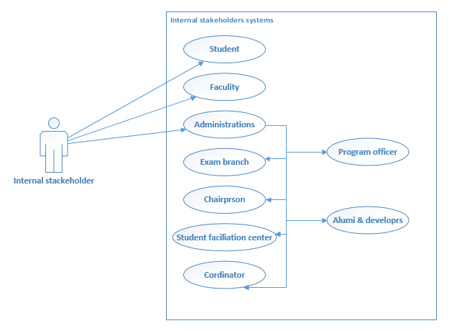

3.2.1
External Stakeholders
