Research into System Analysis and Design
Institution Affiliation
Date

Research into System Analysis and Design
Operating system contains various programs that enable computer’s internal functions to operate effectively. Mainframe operating systems are more refined products with diverse features and functions. IBM together with Microsoft Corporation established OS/2 to enable better functioning of personal computers which were IBM’s second-generation line computers. Due to the development of microchips, the DOS was increasingly becoming obsolete. The OS/2 joined the new graphical user interface (GUI) that was originally obtainable from mainframe computers. In the 1990’s, IBM presented an innovative system known as the OS/2 warp which comprised of numerous features although, it failed to survive in the market. This led to a shift of the corporations business operations to higher-value and profitable markets (Lavenberg, 1983). In this paper, we will be researching into the system analysis and design using IBM computers as a case study.
Computer systems designs at IBM have evolved over the years through the development of enhanced systems for emerging workloads especially in cognitive computing and IoT. IBM has introduced new IBM systems with the aim of producing industry-leading full systems solutions which have the capacity to adapt to customer needs. Flowcharts and data flow diagrams are some of the system designs that have evolved in IBM computer systems design to provide solutions to the emerging workloads. Flowcharts are designs that represent algorithm, workflow or process by use of boxes of various kinds to show steps and their sequence by linking them with arrows. They provide a graphic illustration that explains a remedy to a problem and they are mostly utilized in investigation, planning, recording, and handling a program or process in a certain field. Vintage IBM computer flowcharting template contained an original instructional sleeve plus additional templates that showed standard logic symbols and also, showed a variety of tube shapes ((Gustafson & Sparacio, 1982). The current IBM flowchart is more complex and simpler to use since it involves generation of codes that are derived from actions in the flowchart.
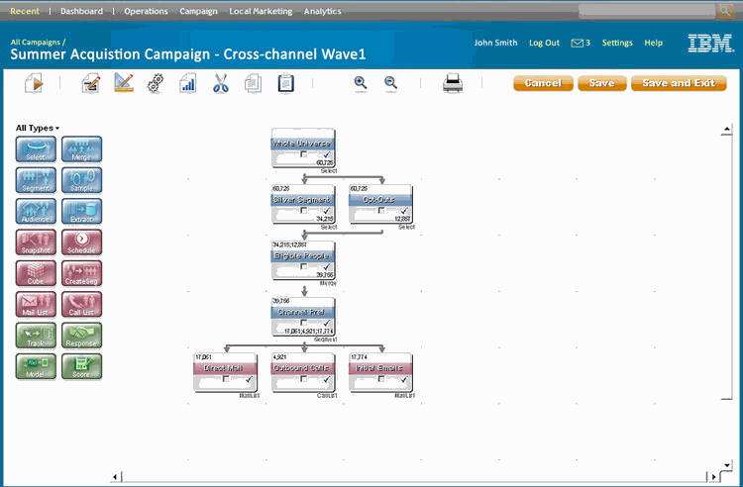
IBM flowchart’s main purpose is to decompose a system into actions that correspond to activities by use of diagrammatic elements. Unlike other charts, IBM flowcharts terminate on completion of an activity as opposed to other which reacts to externally generated event. All actions in the flowcharts have constraints such as guard conditions, non-empty entry actions and also, some outgoing action flows on actions lack triggering events. IBM flowcharts also comprise of action blocks that represent compound actions, one can use pseudocode text or mathematical formula as alternative notations. The IBM flowchart has the ability to advance organizational goals since it has a friendly user interface that makes it easy to operate and also, contains solutions to emerging workloads in organizational setting. According to the user reviews, sometimes the IBM web applications become unresponsive and the flowcharts get corrupted. These reviews claim that the flowcharts at time do not show any records on some process boxes even after the activities have been recorded by the user.

References
Gustafson, R. N., & Sparacio, F. J. (1982). IBM 3081 processor unit: Design considerations and design process. IBM Journal of Research and Development, 26(1), 12-21.
http://www.marketingcampaignmanagement.info/ibm-unica-campaign/
Lavenberg, S. (Ed.). (1983). Computer performance modeling handbook. Elsevier.

