Bradley Choy Professor Palmer

Media literacy assignment Due: 4/19/16

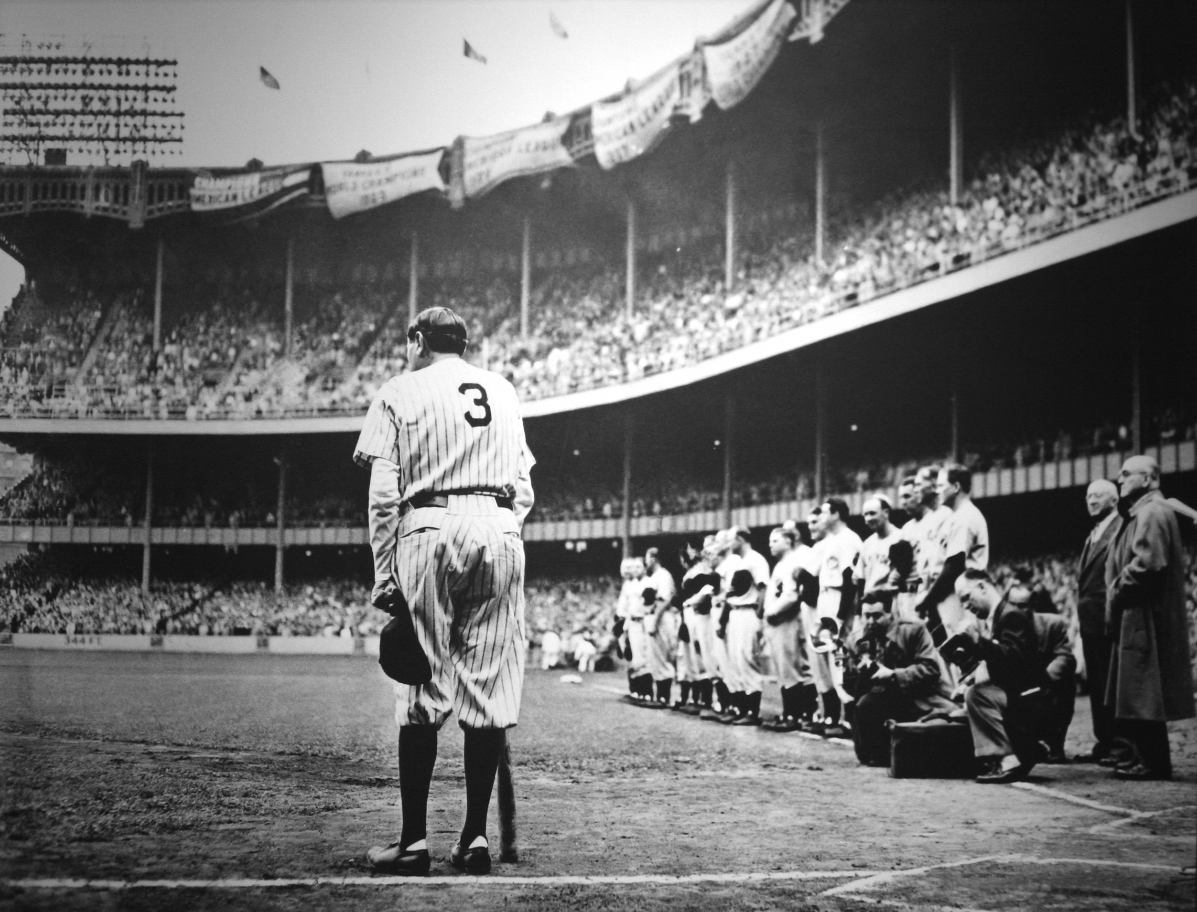

Without a doubt, Babe Ruth is one of the best baseball players who ever lived. In 1949 Nat Fein of the New York Herald Tribune shot a Pulitzer Prize winning photograph titled “The Babe bows out”. This photo impacts the past century for several reasons, the excellent photographic elements it displays, and the emotion the photo successfully delivers.

1) The photographer of this iconic image is Nat Fein. Nat Fein is credited for taking a photograph of Babe Ruth’s final bow. This photo is powerful to not only baseball players, but to any individual who has a love and respect for sports. Mr. Fein called himself a “human- interest photographer.” In fact, he took many photos. Fein was a member of the Herald Tribune Company until they went out of business in 1966. Fein took thousands of pictures showing everyday life in New York. Using a Bulky Speed Graphic camera, he photographed circus elephants sleeping, Mayor Fiorello La Guardia leading the Sanitation Department orchestra, and Dr. Albert Schweitzer kneeling to shake a little girl's hand. According to Fein, he says that the shot that he took of Babe Ruth that day was purely spontaneous. Fein was motivated to get a shot of Ruth (since this was Ruth’s last game), but he never expected that the photo would get so popular. The Pulitzer Prize photo is not a construction. What Fein did have was a keen sense of timing, and in the moment he “felt” the right time to snap the photo. Fein even proclaimed ''I didn't think it was a great shot,'' but he acknowledged that he ''got the feeling'' of the moment.

2) In this photo, there is an apparent reality and an implied reality. The apparent reality shows Ruth grabbing a nearby bat for support. On that day, Babe Ruth was announcing his retirement because he was deathly sick. Although the word ‘cancer’ was never spoken or written, Ruth was nearing the end of his. The day, according to the photo was overcast and dark, unusual for June in New York, but fitting for such a painful moment.  When it was time, Ruth shrugged off the overcoat that was keeping the chill away, and walked up the dugout steps. Babe Ruth is the largest figure in the photograph, but stands humbled by the giant stadium that he had filled so many times, by the realization of time passed, and by the adoration of 49,641 fans who had come to cheer him for the last time. Other than the literal reality, there is an apparent implied reality. The photo itself helps to capture the spirit and the story of Babe Ruth’s magnificent career. In this shot by Fein, it depicts the magnitude of the event and also manages to summarize his career and legacy all in one frame. The photo displays more than just a photo. The photo implies a story. This photo is a Pulitzer Prize winner because of the simplicity, yet profound impact, on baseball.

3) To me, this photo evokes many emotions. This photo has a profound impact on my knowledge and opinion of baseball. To me, this photo shows me that death is inevitable. Babe Ruth, arguably one of the greatest baseball players of all time, had his life cut short due to cancer. This photo shows me that baseball is truly a beautiful sport because there is no time limit. The sport is played regardless of clock, weather, or condition. The photo shows individuals that time is something that will kill us all in the end, but baseball in its beautifulness shows us a sport with no time. This photo has changed my opinion on baseball from being a boring sport to one that has changed my outlook on life. This photo has impacted me individually. This may not be true to all, but for an avid baseball fan like myself, this photo raises emotion because it is a tribute to the greatest man to have ever played the game.

4) This photo of Babe Ruth influences both the media and individuals who love baseball. This photo was first seen in the Herald Tribune Company in 1935. The photograph was taken by Nat Fein, and the subsequent profits went to both the Herald Tribune Company and Fein. This photo went on to shape the standards of media. The media suddenly had an interest in sports coverage because of the success of the Photo taken by Fein. Individuals in the media saw that they could tap into a new audience of sports fans. Therefore, this photo influenced the media in a profound and apparent way. Although the profits of the photo went to The Herald Tribune Company, the legacy that the photo has brought has changed the course of media coverage.

5)In this photo, there are several core values conveyed to the audience. There are no biases contrived from Fein. On the day Fein took the photo, another photographer actually called in sick, so Fein was just there to fill his colleagues spot. Therefore, there are no apparent biases or prejudices for, or against, Babe Ruth in this photo. Some core values portrayed by the photo are: persistence of greatness, and the ideological message shown is one of good life. This photo shows a heartwarming tribute to Babe Ruth, one of America’s greatest baseball players.

6) This content has an impact on social change. This content does not have a choice in shaping politics because the photo is innately not political. But what this photo does help bring a change in is society. So how and why does the Babe continue to have a presence in our lives? Maybe it’s a result of stories passed down through generations and generations of how the Babe somehow touched the lives of parents, grandparents, great-grandparents, and so on. Or, perhaps it’s the stories captured in the numerous books or articles that continue to be published throughout the decades. Or perhaps it’s the ongoing references and comparisons to the Babe still made frequently on sports news shows. Or, maybe it’s a result of the number of films that focus on his life: a number of documentaries, two feature films and a TV movie have been made about Babe Ruth. Therefore, Babe Ruth and this photo have impacted society in many more ways than Babe had ever imagined. Babe Ruth has left a legacy that will stand the test of time.

7) This image is profound not because it was spoken of, but because of the value of a moment. It is often said that a picture is worth a thousand words, but in this photo, a picture is worth much more. If this event was broadcasted through a radio the effect would not be as great. The paper allows both an ability to share and analyze. Individuals will be able to hold the photo in their hands and know where they were on that very day. Individuals who listened to the event via radio will not remember the event as well as those who saw it in person. If this event were broadcasted on a television, the effect would double because a verbal and visual recognition. If individuals can see and event, and listen, they can recall the event faster. But, the print does a good job at capturing the moment in its entirety.

8)This photo, as mentioned in earlier remarks, is not a scene set photo. The photo is not a construction; the photo is a “found” situation by Nat Fein. This photo is more authentic than a construction because if was spontaneous. The iconic photo of Babe Ruth was created by using a Bulky Speed Graphic camera. The Speed Graphic camera has two shutters - focal plane and in-lens; three viewfinders - optical, wire frame and ground glass; interchangeable lenses; a rise and fall front; lateral shifts; a coupled rangefinder; and a double extension bellows adaptable to lenses from 90mm to over 300mm.The Speed Graphic looks complicated, but is one of the simplest and most flexible cameras made. If individuals did not pay attention you can double expose, shoot blanks, fog previous exposures or shoot out of focus images. This is why the photo contrasts dark and light so well, and why at the time it was regarded as one of the best photos taken. The way Fein positioned the photograph is one of perfection, and is why the photo is a Pulitzer Prize winner.

Therefore, “Babe Ruth retires” is one of the great photographs of the 20th century because of the exceptional photographic elements it displays and the story and emotion it provides. It was a pleasure and an honor to be able to critique this outstanding Pulitzer Prize winning photograph.

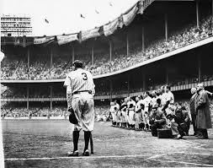

Citations:

"Critical Analysis of a Pulitzer Prize Winner." *Alexseyb*. N.p., 03 Oct. 2012. Web. 29 Mar. 2016. <https://alexseyb.wordpress.com/2012/10/03/critical-analysis-of-a- pulitzer-prize-winner/>.

Goldstein, Richard. "Nat Fein, 86, Pulitzer Winner For Picture of Ruth's Final Bow." *The New York Times*. The New York Times, 28 Sept. 2000. Web. 29 Mar. 2016. <http://www.nytimes.com/2000/09/29/sports/nat-fein-86-pulitzer-winner-for- picture-of-ruth-s-final-bow.html>.

"The Graflex Speed Graphic FAQ." *The Graflex Speed Graphic FAQ*. N.p., n.d. Web. 29 Mar. 2016. <https://graflex.org/speed-graphic/>.

N.p., n.d. Web. 29 Mar. 2016. <http://www.baberuthcentral.com/hero-and-icon/babe- ruths-effect-on-american-culture/>.

N.p., n.d. Web. 29 Mar. 2016. <http://www.sportscollectorsdaily.com/famous-babe-ruth- photo-stands-test-of-time/>.

"- RareNewspapers.com." *- RareNewspapers.com*. N.p., n.d. Web. 29 Mar. 2016. <http://www.rarenewspapers.com/list?q%5Bsearch_method%5D=Exact%2BPhra se&q%5Bquery%5D=babe%2Bruth>.