Module 1 - SLP

Action Research and Organizational Development
For the Session Long Project in this class, you will be applying the principles of organizational development to an organization you currently work for or have worked for in the past. For this first SLP, think carefully about the background readings and how they might apply to a specific organizational situation or problem that you have experienced firsthand. Then write a 2- to 3-page paper answering the following questions:

- What do you think the biggest problem your current organization or one of the previous organizations you worked for faces? Why do you think management has had difficulty with this problem?
- Do you think this problem could be mitigated by hiring an organizational development consultant based on what you’ve read in the background materials? Why or why not? Make sure to cite some of the readings in your answer.
- Of the action research and organizational development steps listed in the required readings, which ones do you think would be the more challenging steps that an organizational development consultant would face coming into your organization? Explain your reasoning and cite at least one of the required background readings.

SLP Assignment Expectations
- Answer the assignment questions directly.
- Stay focused on the precise assignment questions; don’t go off on tangents or devote a lot of space to summarizing general background materials.
- Make sure to use reliable and credible sources as your references. Articles published in established newspapers or business journals/magazines are preferred. If you use articles from the Internet, make sure they are from credible sources.
- Reference your sources of information with both a bibliography and in-text citations. See the Student Guide to Writing a High-Quality Academic Paper, including pages 13 and 14 on in-text citations. Another resource is the “Writing Style Guide,” which is found under My Resources in the TLC portal.

Module 2 - Case

Large Group Interventions

Case Assignment
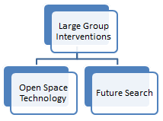First and foremost, remember to go very carefully through all of the required materials before starting this assignment. There are two short videos and two short articles, plus two in-depth book chapters to go through. There are also some optional readings in the background materials that you can use for your paper. It is important to make sure you understand the ins and outs of Open Space Technology and Future Search before starting on this assignment, so make sure to go through the readings and videos carefully before you start on this paper.
For this assignment, you will be going through four scenarios. For each scenario, cite at least two of the readings from the background readings to support your answer. You need to cite at least four of the readings total for your paper—these can include both required and optional readings listed in the background materials. Your paper should be 4–5 pages in length:
- Suppose you win the lottery. Not sure what to do with all of your money, on an impulse you decide to buy a local college as you want to make a positive impact in your community. However, you soon find yourself a bit over your head as all day you have employees or students coming to your office with all kinds of advice, suggestions for changes that should be made, complaints, etc. Never having run a college before, you are a bit confused about how to deal with all of this input and you don’t really have a good idea about what to focus on. The college has about 300 employees and 800 students and want to find a way to get some more organized input and creative ideas for improving the college. Should you use Open Space Technology, Future Search, or neither? Explain your reasoning and justify your answer using at least two of the readings from the background materials.
- A video game company starts out with five undergraduate students living in a dorm, but rapidly grows within three years to around 50 employees and $10 million a year in annual revenues. While the company is still expected rapid growth, there is still sharp tension between the very young video game designers and the older and more experienced executives who run the finance and marketing departments. In particular, the younger employees strive to develop new video games that are unique and much different than any other games available. However, the more experienced executives wish to take a more conservative route and come out with games that are similar to popular games produced by their competitors. The five founding partners are not sure which of these two directions to take and wish to receive input from all of their employees through some type of formal process. Should the CEO use Open Space Technology, Future Search, or neither? Explain your reasoning and justify your answer using at least two of the readings from the background materials.
- An insurance company has most of its employees in three different departments – sales, accounting, and information technology. The CEO is always receiving input from the sales department, as most of the salesforce is very outgoing and they don’t hesitate to give their opinions or make requests. On the other hand, employees in accounting and information technology tend to be quiet and shy and rarely speak up. The CEO notices that there is considerably higher turnover in the accounting and information technology departments, and thus becomes concerned that perhaps employees in these departments are leaving because they are dissatisfied with decisions the CEO has made or because they feel the salesforce is overly favored. There are about 50 employees in each department. The CEO wishes to find a process by which a wider range of employee input can be obtained. Should the CEO use Open Space Technology, Future Search, or neither? Explain your reasoning and justify your answer using at least two of the readings from the background materials.
- A CEO initiates an Open Space Technology conference. At the start of the conference, the CEO provides a list of topics he wants covered and also gives his opinion on what kind of outcomes he wants from the conference. He also makes attendance at the conference mandatory. When the conference starts, participants all volunteer to give sessions on the topics proposed by the CEO. A few participants propose to give sessions on other topics not mentioned by the CEO, but very few employees come to these sessions and instead go to the sessions covering topics suggested by the CEO. At the end of the conference, the CEO is presented with a carefully worded summary of the conference and given conclusions that the CEO wanted to hear. However, after the conference ends and employees go back to work they are very slow at implementing the recommendations from the conference. What do you think went wrong? Which major principles or concepts of Open Space Technology do you think the CEO violated? Explain your reasoning, and cite Leith (1996) and at least one other source on Open Space Technology to support your answer.

Assignment Expectations
- Answer the assignment questions directly.
- Stay focused on the precise assignment questions; don’t go off on tangents or devote a lot of space to summarizing general background materials.
- Make sure to use reliable and credible sources as your references. Articles published in established newspapers or business journals/magazines are preferred. If you use articles from the Internet, make sure they are from credible sources.
- Reference your sources of information with both a bibliography and in-text citations. See the Student Guide to Writing a High-Quality Academic Paper, including pages 13 and 14 on in-text citations. Another resource is the “Writing Style Guide,” which is found under My Resources in the TLC portal.

Module 2 - SLP

Large Group Interventions
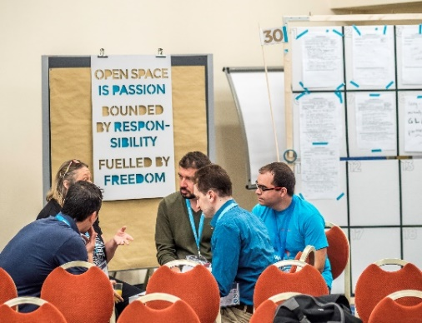For this assignment, continue to write about the current organization you work for or one that you worked for in the past. Before writing this paper, make sure to thoroughly review the background readings. Think carefully about how Open Space Technology and Future Search could be used at your organization. Then write a 3-page paper addressing the following questions. Make sure to cite at least three of the required readings in your paper:
- What issue facing your organization would be most appropriately addressed using Future Search? Explain the issue and why Future Search could effectively address this issue.
- If you organized a Future Search Conference to address the issue identified in Question 1 above, who would you include in the initial planning before the conference? Who you invite to the conference? How many people would you invite, and why? Any other specifics planning details that you would address to ensure the success of the conference?
- What issue facing your organization would be most appropriately addressed using Open Space Technology? This should be a different issue than the one you discussion in Question 1. Explain the issue and why Open Space Technology could effectively address this issue.
- If you organized an Open Space Technology Event to address the issue identified in Question 3 above, who would you include in the initial planning before the conference? Who you invite to the conference? How many total people would you invite, and why? Any other specifics planning details that you would address to ensure the success of the event?

SLP Assignment Expectations
- Answer the assignment questions directly.
- Stay focused on the precise assignment questions; don’t go off on tangents or devote a lot of space to summarizing general background materials.
- Make sure to use reliable and credible sources as your references. Articles published in established newspapers or business journals/magazines are preferred. If you use articles from the Internet, make sure they are from credible sources.
- Reference your sources of information with both a bibliography and in-text citations. See the Student Guide to Writing a High-Quality Academic Paper, including pages 13 and 14 on in-text citations. Another resource is the “Writing Style Guide,” which is found under My Resources in the TLC portal.

Module 3 - Case

Job Redesign

Case Assignment
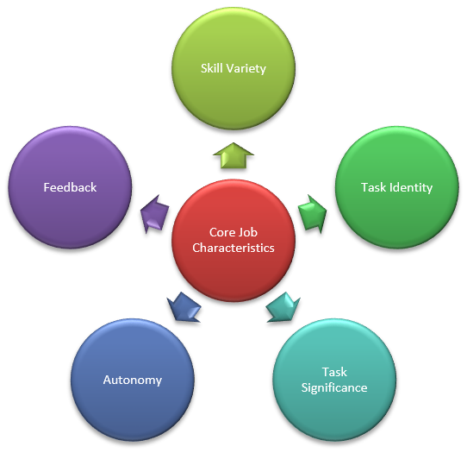In the background materials you had a chance to view some videos and read about the traditional “top down” approach of job redesign as well as the newer “bottom up” approach of job crafting. Before starting on this assignment, make sure you have thoroughly reviewed the videos and readings and understand the key job redesign and job crafting strategies. Once you have finished reviewing the background materials, apply what you’ve learned to the specific scenarios and questions below. Make sure to cite at least one of the required readings for each answer, and try to cite at least four of the readings or videos in your answer. Your paper should be 4–5 pages in length:
- Relax Lines, Inc. is a luxury cruise line that has hired you as a job crafting consultant for two groups of their employees. The first group is the ship crew. The crew have responsibility for safety, navigation, and maintenance of the ship. The second group is the hospitality staff. The hospitality staff is tasked with making sure the passengers are enjoying themselves and are properly entertained with various events that this staff plans and prepares. Before arriving at the cruise line to do interviews and make recommendations, you first need to do some reading on what general approach you will use. As a first step, review Dik and Duffy (2012), where they discuss task crafting, relational crafting, and cognitive crafting. Which of these three types of job crafting do you think would be most appropriate for the ship crew, and which one do you think would be most appropriate for the hospitality staff? Also, read up on “job-crafting swap meets” in Wrzesniewski (2014). Do you think a swap meet would be appropriate for either ship crew members or hospitality staff? Any other strategy from Wrzesniewski (2014) that you think would be useful for either pilots or online marketers?
- The ABC Corporation has a team of telemarketers. The job description for the telemarketers is pretty basic: They call up potential customers who have visited his company’s web page and requested information about the product. Telemarketers’ performance evaluations depend mostly on their monthly sales as well as customer satisfaction surveys, and they receive monthly feedback reports. Their supervisor gives them some initial training, but these telemarketers have a lot of freedom to choose how and when to call customers. For example, they are free to customize their own sales pitch as long as they don’t mislead potential customers. Also, they are not required to fill out a time card or work at the office (they can work from home, if they want). As long as they are making enough monthly sales they are free to set their own schedules. While the telemarketing team is performing well, the company is concerned about high turnover among telemarketers and wants to do some job enrichment. Which of the five core job dimensions discussed in Bauer and Erdogan (2012) or page 9 of Griffin (2007) do you think should be revised the most during a job redesign intervention? Which ones do you think do not need to be revised? Explain your reasoning and cite some of the required readings in your answer.
- Suppose a sports injury clinic has three main practitioners. First, there is a general practitioner doctor who does the basic diagnosis of the injury and works with the patient to come up with an overall treatment program. This doctor also prescribes medicine as needed. Then there is a surgeon who specializes in sports injuries. This doctor only does surgery. Finally, there is a physical therapist who helps patients with exercise programs to help them recover. The owner of the clinic though becomes worried that these three practitioners are becoming bored and dissatisfied with their jobs and there is concern they might all leave unless their jobs change. However, given the high degree of training required for each of their specializations management is not sure how to go about making their jobs less monotonous and more rewarding. In general, would you recommend management undergoes a traditional job redesign approach or a job crafting approach? Which specific job redesign strategy or job crafting strategy would you recommend? For example, if you choose job redesign discuss whether you would recommend job rotation, enlargement, enrichment, etc. If you choose job crafting, refer to one of the specific strategies or interventions discussed in Wrzesniewski (2014) or Dik and Duffy (2012).
- Create a table with the definitions of the three main types of job redesign (job enlargement, job rotation, job enrichment) and the three main types of job crafting (task crafting, relational crafting, and cognitive crafting). Then write two paragraphs explaining which of the three types of job crafting are most similar to any of the three types of job redesign, and on what you think are the key differences between job crafting and job redesign based on the definitions in your table.

Assignment Expectations
- Answer the assignment questions directly in 4 to 5 written pages.
- Stay focused on the precise assignment questions; don’t go off on tangents or devote a lot of space to summarizing general background materials.
- Make sure to use reliable and credible sources as your references. Articles published in established newspapers or business journals/magazines are preferred. If you use articles from the Internet, make sure they are from credible sources.
- Reference your sources of information with both a bibliography and in-text citations. See the Student Guide to Writing a High-Quality Academic Paper, including pages 13 and 14 on in-text citations. Another resource is the “Writing Style Guide,” which is found under My Resources in the TLC portal.

Module 3 - SLP

Job Redesign
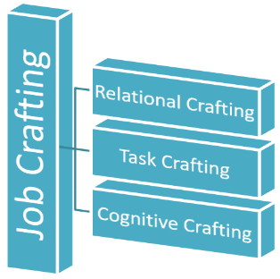As with the Case Assignment, make sure you have thoroughly reviewed the background readings and understand the key concepts of job redesign and job crafting. Then think about your own job and workplace and how these concepts apply to your own work life. Once you have finished reviewing the background readings and have carefully thought about how these concepts relate to your own job, write a 2- to 3-page paper answering the following questions:
- Of the three main types of job redesign (job enlargement, job rotation, job enrichment), which one do you think would be the most effective in your current workplace? Explain your reasoning, and cite Bauer and Erdogan (2012) or Griffin (2007) as part of your answer.
- Suppose your supervisor decides to use job enrichment to redesign your job. Of the five core job characteristics discussed in Bauer and Erdogan (2012) or page 9 of Griffin (2007), which one do you think should be changed as part of your job redesign?
- Which specific job crafting strategy or intervention do you think would be most effective at your organization or for your specific job? Refer to one of the specific strategies or interventions discussed in Wrzesniewski (2014) or Dik and Duffy (2012).

SLP Assignment Expectations
- Answer the assignment questions directly in 2 to 3 written pages.
- Stay focused on the precise assignment questions; don’t go off on tangents or devote a lot of space to summarizing general background materials.
- Make sure to use reliable and credible sources as your references. Articles published in established newspapers or business journals/magazines are preferred. If you use articles from the Internet, make sure they are from credible sources.
- Reference your sources of information with both a bibliography and in-text citations. See the Student Guide to Writing a High-Quality Academic Paper, including pages 13 and 14 on in-text citations. Another resource is the “Writing Style Guide,” which is found under My Resources in the TLC portal.

Module 4 - Case

Appreciative Inquiry

Case Assignment
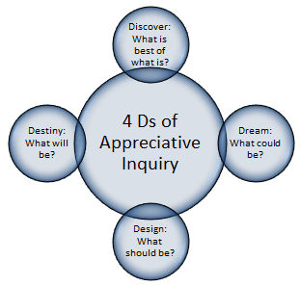For this assignment, first carefully review the required background materials. Make sure you remember the standard organizational development approaches covered in Module 1. Then make sure you understand the main principles of Appreciative Inquiry and how they compare to traditional organizational development approaches (action research, problem solving). It is also important to understand what is involved in each of the “4 Ds” – Discovery, Dream, Design, and Destiny.
When you are finished reviewing the background materials, go through each of the scenarios below and apply what you’ve read to these scenarios. For each scenario, cite at least one of the required readings to support your answer. You should cite at least three of the four required readings in your paper. Your paper should be 4–5 pages in length:
- A corporation notices that suddenly turnover in the human resource department has been extremely high. This corporations prides itself on having a dedicated and committed workforce, so this high turnover in one department is highly troubling for this company. Normally the human resource department investigates when there is a high turnover rate in a department. But since the human resource department is now the department with the high turnover rate, the CEO decides that an outside consultant should be hired to investigate the high turnover rate and propose solutions. Should this team use an Appreciative Inquiry consultant, or hire a more traditional Organizational Development consultant? Explain your reasoning with references to the required readings.
- An organization hires an Appreciative Inquiry consultant to help the company get back on track and improve the performance of its product design team. The consultant starts by asking members of the team how they would like the team to perform and what their ideal vision of the team would be. The consultant collects all of this input and designs a detailed plan regarding how to achieve this ideal future that the team dreams about. However, once this detailed plan is presented to the team they are all shocked that the consultant came up with such an unrealistic plan. Team members say that the expenses involved in this plan are far beyond their budget, and they would also need to hire many new team members in order to achieve this plan in a realistic time frame. They all agree it would be great if they had the time and money to implement this plan, but they also are in consensus that this plan presented by the consultant is highly unrealistic. What do you think went wrong? What steps do you think the Appreciative Inquiry consultant could have taken to make the consulting process go better? Refer to the specific “4 Ds” of Appreciative Inquiry in your answer.
- A group of ten friends decide to start a new social networking company and put their savings together to start this new business. The company grows rapidly for the first five years and morale is very high in the company during this time. Everyone gets along very well and they work together cooperatively in order to continuously improve the company and its services. However, after five years the company stops growing and seems to reach a plateau. Morale seems to drop and there is now noticeable tension between employees including the top leadership team. They are not sure what to do revive the company, so they decide to hire a consultant. Should this team use an Appreciative Inquiry approach or a more traditional organizational development approach? Explain your reasoning with references to the required readings.
- A large supermarket chain decides they would like to expand to have an online division where consumers can order online and have their groceries delivered directly to their homes. The supermarket decides to create a special taskforce to come up with a detailed plan on how they should develop and manage the new online division. This taskforce includes a diverse variety of employees including those from the marketing department, accounting department, inventory department, and most of the main departments. These employees do not have much experience working with each other since they are from different departments. After meeting regularly for a few months, the taskforce makes almost no progress and are constantly bickering. Management is concerned that the online division will never get off the ground. To get back on track and find a way to function more smoothly, should this taskforce use an Appreciative Inquiry approach or a more traditional organizational development approach? Explain your reasoning with references to the required readings.

Assignment Expectations
- Answer the assignment questions directly.
- Stay focused on the precise assignment questions; don’t go off on tangents or devote a lot of space to summarizing general background materials.
- Make sure to use reliable and credible sources as your references. Articles published in established newspapers or business journals/magazines are preferred. If you use articles from the Internet, make sure they are from credible sources.
- Reference your sources of information with both a bibliography and in-text citations. See the Student Guide to Writing a High-Quality Academic Paper, including pages 13 and 14 on in-text citations. Another resource is the “Writing Style Guide,” which is found under My Resources in the TLC portal.

Module 4 - SLP

Appreciative Inquiry
For this assignment, think about a team you currently work with or have worked with in the past and how well this team has functioned. Think about both the positives and the negatives, and how the material from the background readings applies to what you’ve experienced. Then write a 2- to 3-page paper answering the following three questions below. Make sure to cite at least one of the required readings for each of your answers, and to cite at least two of the required readings in your paper:
- What are some of the key positive aspects of this team? Discuss some specific positives and include some stories of times when the team functioned especially well. Do you think these stories could work in an Appreciative Inquiry approach to come up with a plan to improve the performance of the team?
- How is the effectiveness or performance of this team usually measured? Could a traditional organizational development approach help identify problems in this team as well as find ways in which team performance could be improved?
- Overall, do you think an Appreciative Inquiry or a traditional organizational development would be better for this team? If your team was to hire a consultant, what type of approach would you want the consultant to take?

SLP Assignment Expectations
- Answer the assignment questions directly.
- Stay focused on the precise assignment questions; don’t go off on tangents or devote a lot of space to summarizing general background materials.
- Make sure to use reliable and credible sources as your references. Articles published in established newspapers or business journals/magazines are preferred. If you use articles from the Internet, make sure they are from credible sources.
- Reference your sources of information with both a bibliography and in-text citations. See the Student Guide to Writing a High-Quality Academic Paper, including pages 13 and 14 on in-text citations. Another resource is the “Writing Style Guide,” which is found under My Resources in the TLC portal.

