Module 1 - Background

Action Research and Organizational Development

Required Reading
A good place to start is this introductory video on organizational development which will help introduce you not only to this module’s topic but also the entire course:
Weiher, A. (2014). Artifact: Organization Development. https://www.youtube.com/watch?v=x9iLMsogoR0
For more detailed reading on many of the same concepts in the video, read the following introductory book chapter. Pay special attention to the seven steps of action research which will be a major emphasis for the Case Assignment:
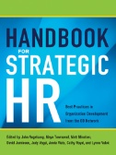Lurey, J. & Griffin, M. (2013). Section 2: Chapter 4: Action research: The anchor of OD practice. In Vogelsang, J. (ed). Handbook for Strategic HR: Best Practices in Organization Development from the OD Network. Saranac Lake, NY, USA: AMACOM Books, pp. 46-52. [EBSCO eBook Business Collection. Note: when looking up a book in the EBSCO book collections do not copy and paste the entire reference into the search engine. Only enter in the title of the book. If you do a search on “Handbook for Strategic HR: Best Practices in Organization Development from the OD Network.” this book will come up.
Now read up in more detail on action research with the following chapter. This chapter has more detail about the main steps of action research such as entry, contracting, etc. Note the names of the steps are a little different than the previous book chapter such as “action planning” instead of “planning change” or “research” instead of “data gathering and diagnosis”. But it is the same basic step-by-step approach:
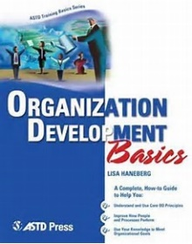
Haneberg, L. (2005). Chapter 3: The action research approach to change. Organization Development Basics. Alexandria, VA: American Society for Training & Development. [EBSCO eBook Business Collection]
Finally, review this more detailed chapter. Pay special attention to the section on action research as applied to organizational development which starts on page 20:
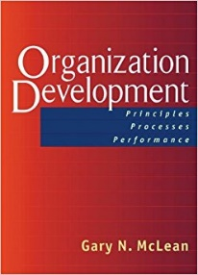
McLean, G. N. (2006). Chapter 1: What is organization development? Organization Development: Principles, Processes, Performance. San Francisco: Berrett-Koehler Publishers. [EBSCO eBook Business Collection.’

Module 2 - Background

Large Group Interventions

Required Reading
To start out this module, view these two videos for a basic introduction to the large group intervention methods Open Space Technology and Future Search. These are short animated videos that will explain the basics of these methods.
Pashley, S. (2012). Open Space. NHS Research and Development Forum. https://www.youtube.com/watch?v=4vEBcr_YkHU
Kaapz. (2010). Kaapz and Future Search https://www.youtube.com/watch?v=yfTHKwvAbiA
Now read these two articles for a basic overview of large group interventions such as Future Search and Open Space Technology:
Nixon, B. (1998). Creating the futures we desire - getting the whole system into the room: Part I. Industrial and Commercial Training, 30(1), 4-11. [ProQuest]
Leith, M. (1996). Organizational change and large group interventions. Career Development International, 1(4), 19-23. [ProQuest]
Finally, take a closer and more detailed look at Future Search and Open Space Technology with these final two readings that are highly important for your assignments. You will be required to cite these readings in your papers:
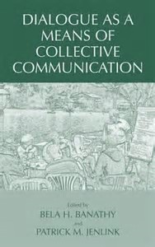
Norum, K. E. (2005). Chapter 15: Future Search conversation. In Dialogue as a Means of Collective Communication (pp. 323-333). Springer Science & Business Media B.V. / Books. [Business Source Complete]
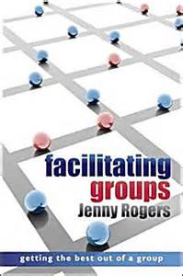
Rogers, J. (2010). Large group interventions. Facilitating Groups. Maidenhead: McGraw-Hill Education. Pp. 98-104 [EBSCO eBook Collection. Note: this is a section at the end of Chapter 3 of this book]

Optional Reading
For some comprehensive guides to Future Search and Open Space Technology written by the original creators of these methods see the following books:
Weisbord, M. R., & Janoff, S. (2010). Future Search: Getting the Whole System in the Room for Vision, Commitment, and Action. San Francisco: Berrett-Koehler Publishers [EBSCO eBook Collection]
Owen, H. (2008). Open Space Technology: A User's Guide (3rd Edition). Williston, VT, USA: Berrett-Koehler Publishers. [EBSCO eBook Collection]

Module 3 - Background

Job Redesign

Required Reading
Start out this module by viewing this two videos that will give you an overview of both traditional job redesign techniques as well as the newer concept of job crafting:
Hartzell, S. (2015). Types of job redesign: Job enrichment, enlargement & rotation. Intro to Business. https://www.youtube.com/watch?v=y8X0HCGKaLA
Wrzesniewski, A. (2015). Job crafting - Amy Wrzesniewski on creating meaning in your own work. Re:Work with Google. https://www.youtube.com/watch?v=C_igfnctYjA
Now for a more in-depth view of job design dig into the following two readings. Pay special attention to the concepts of job rotation, job enrichment, and job enlargement. Also, pay attention to the core job characteristics such as task variety, autonomy, etc. discussed in both readings:
Bauer, T., & Erdogan, B. (2012) Chapter 6.1: Motivating employees through job design. Introduction to Organizational Behavior. Flatworld Knowledge. http://2012books.lardbucket.org/books/an-introduction-to-organizational-behavior-v1.0/s10-01-motivating-employees-through-j.html
Griffin, R. (2007). Chapter 6: Organization structure and design. Principles of Management. Houghton Mifflin, New York. http://college.cengage.com/business/griffin/sas_principles/1e/assets/students/know_bank/griffin_sas_KB_6.1.pdf
Now that you have read up on traditional approaches to job design, read up on job crafting. This reading is by Amy Wrzesniewski, who you saw in one of the videos above:
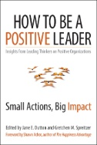
Wrzesniewski, A. (2014). Chapter 6: Engage in job crafting. In Dutton, J. E., & Spreitzer, G. M. (eds). How to Be a Positive Leader: Small Actions, Big Impact. San Francisco, CA, USA: Berrett-Koehler Publishers. [EBSCO eBook Collection]
Finally, this chapter provides a solid overview of job crafting including some relational, cognitive, and task crafting:
Dik, B. J., & Duffy, R. D. (2012). Chapter 7: Job crafting. Make Your Job a Calling: How the Psychology of Vocation Can Change Your Life at Work. West Conshohocken, PA: Templeton Press. [EBSCO eBook Collection]

Module 4 - Background

Appreciative Inquiry

Required Reading
To start off, take a look at this very short introduction to the basic concept of Appreciative Inquiry:
Hayes, J. (2009). Appreciative inquiry. Aarhus School of Business https://www.youtube.com/watch?v=BqHeujLHPkw
Now take a look at this slightly more detailed video. Pay close attention to the discussion of the “4D Model” towards the end of the video:
Kelm, J. (2011). What is Appreciative Inquiry? Appreciative Engagement. https://www.youtube.com/watch?v=ZwGNZ63hj5k
Now take a close look at these two short but important articles which provide direct comparisons between Appreciative Inquiry and traditional Organizational Development techniques as well as some of the main advantages and disadvantages of Appreciative Inquiry:
Venter, J. (2010). Appreciative inquiry. Accountancy SA, , 42-44. [ProQuest]
Zemke, R. (1999). Don't fix that company! Training, 36(6), 26-33. [ProQuest]
Finally, read up in more detail with these more comprehensive chapters on Appreciative Inquiry. For the first of these readings, pay special attention to Table 1 and the comparison between Appreciative Inquiry and traditional Action Research (Deficit-Based) problem solving methods. For the second reading, pay special attention to the discussion of what is involved in each of the “4 D” steps:
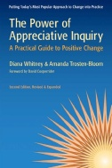
Whitney, D. K., & Trosten-Bloom, A. (2010). Chapter 1: What is Appreciative Inquiry? The Power of Appreciative Inquiry: A Practical Guide to Positive Change. San Francisco: Berrett-Koehler Publishers. [EBSCO eBook Collection]
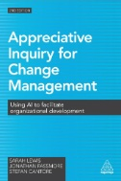
Lewis, S., Passmore, J., & Cantore, S. (2016). Chapter 4: Appreciative inquiry: How do you do it? In Appreciative inquiry for change management: Using AI to facilitate organizational development. London: Kogan Page. [EBSCO eBook Collection]
Some of the other chapters in the books are optional to read but are worth looking at if you want to read up on Appreciative Inquiry in more detail. In addition, the optional readings below include an article about a real life practical use of this method and another book that includes some introductory chapters that may help you gain a better understanding of the concepts.

Optional Reading
Cooperrider, D. L., Whitney, D. K., & Stavros, J. M. (2008). Appreciative Inquiry Handbook: For Leaders of Change. Brunswick, OH: Berrett-Koehler Publishers. [EBSCO eBook Collection]
For a detailed case study of a real-life use of Appreciative Inquiry, see the following article:
Berrisford, S. (2005). Using Appreciative Inquiry to drive change at the BBC. Strategic Communication Management, 9(3), 22-25. [ProQuest]

