Write a maximum of 3-page report of the group’s systematic review process reflection on the group work. Issues to be reflected on the individual report may include:

The group’s systematic review process:

- Specific topic:
Broad topic (“Body height and morbidity or mortality?” has been given to all groups and each group is expected to define a specific question from the broad topic.

What specific topic was decided by the group and how did the group arrive at the decision?

At first, as team work we decided to use the main 3 terms in the broad topic and conducted a (dirty search) pilot search using Pubmed database. We then formulated our research question as ‘’ Effect of short maternal stature on neonatal mortality’’ however and during our next step (search strategy) the group ended up with this topic: Effect of short maternal stature on mortality

I realised at this stage three medical terms can reach hundreds research questions, aims and objectives either in my group project or in other groups of this course. (5 groups used 3 terms and each group has different research interests, outcomes.

- Search Strategies
What search terms and search strategies were used to identify studies
included;
we used PICO framework to answer our research question excluding ‘I’
intervention after defining key concepts.
PEO used where P: foetuses and newborns, E, sort maternal stature, O,
prenatal death.
We revised many key words definitions to compatible with our research
question
by using Mesh we defined all terms in PEO then we built up search block by
block
I learned the importance of precision to answer my research question in future
Study, also, Boolean operator AND, OR should be used carefully. Truncations, *,
() [ ] have significant in databases and
[MesH] and [tiab] are important
More importantly, asking
for help and consulate expertise and a librarian each time especially in
conducting systematic review or umbrella review
Building search terms for PubMed

Search Block Population
Infant, Newborn[MesH] OR infant[tiab] OR newborn*[tiab] OR neonat*[tiab] OR perinat*[tiab] OR babies[tiab] OR stillborn[tiab] OR fetus[tiab] OR fetal[tiab] OR foetus[tiab] OR foetal[tiab]

Search Block Exposure
(Pregnant women[mesh] OR pregnancy[mesh] OR mother[mesh] OR mother*[tiab] OR maternal[tiab] OR parental[tiab] OR pregnancy[tiab])
AND
(Height, body[MesH] OR height[tiab] OR stature[tiab] OR dwarfism[mesh])

Search Block Outcome
Infant mortality[mesh] OR fetal mortality[mesh] OR stillbirth[mesh] OR fetal death[mesh] OR infant death[mesh] OR perinatal death[mesh] OR “infant mortality”[tiab] OR “fetal mortality”[tiab] OR stillbirth[tiab] OR “fetal death”[tiab] OR “infant death”[tiab] OR “perinatal death”[tiab] OR mortality[tiab] OR death[tiab]

I think this is one of time consuming we spent to reach this result. Many times, we refine our concepts and research question to reach our outcomes
All results: 1068

- English language restriction: 936 results
- 5-year restriction: 157 results
- 10-year restriction: 317 results

It is important to justfing inclusion and exclusion criteria in the research study.
Here we included English language and 5 years search date we got 157 which
is low number and could affect our outcomes so then apply 10 years to get
317 articles.

- The reference management system:

The reference management system used for screening
We exported 317 articles from PubMed to EndNote
We used Rayyan QCRI. A very helpful platform for authorship to get suggestions for article inclusion and exclusion. At this stage I leaned how to reference management systems work.
Because this is the first time to mange inclusion and exclusion of articles we first screened 17, remining 300 split to 100 each pair

- PRISMA flowchart:

include a PRISMA flowchart to accompany textual description of the process of screening for eligible studies

throughout PRISMA, I learned very important process. How to present inclusion in flowchart

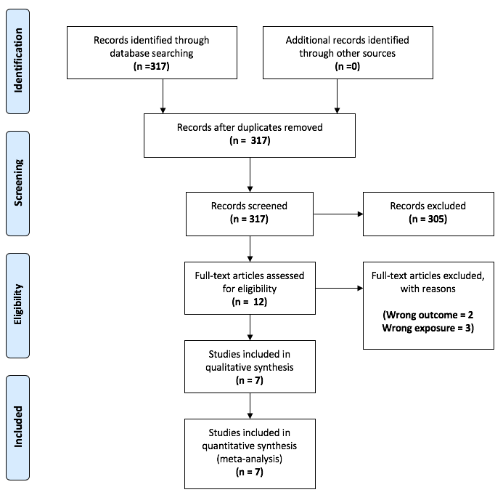

- Data Extraction:
How was the data extraction process undertaken?

Author | Year | Country | Study Design | Inclusion/Exclusion Criteria | Type of Mortality | Total no. Pregnancies
Arendt | 2018 | 34 African countries | cross-sectional | women 20 - 49 years old  (1 delivery in past 5 years, not currently pregnant or <3 months postnatal) | neonatal | 105,132
Felisbino-Mendes | 2015 | Brazil | cross-sectional | women aged 15-49 years | neonatal | 5,392
Kahtun | 2018 | Bangladesh | cross-sectional | women aged 15–49 years | neonatal | 29,128
Oboro | 2010 | Nigeria | case-control | excluded women who were candidates to cesarean section | stillbirth | 114
Ozaltin | 2010 | 54 low- and middle-income countries | cross-sectional | women aged 15–49 years | neonatal | 2,661,519
Sutan | 2010 | Scotland | cross-sectional | singleton pregnancies, GA>20wks, fetus >200g | unexplained stillbirth | 541,811
Zhang | 2010 | Sweden | cohort study | all live births ≥22 weeks, all stillbirths ≥28 weeks (excluded unknown GA, birthweight or sex ≥28 weeks) | stillbirth, early neonatal death | 952,630

Full-text screening of 12 articles together, 5 were excluded, 7 is the final result.
Data extraction on a Google Spreadsheet with each participant having 1-2 papers

It was the most exited stage. Working together online to see the unfilled Excel sheet full off extract

- Quality Appraisal:
how was quality appraisal undertaken and what tool was used for the purpose?

We used Quality assessment EPHPP
The method of quality assessments proved to be more complicated than expected

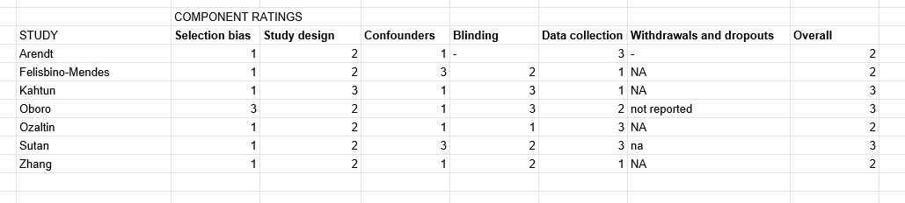

1-strong, 2-moderate, 3-weak
Modified: Study design cross-sectional was given “moderate rating” and we removed Withdrawals and Dropouts
The method of quality assessments proved to be more complicated than expected

- The Evidence Synthesis:
How was the evidence synthesis of the collected evidence done?

We first calculated logORs and SEs for RevMan

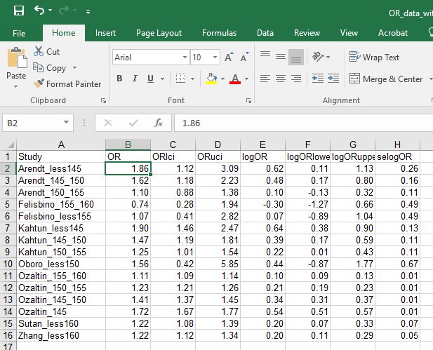

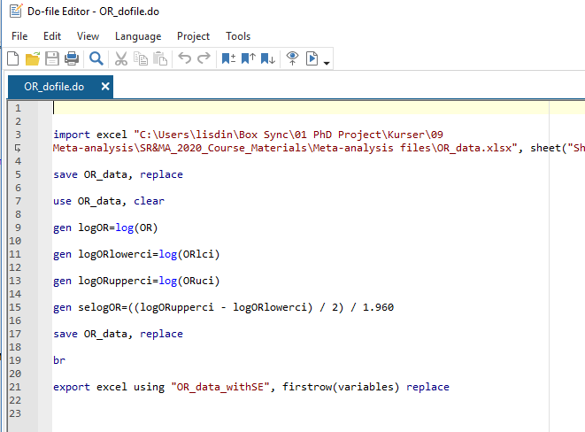

We used RevMan to conduct meta analysis. It was first time for me to use it, first time to conduct meta analysis
using REMA reseons (multiple countries, different cut-off, different outcomes...)

figure: Association between short maternal stature and perinatal mortality: all studies:

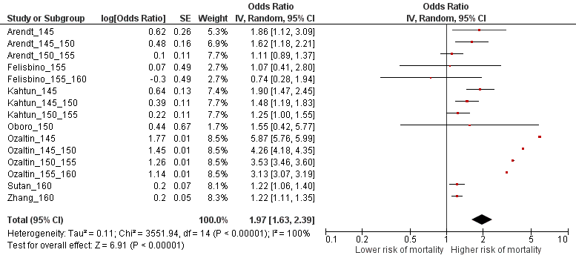

Figure: Association between short maternal stature and perinatal mortality:

Sub-group analysis:
different categories of
maternal height

REMA

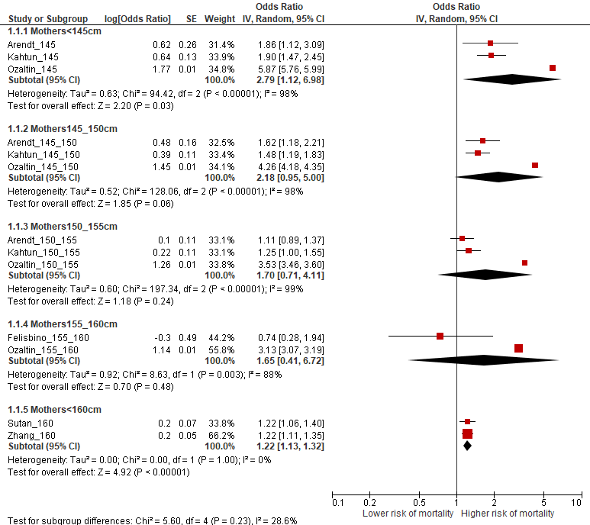

Figure: Sub-group analysis:
Association between short maternal stature and stillbirths

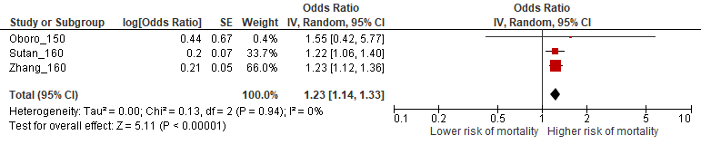

Figure :Sub-group analysis:
Association between short maternal stature and neonatal death

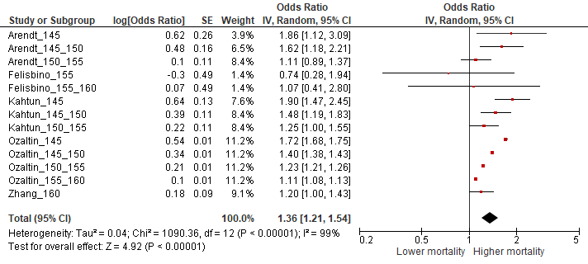

- The Systematic Review Findings:
Give a final conclusion of the systematic review findings.

Across 7 studies, we can see an association that is constant between short maternal stature and increase probability of perinatal deaths

