Book Review Report: The book is Talk Triggers
Name
Institutional Affiliation

Table of Contents
1. Book Summary 2
1.1 Table of Contents 4
2. Book Critique 5
3. Published Critique about Talk Triggers 7
4. Email to the Authors 8
5. Shared Thought on Goodreads.com 9
6. Acknowledgment 10
References 10

Book Review Report: The book is Talk Triggers

1. Book Summary
Talk Tigers provides insights into the approaches required by firms to create customers through word of mouth. The authors talk about the systems that encourage clients to spread information verbally. Different types of conversations allow clients to talk about their experiences and initial impressions with a company's products. Further, engaging customers through verbal interactions encourages them to share information about the firm's products and services on social media. Therefore, word of mouth applies for both small and big businesses due to their low-cost nature and the ability to entice buyers to talk about a brand's products on online and offline media. The fact that word of mouth is a free marketing approach means that companies have an opportunity to inspire customers to talk about them and help the brand stand out in a crowd. Below is an extract about the value of word of mouth technique as an effective way to capture the audience and increase the company's sales.
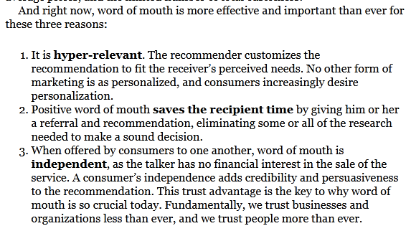
The first chapter emphasizes that this is the most effective technique and increases the chances of clients mentioning the brand. In this case, a company does not need to invest in celebrities or TV personalities to push their products. The word of mouth option replaces the traditional marketing techniques. Customers have a reason to advertise products to their colleagues whenever a firm sparks conversation that capture their attention. Talk Triggers are about initiating conversations that build a firm's profile, enhances visibility on social media, and improved personal referrals. The second chapter discusses the idea that Talk Triggers are remarkable and relevant for marketing. A company needs to be extraordinary in the sense that its products and services are interesting enough to convince customers to mention them on social media or to friends. Relevant Talk Triggers are also essential since they portray a company’s core values. Further insights from the books indicate the word of mouth approach should be reasonable such that an organization does not go overboard and avoids stunts. Keeping the message real elicits trust from buyers and encourages them to establish long-term connections with the brand. The technique should be repeatable to appeal to every client rather than focusing on a narrow target. In this case, every customer has a chance to be part of the marketing scheme and end up mentioning the company to friends and relatives. The next chapter explains the fact that certain types of Talk Triggers uniquely appeal to the emotions of customers. In other words, the triggers give buyers experiences that motivate them to discuss a brand with friends and relatives. However, a firm has to demonstrate empathy and generosity to encourage consumers to talk about products and services. Efficiency is also essential in word to mouth marketing since it makes products and services user-friendly and enhances convenience. Companies should consider gathering insights from all departments and clients to achieve a successful Talk Trigger. The ideas guide an organization in developing and sustaining effective strategies. After gathering insights, a firm should also monitor the influence of its Talk Trigger to determine if it is creating the desired conversation.

1.1 Table of Contents
Title page
Copyright
Foreword by Ted Wright
Section 1 Why Word of Mouth Works
Chapter 1: Talk is Cheap
Chapter 2: Steer the Conversation
Chapter 3: Same in Lame
Section Two The Four Talk Triggers Criteria
Chapter 4: Be Remarkable
Chapter 5: Be Relevant
Chapter 6: Be Reasonable
Chapter 7: Be Repeatable
Section Three The Five Types of Talk Triggers
Chapter 8: Talkable Empathy
Chapter 9: Talkable Usefulness
Chapter 10: Talkable Generosity
Chapter 11: Talkable speed
Chapter 12: Talkable Attitude
Section 4: Create Talk Triggers in Six Steps
Chapter 13: Gather Internal Insights
Chapter 14: Get Close to Your Customers
Chapter 15: Create Candid Talk Triggers
Chapter 16: Test and Measure Your Talk Triggers
Chapter 17: Expand and Turn On
Chapter 18: Amplify Your Talk Trigger
Chapter 19: Create Your Next Talk Trigger
Appendix: Quick Reference Guide
Acknowledgments
Author’s Note

2. Book Critique
The book is an easy read due to the proper arrangement of chapters and coherence of the discussions. The authors use simple language and vocabularies to make it easier for readers to connect the various topics and to understand the contribution of word of mouth to organizational success. A fascinating part of the book is the discussion about the link between this strategy and mention on social media or to friends and relatives. The practical examples of companies located in the United States also help to capture the attention of the reader and to prove the benefits of word of mouth marketing approach. In this regard, the authors reveal that companies experience declining profitability due to weak interactions with customers. The idea of using word of mouth to create a robust online presence shows the need for companies to utilize modern marketing practices to maximize competitive advantage. While there are indications of valid arguments by Baer and Lemin, I think that word of mouth is among the old techniques used for marketing. I also believe that the approach is not as free as the authors assert, since a company has to invest in training and development programs and to recruit talented employees who have excellent customer relations skills. In this sense, the firm spends a substantial amount of financial resources and time to ensure employees understand and respond well to the needs and expectations of clients. Nonetheless, the authors still provide informed insights on the need for firms to establish closer connections with clients through word of mouth. Most businesses in the current world do not believe that the technique is still an effective means to engage clients and use them to expand market size. They tend to think that the approach is old fashioned and instead pursue new marketing techniques such as social media and the use of celebrities. Modern businesses tend to believe that most clients have social media profiles or have access to the internet. However, the case is different for Talk Triggers since it acknowledges the need to involve everyone in company marketing strategies and to personalize relationships through face-to-face conversations. Therefore, the perspectives in the book provide solutions for firms to reconsider the value of word to mouth interactions and to rely on the strategy to empower customers to mention the brand to friends and relatives. However, while the claims apply primarily to the restaurant sector, it is vital to diverse their focus. It uses examples from other industries to prove the impact of the tactics. In such a way, the authors will accommodate multiple perspectives in their arguments and make their claims more convincing to customers and organizations.
The six steps provided by the Trigger Talk outline the different mechanisms to achieve successful sales and profitability in a competitive environment. Baer and Lemin discuss the importance of gathering internal insights whereby everyone in the company takes responsibility for sharing crucial information about the strength and weaknesses of a product. The firm tries to uncover everything before a product launch by collecting data and encouraging everyone to share ideas on the firm’s competitive positioning. The authors also revealed the need for companies to stay close to their clients, and to understand the effects of products on people. In this regard, an organization probes, listens, and observes market trends keenly to compare itself to rivals. Trigger Talk also makes objective conclusions about the value of testing and measuring ideas to ensure they get the desired mentions on online and offline media. Over time, a firm should expand and improve engagement with clients and other parties such as employees and suppliers to not only understand consumer behavior but also deliver the message that resonates with the needs and expectations of buyers.

3. Published Critique about Talk Triggers
Seth Goldstein, a digital marketer, offers a critique of Baer and Lemin’s Talk Triggers. He claimed that the book is approachable and readable due to the multiple case studies used by the authors. Goldstein agrees with the authors that word of mouth marketing is a crucial step towards improving organizational performance. He claimed that the authors’ great case studies help the reader to understand the practical aspects of the word of mouth technique (Goldstein, 2018). Moreover, Goldstein indicated that the book demonstrates adequate knowledge of the authors on marketing issues and the business factors that require firms to seek mentions and responses from clients. He noted that Talk Triggers "is the best example I have seen in a long while," thereby proving the value of the piece in growing organizational success. In this case, Goldstein argued that it provides insights on events in a practical world where businesses strive to meet the needs and expectations of their clients through improved communication. Further, he indicated that the book demonstrates that companies want to share positive information about their products and services. For instance, chapter one uses the case of the Cheesecake Factory's menu to show the value of spreading news through word of mouth. The use of graphics and magical words throughout the books also makes it interesting for readers. In this case, the authors relied on powerful ideas to discuss the purpose of word of mouth communication and to speak directly to readers about the significance of such interactions. Goldstein also provides insights into the tone used in the book and its relevance in capturing the attention of the reader. The smartness in the tone shows the intention of Baer and Lemin to elicit informed thoughts and actions that talk about the connections between online and offline mentions. The structure of the book is also a crucial element that proves the authors’ ability to pass their message conveniently. The division of the chapters makes sense and explains various aspects of word of mouth marketing. The identification of four talk triggers requirements among them remarkable, relevant, repeatable, and reasonable makes the second chapter useful in describing the right procedures for designing and implementing the approach (Goldstein, 2018). Therefore, the structure of the book carries the reader through the story such that it is easier to grasp concepts and visualize practical ways to apply them in the business world.

4. Email to the Authors
I wrote an email to Baer and Lemin, but I am still waiting for their feedback. My objective is to engage the two and capture personal input from them about the motivation behind the book and to recommend areas that could improve the piece in subsequent editions. Below is the email I wrote to the authors. The message to them indicated my take on the effectiveness of the article based on the revelations from the chapters. I made some suggestions that included the need for additional case studies from different industries where face-to-face interactions with clients increase opportunities for more sales and profits. I also addressed the need to provide examples of the social media platforms that make word of mouth an ideal way to engage and improve customers’ experiences.
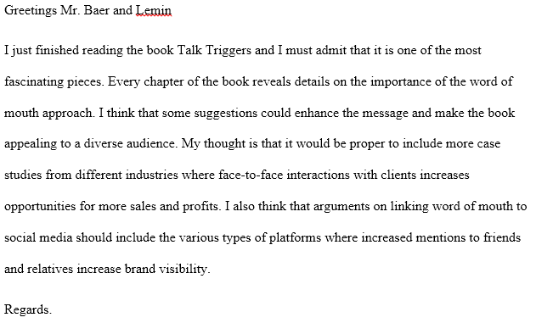

5. Shared Thought on Goodreads.com

I shared my thoughts about the Baer and Lemin’s Talk Triggers on goodreads.com. Based on my views, the book is an exciting piece that demonstrates the right way to increase sales by giving customers stories about products and services. I also indicated that the material provides crucial insights into the best ways to encourage customers to share information with their friends and relatives. For example, I captured the talk about The Cheesecake’s menu that gives clients something to talk about and market the company’s brand (Baer & Lemin, 2018). I further argued that it outlines the various elements of a Talk Trigger, including the process of creating the triggers, testing, and measuring their effectiveness. I agree with the idea of Talk Triggers being relevant, reasonable, and remarkable to capture the interests of different clients. The three factors create a compelling message that motivates clients to share experiences with other people. I also identified chapter one of the book as one of the most insightful parts that reveal the challenges faced by organizations as they strive to implement Talk Triggers. For instance, Baer and Lemin indicated that "employees and customers share an inability to envision different things." In this case, it is crucial to understand the unimaginative aspect of human beings that influences their creativity. My thought about the book concludes by stressing that it encourages readers to be critical thinkers who consider new ideas.

6. Acknowledgment
I would like to express my gratitude to the professor for allowing me to read the book and do a summary of Baer and Lemin’s narratives. The initiative exposed me to different ideas and fascinating stories about the importance of word of mouth in modern business environments. I am willing to read more books to discover further insights into the factors that make a business competitive and ones that encourage customers to share the success of a firm. I already set a goal to read a second book that links communication techniques to a company's profitability and higher customer satisfaction. I would also like to compare the word of mouth and other marketing approaches that enhances a firm's sales and provides better solutions for the long-term growth and stability of an entity. Moreover, I wish to engage in extensive discussions with colleagues to identify more examples besides the ones such as Doubletree Hotel, the Cheesecake Factory’s and Five Guy Burgers used by Baer and Lemin. Further reading will also allow me to gain more insights into the four requirements of word of mouth identified in Talk Triggers. Indeed, I am in a better position to understand why customers care about a brand, the vigilant practices undertaken by entities to make their message meaningful, and the value of reaching out to all customers without restrictions.

References

Baer, J., & Lemin, D. (2018). Talk Triggers (2nd ed.). New York: Penguin. Retrieved from https://www.amazon.com/Talk-Triggers-Complete-Creating-Customers-ebook/dp/B079WMF6YC/ref=sr_1_1?keywords=Talk+Triggers&qid=1582164956&s=digital-text&sr=1-1#reader_B079WMF6YC
Goldstein, S. (2018, December 28). Talk Triggers by Jay Baer and Daniel Lemin-A review. Seth Goldstein.

