Corporate Analysis
Write an analysis report about the UK company “Morrisons”, including each following details.
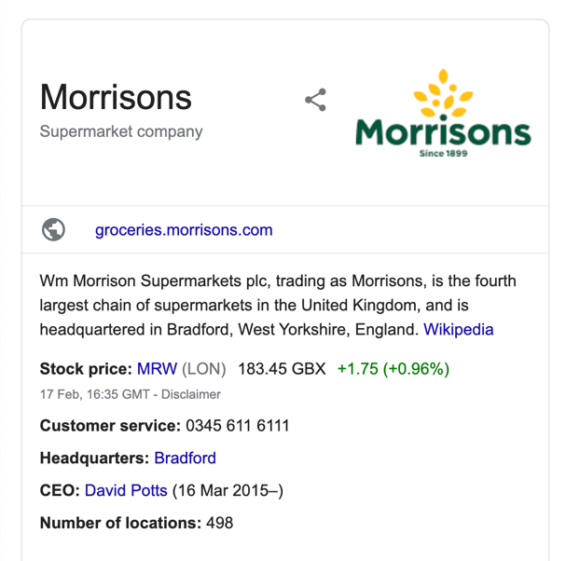
The relationship between managers and stockholders
1. The Chief Executive Officer
- Who is the CEO of the company? How long has he or she been CEO?
- If it is a family run company, is the CEO part of the family? If not, what career path did the CEO take to get to the top? (Did he or she come from within the organization or from outside?)
- How much did the CEO make last year? What form did the compensation take? (Break down by salary, bonus and option components)
- How much stock and options in the company does the CEO currently own?
2. The Board of Directors
- Who is on the board of directors of the company? How long have they served as directors?
- How many of the directors are inside directors? (i.e. employees or managers of the company)
- How many of the directors have other connections to the firm (as suppliers, clients, customers)?
- How many of the directors are CEOs of other companies?
- Do any of the directors have large stockholdings or represent those who do?
3. Share Voting Structure
- Are there differences in voting rights across shares?
- If so, do incumbent managers own a disproportionate share of the voting shares?

