MARK 1130 Research Project

MARK1130 - INTRODUCTION TO MARKETING  SIMULATION RESEARCH PROJECT  DUE DATE: Written Due March 23rd ,2020 |  | WEIGHT FACTOR: 35%  - Written: 15%  - Simulation 10%  - YouTube 10%

INTRODUCTION: Students have gained knowledge and insight into marketing through classroom discussions, group work, textbook readings, and lectures. They will now apply this information by researching and analyzing marketing strategy elements of an assigned topic.

OBJECTIVE/TOPIC: Students will compete in a simulated backpack market. The measures of success in the simulation is based on Profit (40%), Market Share (40%) and Customer Satisfaction (20%). Although there are more metrics, these will determine how well you will compete against your classmates.
REQUIREMENTS: You must register for McGraw=-Hill Connect using the card that has been included in your textbook. This will give you access to the simulation. Six competitors compete in a given market. In other words, you are competing against five other companies. However, your score (Profit, Market Share and Customer Satisfaction) will be graded against everyone in the class. Please go to Moodle and register in the correct section. Your instructor will walk you through this on the first day.
GUIDE: To get used to the technology, students will engage in an in-class tutorial that is created for you by default. Around week 2 of the course you will start, making decisions at the end of the week (See planning calendar). Make decisions on the following six (6) factors:
- MARKET SEGMENTS:
- PRODUCT
- PRICE
- PROMOTIONS
- PLACE
- COMPETIOR’s MOVES
You will upload a 4 page document in Microsoft Word (NO PDF’s accepted) upon the completion of the simulation. The parameters of this document are as follows:

The written portion of your plan should include:
- Your first page will be a Title Page including name of the backpack, your name, instructor, and date of submission. A template is provided in Moodle

- The next two pages of content will include an analysis of your performance metrics which will include the headings: Customer Satisfaction, Market Share and Profits. When assessing this performance try to integrate the success or failure of your decisions on the Four P’s and your segmentation strategy. To add value, comment on the main competitor moves.

- Each individual submission should research at minimum three (3) outside sources to support or critique your decisions in the simulation. These sources can be of current marketing events of any product and or products relevant to the subheadings above in any consumer product category except the backpack industry. You should also provide rationale for your decisions. Your rationale can be supported using research on markets throughout the term. This is called knowledge and innovation transfer. You can find sources through the library databases and/or current events that your instructor brings to class.

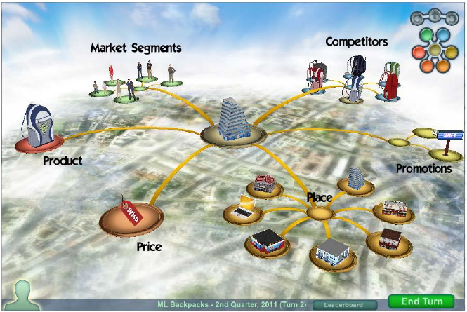

- Your Final Page Four (4) will include the minimum 3 APA formatted sources. Any time you make an argument, you should back this up with a source. Please use in-text citations when doing so. Your submission will be 12 font, 1.5 spaced and include page numbers. A template in Moodle will help to get you started. Please do not put any images into this short analysis. Additionally, successful business writing is succinct and to the point.

A grading rubric is on Moodle for the written portion of your analysis.

YOUTUBE PRESENTATION PRODUCT OF YOUR CHOICE:
10% of Final Grade
Objective: Having went through the simulation throughout the term, you have learned about making marketing decisions. For this presentation, you can choose any product of your choice. The target time for the video should be two- three minutes. Your goal is to market a product to the class. New products are encouraged.
Structure:
- Introduce your name and a marketing role that you are choosing to market the product.
(See next page for different marketing titles that you may chose.) Finally introduce the product and the manufacturer of the product if this is not an innovation.
- Describe the Target Market (Demographic, Geographic and Lifestyle). Also, for extra grades use the PRIZM profiles (Up to a maximum of four) that would fit the lifestyle of your target market.

- Integrate the Marketing Mix into your presentation. Refer to your experience as a Marketing Manager in the Practice Marketing simulation. Refer to at least one area of the Marketing Mix that you have learned the most from as a former marketing manager in the Backpack industry.

- Describe why the product would benefit a potential buyer. (Sometimes it is good to have your audience as college students). It becomes more realistic. In other ways you can tell the class, imagine you are all parents of children aged 4-6 etc.…

- Finally close the presentation with why you would buy the product and thank the audience.

- You will answer anywhere from 3-5 questions upon the completion of your presentation.

Format: YouTube video. You can make this private or public depending on your comfort level.
As a safe measure, have your video saved to a memory stick.
- You should appear in the video. The product or prototype should be enough for the audience to understand.
- Make sure your audio is clear and that you have put some effort into this. This will take more than the 3-5 minutes of appearance. It takes time to create. Don’t spend more than 5 hours for this final presentation.
- Finally, if you have a different format that does not follow the above (safe) presentation, you will be rewarded for creativity. Have fun with this!!!

Some Marketing Titles that you can chose, however you can come up with your own.
- Digital Marketing Product Manager
- Marketing Manager
- Account Manager
- District Sales Manager
- Sales Representative
- Sales Manager
- Regional Director of Sales
- Regional Director of Marketing
- Digital Strategist
- Strategic Sales Manager
- Digital Media Specialist
- Marketing Director
- CEO and President
- President
- National Maketing Manager
- Manager of Innovations
- New Product Developer
- International Trade Manager
- Marketing Consultant
- Media Strategist

