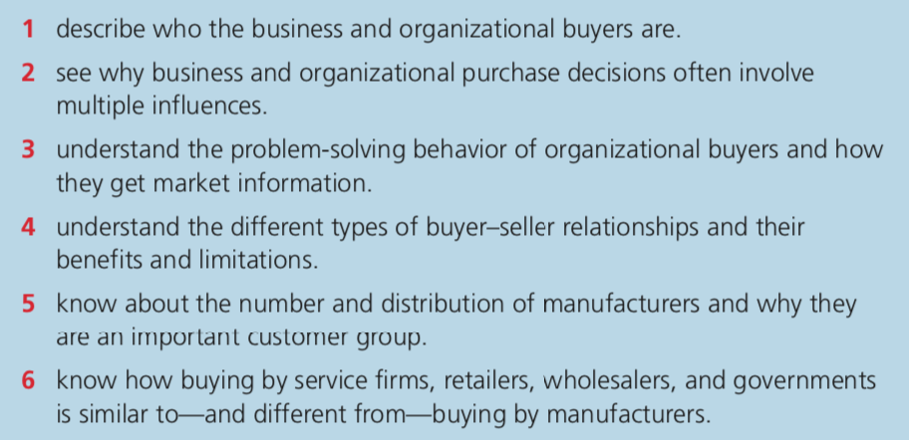
CHAPTER 6
Q3 Organizational buyers are problem solvers. There are three buying processes: a new-task buying process, a modified rebuy process and a straight rebuy. New-task buying occurs when a customer organization has a new need and wants a great deal of information. It can involve setting product specifications, evaluating sources of supply, and establishing an order routine that can be followed in the future if results are satisfactory. Multiple buying influence is most often found in new-task buying. A straight rebuy is a routine repurchase that may have been made many times before. Buyers probably don’t bother looking for new information or new sources of supply. Most of a company’s small or recurring purchase are of this type-but they take only a small part of an organized buyer’s time. Important purchases may be made this way too-but only after the firm has decided what procedure will be “routine”. The modified rebuy is the in-between process where some review of the buying situation is done-though not as much as in new-task buying. Sometimes a competitor will get lazy enjoying a straight rebuy situation. An alert marketer can turn these situations into opportunities by providing more information or a better marketing mix.

There are some major sources of information used by organizational buyers. For personal sources, they use salespeople, others from supplier forms and trade shows as marketing sources and buying center members, outside business associates and consultants and outside experts as nonmarketing sources. For impersonal sources, they use online events and virtual trade shows, sale literature and catalogs, E-mails and newletters and website content including blogs, video, case studies and white papers as marketing sources and online searches, rating services, trade associations, news publications, product directories and online communities as nonmarketing sources.

Q4 There are five key dimensions that can help characterize most buyer-seller relationships: cooperation, information sharing, operational linkages, legal bonds, and relationship-specific adaptations. Cooperation treats problem as joint responsibilities. Shared information is useful but may be risky. Operational linkages share functions between firms. It can help sellers and buyers lower costs and increase efficiency. Some complex relationships may be spelled out in detailed legal contracts. Contracts spell out obligations. Sometimes the buyer and seller know roughly what is needed but can’t fix all the details in advance. Then the relationship may involve negotiated contract buying, which means agreeing to contracts that allow for changes in purchase arrangements. However, it can’t make sure that neither party gets hurt by changing business conditions. Relationship-specific adaptations involve changes in a firm’s product or procedures that are unique to the needs or capabilities of a relationship partner. It can help suppliers lower costs. However, buyers are often hesitant to make big investments that increase dependence on a specific supplier. Typically, they do it only when there isn’t a good alternative.

Q5 In the U.S., there are about 330,000 factories. Majority of these are quite small, but output from these small firms account for less than 3 percent of manufacturing value. The owners of small plants often do the buying- and they buy less formally than buyers in the relatively few large manufacturing plants-which employ most of the workers and produce a large share of the value added by manufacturing. In addition to concentration by company size, industrial markets are concentrated in certain geographic areas. Internationally, industrial customers are concentrated in countries that are more advanced stages of economic development. In U.S., the number of people employed in manufacturing has been shrinking, but the manufacturing output is higher than at any other time in the nation’s history.

Q6 In a smaller service organization, purchases may be made by the person who is in charge rather than a person with full-time responsibility for purchasing. Small service customers like internet buying. Most retail and wholesale buyers see themselves as purchasing agents for their target customers and the reorders are usually straight rebuys. Government is the largest customer group in many countries Different government units buy almost every kind of product. To avoid charges of favoritism, most government customers buy by specification using a mandatory bidding procedure. Often the government buyer must accept the lowest bid that meets the specifications. Specification and bidding difficulties aren’t problems in all government orders. Items that are bought frequently—or for which there are widely accepted standards—are pur- chased routinely. The government unit simply places an order at a previously approved price.

