Ch1
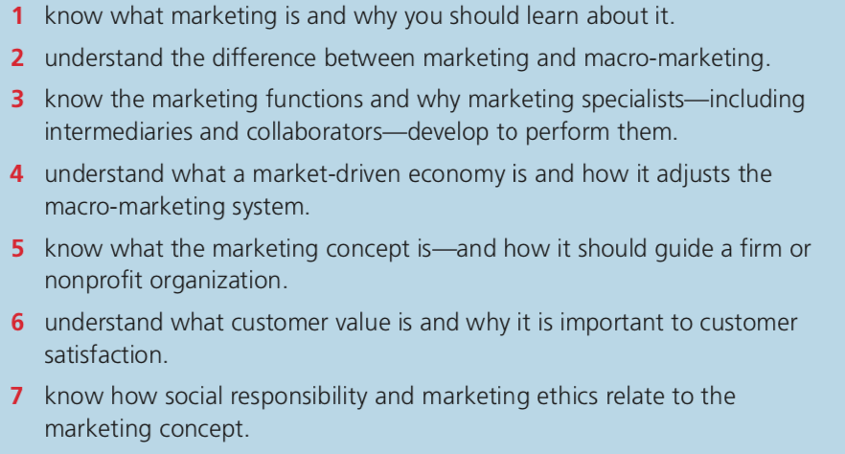
Q1 Marketing is a process which is conducted by an organization for purposes of improving the buying and selling of different goods and services. It deals with delivering, selling and advertising goods to other companies and consumers. Advertising enables experts who work in an organization’s promotion and marketing sector to acquire the interest of different audiences. Majority of the promotions involve appropriate packaging, memorable slogans and they appeal to specific audiences. The concept of marketing proposes that for an organisation to achieve its objectives it should start by assessing the needs and wants of the potential customers and aim to satisfy this needs having greater levels of Execution than their competitors. This concept was founded by specialist Adam Smith in his book the wealth of Nations however it was uncommon practice for this book to be used until the late 19th Century. Note that the marketing concept is the one that determine the marketing decisions that have been reached and is dependent on the preferences of consumers.
Q2Micro marketing refers to a technique used to manage a small group of customers with particular requirements for goods in the business center. Most of the effort made during micro marketing is directed towards a manageable number of highly valued customers. Macro marketing is very broad in its disciplines and describes features that extend beyond the limits of micro marketing. Most business people view macro marketing as a technique that assists them to learn about advertising opportunities and understand the limitations of marketing. .
Q3 distribution in business is a process that is particularly complex and involves a lot of players including manufacturers vendors and distributors.
Most intermediaries enable an organization to provide its services to the appropriate consumers without the need of owning the total chain of supply dealing with different commodities. The various teams function as a single unit since every member contributes towards making the business project successful. It is necessary for the people involved to understand how each group functions in the different departments to assist one another and achieve their goals. An illustration of this is when a new company that manufactures handmade items intends to build a brand and good reputation will decide to select a Renault store in a bid to earn the trust of their customers. After the products are being distributed in a particular popular Boutique there are chances of gaining popularity and brand development. Four purposes of increasing sales the company can increase its brand awareness through social media marketing and the internet to expand in distribution. As a result the company will early make it dependent on other brands and will open up new doors for itself.
.
.
Q4 A market driven economy refers to an aspect of commercial operations and management which is designed in a way that satisfies the consumer standards concerning product distribution and prices of commodities. It affects the macro economy in that it changes the direction of concern from highly competitive decision making activities to one which deals with the concerns of consumer services.
Q5 The marketing concept refers to a technique that businesses use to improve sales, increase profit, defeat possible competition and meet consumer requirements. Different organizations use five concepts of marketing in implementing their business activities. With regards to the marketing concept a company should focus on the product concept. A good example of this is when a company that makes high-quality floppy disk however with the industry trend consumers does not really want to buy high-quality floppy disks. Consumers have shifted to something that can be used to store large quantities of data let's say have USB flash drive. In order to satisfy their demands the companies should try and manufacture portable hard disks memory card and flash drive and this will satisfy the customer’s data storage requirements. Four purposes of having good marketing strategies a business should consider the customer first approach. Following these criteria customers will feel like they are being listened to and that the customers will respond to your product.

Q6 Customer satisfaction refers to a standard describing the way goods and services delivered by an organization achieve the expectations of consumers. The degree of satisfaction of consumers towards your commercial activities is known as customer value. There are many meanings of the term “Value” such as income which reveals that individuals are willing to buy the items that they consider valuable to them.
Q7 Ethics deals with knowing the difference between wrong habits and right behaviors and then following the rules associated with right behaviors. Many commercial ethics literature does not openly describe the correct behaviors conducted in businesses. Social responsibility explains that a firm’s ability to control the balance between adjusting to societal matters and achieving effective commercial performance is a significant aspect in operating appropriately. Ethics is a deep-rooted concept which goes beyond the act of earning money for shareholders as it deals with a business level of integrity. Following the rule of law and having the interest of the shareholders and the community as well will make the business take a more holistic approach. A good example of the corporate social responsibility includes adopting human practices for the employees and taking care of the environment as well as empowering the community. An illustration of ethical code of practice include seeking permission from the local government before proceeding to undertake any project that may have impact on the society.

Ch2
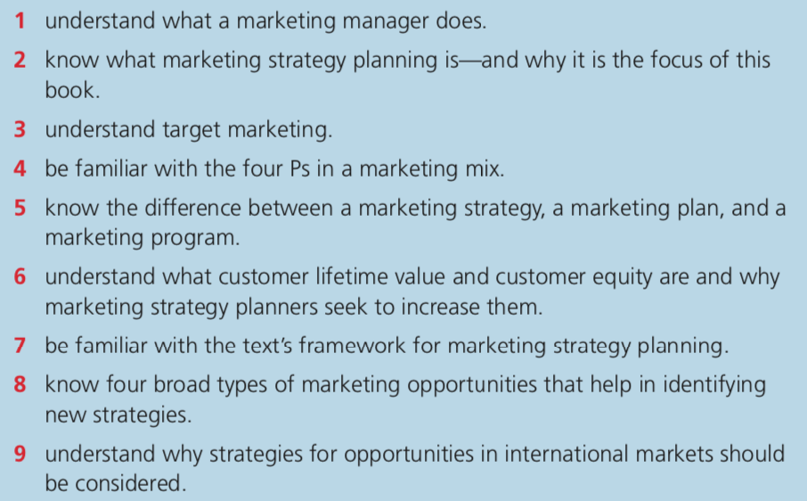
Q1 Majority of the marketing managers perform different roles such as creating budgets for commercial campaigns, indulging in negotiation activities, keeping sales records and collaborating with different marketing agencies. The marketing manager is tasked with numerous duties which are going to be listed below. The marketing manager deals with activities related to marketing for the business as well as overseeing marketing processes. The marketing manager has to develop a strategy used for marketing that is aligned with the objectives and goals of the company. The marketing manager also coordinates sales activities and marketing campaigns for the business. Not only does the marketing manager oversee the marketing budget of a company but also looks to develop marketing plan as well as publication of all marketing material. The marketing manager implement their promotional strategies as well as managing the generation campaigns collect data and prepares an outline for marketing campaign.
Q2 Marketing strategy planning deals with making regulations describing the various ways of selling your goods and services to consumers.
Q3 Target marketing refers to a process whereby a service or product is directed towards a specific group of customers. The target market refers to a well-defined under specific consumer segment. The business intends to sell its services and products to the target market. For purposes of making correct marketing decisions defining a specific target market is significant as the business will be able to identify the most profitable types of customers and channel their resources to convince them. A good example of target marketing is Facebook target market. The company referred as Facebook has widened its target market through the act of positioning itself as a social Media platform used mostly by the youthful people across the world. For companies such as Snapchat there is a target market of more than 178 million users who are between the age of 18 and 24 those of who are in high school preferably by females who are their primary target market.
Q4 There are four important P’s specifically concerned with marketing. They include Place, Product, Promotion and Price. The product is viewed as the most significant aspect of marketing since you cannot apply any of the other features of marketing without it. Good products are easily marketable since they meet the required standards of both wants and needs.
Q5 A marketing strategy refers to a business technique that brings together all of its commercial targets to form a single efficient system. It is necessary for an effective commercial strategy to be derived from the market studies and should have the correct product mix to attain the required commercial standards and improved potential for profits. Marketing strategy has gone digital and it refers to the framework that helps a business in making financial decisions that are sound. Digital marketing strategy takes into account the objectives and goals of the company at the same time draw a plan that is used for reaching the goals. An example of one of the best marketing strategies in this world that works for most businesses is blogging. To put it more simple blogging is an act but involves publishing content writing online on specific topics that are relevant for the business. Blogging is useful for the business since it helps in leading traffic into the business and providing quality information that help consumers make purchase decisions.
Q6 Customer lifetime value (CLV) is an estimate that shows the overall net income that an organization makes from a particular customer. It is a significant metric used in evaluating the amount of money an organization has budgeted on obtaining new consumers and the amount of negotiations that an organization can expect from particular customers.
Customer equity customer equity refers to the total discounted lifetime value of all the clients of the firm. It is important to maximize this value since it represents the total revenue generated in the lifespan of the firm.
Q7 Marketing strategy planning this refers to the approach and continued efforts by the marketing firms to reach their goals while considering the firm’s objectives and goals. In most cases contains the budget, the tactics and key performance indicators. The marketing strategy planning is a framework that describes how a business is going to achieve its goals. This marketing strategy planning includes channels campaigns and content as well as marketing software that the business will use to execute the objectives to achieve the desired outcomes. An illustration of marketing strategy planning is when a company is attempting to launch a new software product with the purpose of ensuring customers wanted to sign up. Now it is up to the marketing department to creatively hook up a marketing plan that will help this product be launched into the industry. One of the best market strategic planning is when the department decided to create a website listing for enabling users to sign up.
Q8 Some examples of marketing opportunities include Identification of the target audience. The second step to come up with new strategies is to recognize buying habits. The next step deals with conducting market research to identify competitors and identify opportunities. There is a strategy where a business can shape its service identity and product.
Q9 Strategies for opportunities in international markets include exporting and joint ventures. Other strategies that should be considered are export processing zones, contract manufacture and free trade zones. Thus organizations should strive to gain access to international markets because of the lucrative opportunities that such markets offer. Businesses will have to take advantage of their agent and distributors for exporting products to overseas markets. This is because this individual acts as the branch between the person and stores. Will attempting to get a foothold with a major store located in Japan as a foreigner is a slippery slope however when one has a reliable distributor things start to become much easier. Whenever one has secured an agent as well as a distributor then this are the key components and contacts that you require in order to succeed when investing in a foreign market. Obviously the business will have to work out other factors as well such as Shipping and logistics but this is much easier as a result of Direct exporting and it will be over similar fashion to selling products in your domestic market.
Ch3
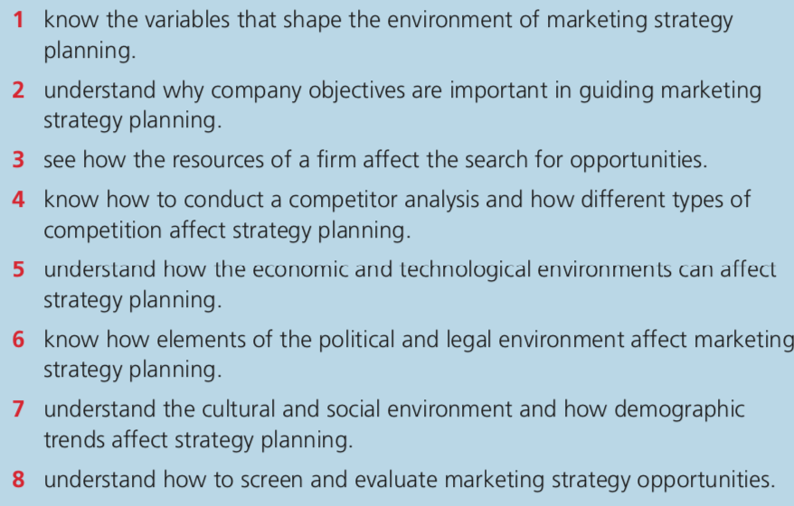
Q1 there are controllable variables which shape marketing in there external environment. This type of variable can be regulated by the business in order to be in line with the supply and demand of the business. Some of these variables are the product where the company marketing can control the product to adjusting mini features regarding this product. The marketer can decide to modify the product in terms of shape fashion design and Colour all increase the capacity to deal with the increasing demand. Among other factors to be put into consideration is the price. The price is control by the company marketer as these people attempt to adjust their price to meet with the market standard. The way in which business is in control of its price is that it can choose to offer price reductions at the same time you can use the buy-two-get-one-free slogan as well as offering great discounts on products.: promotion is another external Factor where the marketer has control over the promotional activities because they are able to use promotional Media depending on the context.
Q2 Company objectives refer to a checklist through which collaboration tools are used to achieve. The objectives of the company generally is to ensure to establish a high level of customer satisfaction, to have high levels of efficiency and productivity and have greater cost control to maximize profits. Other goals of the company are innovation and growth as well as employee engagement and retention.
Q3 Undoubtedly the lack of sufficient resources for a business regardless of its nature whether physical, human or financial, is going to have a significant effect on a business. Lack of enough funding would result in redundancies in the business capacity to operate. Lack of staffing also affects its ability to achieve its objectives. Overworking leads to frustrations of employees and a drop in performance of the business. The lack of innovation in a company can leave a company facing risk of expanding and growth of the business. Lack of innovation will make the company to become a boring workplace and this may stagnate the business. With regards to the finances there might be changes in the interest rates as well as being overly depending on one customer board distributor and a lack of this would lead to detrimental impacts on the business. Employees clearly are vital in running operations of the business and there is a risk such as strike action that could cripple the system.

Q4A perfect consumer analysis uses informed choices using digital consumer insights. Regular competitor analysis is important in outsmarting competitors. There should be in-depth competitive analysis by studying the strengths and weakness of competitors. This is when a business will be able to identify the opportunities they have for improvements and also shape targeting content and many more.
Q5 There is numerous economic factors that affect business and they include important industry trends, consumer behavior, inflation, interest, banking and many more. Change is a common feature when it comes to technology as there is a lot of upgrading and improvements that occurs. It has been identified that innovative technology is wreaking havoc in the writing business as more people are drawn to using e books tablets, rejecting the print world for the digital world. Changes in technology affect consumers as well as other market trends. There is a move away from short product life cycles as people are now embracing other improved devices from rapid technological change. This has led to greater opportunities for innovation for companies and this have to be placed under consideration when developing a strategy for marketing. With regards to the finance the financial position of a business with regards to liquidity cash flow and profitability listen to directly affecting scale of marketing activities. Other economic factors to be placed include the demand as well as challenges such as rotational which normally affect the marketing objectives.
Q6It is true that the political and legal environment have huge impacts on marketing. The environment refers to an area that comprises of laws that have been established by the government to limit various businesses. The laws of mandatory recycling have made it easy for the recycling industry to grow. Then again legislations have been designed in a manner to limit the activities of specific business, protect the interest of the public and eliminate unfair competition.
Q7 With regards to social factors there are consumer preferences that affect the market including, education, minorities, buying habits, attitudes on saving, population growth among many others. Culture also has a huge grip on employee management as it affects how staff is managed depending on the customs, rights and accepted codes of conduct. Demographic factors are normally placed under consideration when it comes to developing a marketing strategy as it includes factors of income, race, and age, among others. An illustration of how consumer preferences are affected by social and cultural factors is where old people are expected not to wear bright colours and prefers clothing that is simple. On the other hand teenagers would prefer to dress in a funky manner with loud colors. When it comes to issues of status in the society the upper class have the habits of spending on luxury items such as expensive dressing and gadgets. People who originate from the lower classes and ghetto hardly spend money on high-end products.
.
Q8 Screening and evaluating marketing strategies is achieved by addressing the changes that have taken place in sales. This system normally involves measuring the profits and rise in sales to know how the strategies are working. It involves accessing the core activities, business efficiency, competitor analysis, market and customer analysis and financial position.
Ch4
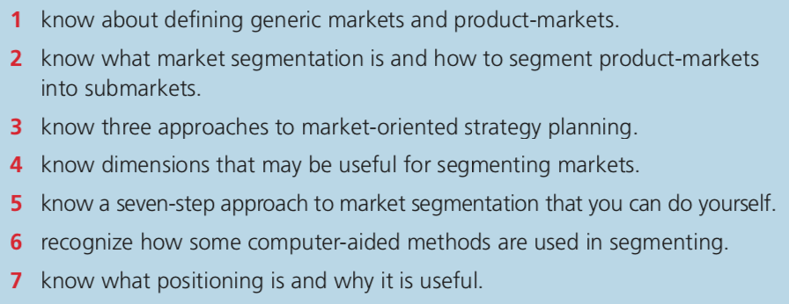
Q1 Generic markets refer to a group of consumers that have the characteristics of sharing a wide range of products and services. While product market refers to a group of consumers who share specific needs closely related to products that can meet. A perfect example of generic market is restaurants and farming cooperatives where people can go and acquire generalized products from foods to vegetables to pork and beef. Apparently according to the rules of the generic market the method that can be used for meeting the needs of these people comes second relative to the capacity to meet the need. With regards to the product market there is this group of smartphone users who only use phones that have less specific comparable capacities and qualities that serve the needs of the specified consumers. According to the rules of the product market the capacity to solve the market is often included in the marketing method. This means that only specific company that produces specific type of smartphones that can call advantage over other competitors
. Q2 Market Segmentation can be defined as the mechanism of dividing up a market into groups of potential customers and segments using specific traits. There are up to four different types of market segmentation which are behavioral, demographic, geographic and psychographic. A product market can be broken down based on trends that possess similar characteristics where the banking market can be broken down onto the submarkets of credit cards.
Q3 one of the approaches of efective market-oriented strategic planning is the one focusing on end Users. This is one of the strategies that many businesses are changing to with the aim of focusing on the needs of consumers and away from the Old approach of product engineering. Focusing on end-users involves a shift of the thinking of workers from the one-size-fits-all approach and directing the efforts to developing the product to meet the demand of the end-user. The second approach to market-oriented strategic planning is personalised online shopping. A case example of this is the Amazon website where there is a high level of market orientation. The company has developed a personalized shopping experience through product recommendation system which is web-based dependent on intelligence gathered and Crossing patterns of the customer. Interestingly just like many other online trading companies Amazon has an automated market orientation process that follows that because customers have become more knowledgeable require higher quality.
The third approach to market orientation strategic planning is customer employee contact. Most companies if not all are gaining more knowledge on how to meet the needs of the consumers. One such program is the "adopt a customer" program that is developed other one way of improving employee customer interaction.
Q4 Dimensions useful in segmenting markets start with the acquisition path. The next step involves the first purchase, geography, the device type. Other factors are the level of income of the customer. Gender and age are among other factors that are placed under consideration with regards to segmentation.
Q5 Seven Step approach to market segmentation involves first the identification of the Broad segment. This is where an individual figures out the broad-market that the business is located at. The second Step is an identification of the inventory of the potential customer needs. This is a step involving a lot of creativity as the individual has to find out what consumers need in this market and if he can possibly come up with better., the third step is formulating and coming up within narrow market. The idea here is formulating submarkets around you such as an aggregate of a number of people around you and regarding them as clients. The first step involves identification of the dimensions Revealing the attitude needs included in each market segment to help you. V step is labelling the possible market segments. then comes the six steps which involved evaluating the behaviour of the market area. The last step is determining the size of the market segment that is targeted.
Q6 Some of the computer aided methods of segmenting is the process that involves Aided Manufacturing Software for purposes of growth opportunities, key players, key markets and future forecast. The purpose of automation is to reduce cost by seeking services from key players such as Cimatron group, Mastercam, Autodesk inc, Software Inc. among others.
Q7 Positioning is a process of establishing a brand, image and identify off the product such that it can be perceived by the consumers in a certain way. The purpose of positioning is to be successful in gaining new customers. Also, a good position in the market will enable a product to be able to ride out bad times.
An illustration of how positioning works can be seen in the case of the Coca-Cola Company. As a certain point in time the company chose to reposition a product since it has already established huge brand awareness. The process involved changing the packaging and increasing the size of the product as well as improving the taste. Then the company went ahead to organise relaunch of the product which featured are new catchphrase. Eventually bukola company was able to successfully reposition its mother energy drink into this particular segment. Because of this repositioning the brand continues to compete with the leading energy drinks market in the world such as Red Bull.
.
Ch5
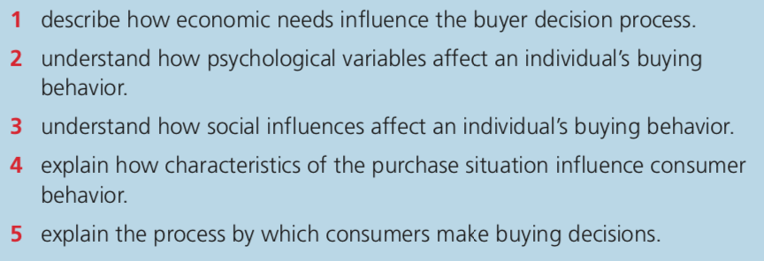
Q1 Economic needs are the factors that describe the position, level of sales, as well as the financial position of the buyer. Simply, this refers to how much an individual can spend on securing services and goods There are various economic factors that come into play and influence the purchasing behavior of a person and it includes family income, personal income, consumer credit, savings, income expectations, liquid assets etc.
For example if a person expects his or her income to increase in the near future he will have a capacity to spend more money and purchase luxury items such as shopping goods and durables. Also credit facility available affects the buying behavior. Liquid assets influence their buying behaviour since they happy capacity to be converted into cash and provided that a consumer has more liquid assets then he has likelihood of spending more shopping goods. In the Instance where liquid assets are fewer than expected then the buy behaviour will expect ar reduction in purchase of luxury items.
Q2 Psychological variables in buying behavior such as logical facts and emotional impulses in making purchase decisions. Buyers have big egos and tend to think about what they stand to gain and become more comfortable with the decisions they make. There are other psychological factors such as the level of motivation that is said to influence buying behavior. Further, other factors to consider include product brand and consumer perception that play a huge role in influencing buying decisions.
Q3 Social factors there are societal preferences that affect the market including, education, minorities, buying habits, attitudes on saving, population growth among many others. Culture also has a huge grip on employee management as it affects how staff is managed depending on the customs, rights and accepted codes of conduct.
There are many social influences search of the family which plays a very critical role in determining the preferences and buying behaviour of an individual. A society in which people live creates an environment where an individual develops personality evolves and acquire specific types of traits. A person start this preferences and buying behaviour as a child by watching other people do the same and eventually develop the same tendencies when he becomes of age. The family influences the decision of people as well as their personality beliefs and attitudes with respect to purchasing specific goods and services. It is the belief of many that an individual passes through the society and receives an orientation process where societal factors have a strong influence on The Culture as well as behavior.
Q4 Simply, there are three types of buying situations that affect the decision of the buyer to purchase the product. The first one is the new task where the buyer is in the act of purchasing the product for the first time. Second refers to the modified rebuy where the buyer wishes for modified product specifications, terms, suppliers and prices. The third is the straight rebuy where the buyer routinely reorders a product without any modifications required.
Q5The buying process refers to a series of steps that a client will take in order to come to a buying decision. The buying process begins with a first step which is problem recognition. Before a purchase can be made by an individual the customer must have a reason to now that they want how they want based on how they view themselves in a situation. The next step is information search where after a problem has been identified a customer begins the search process where there is a challenge and the consumer wants to solve it. After this is the evaluation of alternatives. The client is going to look at the competitive shin prices that are offered for the same product. The next step is the purchase decision. This is very surprising because they purchase decisions is at the middle of the six stages of the consumer buying process. This is where the purchase is made and the consumer has decided to buy the product. After purchasing the product the next step is post-purchase evaluation. Just because I purchase has been made does not mean that the process is come to a conclusion because the issues of customer loyalty and revenues that can be lost after the purchase.

,

Ch9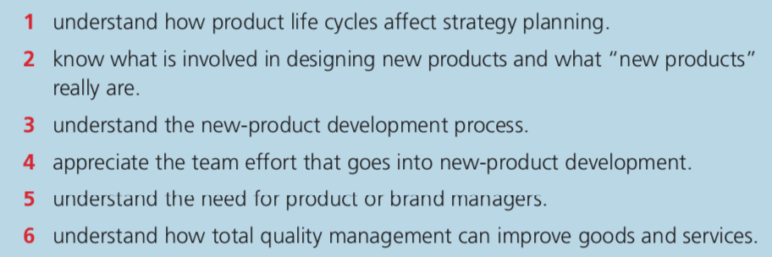
Q1 Product life cycle is a process that contains four stages which are introduction, growth phase, maturity phase and deterioration phase. It becomes clear that each of these stages is affected with the changes that take place in positioning of the product. Each and every stage has it opportunities and challenges with each having unique marketing strategies. Product life cycle is a series of development and changes that lead to rise in sales and a diminishing of sale of product which eventuate in the Demise of the product. For consumer products are the same case as much as it is the same case for living organisms. There are distinct stages in the life of a product in which there are unique marketing strategies that can be applied. Business marketing department should understand that each of these stages work differently and there is ways to navigate each stage in order to achieve maximum profitability.
Q2 Most business aim on developing new products and the eventual outcome of selling such products to clients. For the company there are two main parts to this and they include finding a product that consumers want to pay for and maintaining products that consumers buy generating revenue for the business.
Q3 The first step in designing new product deals with generation of the idea by understanding the needs of the consumers. The second step is screening ideas and removes the ideas that are regarded as not useful. A feasibility study is conducted to establish a market analysis and strategic analysis. Then preliminary designs, pilot runs and new product launch follows. For a business to stay successful when it comes to manufacturing of products there are ways of obtaining new ideas through a carefully crafted plan and product development process. Yes there are challenges along the way when it comes to the development of new products because the odds are heavy against the business. Because of this it is critical for the business owners to understand markets competition as well as consumers in order to develop products that are of superior value to consumers.
Q5 The brand manager is tasked with important duties of ensuring the success of a product. These are the individuals who usually plan, develop and end up enacting specific marketing strategies in a bid to increase the equity, performance and profitability of the business.
Q6 Total equity management refers to the management of outcomes of the assets of a particular business without putting into consideration liabilities. The major purpose of equity management is that it maintains the key principle membership. It represents the investment of the members and serves to protect their interests. The people with more equity in a business own a larger percentage and get greater rewards when profitability is increased.
Ch10

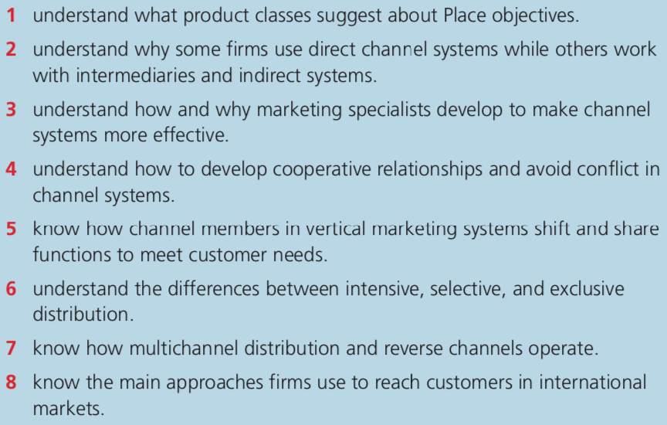Q1 Positioning by product class is another strategy used in marketing that aims at promoting up to two products that belong in a similar class. It is through the act of promoting a product simultaneously with another is what causes the positioning to be improved. The placement will ensure that the two products complement each other and have a greater customer exposure by increasing trust and familiarity.
A case example of positioning product by class is seen when a company manufactures toothbrushes as well as toothpaste among other hygiene products. The company can position toothbrushes as well as toothpaste together in a similar market by ensuring consumers that will get free discount toothpaste with the purchase of a toothbrush. This deal sounds sweet and consumers will increase the likelihood of buying the products. At the same time consumers may have the chance of testing out both the products.
Q2 Firms use direct distribution because the channel appears to be organized and is under the control of the manufacturer. In the beginning the direct channel appears to be challenging to set up as it requires high financial capital. On the other hand the indirect system of distribution relies on intermediaries to perform most of the functions. The difficult part with working with intermediaries is the fact that they handle the manufacturer’s products and there is a risk involved in logistics.
Q3 Specialists have made it clear that an effective distribution system is a good way of a business to gain competitive advantage. It is the norm for these specialists to enter into a long term agreement with the produce in order to set up a channel of distribution. Specialists in distribution identify the level of service required by each of the existing client. Then they set up different channels to meet the different needs of different companies.
The introduction of brokers and agents into the market to help the wholesaler and producer as well as retailer to move the product was a move to reduce the workload. This is because these people are experts in specific markets and ensures that buyers and sellers sell their products at a commission on the value of sales. These people are especially useful since they facilitate negotiations and do not take possession in any physical terms.
Q4 Developing cooperative relationships in distribution are important as they coordinate the logistics of businesses and this enables businesses to thrive and allow the business to focus more energy on delivering quality products. This type of agreement involves the conditions where a member of the distribution chain to own shares at a certain percentage for promotion and advertising costs. Cooperative advertising is where more than one business is able to band together and share cost of advertisement and reduces conflict.
Q5 The vertical marketing system refers to a special type of cooperation that exists between different levels of a distribution network. These systems have the tendencies where members work together in a bid to promote economies of scale and improve efficiency in the ways products reach the customers. The vertical marketing system comprises of members such as retailer, wholesaler, and producer. There are three types of vertical systems that exist when it comes to business and marketing. The three types of vertical marketing systems include administered contraction and corporate. Corporate vertical marketing system Focuses on combining successful stages of production under a single ownership. The second one which is contractual is only used in the case where there independent distribution firms which work together with independent production farms and through the process of integration the business becomes a success. The third vertical marketing system is administered. Administered vertical marketing system is one that and she was there is coordination in distribution and production through influencing the members of the channel as opposed to ownership.
Q6 Intensive distribution seeks to give saturation cover through the use of all available outlets for distribution. Selective distribution on the other hand is different in that the producer uses a limited number of outlets to move the products. The exclusive distribution strategy is where a business chooses to distribute its product in a specific outlet in the market who sole deal in it.
Q7 The multichannel system of distribution is a strategic way of selling, communicating with potential clients through the use of several channels. From the customers point of view it is very lucrative. There are a number of distribution channels such as online shopping, stationery trade, teleshopping, VR shopping, and many more. The reverse channel of distribution represent a system involving a backward flow of process where used goods will go back to the manufacturer and develop a channel reverse reciprocity.
An example of the reverse channel distribution system is reusing products where there are many products such as drums metallic pigment and containers that can be reused by companies to supply. The other system 4rivers distribution channel is the refurbishing of material such as furniture and computers that can be repaired on the parts that are deemed useless and replaced with parts which are working. Another reverse distribution network is recycling of products such as plastic and papers that can be made rich through recycling process.
Q8 The first step to entering foreign markets is franchising. Then the next step is direct exporting of products and selling products directly to the market that one has broken into. The other approach is partnering up. A business can engage in a joint venture and explore overseas markets.

