I had to learn Unity and C# because the app is developed in Unity. I am also learning how to do 2d animations in Unity. What I am currently attempting to do is adding the speech bubbles and animating the tutorial screen for the game.

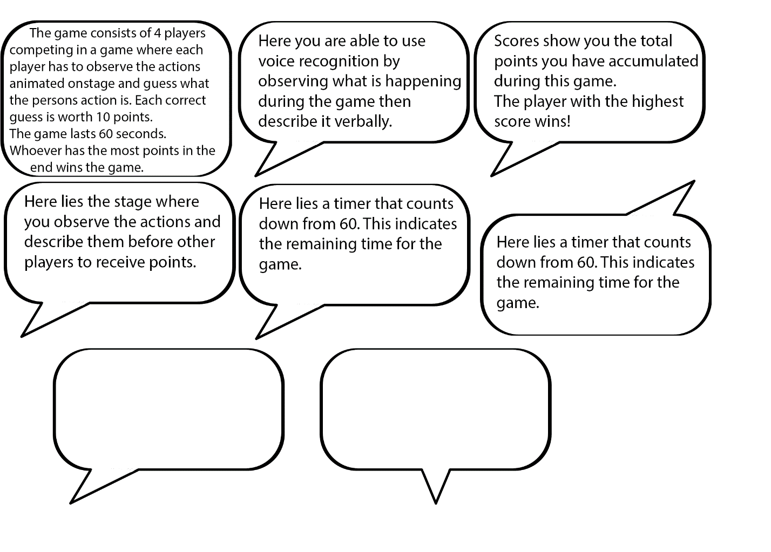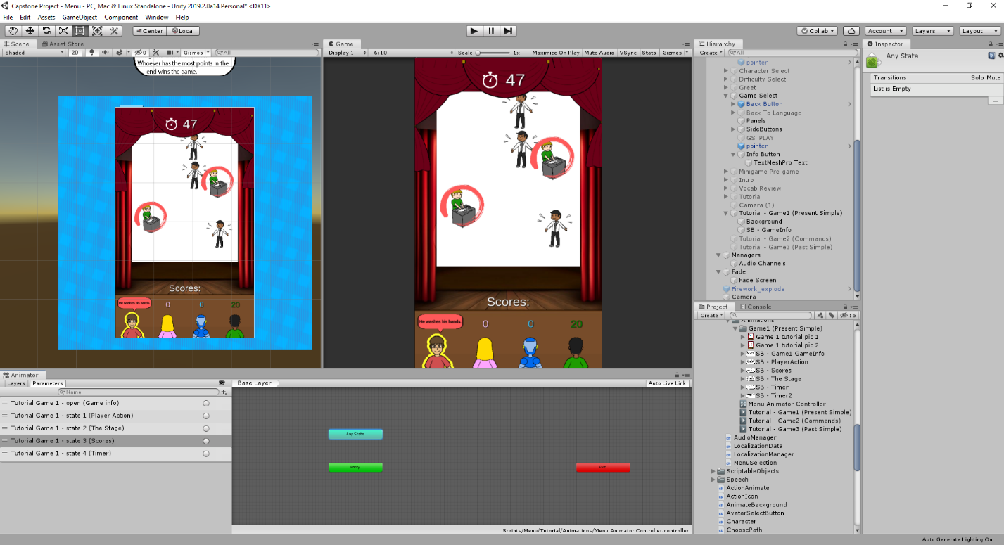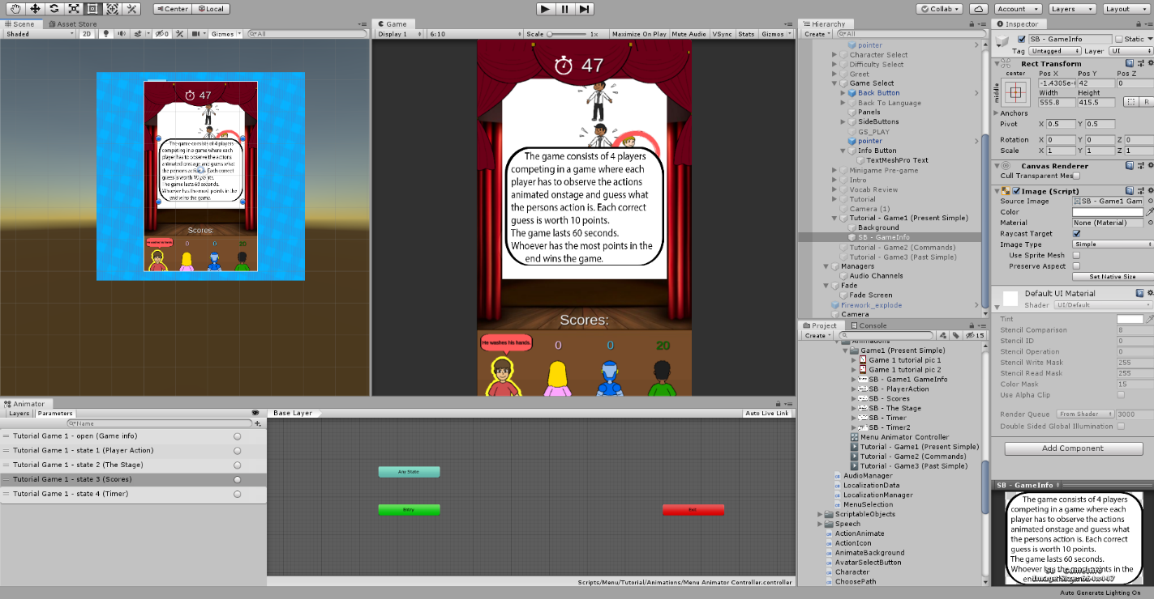

I learned how to use photoshop as well. Initially, I used paint to create the speech bubbles and info logo. But then I realized that I wanted a transparent background. I googled which program I can use to achieve that and settled with photoshop.

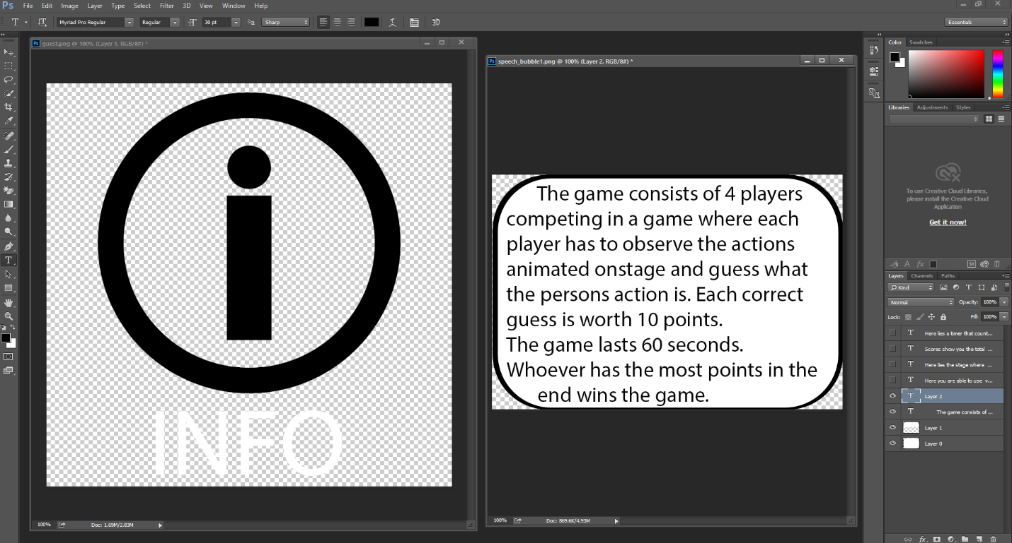

The learning process was mainly though trail and error for photoshop.

For unity, I learned through watching YouTube tutorials initially, after that it was a mix of google, YouTube, and trail and error.