Inquiry Question Guidelines

What to do | Why to do it
Begin your question with “how” or “to what extent.” | This ensures your question will be an Inquiry Question worth exploring rather than a simple or leading question with a too-easy, too-obvious, or yes/no answer.
Include a description of the kind of photograph you’re working with, including (potentially) its genre and rhetorical context. Is it an early 90s fashion photograph? A photojournalistic sports photograph from a magazine? | There are two reasons to do this: 1) it will lead you to more key terms for research, and 2) it will help you think about the bigger “So What?” for your photograph, which might be about a category of photographs (sports photos) or a certain time period (90s).
Include a word related to representation (represent, portray, depict, etc.). | This ensures your question is about representation and can be answered through analysis of the photograph.
Identify the key issue raised by your photograph. What is at stake? | This is the “meat” of the Inquiry Question. This will help you to select course essays from which to source concepts to use in Paper 3.

Samples (you cannot use theses photographs for Paper 3):

Inquiry Question 1
To what extent does the image of Seattle’s black superhero, Phoenix Jones, reflect or redefine our ideas about race and superheroes?

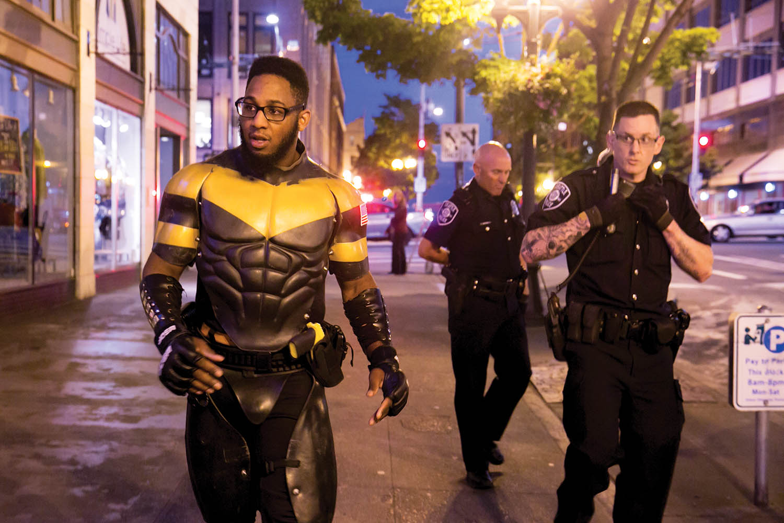
Real-life “superhero” Phoenix Jones (Ericka Schultz, date unknown)

Inquiry Question 2
To what extent does this photograph of Brandi Chastain, a female athlete succeeding at her sport, challenge preconceptions of athletes in North American culture? (note also that this is an iconic photograph of the sort you should avoid).
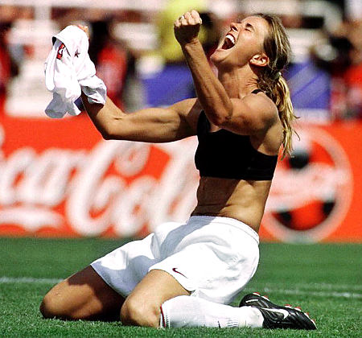
Brandi Chastain ripping off her jersey to celebrate World Cup victory is one of the iconic moments in women's sports history. (Lacy Atkins/Associated Press)

Inquiry Question 3
How does this image, a seemingly casual snapshot of the young royal family, depict the relationship between royalty, celebrity, and branding?
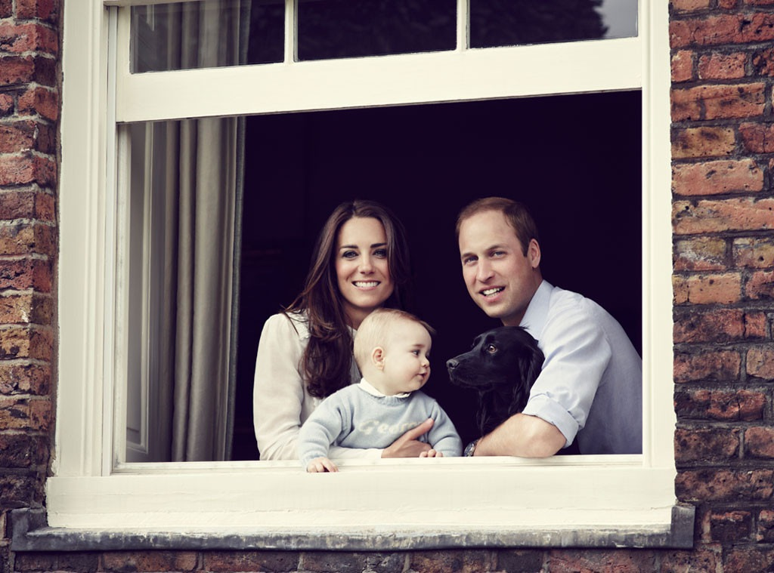
Prince William, Kate Middleton, Prince George, and Lupo the dog on March 29, 2014. Jason Bell/Camera Press/Redux

