Media Coverage Analysis Activity: New York Times Book of Crime

Copy and paste this into a new document. When you are finished, upload it to Blackboard. This should take about a class period to do. It is worth 15 points and will count as your attendance for today’s class.

Select one of the articles from NYT BOC Chapter 6 (“Murder”).
- Read it closely. Write a paragraph about what you notice about the media coverage. Support your observations with brief quotations and details from the article. (I realize it may be difficult to drawn conclusions from a single article, but just do your best.)
- Go to the Library databases and either pull up Proquest News & Newspapers (for older cases) or Proquest Newsstand (for 1970s to present). (You may want to try both databases if your case is from the 70s or 80s.)
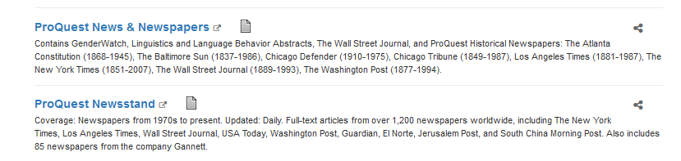
- Search for articles on your case. You may find that the headlines alone are quite revealing, or they may not be: it depends on the time period and which media outlets covered your case. Paste the titles of 3-4 articles below.
- Skim a handful of articles and write 2 paragraphs on what you notice about the media coverage. Support your observations with brief quotes and details from the articles.

