CHAPTER
6
TODAY’S COLLEGE ATHLETE

Joy Gaston Gayles

KEY TERMS
college athletes
intercollegiate athletics higher education
athletes on Division I campuses

When describing the experiences of athletes on Division I college campuses, most scholars compare athletes to nonathletes (Simons, Van Rheenen, & Covington, 1999; Watt & Moore, 2001). Such a comparison illuminates the unique ways in which participation in college sports impacts athletes and the additional responsibilities and requirements that must be managed for success in the classroom and on the field or court. In addition to taking classes, athletes must maintain academic eligibility requirements, take a full load of classes, make progress toward degree completion each year, practice, travel, compete, attend study hall, sustain injuries, and manage the psychological stress of winning and losing (Carodine, Almond, & Gratto, 2001). Although athletes make a conscious choice to endure these additional challenges, such experiences set them apart from their peers and require support from the university and athletic department in order achieve success both on the field and in the classroom.
Many of the ways in which the experiences of athletes are unique compared to their nonathlete peers are a result of the rules and regulations designed to govern and control college sports. The National Collegiate Athletic Association (NCAA), the athletic conference to which the institution belongs, and the college or university have regulations in place to which athletes must adhere in order to participate in college sports each year. The rules and regulations are designed to ensure that athletes make progress toward their degree and maintain a fair and equitable play across institutions within the NCAA.
College athletes who desire to compete in intercollegiate athletics must go through the NCAA Eligibility Center (formerly known as the NCAA Initial-Eligibility Clearinghouse). Initial eligibility requires that athletes graduate from high school and earn a minimum grade point average and test score based on a sliding scale. For example, under the current rules an athlete with a high school grade point average of 2.0 must have a SAT score of 1010 or a cumulative ACT score of 86. The relationship between grade point average and test score is inverted, such that lower grade point averages require higher test scores. In 2016 the sliding scale for initial eligibility will change for athletes at Division I institutions. In order to compete as a freshman in college, athletes will be required to earn a 2.3 grade point average in core courses. Further, athletes must successfully complete 10 of the 16 total required core courses before the start of their senior year of high school and 7 of the 10 courses must be in science, mathematics, and English. The sliding scale for test scores and GPA will increase. For example, a SAT score of 820 will require a grade point average of 2.5 in core courses. High school athletes who do not meet the initial eligibility standards cannot compete as a freshman. College athletes not in compliance will be allowed to practice and receive athletic grant-in-aid. If noneligible athletes are successful in their first academic term, they may continue to practice during their freshman year of college.
Scholarship athletes are required to attend college full-time in order to participate. On most campuses this equates to taking 12 hours (four classes) per semester. To make sure students maintain 12 hours academic advisors often schedule athletes for 15 to 18 credit hours in the event that the student needs to drop a class in which he or she is performing poorly. In addition to taking a full load of classes, there are grade point average requirements that athletes must meet in order to participate each semester. In general, athletes cannot fall below a grade point average

of 2.0.
College athletes are also unique because they have to balance the demands of academic requirements with practicing and competing in their sport. The NCAA mandates athletic departments to provide academic support and counseling services for athletes. Support services such as tutoring, supplemental instruction, computer labs, and course supplies must be provided to help athletes succeed in the classroom. In addition, NCAA rules state that athletes are not allowed to practice more than 20 hours per week; however, reports indicate that some athletes practice more than 40 hours per week on average, volunteering their time to review game tapes and condition for their sport (Wolverton, 2008).

CHALLENGES FOR ATHLETES AND HIGHER EDUCATION
The many rules and regulations, pressures, and scrutiny associated with intercollegiate athletics in higher education have created challenges for athletes and higher education institutions. Reports of scandals involving academic and social misconduct in intercollegiate athletics flood the media each year. The accusations and incidents have increased in severity over the years, and these scandals bring shame to the institution and spark distrust within the community. Some of the major challenges concerning athlete welfare include academic performance and graduation rates, balancing academic and athletic tasks, and the pay-for-play issue.

Academic Performance and Graduation Rates
The 1980s represents a period of increased concern about academic standards and performance for athletes. It was the first time that the NCAA enforced regulations for academic performance that were actually adhered to by member institutions. Proposition 48 and the Student Right to Know Act are two major reform efforts that set the foundation for academic standards.
NCAA member institutions have reported graduation rates since the mid-1980s under the Student Right to Know Act, which requires that higher education institutions make public graduation rate data as well as data on crime statistics so that students can make informed decisions about the institutions they desire to attend. The latest graduation rate data show that athletes graduate at higher rates compared to students in the general population (Christianson, 2012). In 2012 the NCAA reported that athletes who entered as freshmen during the 2004–2005 academic year graduated at a rate of 81%. The NCAA also reported that in 2012 athletes in football and men’s basketball showed remarkable improvement compared to past years. Men’s basketball players graduated at 74%, a 6-point increase from the previous entering class. Further, football players had a graduation rate of 70%, 1-point increase over the previous entering class. Moreover, across an 11-year period of data collection graduation rates for men’s basketball increased 21 percentage points and graduation rates for football players increased 7 percentage points.

STAKEHOLDER PERSPECTIVE

Pay-for-Play: A Moral Dilemma
Darin Moss is the director for compliance at Big Time University, USA. Big Time University is one of the top land- grant universities in the country with highly ranked athletic programs for the majority of the 14 sports offered. The basketball program has clinched two national championships in the past 7 years and is ranked number 1 in the country. Darin has worked in compliance for 10 years. He spent the first few years of his career working in compliance at the National Collegiate Athletic Association before becoming the compliance director at Big Time University. During his time at the NCAA he worked in investigations and is very familiar with the rules and regulations, infractions, and penalties associated with breaking the rules.
Working at Big Time University, Darin understands that students are under a great deal of pressure to manage their affairs both on and off the playing field. At the beginning of every academic year Darin and his staff meet with all athletes by sport to remind them of the rules and regulations associated with participating in intercollegiate athletics. Some of the major issues for athletes in high-profile sports are accepting gifts from agents, boosters, and others in the community. The NCAA is very strict concerning athletes accepting monetary gifts, making deals with agents, and academic misconduct.
The pay-for-play issue is one that Darin struggles with. On one hand, Big Time University generates large sums

of revenue largely based on the athletic prowess of athletes. Yet athletes do not receive a direct share of the profit for their labor. Moreover, Darin knows that some of the most talented players come from poor backgrounds where the families of athletes in high-profile sports are depending on their loved one to “go pro.” However, while the athletes are competing at the college level, they do not have enough money to cover daily living expenses, such as washing clothes, going to the movies, or buying a bus ticket home for the holidays.
The associated press recently interviewed Darin about this issue as Big Time University is currently under investigation for allegations of university basketball players accepting money from boosters. Darin Moss told the Associated Press that pay-for-play is a major issue plaguing college sports. As commercialism and revenue generation increase without consideration of the overall well-being of athletes, misconduct and scandals involving rule infractions will continue to escalate and burden higher education institutions.

Scholars and critics have questioned why the graduation rate data reported by the NCAA are so high (Southall, Eckard, Nagel, & Hale, 2012). One of the major reasons why the data vary so widely is because the NCAA and the federal government use different metric systems. The NCAA developed the Graduation Success Rate (GSR) to better account for transfer students who leave the institution in good standing. Thus, outgoing transfer students in good standing are included in the receiving institutions cohort of athletes. The current GSR is based on four cohorts of entering classes from 2002 to 2006. The GSR reported by the NCAA is usually about 20 percentage points higher than the rate reported by the federal government, which excludes transfer students from the calculation (Steinbach, 2012). Using the Federal Graduation Rate, athletes who entered in 2005 graduated at a rate of 65%, two percentage points higher than students in the general population did. Another reason why the GSR is higher than the Federal Graduation Rate is that for the first time Ivy League institutions were included in the calculations. It is important to note that Ivy League institutions are not like other Division I institutions because they do not award athletic scholarships.
Without probing any further, the fact that graduation rates have increased, particularly for high-profile sports, is good news. However, further examination of graduation data unmasks major differences in academic performance and successful degree completion. For example, disaggregating graduation rates by race and ethnicity shows major disparities. According to the GSR, African American athletes graduated at a rate of 54%. Although this represents an increase of 19% over time, the rate still lags behind students in the general population. More alarming is that African American males graduated at a rate of 49%—an increase of 16 points over time. However, like African American females this rate lags behind the average rate for all African American athletes and students in the general population. African American female athletes, however, are faring well graduating at a rate of 64%, which is on par with the average graduation for athletes in the general student population.

Balancing Academics and Athletics
Perhaps one of the most challenging and stressful tasks faced by athletes is the act of balancing academic, athletics, and social demands (Adler & Adler, 1991; Comeaux & Harrison, 2011; Gaston-Gayles, 2004; Simons, Van Rheenen, & Covington, 1999). On most days athletes wake up early, take a full day of classes, attend practice, eat dinner, and then go to study hall. By the time study hall is over late in the evening it is time to rest and prepare to do it all over again the next day. Such a rigid schedule leaves limited time for social activities and in some cases not enough time to meet with professors during office hours and tutors for supplemental instruction. Moreover, balancing academic and athletic demands can be even more strenuous for athletes who enter college academically underprepared.
Scholars have studied the challenges athletes face balancing academic and athletic roles and responsibilities. Adler and Adler (1991) conducted one of the first studies on the topic using ethnographic techniques to study the basketball team at a major Division I institution. Overall they found that the male basketball players in the study had high aspirations toward academic performance in college; however, the demands of participating in their sport led to overinvolvement in athletics as early as the first and second semester of their college career. Adler and Adler coined the term role engulfment to characterize athletes who became overinvolved with athletic demands and as a result devoted little time to academic and social experiences during college.
A major problem resulting from overinvolvement in athletics is isolation from the general student body. Critics have argued that athletes form a separate subculture on college campuses that isolates them from the student body and impacts the extent to which they benefit from the college experience in ways similar to their peers (Bowen & Levin, 2003; Shulman & Bowen, 2001). Parham’s (1993) study on the experiences of athletes supports that they have difficulty balancing academic and athletic tasks and experience social isolation from spending so much time in the

athletic domain. The study also found that athletes experience mental and emotional stress from dealing with the pressures of winning and losing and managing relationships among competing groups, such as coaches, friends, and family. Parham concluded that the demands of balancing so many stressors make the athlete population vulnerable to other issues, such as lower gains in learning and personal development.
Other studies have examined the issue of balancing academic and athletic demands using motivation theory. It is quite natural for athletes to enter college highly motivated in the athletic domain because the university recruits and awards scholarships based on athletic talent. The problem is when students enter the university without the same level of motivation in the academic domain. Lack of academic motivation seems to be most problematic for high- profile athletes (Gaston-Gayles, 2004; Simons, Van Rheenen, & Covington, 1999). Gaston-Gayles (2004) developed a scale to measure athletes’ motivation toward sports and academics and found that what mattered most in terms of academic performance was the extent to which athletes were motivated academically. Having high aspirations to excel in the athletic domain did not influence academic performance; however, lack of academic motivation, regardless of athletic motivation, had a negative influence on academics.
Other studies have examined motivation using self-worth theory to understand differences in motivation for the student athlete population. Simons, Van Rheenen, and Covington (1999) examined achievement motivation for athletes using self-worth theory and found that most athletes in revenue sports were failure avoiders—motivated to achieve success in one domain while avoiding failure in another. Moreover, failure avoiders are characterized by attitudes and behaviors that result in low academic performance such as use of self-handicapping excuses, low academic self-worth, higher problem levels in reading and studying, and less intrinsic motivation.
When athletes place too much emphasis in the athletic domain and become isolated from the student body, the question is raised as to whether athletes benefit from the college experience similar to their nonathlete peers. The idea that athletes make up a separate subculture on college campuses leads to discussion about possible negative consequences of participating in college sports. Gayles and Hu (2009) examined the athlete experience using national data from the NCAA and found that athletes interacted with peers other than athletes more commonly than any other form of engagement measured in the study. However, athletes participated in student organizations least frequently. In addition, interacting with peers other than teammates was one of the most influential factors in outcomes such as personal self-concept and learning and communication skills. A unique finding in this study, however, was that these effects were more beneficial for athletes in low-profile or Olympic sports. More investigation is needed to understand what factors matter relative to cognitive and affective gains for athletes in high-profile sports.

Pay-for-Play
The debate over whether to compensate athletes for their participation in college sports is a growing area of concern for intercollegiate athletics and higher education. College athletes, particularly those who participate in revenue sports such as football and men’s basketball, generate large sums of revenue for athletic departments; yet athletes do not receive any share of the profit from the revenue they help generate. Further, athletic departments generate revenue from merchandise sales using the number and image of high-profile athletes.
Commercialism associated with college sports is a growing problem that institutions will have to address in the near future. As commercialism increases in the form or television contracts, ticket sales, high-salary coaches, and advertising endorsements, so does the pressure to produce winning teams and generate revenue. Over the years, cases of academic and social misconduct have increased in frequency and severity. Further, the commercialized values of intercollegiate athletics run contrary to the goals and values of higher education institutions. Institutions of higher education will need to figure out the proper role and function of intercollegiate athletics in higher education
and take steps to align the values and goals of educating students to the goals and values associated with participation in college sports.
CASE STUDY
Pay-for-Play
The pay-for-play issue is predicated on the question of whether athletes should receive monetary compensation for their participation in college sports. The commercialism associated with college sports has increased exponentially over the years and institutions generate millions of dollars annually from television contracts, ticket sales, tournaments, and advertising deals. At the heart of the pay-for-play issue is the tension between the fact that athletic

departments generate large sums of revenue and the individuals responsible for generating the revenue do not receive a direct share of the profit. In fact, athletes represent the only stakeholders who do not receive a direct share of the profit.
Some have argued that college athletes do receive payment in the form of an athletic scholarship. However, others have questioned if $40,000 to $50,000 over a total of 4 years is equivalent to the billions of dollars generated annually by athletic departments. Moreover, if athletes in high-profile sports are not successfully graduating from college, then is the promise of earning a college degree enough to compensate athletes for their labor?
Institutions of higher education adhere to the principle of amateurism as it allows for a peculiar institution such as college sports to exist within higher education institutions (Thelin, 2012). Compensating athletes directly would go against the values and principles of higher education and would change the face of college sports as we know it.
Questions about how much athletes should be paid, should all athletes receive the same amount, should all athletes be paid or just athletes in revenue-producing sports are some of the questions that will have to be addressed if such a policy were enacted.
The NCAA recognizes the academic, financial, and social pressures faced by college athletes but remains strictly against compensating athletes for participation in the college sports. The collegiate model dates back to the 1950s and implies that athletes are also students (not employees of the institution). The NCAA recently passed legislation for institutions to award athletes up to $2,000 over the cost of attendance. However, this legislation was put on hold because athletic departments complained that they did not have enough revenue to do so. Further athletes are allowed to work no more than 20 hours per week and cannot be compensated more than $2,000 beyond the cost of attendance. Although this would allow athletes to earn additional money for daily living expenses, working a part-time job further complicates the issue of balancing academic and athletic demands.
About 300 athletes participating in high-profile sports across several Division I institutions recently filed a law suit against the NCAA for rights and royalties associated with marketing jerseys with players’ names and numbers on them. College athletes feel that they should benefit from advertising and merchandise sales that use their names and numbers. The lawsuit indicates that they want direct compensation for and rights to merchandise sales.

The NCAA has taken a firm stance against pay-for-play and has held true to the amateur status of college sports. A few reform efforts that address the pay-for-play issue have been approved, but the NCAA has made clear that the measures taken are not a form of pay-for-play. In the 1990s the NCAA allowed athletes to work no more than 20 hours per week and earn no more than $2,000 above the cost of tuition. In 2011 the NCAA also approved a rule allowing athletic departments to add up to $2,000 above the cost of tuition to athletic grant-in-aid for athletes in an effort to close the gap between tuition and fees and the full cost of attendance. Because of complaints from athletic departments across the country, the NCAA has since tabled the rule until a solution is reached concerning how athletic departments can afford to increase scholarships for athletes. The following questions remain:
Should athletes be compensated beyond athletic grant-in-aid, and what does this mean for intercollegiate athletics on college campuses?

CONCLUSION
Although there are many challenges and problems with college sports on college campuses, intercollegiate athletics serves a unique purpose that should not be overlooked. If governed and controlled properly, intercollegiate athletics can serve as a bridge that connects the university to the community, provide opportunities for students to receive a quality education and develop character, and unite the campus community around a common goal. Reform agendas led by groups such as the Knight Commission on Intercollegiate Athletics and The Drake Group call for better alignment between the values and goals and intercollegiate athletics and institutions of higher education. For example, a recent Knight Commission Report (2010) entitled Restoring the Balance calls for greater transparency concerning spending in intercollegiate athletics, putting into place practices that lead to making academics a priority, maintaining the amateur status of college sports, and treating athletes as students first. At the heart of all reform efforts should be the welfare of the student athlete. Policy recommendations and rule changes must consider what is in the best interest of students and how can we better educate and support the athlete population in ways that support the mission of higher education institutions.

CHAPTER
7
MVP
Predictors of Four-Year Transfer for Community College Athletes

David Horton Jr.

KEY TERMS
community college student success
four-year transfer athletes

Intercollegiate athletics is a popular student activity at community colleges, especially at institutions situated in rural locales. Approximately 60% of all public community colleges in the United States sponsor at least one varsity athletic team (Castañeda, Katsinas, & Hardy, 2006; Kissinger & Miller, 2007). Between the three major athletics governing associations for community colleges (California Community College Commission on Athletics, National Junior College Athletic Association, and Northwest Athletic Association of Community Colleges), more than 75,000 individuals annually participate. At rurally located institutions athletes can compose as much as 22% of the total full- time enrolled student population (Castañeda et al., 2006). Though much research has been conducted on community college students, little is known about athletes or the factors that impact their academic experiences (Horton, 2009; Kissinger & Miller, 2007). Specifically, what is not fully understood is the impact of athletic participation on students’ academic experiences.
The objective of the larger study from which this chapter was derived was to test empirically the effect of athletic participation and institutional and individual factors on the academic performance of community college athletes. This chapter is intended to answer the following two questions: To what extent do the academic experiences of athletes differ from their nonathlete peers; and what effect do academic performance and individual, precollege and institutional characteristics have on four-year transfer for athletes, compared to their nonathlete peers?

ATHLETICS AT THE COMMUNITY COLLEGE
Athletics at community colleges provide many benefits to students, institutions, and the communities they serve. For instance, athletics provide students with a true collegiate experience, contribute to the institution’s efforts to recruit a more diverse student body, and address the missing male phenomenon (Bush, Castañeda, Hardy, & Katsinas, 2009). Institutions also benefit from increased enrollment of nonscholarship athletes that have been recruited by other institutions that do not permit athletic aid (Castañeda, et al., 2006). In their 2012 study, Barreno and Traut examined factors that influence individuals to choose to attend a community college. The authors found that female and black students in general were more likely than their peers to be influenced to attend a community college because of the availability of athletic teams and sports. Athletic programs are also likely to have a positive impact on the local economy (McCullough, 2000). For college athletes, athletics is a viable way to gain access to higher education, especially for students of color and those from minimal to modest financial means (Horton, 2011). Participation, in many states, also affords students access to athletic aid, which helps with tuition costs, and substantially provides upward social mobility for students through degree attainment, four-year transfer, or job placement (Hawkins, 1999).
STAKEHOLDER PERSPECTIVE

The Importance of Collaboration in the Best Interest of College Athletes
Christopher M. Mullin is the program director for policy analysis at the American Association of Community Colleges (AACC). In this capacity, his chief responsibility is to provide analysis and supporting data to guide and enhance AACC’s advocacy efforts while also playing a central role in shaping AACC’s long-term federal policy agenda. He earned a Ph.D. in Higher Education Administration at the University of Florida in 2008.
Mullin’s work, especially a policy brief focused on the issue of transfer, notes that the research literature on transfer student success is varied. He also notes that rarely does the research acknowledge that success for students post-transfer may be due in part to the actions of the receiving institution. When unaccounted for, institutional inaction skews comparisons between the experiences of those who initially enroll in four-year colleges and those who start at community colleges. Put in another context, a team cannot win a relay race if subsequent runners drop the baton.
A real inequity exists for community college athletes, who now, as the result of policy changes by the National Collegiate Athletic Association (NCAA), must have a higher college grade point average to transfer and participate in Division I athletics than those students who transfer laterally. The data to justify the decision are severely limited, their legitimacy questionable, and the impact on community college athletes—especially students of color—is substantial.

STUDENT SUCCESS AND TRANSFER
Throughout the higher education literature diverse examples can be found of varying criteria that have been used to define transfer, identify possible transfer students, and calculate student transfer rates. In general, the term transfer encompasses various transitions students are likely to make between institutions and institutional types (Jones-White, Radcliffe, Huesman, & Kellogg, 2010). One of the most studied and perhaps most understood form of transfer is linear transfer. In this linear form the community college serves as the entry point to higher education for students who wish to eventually earn a bachelors degree (Townsend, 2002). Berkner, Horn, and Clune (2000) suggest the transition from community college to a four-year institution is one of the most important forms of transfer, “because its success (or failure) is central to many dimensions of state higher education performance, including access, equity, affordability, cost effectiveness, degree productivity, and quality” (p. 3). For the purposes of this study, four-year transfers were defined as any full-time first-time (FTFT) enrolled student who attended a community college and later enrolled in a four-year college or university (Romano & Wisniewski, 2003).

THEORETICAL APPROACH TO EXAMINING COLLEGE ATHLETE SUCCESS
Within the context of this study, a student’s decision to participate in athletics at the collegiate level and an institution’s role in providing access to higher education and awarding athletically related financial aid to athletes are viewed as investments in human capital. The basic tenets of human capital theory include the benefit of investments in activities that increase job-specific skills and academic credentials that generate income for future benefit (Becker, 1964, 1993). Human capital theory views increases in job-specific training and academic credentials as capital that yields higher wages, opportunities for personal and professional advancement, and upward social and economic mobility (Becker, 1964, 1993; Blaug, 1976). Becker (1964) primarily focused on the economic return that increased education yields over an individual’s lifetime, compared to returns for those who choose not to invest in additional education beyond high school or specialized job training. The internal rate of return to costs associated with participation in higher education or other training opportunities is quantified by the net difference between investment costs (i.e., forgone earning, expenses for tuition, books, and other supplies) and future gains in income (Becker, 1964; Perna, 2006).
Participating in intercollegiate athletics requires a substantial commitment on behalf of the athlete. Comeaux (2011) asserts that “student-athletes devote more than 40 hours a week to sport-related activities, not to mention the mental fatigue, physical exhaustion, and nagging injuries that accompany those who participate in college sports” (p. 75). Across the United States, two-year institutions allocate nearly $50 million annually for athletically related financial aid. The desired and ultimate product of this investment, I argue, is the students’ successful completion of a credential at a community college, accumulation of tools and skills necessary to enter the work force, or the opportunity to further their academic studies at a four-year institution. Accordingly, this study explores the impact and product of this investment.

RESEARCH DESIGN
Data for this study were provided by the Florida Department of Education’s PK-20 Education Data Warehouse (EDW) and Community College and Technical Center MIS (CCTCMIS). The EDW has been the single repository of student-level data for public secondary schools, community colleges, career and technical education institutions, adult education, and four-year institutions since 1996 (Hansen, 2006). For the purposes of this study, a student was deemed “academically successful” if he or she transferred to a four-year institution within a maximum of 11 semesters. As such, a maximum of 11 semesters was set as the parameter for this study owing to limitations in the availability of data regarding the disbursement of athletically related aid to students in the state of Florida before the 2003–2004 academic year. Institutional level data from the National Center on Education Statistics Integrated Postsecondary Education Data System (IPEDS) 2005 survey were also incorporated in the present analysis.

Sampling
The institutional sample consisted of two-year institutions within the Florida community college system that sponsored athletic programs and teams during the 2004–2005 academic year. At the time of this study Florida’s community college system consisted of 28 institutions. Because of the preceding criteria, three institutions and students who matriculated at one of these three institutions were excluded from this analysis. Five additional institutions and students attending these institutions were also excluded because of missing data. Students included in the nonathlete and athlete samples were limited to individuals who began their academic studies at 1 of 20 institutions in the state that sponsored intercollegiate athletics, and who were enrolled full-time (enrolled in 12 credit hours or more during the 2004 fall term) and members of 2004–2005 student cohort. The athlete sample was limited to students in the 2004–2005 cohort who were awarded athletically related aid during at least one academic term during their enrollment.

Methodology
The preliminary data analysis stage included descriptive analysis and independent t-tests. Findings from this stage are discussed alongside the discussion of independent and dependent variables provided in the next section. The second step of data analysis employed logistic regression methods to explore the effect of selected variables on four- year transfer propensity for athletes and nonathlete students. Within higher education research, logistic regression is the preferred statistical method when developing statistical models that incorporate dichotomous dependent variables, such as persistence, transfer, major and degree attainment, and both dichotomous and continuous independent variables (Cabrera, 1994).
Independent variables in the regression models were placed in blocks and added in succession to the baseline models. The baseline equation for model I (all students) included the group of variables representing student background characteristics: Y1= β0+β1(Athletic status)+ β2(Race) + β3(Gender) + β3(SES) + ε1, where Y1 represents four-year transfer, βj the coefficient, and ε1 the constant or error term. The baseline equation for model II (athletes) included similar background characteristics as found in model I but was tailored to the athlete sample. Specifically, in model II, athlete status was replaced with sports team participation in order to capture the effect of athletic team participation. The regression model was represented as follows: Y1= β0 + β1(Sport) + β2(RACE) + β3(Gender) + β4(SES)+ ε1, where Y1 represents four-year transfer, βj the coefficient, and ε1 the constant or error term.

Independent Variables and Descriptive Statistics
Independent variables were placed in groups (i.e., athlete status, sports team participation, individual background characteristics, precollege characteristics, academic experience, and institutional characteristics). College athlete status was a binary variable based on the award of athletically related financial aid and was used to identify athletes in the student sample. The sample included 568 athletes. Sports team participation incorporated three binary variables, which included basketball (n = 173), baseball (n = 149), and golf, soccer, softball, swimming/diving, tennis, and volleyball (n = 246). Golf, soccer, swimming/diving, tennis, and volleyball were combined in the original dataset received from EDW, and thus were combined into one binary variable. The latter group was selected as the reference group in regression model II owing to a high concentration of ethnic majority students represented on these sports teams. Table 7.1 illustrates team participation by race.

Individual background characteristics consisted of race, gender, and socioeconomic status (SES). Because of a low representation of athletes from Asian or Pacific Islander (1.1%), Hispanic (6.4%), and American Indian (0.2%) racial/ethnic groups, a dummy variable for race was created where 0 = white and 1 = students of color. White students composed 59.2% (n = 8,646) of the nonathlete student sample and 61.7% (n = 345) of athlete sample.
Students with missing data for race/ethnicity were excluded from analysis. Gender was coded with males serving as the reference group. Gender was reported for a total of 15,457 students (nonathlete and athletes combined). Female students had the highest representation across samples. Specifically, 61% (n = 9,087) of nonathletes and 56.1% (n =
317) of athletes were female.
To explore the impact of SES on student success, a proxy variable based on the receipt of a Pell Grant was created. Pell Grants are need-based awards given to undergraduate and postbaccalaureate students from low-income backgrounds attending public and proprietary colleges and universities (U.S. Department of Education, 2009). For classification purposes that were based on the criteria for receiving a Pell Grant, grant recipients were classified as low SES; students in the sample that did not receive grant aid were classified as high SES. Low-SES students totaled 68% of all students. When delineated by athletic status, 69% (10,307) of nonathlete students and 36% (207) of athletes were categorized as low SES.
TABLE 7.1

Crosstabs for Sport Participation by Race/Ethnicity
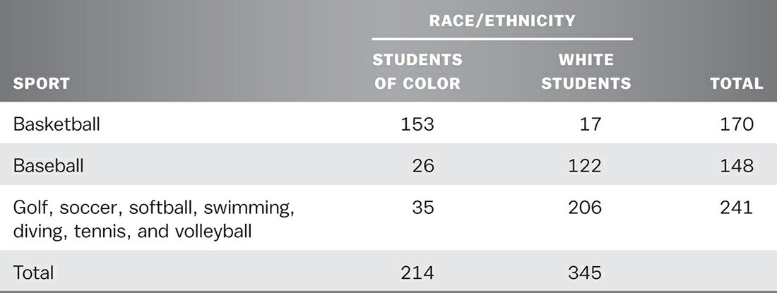
A dummy variable was created to capture the impact of time elapsed between high school completion and college entrance, where 0 = students that entered college within one calendar year of receipt of their high school diploma and 1 = students that delayed entry for more than one calendar year. Approximately 59% (n = 8,776) of nonathlete students enrolled in college within one year. A substantially higher percentage of athletes (89%) enrolled in college within a year.
Level of college readiness is of particular importance to the conversation of student success in general, and the discussion of athletes more specifically as little is known about its impact on athletes. Accordingly, a dummy variable was constructed for college readiness using a multiple-step process. First, student scores for the ACT were converted to SAT scores using the “ACT/SAT Conversion Table” provided by The Princeton Review. Next, student scores from the College Placement Test (CPT) were converted to SAT scores using the Florida Department of Education “Remedial Cutoff Score table” (Florida Department of Education, 2005). The table was used to determine students’ academic readiness for college-level math, reading, and writing, where 0 = college ready and 1 = not college ready. Additionally, a categorical variable was created that was based on the number of content areas remediation where was needed. This variable was coded as 0 = if no remediation was needed, 1 = remediation in one content area was necessary, 2 = remediation in two content areas was required, and 3 = remediation was necessary in reading, writing, and math. Only 36% of all students (athletes and nonathletes combined) were college ready in all three content areas. Twenty-six percent of all students required remediation in at least one content area, 18.6% in two content areas, and 19.1% in all three content areas.

TABLE 7.2

Analysis of Mean GPA for Athletes and Nonathlete Students
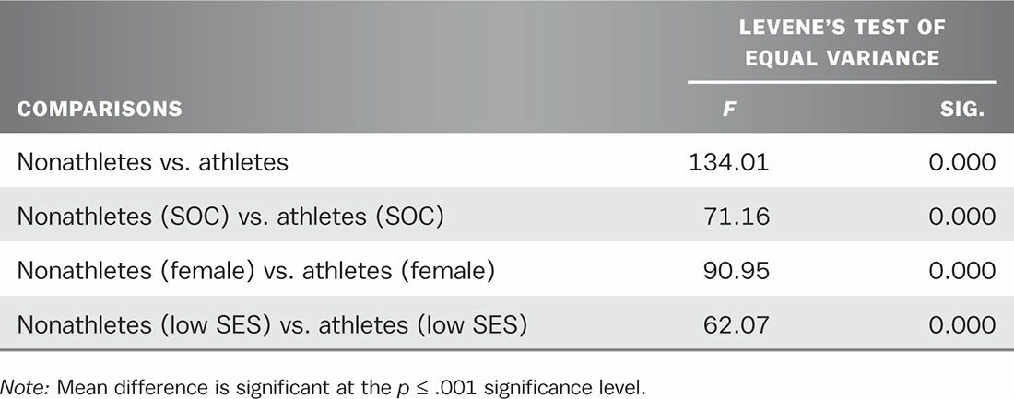
Students’ academic experiences were operationalized using three continuous variables (overall GPA, course credit hours enrolled, and course credit hours earned). Students’ cumulative GPAs were calculated from transcript data obtained from EDW. Table 7.2 presents t-tests for comparisons conducted for GPA between students and athletes, and groups of athletes and nonathletes, and was based on race, gender, and SES. College athletes had a mean GPA of 2.59 compared to nonathlete students, who had a mean GPA of 2.29. These differences between athletes and nonathletes were found to be significantly different. Moreover, athletes enrolled in and earned more credit hours per semester than nonathlete students. Specifically, athletes enrolled in 12.53 credit hours and earned 10.08 credit hours per semester. In comparison, nonathletes enrolled in 9.00 credit hours and earned 6.18 credit hours (SD = 3.69) per semester.
A categorical variable was created to represent institutions located in suburban, urban, and rural geographic locales. Dummy variables were then created for each category with suburban institutions serving as the reference group. Institution’s full-time-equivalent (FTE) enrollment size provided another index in which to examine the impact of institutional characteristics on student success. Institutional FTEs were categorized as small (500–1,999), medium (2,000–4,999), large (5,000–9,999), and very large (at least 10,000). Categorical variables were recoded into three separate binary variables (e.g., 1 = small, 0 = medium, large, very large). Large institutions served as the reference group. Eleven institutions (55%) were classified as urban, four (20%) as rural, and the remaining institutions as suburban, according to IPEDS definitions. Ten (50%) of the included institutions had an enrollment size of 10,000 FTE or more, and five (25%) between 2,000 and 4,999, and two institutions had an enrollment size between 200 and 1,999 FTEs.

FINDINGS
Findings from this study are discussed in term of odds-ratios (Exp(β)), which represent the odds change for a one- unit change in the predictor factor when all other predictor variables in the equation are held at a constant value (Peng, So, Stage, & St. John, 2002). Additionally, probability values, another term commonly used throughout this chapter, are used to explain the likelihood of an event occurring for one designated group over another group and are discussed within this section as a percentage (Exp(β) × 100) or decimal value (Exp(β) = .469). For instances where results are discussed for continuous variables (i.e., GPA and credit hours earned), the odds-ratios of transfer occurring were calculated at different values of the continuous variable, using the following formula:
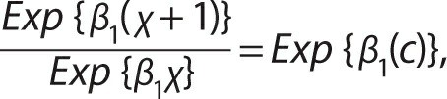
where, β1 is the coefficient’s beta weight, χ and is the selected value of the independent continuous variable. Both model I and model II were significant at p < 0.001. Model I (all students) correctly predicted four-year transfer for 98.4% of the students in the samples and model II (athletes) correctly predicted 97.3%. Table 7.3 presents an illustration of findings from the regression analyses.

Regression Model I: All Students

Nine variables in model I were found to be significant predictors of four-year transfer (athlete status, gender, SES, delayed entry to college, math readiness, writing readiness, GPA, credit hours earned, and institutional enrollment size [large]). College athletes and students from low SES were found to be less likely to transfer. Females were found to be nearly two times more likely than males to transfer. Precollege characteristics had a significant impact on transfer. Specifically, students who delayed entry to higher education beyond one year and those who were not college ready in math or writing were less likely to transfer. Moreover, students’ academic experiences were also highly significant predictors of four-year transfer for first-time students. As would be expected, students who maintained higher GPAs and those who earned more credit hours per semester were more likely than their peers to transfer. Lastly, only one factor within institutional characteristics, enrollment size (large), was found to impact transfer.

Regression Model II: College Athletes
Only three factors were found to be significant in model II (gender, GPA, and sports team participation). Females were nearly 14% more likely than males to transfer to a four-year institution. When holding all other predictor variables constant, athletes’ GPAs were highly significant. For example, athletes with a mean GPA of 3.30 were found to be 26 times more likely to transfer than students with a 2.30 average GPA. When considering specific sport participation, students who participated in baseball were less likely to transfer than students participating in golf, soccer, softball, swimming/diving, tennis, and volleyball.

TABLE 7.3

Likelihood of Four-Year Transfer by Individual and Institutional Factors
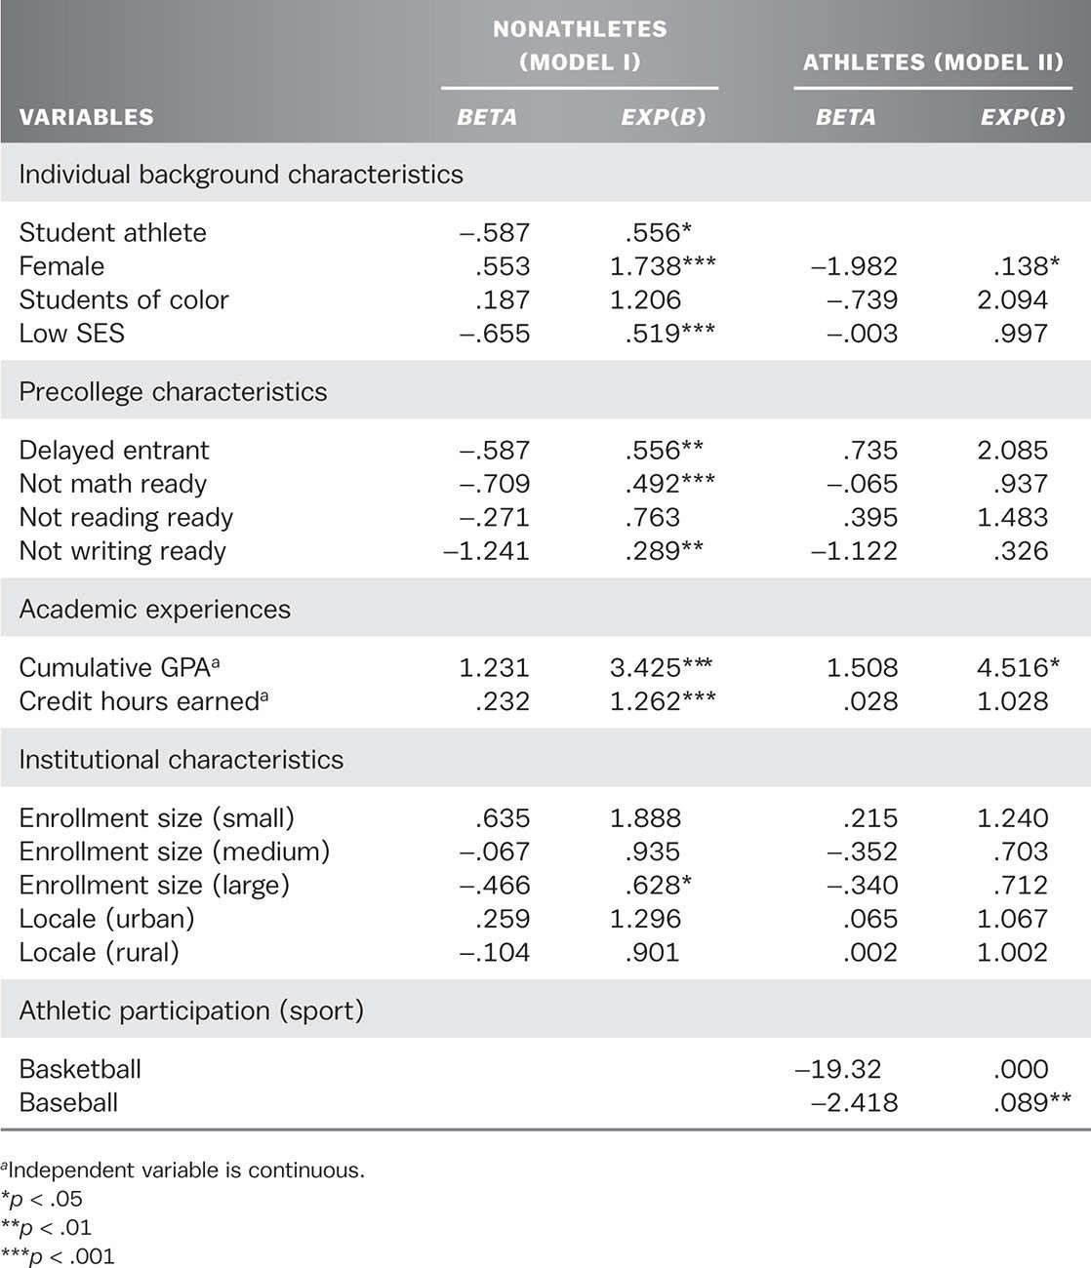

CONCLUSION
Continued research on community colleges, student success, and four-year transfer more specifically, has broad implications for higher education. As the rising cost of college continues to be debated, athletics and athletes continue to be an easy target as many stakeholders in the academic community hold athletics partially responsible for these rising costs. Gaining a better understanding of the impact athletics plays in athletes’ academic success is of utmost importance in these times. Two main issues regarding athletes and athletics were addressed in this study.

First, differences in individual characteristics, precollege characteristics, and the academic experiences of athletes and nonathlete students were addressed. Second, the impact of risks factors as predictor of academic success for athletes, and for select racial, gender, and SES subgroups was tested.
The title of this chapter is “MVPs: Predictors of Four-Year Transfer for Community College Athletes.” The title MVP, most valuable player, is given to a person who has the greatest instrumental value toward the goal of winning. It is clear which factors stand above the rest in making athletes at community colleges the MVPs. In sum, findings corroborate previous research that women are more likely to be successful than men; and students who exhibit positive academic behaviors, such as earning a majority of the credit hours they attempt and maintaining at least a “B” GPA are likely to transfer. Furthermore, students who enter college underprepared and those from low socioeconomic backgrounds are less likely to be successful with institutional intervention.
One practice employed by athletic programs at community colleges is to recruit students from disadvantaged socioeconomic or academic backgrounds to attend and participate in sponsored sports at their institution. Many lament that such institutional practices do more harm than good to students. It appears, however, that one’s decision to participate in athletics and the institution’s investment in students by providing college access does positively impact outcomes at the community college level. As Becker (1964; 1993) suggested, opportunities to earn academic credentials and job specific skills afford individuals higher wages, opportunities for personal and professional advancement, and upward social and economic mobility. Specifically, findings indicate that several predictors that have been found in previous research (e.g., Crisp & Nora, 2010; Dougherty & Kienzl, 2006) to negatively affect students’ ability to be successful at community colleges do not similarly affect athletes. These findings suggest that institutions should give credence to the fact that athletics may not only provide access to higher education but also serve as an impetus for students to excel in their academic studies.
Despite the maturation of research on student outcomes, few studies have examined these or other factors and their impact on athletes’ academic performance. This is especially surprising considering that many have long argued that collegiate athletes are at-risk students, less likely to complete a college degree, and inclined to perform at a lower level academically than their nonathlete peers. As debates have transpired throughout the higher education community and within political circles regarding degree completion and four-year transfer rates for community college students, some of these debates have centered on the paradoxical expectations placed on institutions to maintain open access while also producing large quantities of academically prepared students.

