Co-Teaching an Online Action Research Class Co-enseignement et classe de recherche-action en ligne

Contents
- A Practice-Centered Approach
- Description of Course
- Key Elements Contributing to Course Success
- Supporting Students
- Community of Learners
- Challenges
- Requirements
- Time Management
- Ongoing Improvements
- Conclusions and Implications for Practice
- References
- Appendix A: Sample of an Activity Checklist and Discussion (from Week 4)

Full Text
Listen
Problem and Purpose
Two instructors report their experience co-teaching an online action research (AR) course required as part of an e-learning master's degree. Adopting a practice-centered stance we focus on the course activities of participants (instructors and students), with particular attention to the careful crafting of course elements with the goal of achieving an excellent learning experience for students. The case narrative describes the course and ways in which we have modified the course based on a variety of considerations. We also outline problems and areas still in need of improvement. We reflect on the role of theory in our own pursuit of excellence, and the role of theory in our students' inquiry processes. We find that theory is just another tool or resource to apply to the work, with the core concerns being the needs of students and the learning environment.
Deux enseignants font le rapport de leur expérience de co-enseignement d'un projet de recherche-action requis pour un cours de formation en ligne au niveau de la maîtrise. À l'aide d'une approche axée sur la pratique, nous nous sommes concentrés sur les activités de cours des participants (enseignants et étudiants), avec une attention particulière pour l'élaboration minutieuse d'éléments de cours. Il s'agissait finalement de créer une expérience d'apprentissage enrichissante pour les étudiants. L'exposé décrit le cours et les façons par lesquelles nous avons modifié le cours à partir de considérations diverses. Nous donnons également un aperçu des problèmes et secteurs nécessitant des améliorations. Nous nous sommes penchés sur le rôle de la théorie dans notre propre quête d'excellence et dans le processus d'enquête de nos étudiants. Nous concluons que la théorie n'est qu'un outil ou une ressource s'appliquant au travail et qu'il faut davantage se préoccuper des besoins des étudiants et de l'environnement d'apprentissage.
In just about every university, instructors and program leaders are trying to plan and deliver effective online courses and programs. Making this happen is a matter of both theory and practice. Theory looks for the general knowledge that applies to a wide range of cases, whereas practices attends to the lived experience of participants and the demands of the local situation. The present case report describes how two experienced instructors teamed together to plan and co-deliver an action research (AR) course to students in an e-learning master's program. We frame our method as practice-centered: describing and analyzing various needs and challenges and highlighting the design thinking that led to critical course elements. We also reflect on the theoretical grounds for our design thinking, as well as how our knowledge about teaching and learning informed our activity. We conclude by reflecting on the role of ongoing professional commitment, rounds of feedback and action, and attention to detail in supporting outstanding course and program design.

A Practice-Centered Approach
Descriptions of pedagogy are usually centered on pedagogical models or instructional theories of some kind - problem-based learning, scaffolding theory, situated or constructivist learning, etc. A problem however with such models and theories is that they seriously underspecify what is needed for good instruction to happen. Precisely because of their generality and broadly intended scope, models and theories leave out many details that are critical to the success of any particular course. Any particular situation will fit a given theory or model to some extent - but in other respects will need special handling and some custom design.
Wilson (2013) outlined a practice-centered approach to instructional design (ID) that foregrounds the situated and idiosyncratic details and the improvization formns of design thinking done by teachers and designers in work situations. A practice-centered approach to instructional design is defined as:
A view of ID work framed in technical, craft, and critical terms, involving activity mediated by tools and situation, where opportunities for innovation emerge from new technologies, ideas, and systemic tensions, as well as the craftsmanship, character, and agency of participants. (Wilson, 2013, p. 40)
Our approach tries to respect the complexity of professional practice and decision-making. Participants are seen as autonomous, collaborating agents engaged in real-time, real-world problem solving in pursuit of worthwhile goals but buffeted and conditioned by myriad constraints. We try to be open to influences of cognitive learning theory and instructional best practices - but also to technical, craft, and critical perspectives on our practice.
Rather than depending on a particular pedagogical model or theory, a practice-centered approach achieves coherence in instruction by carefully configuring an elegant response to the problems and resources available in the learning situation. We are promiscuous in our theorizing and willing to mix and match in a way that would raise eyebrows in the Academy. Bricolage is a useful metaphor for the creative, sometimes improvisational mixing and combining of instructional elements, but also of the supporting theories themselves. This approach is meant to fill in the gaps and tell a more complete story than a typical theory-centered report would do. The coherence of a course is not achieved by its adherence to a model, but instead in the details of implementation and delivery.
A stream within sociology called practice theory closely examines the practice of work to reveal the knowledge, aims, and values of participants (Bourdeiu, 1990; Kemmis, 2011; Postill, 2008). Activity theory frames learning in terms of collaborative activity, working toward defined objects, using tools and rules of engagement (Engeström, 2000). Our approach is similar to these, with the added affinity of craft theory, which shows how people devote a lifetime to gaining knowledge and expertise toward make a high-quality product or demanding performance (Sennett, 2008).
Our practice-centered approach examines the practices of course design and delivery with a craft-like commitment intended to achieve excellence over time. In the narrative that follows, we describe the setting, participants, activities, and outcomes of a co-teaching experience. Our report is partly framed in terms of a narrative research paradigm (Friesen, 2008), but only loosely so. No human-subjects approval was sought or granted, and no confidential data are reported. Primarily the study can be read as a straightforward report of the two instructors' collaboration. In some ways the report is like a design rationale accompanyng a newly designed course, the kind routinely recommended by instructional design textbooks - with added detail and reflection. The project arose from the conviction that designs for instruction are under-reported and often unacknowledged, yet critical containers of professional knowledge. We hope in the sharing of our experience, designers and instructors of online courses may see points of connection to their own work and transfer insights and ideas to their situations (see Wilson, 2014 for a discussion of non-traditional forms of knowledge creation).

Description of Course
Most e-learning master's programs require a research course, teaching students how to read and interpret research, or how to do it themselves. For more than 15 years students at our university have completed action-research projects as part of a master's curriculum in education technology. We see research as an essential part of an e-learning professional's skill repertory and a fundamental role on the job, to actively and systematically gather data and knowledge to help guide decisions and policies in practice. The master's degree is based on professional standards of Association for Educational Communications and Technology (AECT), International Society for Technology in Education (ISTE), and International Board of Standards for Training, Performance and Instruction (IBSTPI), all of which include research, inquiry, and evaluation as core professional competencies.
The purpose of INTE 6720 Research in Instructional Technology is for learners to apply research methods in order to analyze and improve their professional practices. Students apply AR principles to conduct research in practical settings such as corporate training environments, academic technology and media centers, schools and classrooms, or other settings such as home, community, or place of worship.
We approach AR as a practice of in-depth inquiry to create positive change and action. Practitioners identify a problem or opportunity in need of further inquiry, plan the project, and collect data. By analyzing the data, practitioners look for evidence of change, seek to understand the perspectives of others affected by the change, and gain a deeper understanding of their professional practices. Finally, action researchers make critical reflections on what has been learned in order to create conceptual tools for planning new actions. We encourage learners to act as agents of change (Stringer, 2007) as they extract a narrative account of their professional environment (Friesen, 2008). Friesen explains how narrative and theoretical thinking can work together. Whereas a principle conveys knowledge in its general form, a story works from the particular. In our course we encourage learners to use both theory and narrative to guide their inquiries.
The course guides learners through a step-by-step process to build and implement their own project, using an adaptation of Sagor's (2000) AR process (pp. 3-7) - see Table 1 below.
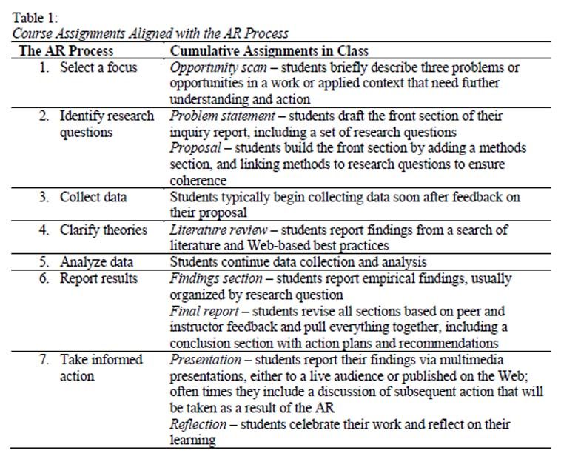TABLE: Table 1: Course Assignments Aligned with the AR Process
Table 1: Course Assignments Aligned with the AR Process The AR Process Cumulative Assignments in Class 1. Select a focus Opportunity scan - students briefly describe three problems or opportunities in a work or applied context that need further understanding and action 2. Identify research questions Problem statement - students draft the front section of their inquiry report, including a set of research questions Proposal - students build the front section by adding a methods section, and linking methods to research questions to ensure coherence 3. Collect data Students typically begin collecting data soon after feedback on their proposal 4. Clarify theories Literature review - students report findings from a search of literature and Web-based best practices 5. Analyze data Students continue data collection and analysis 6. Report results Findings section - students report empirical findings, usually organized by research question Final report - students revise all sections based on peer and instructor feedback and pull everything together, including a conclusion section with action plans and recommendations 7. Take informed action Presentation - students report their findings via multimedia presentations, either to a live audience or published on the Web; often times they include a discussion of subsequent action that will be taken as a result of the AR Reflection - students celebrate their work and reflect on their learning
As a complex undertaking, AR needs some kind of support for novices. We break the work into sequential steps that build incrementally throughout the semester toward a final completed report (see the Appendix for an example of a weekly overview). Extensive peer and instructor feedback is provided at each step, leading to corrections and adjustments along the way. The final product is a high-quality, comprehensive AR report. Learners understood the schedule was adaptable, but they also expressed appreciation in knowing what was expected of them each week. Periodic chapters from a required text (Stringer, 2007) provided further support, along with a series of handouts, rubrics, optional synchronous meetings and five-minute pre-recorded mini-lectures.
Students submitted a list of burning questions related to problems faced in their settings, along with three potential areas of inquiry during the first week of class. From that list and with instructor guidance, they chose one topic and moved forward in articulating research questions and creating a proposal.
Proposal submission was a major milestone and quality-control marker. Students include a questions and methods table, ensuring coherence between the ends and means of inquiry. As data collection ensued, learners conducted a review of literature (and best practices found on the Web) as a first round of answering their research questions. Students then submitted a draft findings section that provided qualitative and quantitative evidence bearing on research questions. Each section was integrated into a final report. Examples of reports from our co-taught term (Spring 2011) include Adams (2011), DeNio (2011), Harding (2011), and Shipman (2011), all recent alumni who have published their studies as part of their graduation portfolios.
After teaching the course at least twice individually prior to co-teaching, we determined that it was essential to provide learners with a variety of examples throughout the course. Part of the weekly discussion routine involved reflecting on one or two examples of research, usually student-written reports. Questions for discussion always correlated with the reading and the overall weekly objectives. We made a concerted effort to identify a wide array of research reports, including formal publications, qualitative, quantitative and mixed-methods research approaches, settings to include K12, higher education, library, religious congregations, home life, corporate training and more. Through conversations around these diverse cases, learners formulated stable concepts of AR and found examples suitable for emulation in their own work. Equally important, they developed the skill of critiquing AR.
As co-instructors, we communicated a lot behind the scenes so that students perceived us as a united front. Oftentimes with two instructors, students get confused or take sides when they hear different perspectives and interpretations (Wiesenberg, 2004). In spite of occasional differences, students seemed to accommodate both of us as we each offered support and guidance. Because we were both in agreement on approach and terminal goals, it was easy to take individual initiative when needed and support decisions made by the other instructor. We brought different strengths to the course and learned by observing each other's approach.
In spite of our planning, we appreciate Holly, Arhar and Kasten's (2005) adoption of the metaphor "yellow brick road" for the title of their book on AR. The AR spirit of adventure applies to our co-teaching as well. While we referred to several AR textbooks to build the course, we acknowledge the journey that both learners and instructors commit to as they engage in the action inquiry process.

Key Elements Contributing to Course Success
Instructor and course ratings for the co-taught course ranged between 5.5 and 5.7 (out of a 6.0) on a co-taught course. This was in the 90th percentile of university taught courses and better than either of us had accomplished with our individual teaching. In this section we review particular course elements that contributed to student learning and a successful experience for instructors and students alike. Much of the literature on student success builds on Vincent Tito'swork in the 1980s regarding student retention (Tito, 1993); online students face special challenges but share a common need for care, engagement, and supports specifically addressing their needs.

Supporting Students
"It is important that distance educators determine the most effective means of introducing students to the online environment, supporting their assimilation to the virtual learning community and sustaining their motivation as online learners" (Motteram & Forrester, 2005, p. 284). Boettcher and Conrad (2010) listed 10 best practices for teaching online, the first of which is being present at the course site. "Being present at the course site is the most fundamental and important of all the practices" (Boettcher and Conrad, 2010, p. 37). They continue to explain what this means - checking in with the class daily. Learners want to know that someone is on the other line, and expect a response to a question as soon as the email is sent/question is posted.
One of the obvious advantages of having two instructors in an online course is the additional support that can be provided to students. While one instructor is grading papers, the other one can focus on engaging in the weekly discussion and planning for the next week's activities. Even with the additional support, early interventions with under-performing students can be a challenge. We provided feedback on major assignments typically within a week, and updated grades on a weekly basis. A quick scan of student performance allowed us to keep tabs on students who needed additional attention.

Community of Learners
Russo and Campbell (2004) explored students' perceptions of social presence in an asynchronous online course. They determined that frequency of interaction, responsiveness, nonverbal communication, and tone all contributed to the sense that other participants were real and involved in the course. For onine classes, non-verbal cues and tone remain important for synchronous sessions, group conferencing, and recorded feeedback. The authors encouraged learners to communicate with each other about topics outside of the focused academic conversation because it allowed for the creation of a stronger sense of community. These conversations may start at the beginning of a course when each participant is introduced. Gunawardena, Nolla, Wilson, Lopez-Islas, Ramirez-Angel and Megchun-Alpizar (2001) also support informal interaction to facilitate in the development of social presence. We offered threaded discussions for formal and informal discussions. The Virtual Café offered social conversations about classes, travel, professional engagements, etc. While not heavily used, the forum did provide a comfortable area for sharing and networking. The formal discussions occurred weekly and focused on either (a) discussion of the AR examples, or (b) sharing progress/drafts of work on personal AR project. These formal discussions proved to be both beneficial and detrimental to the online classroom. On one hand, they helped build community and encouraged co-learning. On the other hand, they required an inordinate amount of reading, which can be extremely demanding for anyone, especially a learner who is not a native speaker of the language of instruction. Replacing asynchronous discussion boards with Web 2.0 tools such as Wallwisher, VoiceThread, etc. may help to mitigate fatigue that can set in over the long term with text-based discussions.
The following table provides an overview of several key elements in the course, which we believe contributed to its success.
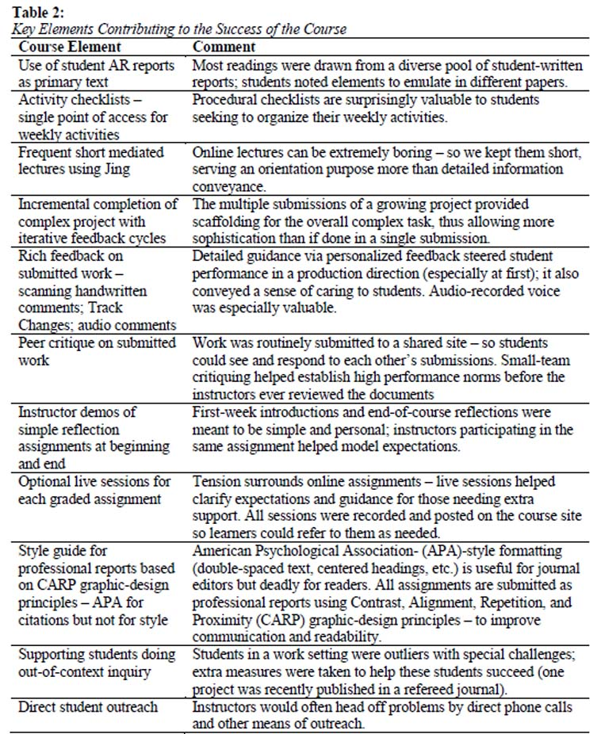TABLE: Table 2: Key Elements Contributing to the Success of the Course
Table 2: Key Elements Contributing to the Success of the Course Course Element Comment Use of student AR reports as primary text Most readings were drawn from a diverse pool of student-written reports; students noted elements to emulate in different papers. Activity checklists - single point of access for weekly activities Procedural checklists are surprisingly valuable to students seeking to organize their weekly activities. Frequent short mediated lectures using Jing Online lectures can be extremely boring - so we kept them short, serving an orientation purpose more than detailed information conveyance. Incremental completion of complex project with iterative feedback cycles The multiple submissions of a growing project provided scaffolding for the overall complex task, thus allowing more sophistication than if done in a single submission. Rich feedback on submitted work - scanning handwritten comments; Track Changes; audio comments Detailed guidance via personalized feedback steered student performance in a production direction (especially at first); it also conveyed a sense of caring to students. Audio-recorded voice was especially valuable. Peer critique on submitted work Work was routinely submitted to a shared site - so students could see and respond to each other's submissions. Small-team critiquing helped establish high performance norms before the instructors ever reviewed the documents Instructor demos of simple reflection assignments at beginning and end First-week introductions and end-of-course reflections were meant to be simple and personal; instructors participating in the same assignment helped model expectations. Optional live sessions for each graded assignment Tension surrounds online assignments - live sessions helped clarify expectations and guidance for those needing extra support. All sessions were recorded and posted on the course site so learners could refer to them as needed. Style guide for professional reports based on CARP graphic-design principles - APA for citations but not for style American Psychological Association- (APA)-style formatting (double-spaced text, centered headings, etc.) is useful for journal editors but deadly for readers. All assignments are submitted as professional reports using Contrast, Alignment, Repetition, and Proximity (CARP) graphic-design principles - to improve communication and readability. Supporting students doing out-of-context inquiry Students in a work setting were outliers with special challenges; extra measures were taken to help these students succeed (one project was recently published in a refereed journal). Direct student outreach Instructors would often head off problems by direct phone calls and other means of outreach.

Challenges
Although responding to challenge is what design is all about, the two issues below deserve special mention.

Requirements
One trend we have noticed, as we develop best practices in guiding students to complete an AR project, is that the projects themselves are increasing in scope. Over the years the average word-count had grown to around 7,000 to 8,000 words. In response, we have encouraged smaller scope and shorter reports. These conversations must happen during the proposal phase so learners do not take on more work than they can possible complete in a semester. Length of paper is not in itself a virtue. Longer papers typically provide more details, but they can try a reader's patience. Students could see this occasionally as they read assigned reports from other students. Just as we try to use students' time well in class, we encourage students to consider their readers' time as they complete their projects and write their papers.

Time Management
Time management in online courses has long been recognized as a continuing challenge for both instructors and students (Dunlap, 2005; Hara & Kling, 1999). Romero and Barbera (2011) surveyed 48 students enrolled in a graduate online course and found that students who committed time to focus on studies were more likely to be successful in class. Interestingly, students who reported studying in the mornings had the highest levels of success. Bozarth, Chapman, and LaMonica (2004) recommended offering an orientation class for learners new to the online environment, with one of the primary foci of the course being time management.
In the syllabus we explain to students that taking an online course requires them to take more responsibility for structuring their time. Learners cannot depend on live meetings to structure their time and workload, as they might in a face-to-face setting. In constrast to practices of some colleagues, we tell students to expect to spend only six to nine hours per week on the course. This includes the time to complete assigned readings, as well as any group activity or discussion work that week. We believe that professionals need to be careful guardians of their time - and learn not to put inordinate amounts of time into their studies. We do our best to set expectations that learners will work hard but that we are respectful of their time and will not waste a minute. In more recent courses, we have offered a video tour of the course with guidance for learners on how to save time navigating the course and engaging in course discussions.
Bender, Wood and Vredevoogd (2004) investigated the time required to teach in an online environment versus in a face-to-face environment. When considering the number of students enrolled in both courses, they determined that instructors tended to spend almost double the amount of time in the asynchronous online course. Their research was conducted in 2002, before many of the social media tools were available and certainly before online instructors started understanding the interaction required to successfully connect with students (LaPointe and Gunawardena, 2004).
Time management for us as instructors is equally challenging. Before the class is available to students, all lessons have been drafted, each week is planned and rubrics are available. This helps us focus on the learners and their needs throughout the semester. However, even with all that pre-work and planning, lessons need to be modified to fit the individual classroom needs, papers need feedback and discussions need to be monitored. Co-teaching helps remedy this issue.

Ongoing Improvements
Co-teaching the class was a rare occurrence - we each are so busy with work and other assignments. But the evolution of the course continues through our independent teaching of different sections. We continue to gather student feedback both in the form of unsolicited student correspondence and more formal faculty course questionnaire data. In the future, we would like to compare the feedback from one semester to the next to determine the extent to which student are satisfied with the course after changes are implemented.
Table 3 offers a wish list of contemplated changes under consideration. Some have been implemented in subsequent offerings of the course, and some remain to be done. Most of these points are noteworthy for their lack of innovativeness or theoretical sophoistication. Even so, they does not signify a poorly taught course in need of obvious revisions, nor a lack of grounding in the course's desing or development. Every instantiated course is a work in progress. The proess of empirial tryout and noticing of needs is a critical part of effective instructional design. The needs outlined above are very feasible and indeed have been largely integrated into continuing offerings of the course. That ongoing improvement cycle poses perhaps the best opportunity at excellence for online instructors (for a related discussion about "improvement science," see Bryk et al., 2013).
Two additional needs of students warrant mention, but they are not course elements exactly, and have no simple fix.
* Professional voice. Students sometimes struggle to find a professional voice suitable for technical reports. We work closely with students as they pursue a direct, honest, first-person active, yet professional and credible voice in their papers. Repeating cycles of feedback is time-intensive but the best way we know of to help with this. Referring students to university-sponsored writing labs has also helped.
* Critical stance. Students need to find that balance between relevance and rigor in their planning and thinking. Additionally, they need to develop and maintain a critical stance as they weigh evidence and assign value, with particular attention to social-justice impacts (Wilson, 2012). This is a continuing issue/goal for our instruction. Again, there is no easy answer, but a continuing priority for the course.
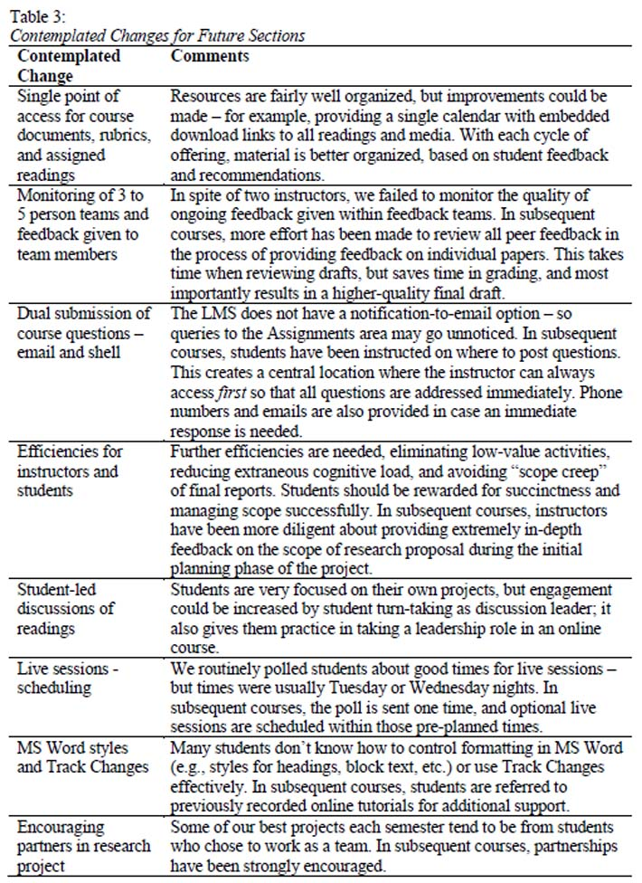TABLE: Table 3: Contemplated Changes for Future Sections
Table 3: Contemplated Changes for Future Sections Contemplated Change Comments Single point of access for course documents, rubrics, and assigned readings Resources are fairly well organized, but improvements could be made - for example, providing a single calendar with embedded download links to all readings and media. With each cycle of offering, material is better organized, based on student feedback and recommendations. Monitoring of 3 to 5 person teams and feedback given to team members In spite of two instructors, we failed to monitor the quality of ongoing feedback given within feedback teams. In subsequent courses, more effort has been made to review all peer feedback in the process of providing feedback on individual papers. This takes time when reviewing drafts, but saves time in grading, and most importantly results in a higher-quality final draft. Dual submission of course questions - email and shell The LMS does not have a notification-to-email option - so queries to the Assignments area may go unnoticed. In subsequent courses, students have been instructed on where to post questions. This creates a central location where the instructor can always access first so that all questions are addressed immediately. Phone numbers and emails are also provided in case an immediate response is needed. Efficiencies for instructors and students Further efficiencies are needed, eliminating low-value activities, reducing extraneous cognitive load, and avoiding "scope creep" of final reports. Students should be rewarded for succinctness and managing scope successfully. In subsequent courses, instructors have been more diligent about providing extremely in-depth feedback on the scope of research proposal during the initial planning phase of the project. Student-led discussions of readings Students are very focused on their own projects, but engagement could be increased by student turn-taking as discussion leader; it also gives them practice in taking a leadership role in an online course. Live sessions -scheduling We routinely polled students about good times for live sessions - but times were usually Tuesday or Wednesday nights. In subsequent courses, the poll is sent one time, and optional live sessions are scheduled within those pre-planned times. MS Word styles and Track Changes Many students don't know how to control formatting in MS Word (e.g., styles for headings, block text, etc.) or use Track Changes effectively. In subsequent courses, students are referred to previously recorded online tutorials for additional support. Encouraging partners in research project Some of our best projects each semester tend to be from students who chose to work as a team. In subsequent courses, partnerships have been strongly encouraged.

Conclusions and Implications for Practice
The most powerful benefit of the co-teaching experience may be in the opportunity to build capacity (in the course and in the instructors) and learn from one another. This happens when we are open to making mistakes, letting each other take risks, and afterward reflecting on the effectiveness on whatever approach we chose to take. Maintaining positive energy in spite of lags or challenges can be tremendously empowering in teams; our experience confirms that as well.
The narrative above made minimal mention of theories of learning and instruction, yet they did exert an influence on design decisions, simply because we are both knowledgeable about the field. Theories relevant to the course include:
* Pedagogical capital (Wilson & 1Switzer, 2012). By consistently meeting students' needs over time, instructors can build a store of trust with students, which at critical points can be drawn on to challenge and motivate students to achieve more than they normally would.
* Scaffolding of complex performance. Completing the inquiry process by breaking down the task into pieces with iterative feedback cycles may be seen in either behaviorist or Vygotskian terms (Wood, Bruner, & Ross, 1976).
* Dramatic pacing. Courses need to maintain sustainable effort throughout a course (Duffy & Jones, 1995); principles of dramatic pacing drawn from aesthetics can help (Parrish, 2005).
* Cognitive load. Students' limited cognitive load needs to focus on material intrinsically related to the task, avoiding unnecessary distractions. Time and cognitive load spent finding info, managing the interface, and learning class-related performance routines should be kept to a minimum (Clark, Nguyen, & Sweller, 2005).
* Self-efficacy and self-regulation. Students who see themselves as competent and resourceful learners, and who learn strategies for self-regulation, are more successful in academic work (Schunk, 1991).
* Caring. Instructors can show care toward students (even adults) through personal attention, respectful treatment and personalized feedback and interactions (cf. Noddings, 2003).
* Community of inquiry. Instructors can foster a positive learning experience through selecting appropriate content, supportive content-relevant discourse, and setting a healthy and trusting climate (Garrison, Anderson, & Archer, 2001).
* Activity theory. An online course is an activity system, with meaningful objects, tools, and division of labor. Improvements can be made by examining tensions and contradictions in the system (Engeström, 2000).
* Worked cases. Students can learn AR practices by reviewing a diverse set of worked examples (Chi & Bassok, 1989; Merrill, 1968).
* Authentic learning. Students benefit when assigned projects are grounded in significant real-life problems (Herrington & Herrington, 2006).
This is an eclectic mix of theoretical perspectives, with incompatibilities and contradictions among them. This violates Hannafin et al.'s (1997) rule to ground instruction in a consistent theory. Instead, as noted in the introduction, the grounding is in the practice itself. Throughout our collaboration, we were willing to mix and match ideas drawn from different theories. The fidelity we sought was not to any theory, but rather to the students, the course goals, and the situation. This is consistent with a practice-based approach to design, described above. We have tried to make our thinking and decision-making transparent, so facilitate ttransfer of ideas to the reader's own situation, depending on the need and problems addressed.
As a means of professional development, co-teaching can be expensive (paying two instructors rather than one - or asking instructors to work for less). Co-teaching is more participatory and less authority-driven than most methods of professional development. It has a benefit though of building capacity within a course, as well as within instructors, and fostering more innovation than traditional methods. More research is needed to fully determine the benefits and concerns related to co-teaching, particularly in an online setting, as an institutional means for accomplishing both ends.

References
Adams, B. (2011, April). Maintaining quality of instruction while transitioning from face-to-face to online training. Retrieved from http://brentadams.weebly.com/uploads/3/6/2/6/3626763/brentadams%5Faction%5Finquiry%5Fproject%5F041511.docx
Bender, D. M., Wood, B. J., & Vredevoogd, J. D. (2004). Teaching time: Distance education versus classroom instruction. American Journal of Distance Education, 18(2), 103-114.
Boettcher, J. V., & Conrad, R. M. (2010). The online teaching survival guide: Simple and practical pedagogical tips. San Francisco, CA: Jossey Bass.
Bourdeiu, P. (1990). The logic of practice (R. Nice, Trans.). Stanford, CA: Stanford University Press.
Bozarth, J., Chapman, D. D., & LaMonica, L. (2004). Preparing for distance learning: Designing an online student orientation course. Educational Technology and Society, 7(1), 87-106.
Bryk, A. Yeager, D.S., Hausman, H., Muhich, J., Grunow, A., LeMahieu, P., & Gomez, L. (2013). Improvement research carried out through networked communities: Accelerating learning about practices that support more productive student mindsets. Retrieved from http://www.carnegiefoundation.org/sites/default/files/improvement%5Fresearch%5FNICs%5Fbryk-yeager.pdf
Chi, M. T. H., & Bassok, M. (1989). Learning from examples via self-explanations. In L. B. Resnick (Ed.), Knowing, learning, and instruction: Essays in honor of Robert Glaser (pp. 251-282). Hillsdale NJ: Erlbaum.
Clark, R. C., Nguyen, F., & Sweller, J. (2005). Efficiency in learning. San Francisco: CA: Pfeiffer.
DeNio, D. (2011, May). Lyme disease: A hidden epidemic. Investigating the impact of social media on patient education. Retrieved from http://dawndenioportfolio.weebly.com/uploads/2/1/8/3/2183383/lymedisease%5Factionresearchproject.doc
Duffy, D. K., & Jones, J. W. (1995). Teaching within the rhythms of the semester. San Francisco: Jossey-Bass.
Dunlap, J. C. (2005). Workload reduction in online courses: Getting some shuteye. Performance Improvement, 44(5), 18-25.
Engeström, Y. (2000). Activity theory as a framework for analyzing and redesigning work. Ergonomics, 43(7), 960-974.
Friesen, N. (2008). Chronicles of change: The narrative turn and e-learning research. E-Learning and Digital Media, 5(3).
Garrison, D. R., Anderson, T., & Archer, W. (2001). Critical thinking, cognitive presence, and computer conferencing in distance education. The American Journal of Distance Education, 15(1), 1-24.
Gunawardena, C. N., Nolla, A. C., Wilson, P. L., Lopez-Islas, J. R., Ramirez-Angel, N., & Megchun-Alpizar, R. M. (2001). A cross-cultural study of group process and development in online conferences. Distance Education, 22(1), 85-121.
Hannafin, M. J., Hannafin, K., Land, S. M. & Oliver, K. (1997). Grounded practice and the design of constructivist learning environments. Educational Technology Research and Development, 45(3), 101-117.
Harding, D. (2011, May). Is there a benefit to using flipchart software for individual student interaction? Retrieved from https://docs.google.com/file/d/0B%5Fl2PyVfdCVXZDEwMDM5MmUtNDRjOC00ZjEzLWE 5YmQtZGI1ZDgwMGFmOGJh/edit
Hara, N. & Kling, R. (1999). Students' frustration with a web based distance education course. First Monday, 4(12). Retrieved from http://firstmonday.org/ojs/index.php/fm/article/view/710/620
Herrington, A., & Herrington, J. (Eds.). (2006). Authentic learning environments in higher education. Hershey, PA: Information Science Publishing.
Holly, M. L., Arhar, J., & Kasten, W. C. (2005). Action research for teachers: Traveling the yellow brick road (2nd ed.). Upper Saddle River, NJ: Pearson Education, Inc.
Kemmis, S. (2011). Recognising and respecting diversity in understandings of practice. In C. Kanes (ed.), Elaborating professionalism: Studies in practice and theory, 5, 139-165.
LaPointe, D. K., & Gunawardena, C. N. (2004). Developing, testing and refining of a model to understand the relationship between peer interaction and learning outcomes in computer-mediated conferencing. Distance Education, 25(1), 83-106.
Merrill, M. D. (1968). Teaching concepts: An instructional design guide. Englewood Cliffs, NJ: Educational Technology Publications.
Motteram, G., & Forrester, G. (2005). Becoming and online distance learner: What can be learned from students' experiences of induction to distance programs? Distance Education, 26(3), 281-298.
Noddings, N. (2003). Happiness and education. Cambridge: Cambridge University Press.
Parrish, P. (2005). Embracing the aesthetics of instructional design. Educational Technology, 45(2), 16-25.
Postill, J. (2008, October 30). What is practice theory? Retrieved from http://johnpostill.com/2008/10/30/what-is-practice-theory
Romero, M., & Barbera, E. (2011). Quality of e-learners' time and learning performance beyond quantitative time-on-task. The International Review of Research in Open and Distance Learning, 12(5), Retrieved from http://www.irrodl.org/index.php/irrodl/article/view/999/1870
Russo, T. C., & Campbell, S. W. (2004). Perceptions of mediated presence in an asynchronous online course: Interplay of communication behaviors and medium. Distance Education, 25(2), 215-232.
Sagor, R. (2000). Guiding school improvement with action research. Alexandria, VA: Association for Supervision and Curriculum Development.
Schunk, D. (1991). Self-efficacy and academic motivation. Educational Psychologist, 26 (3/4), 207-231.
Sennett, R. (2008). The craftsman. New Haven: Yale University Press.
Shipman, J. (2011, April). Exploring impacts of interactive whiteboard use in elementary school. Retrieved from http://www.scribd.com/doc/54090044/Interactive-Whiteboard-Research-Paper
Stringer, E. T. (2007). Action research (3rd ed.). Los Angeles, CA: SAGE Publications.
Tinto, V. (1993). Leaving college: Rethinking the causes and cures of student attrition (2nd ed.). Chicago: The University of Chicago Press.
Wiesenberg, F. (2011). Designing and co-facilitating online graduate classes: Reflections and recommendations. Canadian Journal of University Continuing Education, 30(2), p. 39-57. Retrieved from http://www.ccde.usask.ca/cjuce/articles/v30pdf/3022.pdf
Wilson, B. G. (2012). Developing a critical stance as an e-learning specialist: A primer for new professionals. In S. B. Fee & B. Belland (Eds.), The role of criticism in understanding problem solving: Honoring the work of John C. Belland (pp. 57-68). New York: Springer.
Wilson, B. G. (2013). A practice-centered approach to instructional design. In M. M. Spector, B. B. Lockee, S. E. Smaldino, & M. Herring (Eds.), Learning, problem solving, and mind tools: Essays in honor of David H. Jonassen. New York: Routledge.
Wilson, B. G. (2014, April). Knowledge creation in design-based research projects: Complementary efforts of academics and practitioners. Presented at the meeting of the American Educational Research Association, Philadelphia, PA.
Wilson, B. G., & Switzer, S. H. (2012, June). Pedagogical capital: Strengthening and leveraging trusting relationships in online courses. Paper presented at EdMedia, Denver, CO.
Wood, D. J., Bruner, J. S., & Ross, G. (1976). The role of tutoring in problem solving. Journal of Child Psychiatry and Psychology, 17(2), 89-100.

Appendix A: Sample of an Activity Checklist and Discussion (from Week 4)
This week you submit your Problem Statement, consisting of the front section of your research project, including introduction, purpose statement, research questions, and initial thoughts about method. A number of readings relating to research methods are planned, beginning this week and continuing throughout the course.
1. Download revised schedule with readings. Readings with links are available on the Web; those unlinked should be available in Doc Sharing. Feel free to look ahead at upcoming readings if you are anxious to proceed with your inquiry project.
- 2. Watch the mini-lecture, describing how his underlying beliefs have evolved over the years.
- 3. Read Gary Thomas's chapter, The Design Frame, available in three parts in Doc Sharing. This is a long and sometimes tangential chapter; feel free to skim parts that seem less central to our purposes. Our goal in assigning this chapter is to convey the various forms your inquiry can take - and how each form of inquiry makes different assumptions about the world.
- 4. In addition to the Thomas chapter, download and read these two short items for discussion: Darcie Gudger's reflection Melissa Vance's comparison of intellectual development models.
- 5. Prepare and submit your Problem Statement within the weekly area, using the scoring rubric to guide your work. Submit to the common area, then look for your Group's area (A, B, C, or D) to provide feedback to your group members. The Problem Statement is due Sunday, but you may begin reading and critiquing group members' submissions as soon as you see them submitted.
We have scheduled a live session for discussion about this week's assignment (see the announcement area for more detail). Here is the web location: https://connect.cuonline.edu/assignment-support/.
[Direction for weekly discussion]
Our discussion reflects on how our experience shapes our beliefs - and how our beliefs shape our practices.
* Download and read Darcie Gudger's reflection (below).
* Think about your own intellectual and career development over the years.
* Then reflect on your inquiry project and how your beliefs and assumptions about learning and practice are shaping it (and perhaps shaped by it).
Theorists of intellectual development describe how people evolve in their views of knowledge -from very black-and-white, authoritarian views to a more situated view, contingent on timing, place, and circumstance. See the attached handout below, from Melissa Vance's dissertation.
With all these thoughts in mind, let's consider:
* How have your experiences shaped your beliefs - and in turn, your beliefs shaped your professional practice (including your inquiry project)?
* How would you describe your stage or progression of intellectual development? How have you progressed since beginning work in education and training? How does this affect your choices in your career?
This work is licensed under a Creative Commons Attribution 3.0 License.
~~~~~~~~
By Brent G. Wilson, University of Colorado Denver and Professor of Information and Learning Technologies, University of Colorado Denver and Jennifer Linder VanBerschot, University of Colorado Denver and Instructional designer/project manager for Colorado State University-Global Campus and an adjunct professor for University of Colorado Denver
Brent G Wilson. Email: brent.wilson@ucdenver.edu. Brent is Professor of Information and Learning Technologies at the University of Colorado Denver. His research addresses these questions: What is good instruction and how can we support its creation? How can we help instructors and learners make appropriate use of tools and resources? Jennifer Linder VanBerschot. Email: jennifer.vanberschot@ucdenver.edu. Jenna is an instructional designer/project manager for Colorado State University-Global Campus and an adjunct professor for University of Colorado Denver. She is interested in the use of technology and social software to promote interaction across cultures and between international learning communities.

Source: Canadian Journal of Learning and Technology, 20140101, Vol. 40 Issue 2, 18p
Item: EJ1030427

