PAPER OUTLINE

- Table of Contents/Executive Summary
I. Introduction and History of Silo
-
II. Product Environment
-
- Recent sales, profits, and history
- PAPER OUTLINE

- Table of Contents/Executive Summary
I. Introduction and History of Silo
-
II. Product Environment
-
- Recent sales, profits, and history
-
- Industry overview and driving trends
-
- Key Competitors by industry type
-
III. Marketing Plan
-
- SWOT Analysis
-
- Target markets
-
- Market Segmentation Base(s)
-
- Marketing Mix
-
  - Product
-
  - Pricing
-
  - Place/Distribution
-
  - Promotions
-
IV. Firm Recommendations
-
- Strategic Development
-
- Modifications to the Marketing Mix
-
- Prototype/Sample Explanation
-
V. Appendix
-The appendix includes a compiled list of all figures, graphs, and statistical information used in this study for marketing and strategic business development purposes
VI. References
-Citation and sourcing information used in reference to develop business strategies and firm recommendations including firm information, market analysis, and consumer/product trends

- Introduction and Brief History of Firm

- Product Environment
  - Recent Sales/Profit History
  - Industry Overview and Trends
  - Key Competitors

- Marketing Plan
  - SWOT analysis
  - Target Markets
  - Segmentation Base(s) - dependent on approach (undifferentiated, concentrated, multi)
  - Marketing Mix
    - Product
    - Pricing
    - Distribution
    - Promotion
      - Personal selling, sales promotion, public relations

- Recommendations (1 idea from ch. 2 + maintaining marketing mix)
  - market/product development, market penetration, or diversification
  - 3 recommendations as to how marketing mix will be modified based on this
  - Create 2 tangible prototypes/samples of how this could be done

- Appendix

History

https://www.kickstarter.com/projects/simplifyfreshness/your-remarkably-simple-one-touch-connected-vacuum

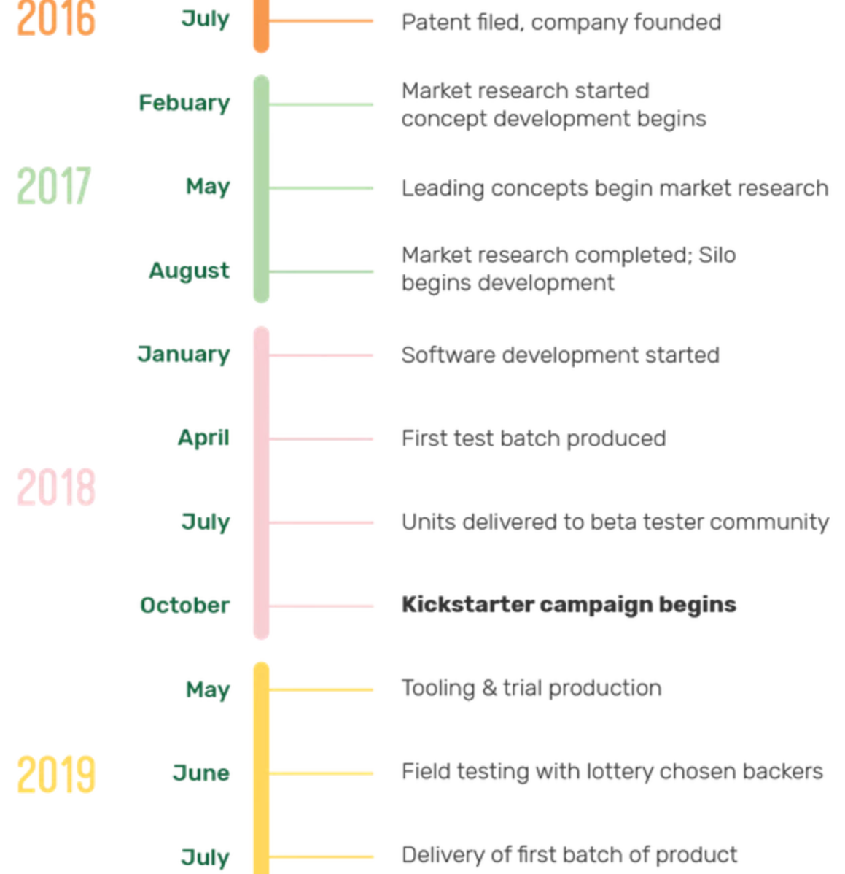

BOSTON (Demographics, market shares, and prospective influencers):

***Tupperware was created in Massachusetts (not Boston, though)

http://worldpopulationreview.com/us-cities/boston-population/

Boston is the capital and largest city in Massachusetts in the United States. It's also the largest city in New England and represents the 23rd largest city in the US.

14,171.4 people/mi^2 (685,094 total population)

*Somerville (north Boston area) = highest pop density of 18,431.6 ppl/mi^2
According to the 2010 Census, the racial/ethnic makeup of Boston was as follows:
- White: 53.9% (non-Hispanic: 47%)
- Black or African American: 24.4%
- Native American: 0.4%
- Asian: 8.9%
- Native Hawaiian and Pacific Islander: 0.0%
- Two or more: 3.9%
- Hispanic or Latino of any race: 17.5%
*Females = 51.9% of population
Average residential home cost (2017) = $455,100
Average monthly rent (2017) = $1,445
Average Households = 2.36 ppl/home
Total Retail sales per capita (2012) = $12,389
Poverty rate = 20.5%
Median household income (2017) = $62,021
Total amount of business firms (Boston) = 59,268

Prospective Influencers/Promotion & Place(distribution):
-NE Patriots, Boston Bruins, Red Sox (sports teams/organizations)
-Boston Startup Guide (online site)
-Local kitchen/houseware stores
-Public Advertisement (due to high public transit/walking rate)

Boston Economic Report (2017):
http://www.bostonplans.org/getattachment/d835ad4c-e8a9-4f17-b342-468f02301c58
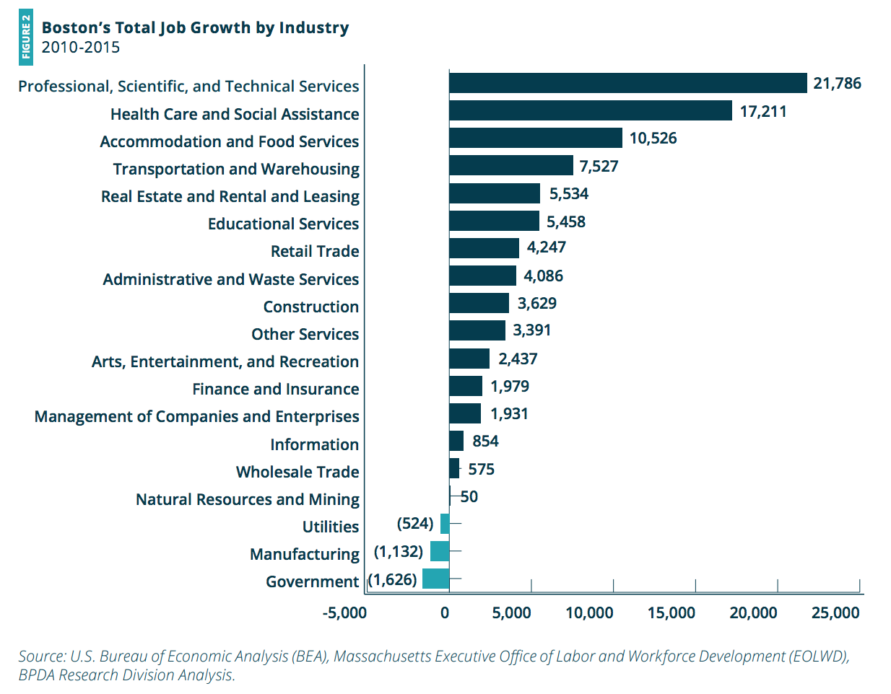
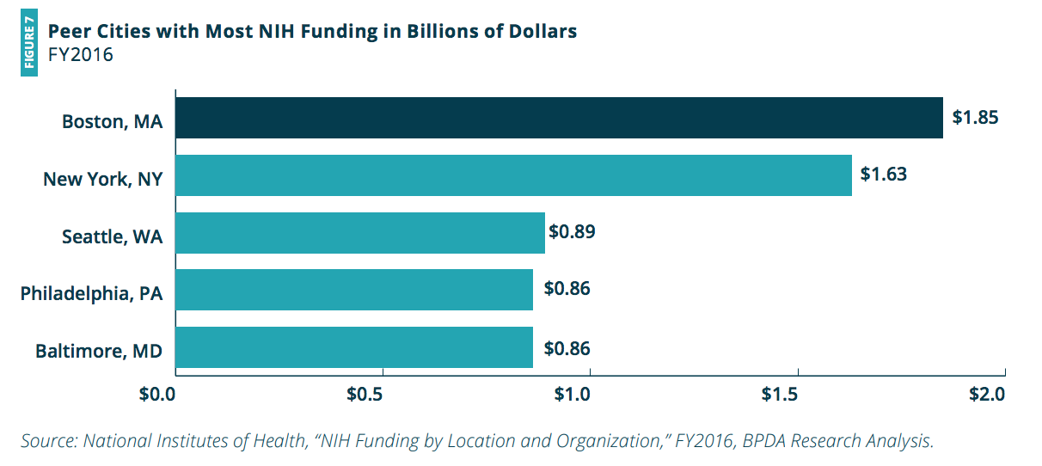
The largest industry in Boston is health care and social assistance with nearly 140,000 jobs, 18.5 percent of total employment
The average weekly payroll wage in Boston in 2015 was $1,770. The highest wages were in finance and insurance ($4,248/week) and the lowest wages were in accommodation and food services ($578/week).
(2010-2015) Boston grew 8.4% over this time period, an impressive rate for a historic city that is geographically constrained. Boston grew faster than other cities in the northeastern United States
Residents of Greater Boston rank fourth among U.S. metropolitan areas in the percentage of the population with at least a Bachelor’s degree at 43.4 percent.
Among the 25 comparable cities, the American Community Survey shows that Boston has the largest percentage of people who walk to work, 17%
Among city residents age 16 and older, Boston has the fourth highest share of people who use public transportation to get to work, among a list of 25 comparable cities
Boston has the highest share of young adults among peer cities, at 34.5 percent
Among our set of 25 comparable cities, Boston’s median rent is the fourth highest, at $1,423
*Nationally, constraints to long-term growth include the federal deficit, labor supply, and wage growth among low wage occupations
https://www.bls.gov/regions/new-england/news-release/consumerexpenditures_boston.htm
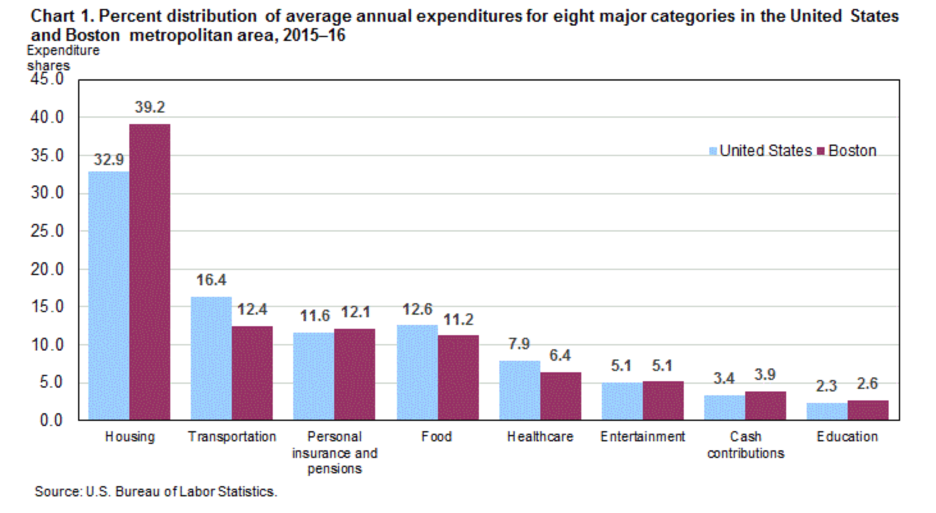
Consumer units in the Boston-Cambridge-Newton metropolitan area spent an average of $68,119 per year in 2015-16, the U.S. Bureau of Labor Statistics reported today. Regional Commissioner Deborah A. Brown, noted that this figure was over 20 percent above the $56,648 average expenditure level for a typical household in the United States
Food: The portion of a Boston household’s budget spent on food, 11.2 percent, was significantly below the 12.6-percent U.S. average. Boston-area households spent $4,702, or 61.6 percent, of their food dollars on food at home and $2,934 (38.4 percent) on food away from home. In comparison, the average U.S. household spent 56.7 percent of its food budget on food at home and 43.3 percent on food away from home
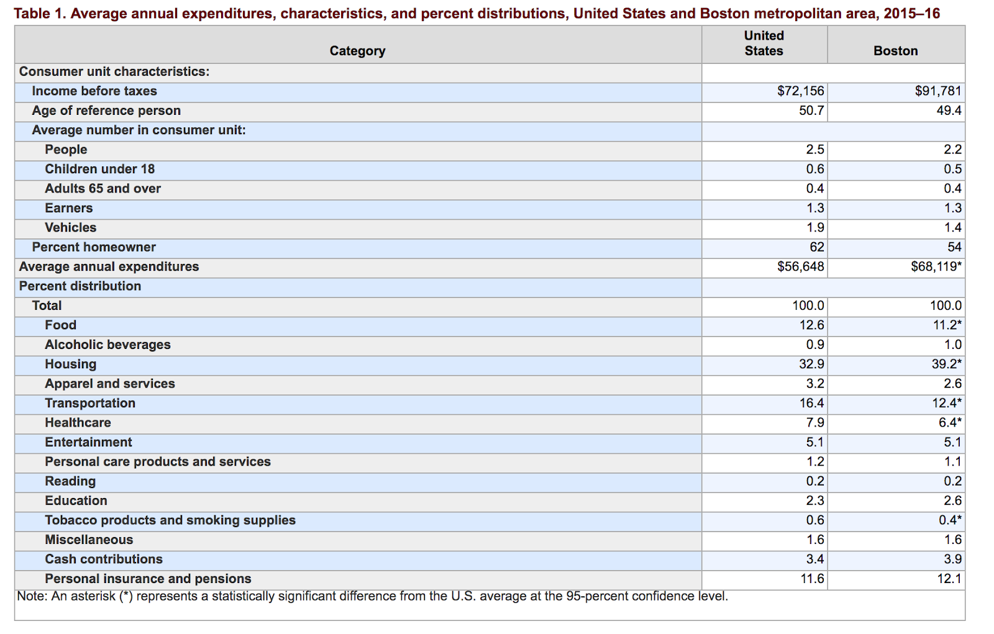

https://www.bostonfed.org/publications/research-department-working-paper/2016/the-effect-of-demographics-on-payment-behavior-panel-data-with-sample-selection.aspx
We find that age, education, income, and race are significant in explaining payment behavior even after controlling for all the other attributes of consumers and for payment-instrument characteristics
Most notably, the lowest-income, lowest-education, and minority consumers adopt a very limited set of payment instruments compared with their counterparts even when education and age are controlled for
Women use significantly less cash than men, but use more debit cards, checks, and online banking bill pay, even when we control for the degree of bill-paying responsibility they have for their households
(those who earn less than 25K per year) On average, check adoption was 83 percent lower, debit card adoption was 41 percent lower, and credit card adoption was 68 percent lower than the omitted category
*Boston Startup Guide

Food Storage Market Analysis:
https://www.marketwatch.com/press-release/food-container-market-worldwide-overview-by-industry-size-share-future-trends-growth-factors-and-leading-players-to-2023-2018-11-16
- Bemis Company Inc. (US)
- Berry Plastics Corporation (US)
- Crown (US)
- Graham Packaging Company (US)
- Graphic Packaging International LLC (US)
- Ball Corporation (US)
- Constar International UK Ltd. (UK)
- Anchor Glass Container Corporation (US)
- Plastipak Holdings Inc. (US)
- PRINTPACK (US)
“The global food container market has been segmented based on type, material, application, product, and region”
“Rigid containers are utilized extensively in the food & beverage industry for facilitating convenience in handling food products and preventing damages. Rigid packaging products have high stiffness, high impact strength, and high barrier properties”
“Plastic accounts for the highest share with respect to consumption in the manufacturing of food containers followed by paper & paper boards. Glass storage containers generally have a plastic lid that helps in keeping the container airtight. These containers are available in clear, frosted, and colored varieties. The demand for glass containers is more because of its ability to keep the food fresh for a longer period as compared to other container types”
“basis of the product, the market has been segmented into bags, pouches, containers, and others. Bags and pouches will remain the largest category due to benefits of lightweight, portability, and convenience. Pouches are expected to make further inroads into rigid packaging applications due to cost and performance advantages”
“The dairy and frozen meat segment accounted for the highest market share in 2017 and is expected to continue to dominate the market. Frozen food was the leading segment and is expected to show strong growth”
“North America accounts for the largest share of the market. The reasons contributing to the growth of the food container market in this region include growing use of packaged goods, reduce waste, increasing adoption of small-sized food containers in homes, and the demand for fresh foods. Asia-Pacific is the fastest growing region in the food container market, followed by Europe”

https://www.businesswire.com/news/home/20170308005035/en/Food-Storage-Container-Market---Top-Trends
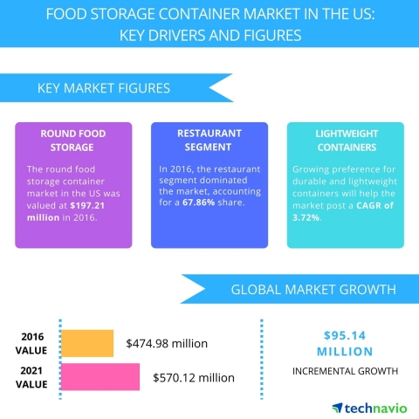
Key vendors in this market are -
- Amcor
- Bemis
- Berry Plastics
- RPC
- Silgan Holdings
- Cambro Manufacturing
- Carlisle
- Newell Brands
- Vollrath
Berry Plastics, Bemis, Silgan Holdings, Amcor, Ball Corporation, Ardagh Group, Sealed Air Corporation, and Graham Packaging

https://www.marketresearchfuture.com/reports/food-container-market-1799

The popularity of quality, leakage proof, airtight, and aesthetically appealing products is leading to the demand for a variety of food containers. Additionally, government regulations towards greenhouse emissions in the food and beverage industry are expected to drive the demand for sustainable packaging which can contribute to the growth of the market
Moreover, growth in the demand for perishable products such as meat and dairy products worldwide is creating new opportunities for the growth of the market for food containers
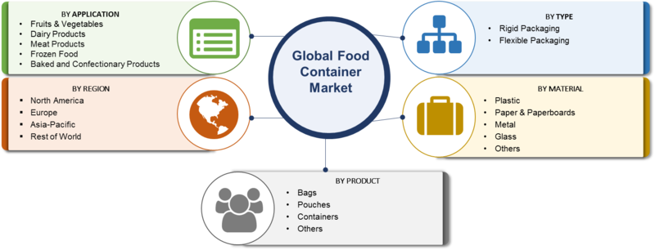

Market Segments by Application:
Grain Mill Products
Fruits & Vegetables
Bakery Products
Meat Processed Products
Others
Read more: http://www.digitaljournal.com/pr/4039045#ixzz5kQAbe5Eb

https://www.persistencemarketresearch.com/market-research/household-food-storage-container-market.asp
The consumer demands for quality products, which are leakage proof, airtight, micro able and aesthetically appealing. It has become highly important for food container manufacturers to keep pace with these changing consumer preferences. The plastic container industry is growing at the rate of 12-15% with the increasing storage requirement of people and preference for more aesthetically appealing containers rather than stainless steel containers due to modular kitchen concept coming in place
Moreover the rising number of women in workforce, rise in per capita income and vast surge in double income families help drive the demand for household food storage container in global market
*Some of the key players in this market are Alcan Packaging Food Americas, Tupperware, Caraustar Industries Incorporated, Anchor Glass Container Corporation, Constar International Incorporated, Plastipak Holdings Incorporated, Evergreen Packaging, Ring Companies, PWP Industries, Rio Tinto Group, Sonoco Products Company, Printpack Incorporated

https://www.freedoniagroup.com/industry-study/world-food-containers-3124.htm
China is expected to become the largest global consumer of food packaging, surpassing the US based on increasing urbanization, rising personal incomes, and an escalating interest in packaged foods. Robust food container demand growth is also expected in other emerging markets such as Thailand, Brazil, Argentina, and Turkey. For developed countries, especially those in North America and Western Europe, market maturity will restrict growth, but technological innovation and higher end formats will boost particular material and package types

http://news.bostonnewsdesk.com/story/178522/plastic-product-market-news-business-growth-top-key-players-update-business-statistics-and-research-methodology-till-2022-radiant-insights-inc.html
https://www.westernmassedc.com/industries/plastics/
http://www.ktvn.com/story/39972212/long-term-food-storage-market-2019-global-industry-key-players-size-trends-opportunities-growth-analysis-to-2025
- https://www.freedoniagroup.com/Food-Containers-Rigid-Flexible.html
- https://www.grandviewresearch.com/industry-analysis/food-container-market
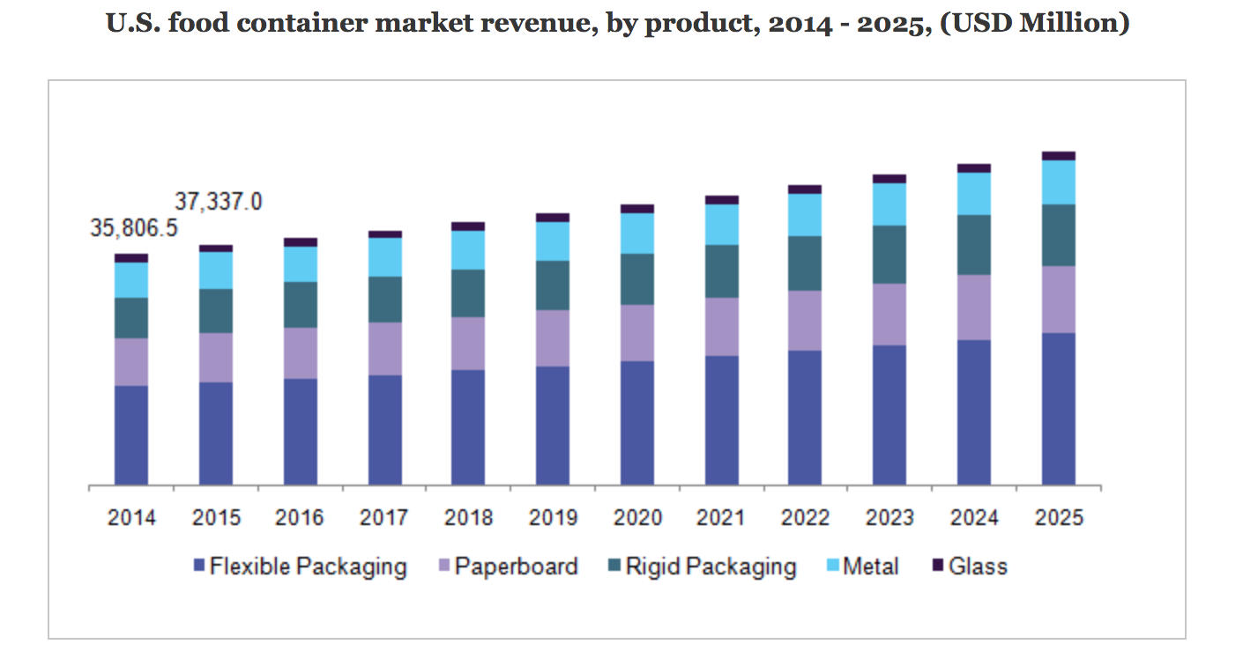
https://www.refrigeratedfrozenfood.com/articles/95199-demand-for-reusable-plastic-containers-to-grow-76-annually
https://www.marketwatch.com/press-release/food-container-market-worldwide-overview-by-industry-size-share-future-trends-growth-factors-and-leading-players-to-2023-2018-11-16

https://www.prnewswire.com/news-releases/global-food-storage-containers-market-2017-2021-300393935.html

SWOT Analysis (Silo):
- Target market, business strategies and development/innovation matrix, market segmentation, sustainability, and environment of product

STRENGTHS

-Innovative
-Smart and customizable
-Integrated into everyday activities
-Potential to provide complementary/alternative services and products
-Increases shelf life of food
-Prevention of cross-contamination of food
-Increased life compared relative to other storage containers
-dishwasher safe
-multiple product markets = frozen and raw/fresh foods, food storage, restaurant, marijuana dispensary, gardening, fitness/meal prepping, appliances
-multiple demographic/lifestyle markets = families, households, babysitters/nannies, male, female, athletes, gardeners, weight-watchers/conscious eaters, young adults or elderly, businesses

WEAKNESSES

-changes in consumer preferences
-communication of product utility, ease of use without trial
-takes up counter space
-not currently integrated into an app
-defining the product category/market
-retail/commercial, partnership, or exclusive distribution?
-price
-price for additional products
-partner with major fridge appliance company for innovative tech?
-Proof of differentiation from competitors
-No alternative bags, pouches, or more flexible products
-

OPPORTUNITIES - define target market, describe business strategies,

-worldwide demand for perishable products/fresh foods (dairy, meats, etc)
-dairy and frozen meat holds largest market share
-Increased disposable income (global- Eur/Asia)
-Asia = fastest growing
-Increased interest in diet/nutrition

-Increasing demand for ergonomically designed containers
-COLORS
-Chargeable option rather than plug-in
-partner with major fridge appliance company for innovative tech?
-distribution = retail, ecommerce, exclusivity?
-partner with local grocery stores/markets for suggested promotions, sales, recipes based on current food being stored
-multiple product markets = frozen and raw/fresh foods, food storage, restaurant, marijuana dispensary, gardening, fitness/meal prepping, appliances
-multiple demographic/lifestyle markets = families, households, babysitters/nannies, male, female, athletes, gardeners, weight-watchers/conscious eaters, young adults or elderly, businesses
-complementary/alternative products = bags/pouches, app development, integrate local grocery store promotions/rewards/coupons, recipe suggestions, *smart-garden urban gardening kit
-Amazon + whole foods + silo = no need to go to the store at all!
-lifetime warranty on device (still have to pay for containers)?
-antimicrobial storage solutions?

THREATS/CHALLENGES

-PRICE
-Environmental consciousness
-Increased demand for glass
-cost of replacement/additional containers or lids
-Additional “smart” appliances with built in features
-Freezer bags, pouches, etc.
-tupperware
-plastic vs glass or other material
-global market sustainability = decrease in use of plastics
-Storage solutions = containers are bulky and take up a lot of room

Competition:
-Tupperware

OUR (NEW) MISSION:

MARKETING MIX IDEAS:
PRODUCT
- Cordless design = rechargeable battery for easy storage
- Integrated app
  - Tells you what you have
  - Tells you possible recipes
  - Gives you local grocery store promotions/discounts on food you are low on or things that you could get to add to recipe
- Monitor dietary/caloric intake
- Marijuana storage, weight, and freshness (dispensaries, manufacturers, and distributors)
- Create smart-water filter (combat tap water contamination & monitor water intake)
  - Appliance partnership?? = built in features or multi-feature appliances
- Amazon/whole foods partnership = software, promotions, delivery (convenience)

PRICE

PROMOTION
- Influencers
- Public Advertisement (physical/digital throughout metro)
- Partnerships with local household ware/ kitchen ware stores & amazon (built in alexa)
- Partner with dispensaries and marijuana distribution/manufacturers

PLACE (DISTRIBUTION)

Other sources for information:
https://www.scribd.com/doc/204007214/Marketing-Report-Tupperware

http://bi.galegroup.com.esearch.ut.edu/global/?u=tamp73569

http://bi.galegroup.com.esearch.ut.edu/essentials/?u=tamp73569

http://web.a.ebscohost.com.esearch.ut.edu/ehost/search/advanced?vid=0&sid=d5ea9fb8-88fe-4e29-8c13-9d1118172cf2%40sdc-v-sessmgr03

https://www-cambridge-org.esearch.ut.edu/core

https://search-proquest-com.esearch.ut.edu/ebookcentral/advanced/fromDatabasesLayer?accountid=14762

http://www.portal.euromonitor.com.esearch.ut.edu/portal/magazine/homemain

https://clients1-ibisworld-com.esearch.ut.edu/processlogin.aspx?u=4vaVbgx01DvQ2TG1kEeXAg%3d%3d&p=4vaVbgx01DvQ2TG1kEeXAg%3d%3d&cid=1

https://search-proquest-com.esearch.ut.edu/hnpnewyorktimes/advanced/news/fromDatabasesLayer?accountid=14762

http://web.b.ebscohost.com.esearch.ut.edu/ehost/search/advanced?vid=0&sid=6e02f4b4-40ab-4fff-b546-fe0f83b35f31%40pdc-v-sessmgr05

http://go.galegroup.com.esearch.ut.edu/ps/headerQuickSearch.do?quickSearchTerm=plastic+kitchenware&inputFieldNames%5B0%5D=OQE&searchType=BasicSearchForm&userGroupName=tamp73569&nwf=y&prodId=SBRC&stw.option=&ebook=&quicksearchIndex=OQE&spellCheck=true&hasCoProduct=false

https://www-statista-com.esearch.ut.edu

- Industry overview and driving trends
-
- Key Competitors by industry type
-
III. Marketing Plan
-
- SWOT Analysis
-
- Target markets
-
- Market Segmentation Base(s)
-
- Marketing Mix
-
  - Product
-
  - Pricing
-
  - Place/Distribution
-
  - Promotions
-
IV. Firm Recommendations
-
- Strategic Development
-
- Modifications to the Marketing Mix
-
- Prototype/Sample Explanation
-
V. Appendix
-The appendix includes a compiled list of all figures, graphs, and statistical information used in this study for marketing and strategic business development purposes
VI. References
-Citation and sourcing information used in reference to develop business strategies and firm recommendations including firm information, market analysis, and consumer/product trends

- Introduction and Brief History of Firm

- Product Environment
  - Recent Sales/Profit History
  - Industry Overview and Trends
  - Key Competitors

- Marketing Plan
  - SWOT analysis
  - Target Markets
  - Segmentation Base(s) - dependent on approach (undifferentiated, concentrated, multi)
  - Marketing Mix
    - Product
    - Pricing
    - Distribution
    - Promotion
      - Personal selling, sales promotion, public relations

- Recommendations (1 idea from ch. 2 + maintaining marketing mix)
  - market/product development, market penetration, or diversification
  - 3 recommendations as to how marketing mix will be modified based on this
  - Create 2 tangible prototypes/samples of how this could be done

- Appendix

History

https://www.kickstarter.com/projects/simplifyfreshness/your-remarkably-simple-one-touch-connected-vacuum

BOSTON (Demographics, market shares, and prospective influencers):

***Tupperware was created in Massachusetts (not Boston, though)

http://worldpopulationreview.com/us-cities/boston-population/

Boston is the capital and largest city in Massachusetts in the United States. It's also the largest city in New England and represents the 23rd largest city in the US.

14,171.4 people/mi^2 (685,094 total population)

*Somerville (north Boston area) = highest pop density of 18,431.6 ppl/mi^2
According to the 2010 Census, the racial/ethnic makeup of Boston was as follows:
- White: 53.9% (non-Hispanic: 47%)
- Black or African American: 24.4%
- Native American: 0.4%
- Asian: 8.9%
- Native Hawaiian and Pacific Islander: 0.0%
- Two or more: 3.9%
- Hispanic or Latino of any race: 17.5%
*Females = 51.9% of population
Average residential home cost (2017) = $455,100
Average monthly rent (2017) = $1,445
Average Households = 2.36 ppl/home
Total Retail sales per capita (2012) = $12,389
Poverty rate = 20.5%
Median household income (2017) = $62,021
Total amount of business firms (Boston) = 59,268

Prospective Influencers/Promotion & Place(distribution):
-NE Patriots, Boston Bruins, Red Sox (sports teams/organizations)
-Boston Startup Guide (online site)
-Local kitchen/houseware stores
-Public Advertisement (due to high public transit/walking rate)

Boston Economic Report (2017):
http://www.bostonplans.org/getattachment/d835ad4c-e8a9-4f17-b342-468f02301c58
The largest industry in Boston is health care and social assistance with nearly 140,000 jobs, 18.5 percent of total employment
The average weekly payroll wage in Boston in 2015 was $1,770. The highest wages were in finance and insurance ($4,248/week) and the lowest wages were in accommodation and food services ($578/week).
(2010-2015) Boston grew 8.4% over this time period, an impressive rate for a historic city that is geographically constrained. Boston grew faster than other cities in the northeastern United States
Residents of Greater Boston rank fourth among U.S. metropolitan areas in the percentage of the population with at least a Bachelor’s degree at 43.4 percent.
Among the 25 comparable cities, the American Community Survey shows that Boston has the largest percentage of people who walk to work, 17%
Among city residents age 16 and older, Boston has the fourth highest share of people who use public transportation to get to work, among a list of 25 comparable cities
Boston has the highest share of young adults among peer cities, at 34.5 percent
Among our set of 25 comparable cities, Boston’s median rent is the fourth highest, at $1,423
*Nationally, constraints to long-term growth include the federal deficit, labor supply, and wage growth among low wage occupations
https://www.bls.gov/regions/new-england/news-release/consumerexpenditures_boston.htm
Consumer units in the Boston-Cambridge-Newton metropolitan area spent an average of $68,119 per year in 2015-16, the U.S. Bureau of Labor Statistics reported today. Regional Commissioner Deborah A. Brown, noted that this figure was over 20 percent above the $56,648 average expenditure level for a typical household in the United States
Food: The portion of a Boston household’s budget spent on food, 11.2 percent, was significantly below the 12.6-percent U.S. average. Boston-area households spent $4,702, or 61.6 percent, of their food dollars on food at home and $2,934 (38.4 percent) on food away from home. In comparison, the average U.S. household spent 56.7 percent of its food budget on food at home and 43.3 percent on food away from home

https://www.bostonfed.org/publications/research-department-working-paper/2016/the-effect-of-demographics-on-payment-behavior-panel-data-with-sample-selection.aspx
We find that age, education, income, and race are significant in explaining payment behavior even after controlling for all the other attributes of consumers and for payment-instrument characteristics
Most notably, the lowest-income, lowest-education, and minority consumers adopt a very limited set of payment instruments compared with their counterparts even when education and age are controlled for
Women use significantly less cash than men, but use more debit cards, checks, and online banking bill pay, even when we control for the degree of bill-paying responsibility they have for their households
(those who earn less than 25K per year) On average, check adoption was 83 percent lower, debit card adoption was 41 percent lower, and credit card adoption was 68 percent lower than the omitted category
*Boston Startup Guide

Food Storage Market Analysis:
https://www.marketwatch.com/press-release/food-container-market-worldwide-overview-by-industry-size-share-future-trends-growth-factors-and-leading-players-to-2023-2018-11-16
- Bemis Company Inc. (US)
- Berry Plastics Corporation (US)
- Crown (US)
- Graham Packaging Company (US)
- Graphic Packaging International LLC (US)
- Ball Corporation (US)
- Constar International UK Ltd. (UK)
- Anchor Glass Container Corporation (US)
- Plastipak Holdings Inc. (US)
- PRINTPACK (US)
“The global food container market has been segmented based on type, material, application, product, and region”
“Rigid containers are utilized extensively in the food & beverage industry for facilitating convenience in handling food products and preventing damages. Rigid packaging products have high stiffness, high impact strength, and high barrier properties”
“Plastic accounts for the highest share with respect to consumption in the manufacturing of food containers followed by paper & paper boards. Glass storage containers generally have a plastic lid that helps in keeping the container airtight. These containers are available in clear, frosted, and colored varieties. The demand for glass containers is more because of its ability to keep the food fresh for a longer period as compared to other container types”
“basis of the product, the market has been segmented into bags, pouches, containers, and others. Bags and pouches will remain the largest category due to benefits of lightweight, portability, and convenience. Pouches are expected to make further inroads into rigid packaging applications due to cost and performance advantages”
“The dairy and frozen meat segment accounted for the highest market share in 2017 and is expected to continue to dominate the market. Frozen food was the leading segment and is expected to show strong growth”
“North America accounts for the largest share of the market. The reasons contributing to the growth of the food container market in this region include growing use of packaged goods, reduce waste, increasing adoption of small-sized food containers in homes, and the demand for fresh foods. Asia-Pacific is the fastest growing region in the food container market, followed by Europe”

https://www.businesswire.com/news/home/20170308005035/en/Food-Storage-Container-Market---Top-Trends
Key vendors in this market are -
- Amcor
- Bemis
- Berry Plastics
- RPC
- Silgan Holdings
- Cambro Manufacturing
- Carlisle
- Newell Brands
- Vollrath
Berry Plastics, Bemis, Silgan Holdings, Amcor, Ball Corporation, Ardagh Group, Sealed Air Corporation, and Graham Packaging

https://www.marketresearchfuture.com/reports/food-container-market-1799

The popularity of quality, leakage proof, airtight, and aesthetically appealing products is leading to the demand for a variety of food containers. Additionally, government regulations towards greenhouse emissions in the food and beverage industry are expected to drive the demand for sustainable packaging which can contribute to the growth of the market
Moreover, growth in the demand for perishable products such as meat and dairy products worldwide is creating new opportunities for the growth of the market for food containers

Market Segments by Application:
Grain Mill Products
Fruits & Vegetables
Bakery Products
Meat Processed Products
Others
Read more: http://www.digitaljournal.com/pr/4039045#ixzz5kQAbe5Eb

https://www.persistencemarketresearch.com/market-research/household-food-storage-container-market.asp
The consumer demands for quality products, which are leakage proof, airtight, micro able and aesthetically appealing. It has become highly important for food container manufacturers to keep pace with these changing consumer preferences. The plastic container industry is growing at the rate of 12-15% with the increasing storage requirement of people and preference for more aesthetically appealing containers rather than stainless steel containers due to modular kitchen concept coming in place
Moreover the rising number of women in workforce, rise in per capita income and vast surge in double income families help drive the demand for household food storage container in global market
*Some of the key players in this market are Alcan Packaging Food Americas, Tupperware, Caraustar Industries Incorporated, Anchor Glass Container Corporation, Constar International Incorporated, Plastipak Holdings Incorporated, Evergreen Packaging, Ring Companies, PWP Industries, Rio Tinto Group, Sonoco Products Company, Printpack Incorporated

https://www.freedoniagroup.com/industry-study/world-food-containers-3124.htm
China is expected to become the largest global consumer of food packaging, surpassing the US based on increasing urbanization, rising personal incomes, and an escalating interest in packaged foods. Robust food container demand growth is also expected in other emerging markets such as Thailand, Brazil, Argentina, and Turkey. For developed countries, especially those in North America and Western Europe, market maturity will restrict growth, but technological innovation and higher end formats will boost particular material and package types

http://news.bostonnewsdesk.com/story/178522/plastic-product-market-news-business-growth-top-key-players-update-business-statistics-and-research-methodology-till-2022-radiant-insights-inc.html
https://www.westernmassedc.com/industries/plastics/
http://www.ktvn.com/story/39972212/long-term-food-storage-market-2019-global-industry-key-players-size-trends-opportunities-growth-analysis-to-2025
- https://www.freedoniagroup.com/Food-Containers-Rigid-Flexible.html
- https://www.grandviewresearch.com/industry-analysis/food-container-market
https://www.refrigeratedfrozenfood.com/articles/95199-demand-for-reusable-plastic-containers-to-grow-76-annually
https://www.marketwatch.com/press-release/food-container-market-worldwide-overview-by-industry-size-share-future-trends-growth-factors-and-leading-players-to-2023-2018-11-16

https://www.prnewswire.com/news-releases/global-food-storage-containers-market-2017-2021-300393935.html

SWOT Analysis (Silo):
- Target market, business strategies and development/innovation matrix, market segmentation, sustainability, and environment of product

STRENGTHS

-Innovative
-Smart and customizable
-Integrated into everyday activities
-Potential to provide complementary/alternative services and products
-Increases shelf life of food
-Prevention of cross-contamination of food
-Increased life compared relative to other storage containers
-dishwasher safe
-multiple product markets = frozen and raw/fresh foods, food storage, restaurant, marijuana dispensary, gardening, fitness/meal prepping, appliances
-multiple demographic/lifestyle markets = families, households, babysitters/nannies, male, female, athletes, gardeners, weight-watchers/conscious eaters, young adults or elderly, businesses

WEAKNESSES

-changes in consumer preferences
-communication of product utility, ease of use without trial
-takes up counter space
-not currently integrated into an app
-defining the product category/market
-retail/commercial, partnership, or exclusive distribution?
-price
-price for additional products
-partner with major fridge appliance company for innovative tech?
-Proof of differentiation from competitors
-No alternative bags, pouches, or more flexible products
-

OPPORTUNITIES - define target market, describe business strategies,

-worldwide demand for perishable products/fresh foods (dairy, meats, etc)
-dairy and frozen meat holds largest market share
-Increased disposable income (global- Eur/Asia)
-Asia = fastest growing
-Increased interest in diet/nutrition

-Increasing demand for ergonomically designed containers
-COLORS
-Chargeable option rather than plug-in
-partner with major fridge appliance company for innovative tech?
-distribution = retail, ecommerce, exclusivity?
-partner with local grocery stores/markets for suggested promotions, sales, recipes based on current food being stored
-multiple product markets = frozen and raw/fresh foods, food storage, restaurant, marijuana dispensary, gardening, fitness/meal prepping, appliances
-multiple demographic/lifestyle markets = families, households, babysitters/nannies, male, female, athletes, gardeners, weight-watchers/conscious eaters, young adults or elderly, businesses
-complementary/alternative products = bags/pouches, app development, integrate local grocery store promotions/rewards/coupons, recipe suggestions, *smart-garden urban gardening kit
-Amazon + whole foods + silo = no need to go to the store at all!
-lifetime warranty on device (still have to pay for containers)?
-antimicrobial storage solutions?

THREATS/CHALLENGES

-PRICE
-Environmental consciousness
-Increased demand for glass
-cost of replacement/additional containers or lids
-Additional “smart” appliances with built in features
-Freezer bags, pouches, etc.
-tupperware
-plastic vs glass or other material
-global market sustainability = decrease in use of plastics
-Storage solutions = containers are bulky and take up a lot of room

Competition:
-Tupperware

OUR (NEW) MISSION:

MARKETING MIX IDEAS:
PRODUCT
- Cordless design = rechargeable battery for easy storage
- Integrated app
  - Tells you what you have
  - Tells you possible recipes
  - Gives you local grocery store promotions/discounts on food you are low on or things that you could get to add to recipe
- Monitor dietary/caloric intake
- Marijuana storage, weight, and freshness (dispensaries, manufacturers, and distributors)
- Create smart-water filter (combat tap water contamination & monitor water intake)
  - Appliance partnership?? = built in features or multi-feature appliances
- Amazon/whole foods partnership = software, promotions, delivery (convenience)

PRICE

PROMOTION
- Influencers
- Public Advertisement (physical/digital throughout metro)
- Partnerships with local household ware/ kitchen ware stores & amazon (built in alexa)
- Partner with dispensaries and marijuana distribution/manufacturers

PLACE (DISTRIBUTION)

Other sources for information:
https://www.scribd.com/doc/204007214/Marketing-Report-Tupperware

http://bi.galegroup.com.esearch.ut.edu/global/?u=tamp73569

http://bi.galegroup.com.esearch.ut.edu/essentials/?u=tamp73569

http://web.a.ebscohost.com.esearch.ut.edu/ehost/search/advanced?vid=0&sid=d5ea9fb8-88fe-4e29-8c13-9d1118172cf2%40sdc-v-sessmgr03

https://www-cambridge-org.esearch.ut.edu/core

https://search-proquest-com.esearch.ut.edu/ebookcentral/advanced/fromDatabasesLayer?accountid=14762

http://www.portal.euromonitor.com.esearch.ut.edu/portal/magazine/homemain

https://clients1-ibisworld-com.esearch.ut.edu/processlogin.aspx?u=4vaVbgx01DvQ2TG1kEeXAg%3d%3d&p=4vaVbgx01DvQ2TG1kEeXAg%3d%3d&cid=1

https://search-proquest-com.esearch.ut.edu/hnpnewyorktimes/advanced/news/fromDatabasesLayer?accountid=14762

http://web.b.ebscohost.com.esearch.ut.edu/ehost/search/advanced?vid=0&sid=6e02f4b4-40ab-4fff-b546-fe0f83b35f31%40pdc-v-sessmgr05

http://go.galegroup.com.esearch.ut.edu/ps/headerQuickSearch.do?quickSearchTerm=plastic+kitchenware&inputFieldNames%5B0%5D=OQE&searchType=BasicSearchForm&userGroupName=tamp73569&nwf=y&prodId=SBRC&stw.option=&ebook=&quicksearchIndex=OQE&spellCheck=true&hasCoProduct=false

https://www-statista-com.esearch.ut.edu

