Overall: 2400 maximum
Executive Summary
250 words
Introduction
Babylon is an online health service provider that offers healthcare remote consulting services in the form of text and video through its mobile application. Its main services include ask Babylon (communication with artificial intelligent robot), remote diagnosis and health check. Founded in 2013, Babylon has grown to have a team of hundreds of experts from over 60 countries, including clinicians, engineers, and mathematicians (Babylon,2019a). The key to success in Babylon is the combination of an accurate and advanced artificial intelligence system with a professional medical team to provide patients with more personalized and high-quality health services. Wickware (2018) reveals that these extraordinary IT technology and excellent business sense make the platform the most disruptive innovation at the moment.
Business Process, Business Model, Value Proposition and Revenue Model
Babylon is committed to providing a comprehensive, convenient and affordable healthcare service to every resident of the world to democratize health care. As long as users have a smartphone, they can get an immediate, personalized and reliable medical consultation service (Babylon,2019b). In order to fulfill this mission, the platform offers free AI services to help popularize healthcare in society. This AI technology is based on cutting-edge machine research, which is achieved by collecting a large amount of data from the medical community, learning from the practice of serving its own users and combining with the feedback from experts on the platform. The significant advantage of Babylon against other AI diagnostic platforms already in the medical market is that it has one of the largest medical knowledge bases in the world, with thousands of symptoms and related diseases. Meanwhile, the medical terms would be transformed into a more natural and personalized language mode through Natural Language Processing (NLP) to chat with users. The qualities of AI robots in the process are that they are capable of analyzing the patient's interactive answers based on big data and providing more accurate health reports in accordance with the patient's historical medical records (Babylon,2019c).

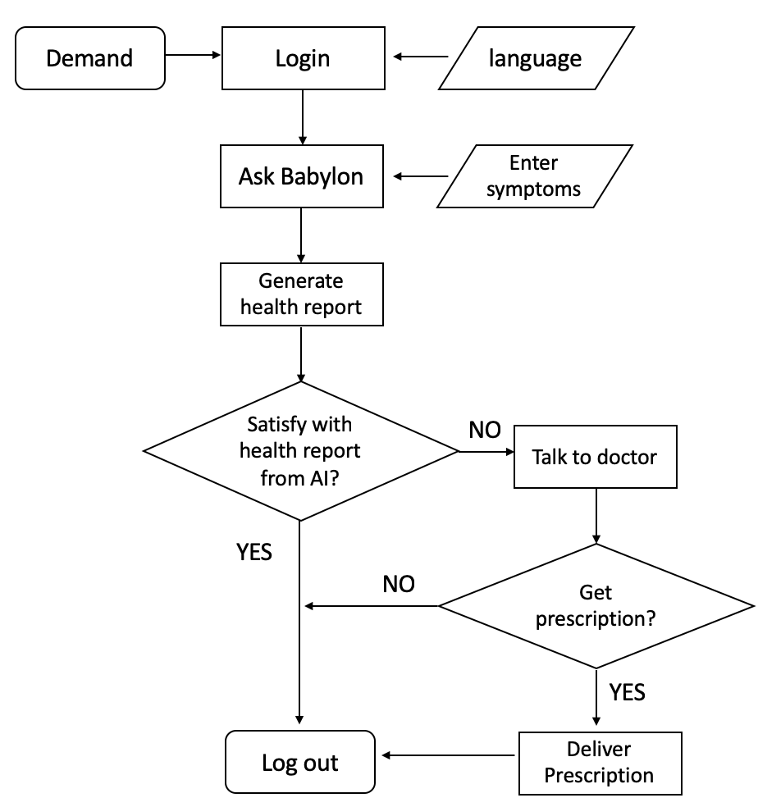
Figure 1: Business Process
As shown in figure 1, after interacting with AI to get health reports, if users want to know more about their symptoms or is not satisfied with the initial health report, Babylon also hired the most professional medical team in the world to provide them with 24/7 full-day diagnosis services. There are two ways to talk to doctors, video and audio, for users to choose from, and then they will get effective advice from high-quality doctors and finally receive the prescriptions delivered. According to Babylon (2019), the company operates to the most rigorous clinical standards throughout the process. Babylon provides customers with a one-stop service ranging from health consultation to prescription generation to medicine delivery. Hence Babylon platform can be regarded as a service model as all health issues of users can be addressed immediately in this application.
Online diagnosis, as the main source of revenue of Babylon, provides two payment options: subscription and pay-as-you-go. The difference between the two is that in the subscription service, users can get unlimited virtual general practitioner consultations as well as free prescription delivery service by paying a fixed fee each month. For the latter, users need to pay a one-time fee for each appointment with a specialist (Babylon, 2019). Furthermore, according to GP at hand (2019), the company has signed a long-term deal with the NHS to provide it with new digital technology to help patients with intelligent triage who consult medical services over the phone. They developed the GP at hand APP through cooperation to provide patients with continuous and safe services throughout the year, greatly shortened the average waiting time for medical treatment. In this aspect, Babylon’s revenue model can be seen as brokerage because it acts as an intermediary, combining buyers and commercial providers.
Mann (2017) believes that by 2025, the United States will face a shortage of 61,700 to 94,700 doctors, among which the shortage of some primary surgeons is particularly severe. In this situation, with the rapid growth of physical health care costs and the popularity of consumers’ access to the Internet, it is imperative to provide low-cost and high-quality digital medical services (Fife & Pereira, 2011). In the context of tremendous opportunities, Babylon's advanced AI technology and secure product advantages will have significant potential for development. It can not only reduce the cost of health care in developed countries, but also make medical services in developing countries more accessible and affordable. However, the platform still has some limitations that need to be improved. For example, the platform lacks a complete doctor assessment system, resulting in limited information users can obtain in the process of selecting doctors. Another vital problem is whether the audio, personal information and other data stored on the platform during the diagnosis are absolutely safe. And how this data will be used in future researches is unclear. Therefore, this paper argues that the platform needs to obtain the consent of users in advance and improve the transparency to gain more trust from potential users. These issues of privacy and ethics are crucial and will be discussed in the following paragraphs. Furthermore, the current cost of consultation of Babylon is still relatively high, which is not in line with their mission to some extent. The existing mechanism of the platform has great difficulty in achieving profitability in backward countries, such as Myanmar.
The Benefits of Babylon Brought to Myanmar
This paper explores the contribution in various aspects that Babylon brings to Myanmar, a developing country, particularly in health care, e-commerce and economy.
Political | Economic
- Increasing funding for public health services  - Government Initiatives to promote healthcare industry | - increasing per capita income  - Unbalanced economic level between urban and rural area
Socio-cultural | Techological
- Spreading awareness of healthcare  - High out-of-home costs | - Development of network infrastructure  - Development of big data and IT
Figure 2: PEST Analysis of Myanmar
Myanmar’s health care level has always been among the lowest in the world. Almost 70% of the population lives in rural areas. Primary care workers are their primary health care providers, and patients continue to pay most of their own medical costs (Latt et al., 2016). Fortunately, the Myanmar government is making significant efforts to improve the health care situation through various measures, including the promotion of mHealth (Telenor Group, 2014). Mhealth supports public health and clinical practice through wireless communication devices, making communication between researchers, clinicians, and patients easier (Mechael, 2009). Babylon as an mHealth application, the free, advanced AI technology it provides will effectively reduce the medical expenses of residents by strengthening their health awareness and increasing the proportion of patients in self-management. Patel (2017) reveals that when people are empowered to learn about their conditions and to make the right choices, it can be economically and medically effective. Meanwhile, Babylon likewise can reduce the time and money that the disadvantaged residents of Myanmar spend on outing to medical treatment in a less developed transportation system.
Additionally, Mann (2017) suggests that the shortage of surgeons will be significantly serious in the future. Babylon can also be a useful tool for reducing the demand for overloaded doctors and nurses. Large-scale medical databases and AI technology can help healthcare providers simplify and intelligentize backward healthcare processes (Russell,2016). According to Islam et al., (2018), substandard medicines are widely available in Myanmar and pose a considerably threat to public health. Babylon's one-stop service for delivery prescriptions, from drug monitoring to ensuring the supply chain, plays a positive role in combating counterfeit drugs. Furthermore, mobile-health concepts application such as Babylon and the trend toward mobile network capitalization will drive the rapid development of e-commerce related digital fields such as local IT companies and application development agencies (Leon., Schneider & Daviaud, 2012). Economic development and healthy development will promote each other and form a "virtuous circle". A healthy physical condition can increase labor productivity, reduce the loss of labour due to illness, decrease medical expenses, and promote investment in education and capital. Thereby stimulating economic growth (Kahn, Yang & Kahn, 2010).
In summary, with the increase of per capita income in Myanmar, the dramatic growth of mobile users (achieving 80% smartphone usage) (Digital in Asia, 2017), and the balanced development of urban and rural telecom infrastructure (Myanmar Infrastructure Summit, 2018), this paper believes that Babylon will have a successful development in Myanmar in the future, and provide significant support for medical care in remote areas.
Potential Obstacles to the Development of Babylon in Myanmar.
Although based on the above analysis, it can be concluded that Babylon has a very promising market prospect in Myanmar, it must be pointed out that there are still many factors hindering the development of Babylon.
Firstly, Babylon is not yet available in the Burmese language. In fact, Burmese is the official language of Burma, spoken by more than two-thirds of the population (Wikipedia, 2019a). This is the primary hurdle that needs to be solved when entering the Myanmar market. Secondly, even if residents in remote areas of Myanmar can afford a mobile phone, they cannot afford the high cost of Internet service, which has a penetration rate of only 25.1% (Wikipedia, 2019b). This holds back the expansion of mobile health services. At the same time, paying for another dozens of pounds of health advice makes it more difficult for the poor. Finally, Myanmar's poor health facilities and limited public resources to partner with mHealth make it difficult to expand the source of profits (Tamrat & Kachnowski, 2012). Therefore, Babylon needs to adjust its current operating model to successfully enter the Myanmar market and make it profitable. The following paragraphs will analyze what changes need to be made to overcome these problems.
Required Modifications in Babylon
This section explores the current status of Babylon in Myanmar based on the SWOT model, and put forward improvement suggestions in accordance with its weaknesses and the analysis above.
Strengths | Weaknesses
- Advanced and accurate AI system  - Professional medical team | - Language  - High Charges
Opportunities | Threats
- The shortage of doctors  - Policy support  - Economic growth  - Developing technologies  - Spreading awareness | - Increasing competitors  e.g. Existing mhealth apps,  hospitals/clinics, private doctors  - Regulation  - High IT costs  - User resistance to new technology.
Figure 3: SWOT Analysis
Firstly, Babylon needs to introduce the option of Burmese language on the application and use the NLP system to simplify medical terms, because to reach a larger user base in Myanmar, the most important thing is to make it readable for potential customers. Additionally, although more than 80% of Burmese people have mobile phones, most rural people cannot afford the high cost of data (Digital in Asia, 2017). Secondly, this paper suggests that AI diagnosis service could be run in the form of SMS or telephone service. In addition to this, Babylon can also launch the subscription service in the form of SMS to push personalized health articles based on user's health files, since patient mortality was found to be significantly reduced by using mHealth-based information dissemination (Latif et al., 2017). This can effectively promote Babylon and reduce costs while improving the local medical conditions. For online consultation, Babylon can cooperate with local Internet agencies to launch cheap data traffic specifically for online diagnosis, so as to reduce its own medical price, and bring agencies more customer flow in return.

Furthermore, introduce a new revenue model
Can corporate with business
Babylon can corporate with local companies of various sizes
provides companies with valuable insights into the health of their teams so they can make informed decisions about their benefit plans and strategies to keep employees present, efficient and engaged.

Ethics and risks should be discussed
Security of patient data information

Reference
http://www.pulsetoday.co.uk/news/gp-topics/it/nhs-has-a-lot-to-learn-from-phenomenal-babylon-model-says-rcgp-chair/20036920.article

https://www.gpathand.nhs.uk/how-we-work

Fife, E. and Pereira, F. (2011). Digital home health and mHealth: Prospects and challenges for adoption in the U.S.
Mann, S. (2017). New Research Confirms Looming Physician Shortage - News Releases - Newsroom - AAMC. [online] Aamc.org. Available at: https://www.aamc.org/newsroom/newsreleases/458074/2016_workforce_projections_04052016.html [Accessed 27 Apr. 2019].
Latt, N. N., Myat Cho, S., Htun, N. M., Yu Mon Saw, Myint, M. N., Aoki, F., … Hamajima, N. (2016). Healthcare in Myanmar. Nagoya journal of medical science, 78(2), 123–134.
Kahn, J., Yang, J. and Kahn, J. (2010). ‘Mobile’ Health Needs And Opportunities In Developing Countries. Health Affairs, 29(2), pp.252-258.
Russell, T. (2016). An Interview with babylon Health - Impakter. [online] Impakter. Available at: https://impakter.com/interview-babylon-health-instagram/ [Accessed 1 May 2019].
Patel, U. (2017). The Future of Healthcare | Babylon Health. [online] Babylon Health. Available at: https://www.babylonhealth.com/blog/business/the-future-of-healthcare [Accessed 1 May 2019].
Telenor Group. (2014). Telenor and Marie Stopes announce joint mHealth initiative in Myanmar. [online] Available at: https://www.telenor.com/telenor-and-marie-stopes-announce-joint-mhealth-initiative-in-myanmar/ [Accessed 1 May 2019].
Mechael, P.N., (2009). The case for mHealth in developing countries. Innovations: Technology, Governance, Globalization, 4(1), pp.103-118.
Leon, N., Schneider, H. and Daviaud, E. (2012). Applying a framework for assessing the health system challenges to scaling up mHealth in South Africa. BMC Medical Informatics and Decision Making, 12(1).
Islam, M., Yoshida, N., Kimura, K., Uwatoko, C., Rahman, M., Kumada, S., Endo, J., Ito, K., Tanimoto, T., Zin, T. and Tsuboi, H. (2018). An Investigation into the Quality of Medicines in Yangon, Myanmar. Pharmacy, 6(3), p.96.
Digital in Asia. (2017). Myanmar 33 million mobile users, smartphone usage 80% | Digital in Asia. [online] Available at: https://digitalinasia.com/2017/01/09/myanmar-33-million-mobile-users-smartphone-usage-80/ [Accessed 1 May 2019].
Myanmar Infrastructure Summit (2018). Myanmar Infrastructure Summit 2018. [online] Available at: http://www.myanmarinfrastructuresummit.com/ [Accessed 2 May 2019].
En.wikipedia.org. (2019b). Internet in Myanmar. [online] Available at: https://en.wikipedia.org/wiki/Internet_in_Myanmar#Internet_in_other_towns_and_rural_areas [Accessed 2 May 2019].
Latif, S., Rana, R., Qadir, J., Ali, A., Imran, M. A. and Younis, M. S. (2017) “Mobile Health in the Developing World: Review of Literature and Lessons from a Case Study,” IEEE Access, 5. doi: 10.1109/ACCESS.2017.2710800.
Tamrat, T. and Kachnowski, S. (2012) “Special Delivery: An Analysis of Mhealth in Maternal and Newborn Health Programs and Their Outcomes Around the World,” Maternal and Child Health Journal, 16(5), pp. 1092–1101. doi: 10.1007/s10995-011-0836-3.

