SHR037-6: Marketing Management
Case Study for Assessment 2 : Marketing Plan Report

SPAR Oman plans to open 21 stores in Oman by the end of 2018

Oman Economic Review, December 11th, 2015

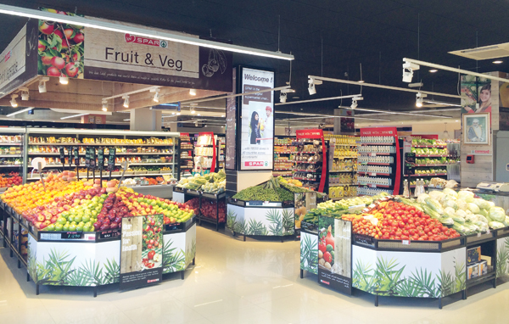
SPAR Oman plans to open 21 stores in Oman by the end of 2018. Some of the Khimji Mart outlets in Oman will be rebranded and converted to SPAR Supermarkets, explains Dr Gordon R Campbell, CEO, SPAR International, who was on a visit to Muscat, in an interview with Oommen John P.
Could you tell us about SPAR International’s operations in Oman?
SPAR International, which was established more than 80 years ago, is the world’s largest voluntary food retailer with over 12,000 stores across 40 countries. Globally recognised for great value and quality offerings, SPAR prides itself on the concept of fresh food.
SPAR International signed a direct permanent license agreement with Khimji Ramdas recently, and we discussed the future plans. We visited the three stores that have been opened in Muscat. And they are exceptionally well done and sales are growing. We now have plans to open a minimum of 21 stores by the end of 2018.

What formats will SPAR operate in Oman?
SPAR operates across all formats worldwide. The formats which we operate that fit this market are neighbourhood stores, neighbourhood supermarkets and local supermarkets. In Oman, SPAR will operate supermarkets and friendly neighbourhood stores. The stores will not be in big shopping malls but in residential areas. Khimji Mart outlets will be rebranded and converted to SPAR Supermarkets. SPAR will have unique and distinctive products that will attract shoppers.
We are not a multi-national organisation. We bring the know-how, bring in the international expertise in retailing, formats of the stores, layouts and design, merchandising operations and training. Investments will be made by Khimji Ramdas. SPAR is investing in good systems and best practices on an international platform. And KR as the franchise partner is investing into it. The Staff will be trained by SPAR International.

What differentiates SPAR from the rest?
We are an organisation which builds neighbourhood convenient stores that bring good value shopping to local neighbourhoods and local consumers. In Muscat, consumers will be experiencing modern shopping. Now they will have an opportunity to come to SPAR and have the same experience, close to where they reside. This will be a huge advantage as consumers will not have to drive long distances for shopping. At SPAR, consumers get the same standard of shopping. SPAR stores are well laid out, easy to shop, offer great choice of goods and deliver fresh foods.
All our products are competitively priced. We have new product lines that include a range of SPAR brands from Europe, such as biscuits and energy drinks. KR is also sourcing products internationally such as coconut water from Thailand. It’s our values that inspire our customers.
Any customer who walks through the doors of SPAR, will get to see a wide range of products, fruits and vegetables at good prices. They will also get to see high operational standards and customer service. Our values of freshness, choice and value of service will enable customers to experience a new brand of shopping closer to their home.

Why should customers shop at SPAR?
Customers will have a far better range of fresh products, which are very well sourced and of high standards and excellent quality. They will have a modern shopping experience with well trained, friendly staff and a choice that they don’t have elsewhere.
SPAR has followed a value system which includes customer service excellence, offering their best to customers. SPAR is keen to deliver customer service excellence and wants to be recognised as delivering fresh products and also as a promoter of local products. SPAR will be supporting KR through expertise and also help them by developing the management expertise for running the stores.

SPAR’s growth strategy in the GCC region and globally?
SPAR will be expanding its operations in the UAE. Currently, we operate 13 stores. We plan to open 20 stores by the end of the year. In 2016, we anticipate to open the first store in Qatar. We also have plans to enter Saudi Arabia. In Oman, SPAR has opened three stores and sales are growing.
Globally, SPAR operates 12120 stores in 40 countries. We had global retail sales of 32 billion Euros in 2014. Our strength is in Western Europe, where we are present virtually in every country. Austria is SPAR International’s biggest market, with a market share of over 30 per cent. We are very strong in South Africa, where we are the No 2 retailer with 870 stores and a market share of 28 per cent. In recent years, we have been expanding very rapidly in Russia with 430 stores. China is also a strong market where we have 300 stores.

SPAR International’s foray into new markets?
India and Indonesia have seen big development in 2015. In India, SPAR has opened 17 hypermarkets since September 2014. In Indonesia, SPAR operates 14 super markets. India is a hugely exciting market and so is Indonesia. Additionally, we have opened in Cameroon and very shortly will open in Azerbaijan. We will continue to develop Middle East, South East Asia, Eastern Europe and Africa. But our focus will be Middle East and South East Asia.

SPAR OMAN LAUNCHES ‘NATURAL’ CONCEPT AT MADINAT AS SULTAN QABOOS BRANCH
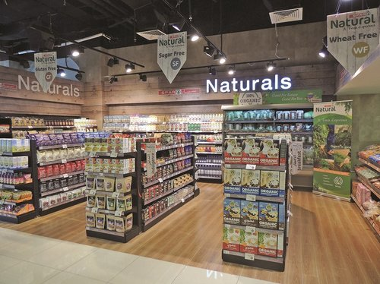

Like0

January 16, 2018 (muscatdaily.com)
MUSCAT -
Consumers are becoming more conscious of the advantages of healthy living in a fast-paced world, and the significance of consuming fresh, unadulterated produce that enhances their overall health.
Growing consumer interest in fresh, natural and organic products is also being connected to them using food to manage their health issues like diabetes, hypertension among others.
To deliver the freshest and healthiest foods to customers and satisfy the growing demand for organic food and drinks, SPAR in Oman has launched a ‘Natural’ concept at its Madinat as Sultan Qaboos branch.
Understanding the benefits of consuming natural and organic foods, SPAR Oman has added products in multiple categories including gluten free, organic, vegan, wheat free, vegetarian, dairy free, lactose free and sugar free at the section.
SPAR Oman’s organic Fruits and Vegetables have been sourced from a family farm in Oman which produces leafy vegetables, fruits, eggs, poultry, milk and meat. The farm which covers a 10,000sq m is three years old is run by two agricultural engineers and a number of farmers. This farm is certified by USDA.
In all, there are 268 organic and natural products and they will be sourced from countries including Germany, Italy, the US, the UAE, India, the UK, Canada and many others.
The natural products range will include snacks, breakfast items, baby food, confectionery, culinary product, instant prepared food, pulses, breads and rolls, to name a few.
Plans are on to launch this section, which celebrates great, healthy food from start to finish, in Ghubra and other SPAR outlets across Oman.
The launch event of the Naturals section at SPAR Oman’s Madinat as Sultan Qaboos branch was attended by Kanan Kapadia, director, SPAR Oman; Sridhar Moosapeta, CEO SPAR Oman; Devendra Kumar Kolapalli, general manager, SPAR Oman; Narges Mirza, owner and founder, Pairidaeza Organic Farm and Rhonda Janke, professor, Sultan Qaboos University.
First launched in 2014, SPAR Supermarket at present has 22 stores across Oman. SPAR’s success story in Oman has been possible because of customers’ acceptance, which has been driven by the four core values of freshness, choice, value and excellent customer service.

SPAR Oman launches first 24/7 supermarket
NOVEMBER 16, 2016 IN THE CATEGORY: STORE OPENINGS

Extending its presence across the Sultanate, SPAR Oman has opened its 10th SPAR Supermarket, which sees the brand entering Madinat Darsait for the first time.
This latest SPAR Supermarket is open 24/7 and features a broad range of fresh service departments including Fruit & Veg, Food-to-Go, Butchery and Fish & Seafood. The 630m² store meets the needs of a broad shopper group comprising both families and single households, spanning expatriate workers to local citizens.
At the opening of the new store, Sridhar Moosapeta, SPAR Oman CEO said: “Since its launch, SPAR has quickly garnered a reputation for being one of the most trusted names in Oman’s retail sector. We have been setting benchmarks for product quality and efficient customer service based on a tradition that SPAR has perfected for over eight decades, worldwide.”
Consumer reaction to the new store has been incredible, with many shoppers taking advantage of the fantastic special offers that were run during the first week of trading. The extensive advertising campaign ahead of the opening included local newspaper ads, flyers delivered to 15,000 homes in the area and a SMS campaign to over 100,000 consumers. Additional buzz was created with an online campaign crossing a variety of social media channels.
Commenting on the launch of the latest SPAR store, Devendra Kumar, Head of SPAR Oman’s Retail Division said: “SPAR Oman brings customers global offerings along with the best of local produce. Our team is working relentlessly to create the highest value across our entire product range. Freshness, value, choice and excellent service form the bedrock of our retail strategy.”
Other prominent areas in the Sultanate where SPAR has established its presence are: Bausher, Al Khuwair, Madinat Sultan Qaboos, Mumtaz, MBD, Muttrah and ISD. SPAR Express stores have also opened in Al Khoud and Mawellah North, developed in partnership with Al Maha Petroleum. (Spar-international.com)

