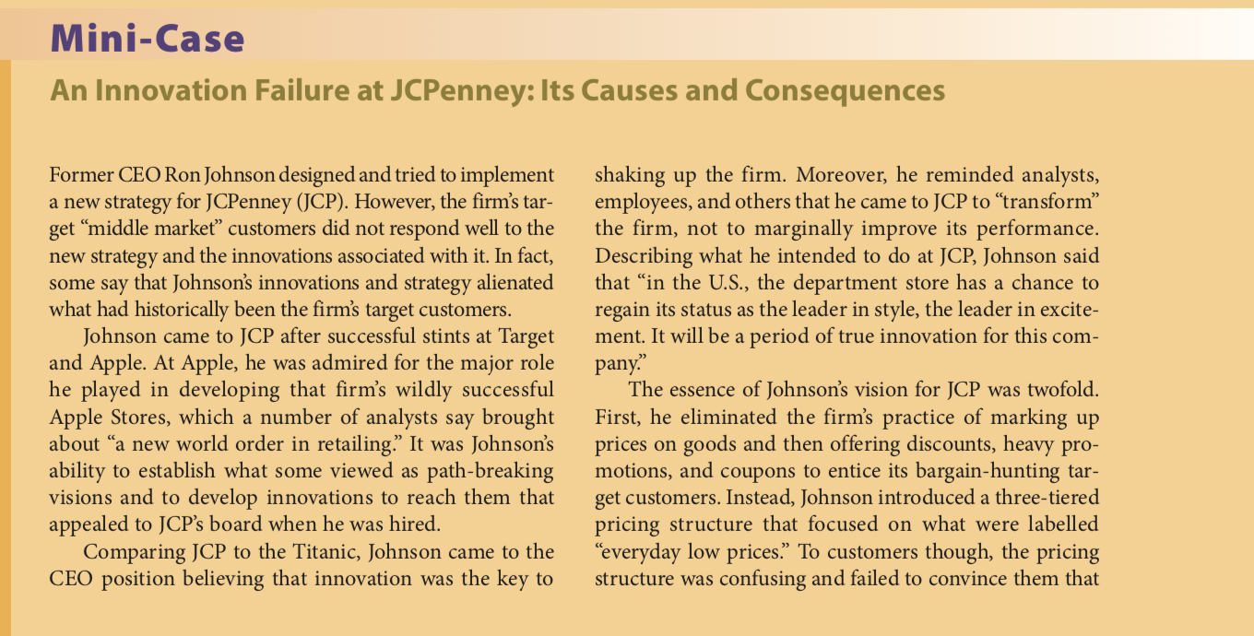
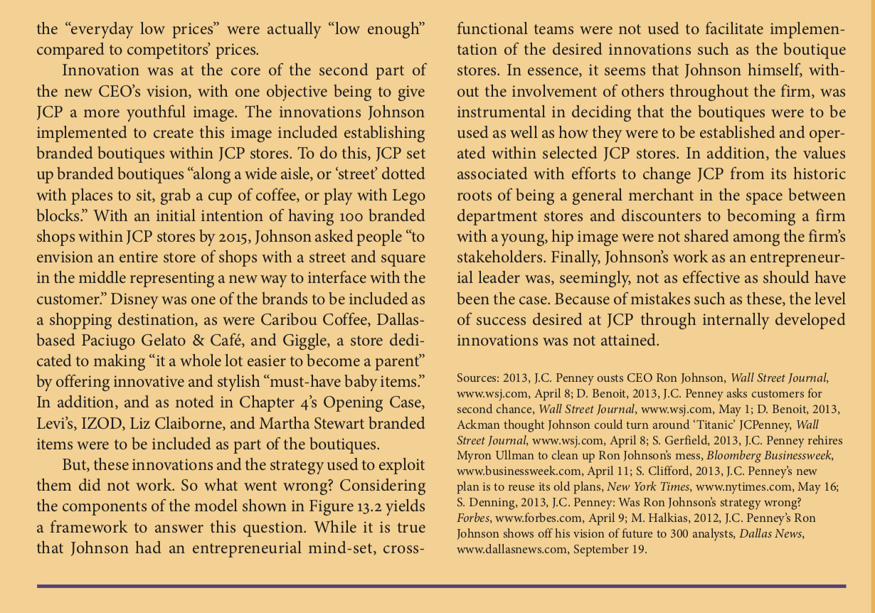
Respond to question: Do the innovations implemented by JCP sound interesting to you? Would you shop at a store with these features? Why or why not? Use examples and illustrations from your personal experience.

