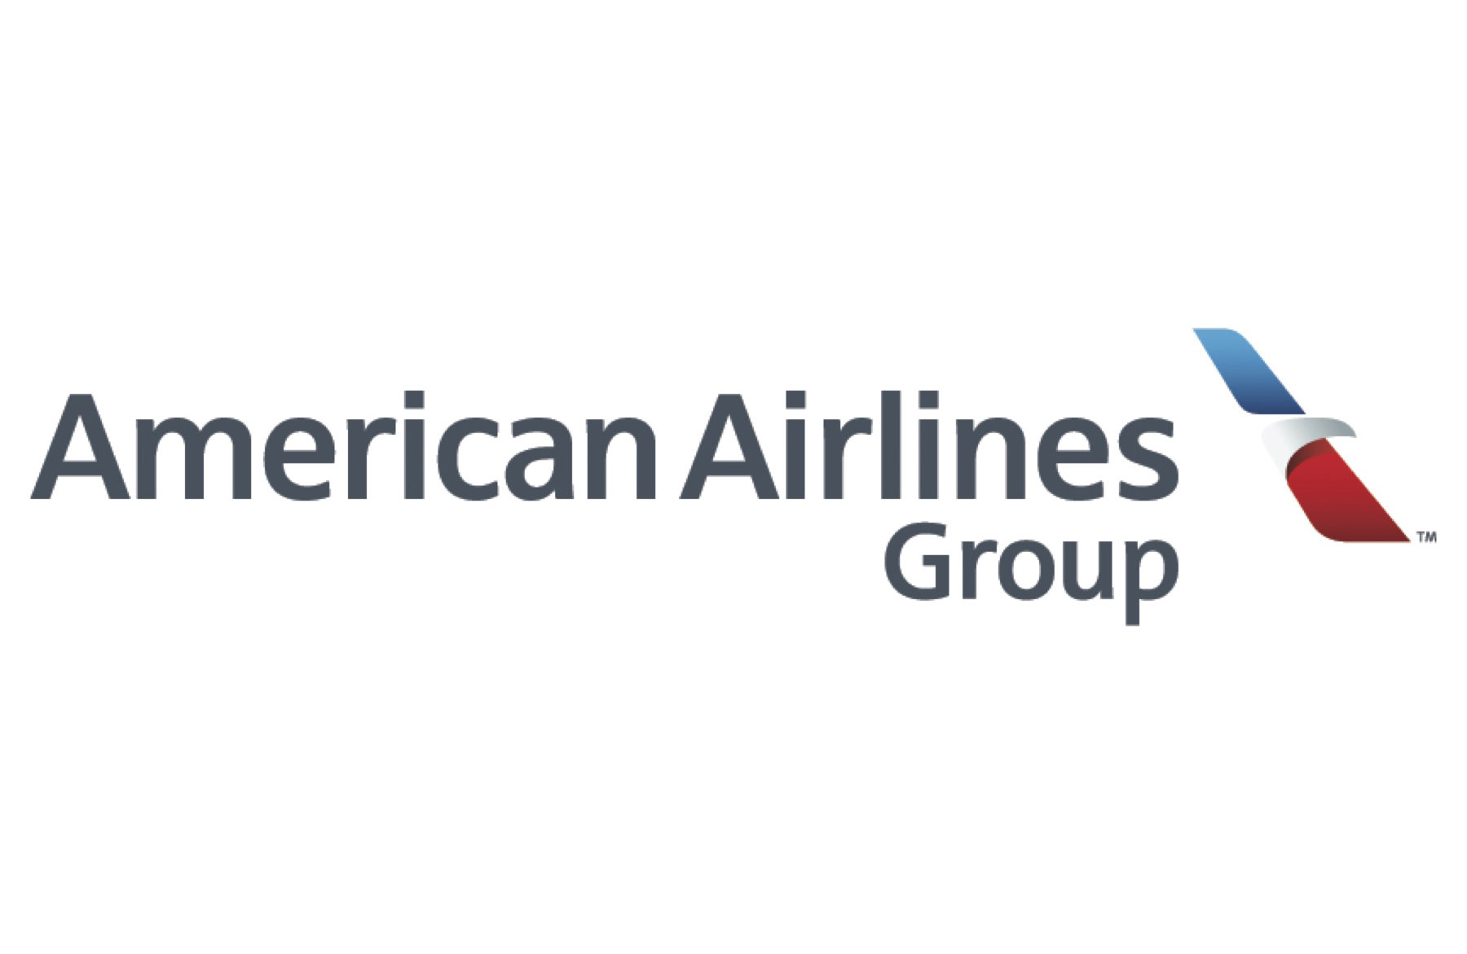
Inter-Company Memorandum
To: All Employees
Re: Termination of contract with Wakanda Worldwide Food Suppliers
From: Doug Parker, Chairman & CEO of American Airlines
Please be advised that American Airlines, American Eagle, and all its subsidiaries has officially severed its contract with Wakanda Worldwide Food Suppliers. It was recently made known to our Board of Directors that children as young as 7 years old were seen working in food factories for 12 or more hours.
We at American Airlines do not adhere nor have business relationships with companies that have questionable child labor practices. We are a company that stand very high on our ethical beliefs and values when it comes to labor laws. This should never be tolerated under any circumstances.
We know that passengers may enquire about this matter and due to legalities and the sensitive matter of this situation, we ask that you DO NOT divulge any information and to direct them Mary Poppins in our legal department for further questions or concerns. We have sent out a press release to all Advantage passengers world-wide and to all media outlets.
Due to the sensitivity of this matter, we have set up Toll-Free counselors for employees who are affected by this matter. Please note this is a free confidential service that is part of your EAP program. If you have any questions or concerns, please contact your immediate supervisor, shift manager, or Human Resource Business Partner.

