**India:**

is a country in [South Asia](https://en.wikipedia.org/wiki/South_Asia). It is the [seventh-largest](https://en.wikipedia.org/wiki/List_of_countries_and_dependencies_by_area) country by area and with more than 1[.3 billion people](https://en.wikipedia.org/wiki/Demographics_of_India), it is the [second-most populous](https://en.wikipedia.org/wiki/List_of_countries_and_dependencies_by_population) country and the most populous [democracy](https://en.wikipedia.org/wiki/Democracy) in the world.

Bounded by the [Indian Ocean](https://en.wikipedia.org/wiki/Indian_Ocean) on the south, the [Arabian Sea](https://en.wikipedia.org/wiki/Arabian_Sea) on the southwest, and the [Bay of Bengal](https://en.wikipedia.org/wiki/Bay_of_Bengal) on the southeast, it shares land borders with [Pakistan](https://en.wikipedia.org/wiki/Pakistan) to the west;[[f]](https://en.wikipedia.org/wiki/India#cite_note-24) [China](https://en.wikipedia.org/wiki/China), [Nepal](https://en.wikipedia.org/wiki/Nepal), and [Bhutan](https://en.wikipedia.org/wiki/Bhutan) to the northeast; and [Bangladesh](https://en.wikipedia.org/wiki/Bangladesh) and [Myanmar](https://en.wikipedia.org/wiki/Myanmar) to the east. 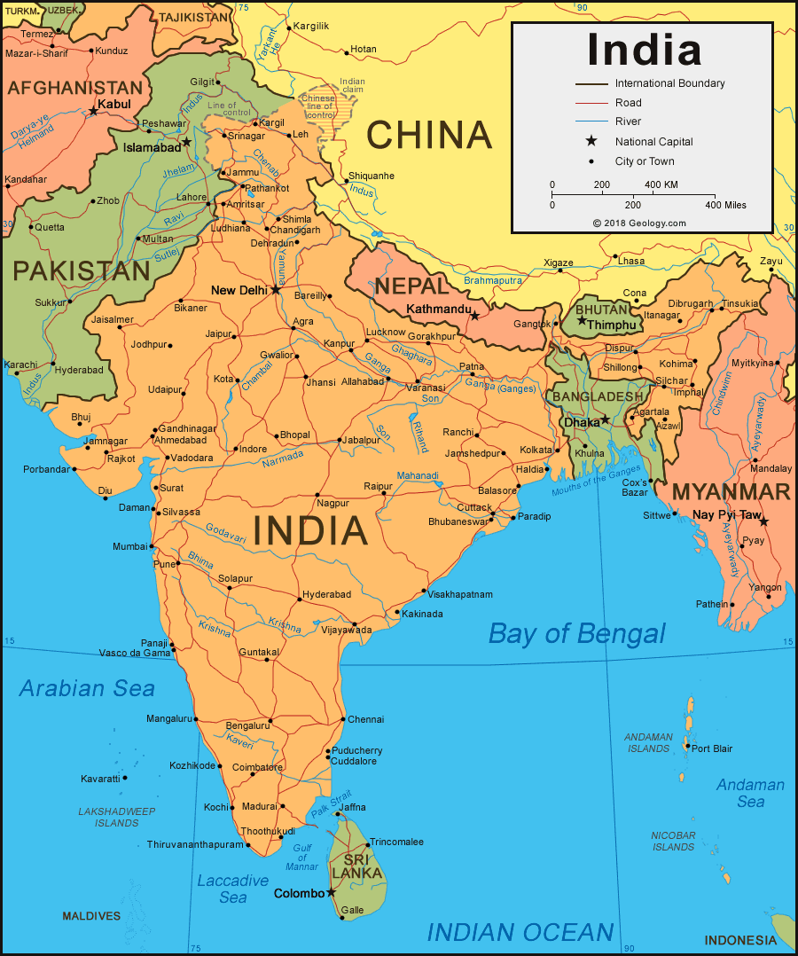

According to the US trade representative website:

**GDP:**

It is the world's sixth-largest economy by [nominal GDP](https://en.wikipedia.org/wiki/Gross_domestic_product) of $2.848 trillion as of 2018  and the [third-largest](https://en.wikipedia.org/wiki/List_of_countries_by_GDP_(PPP)) by [purchasing power parity](https://en.wikipedia.org/wiki/Purchasing_power_parity) (PPP) which was estimated to be $10.385 trillion.

**GDP per capita (income):**

The country ranks 139th in [per capita GDP (nominal)](https://en.wikipedia.org/wiki/List_of_countries_by_GDP_(nominal)_per_capita) with $2,134 and 122nd in [per capita GDP (PPP)](https://en.wikipedia.org/wiki/List_of_countries_by_GDP_per_capita_(PPP)) with $7,783 as of 2018.[[](https://en.wikipedia.org/wiki/Economy_of_India#cite_note-36)

**Rate of economic growth:**

India's economy has been the world's fastest growing [major economy,](https://en.wikipedia.org/wiki/G20_major_economies) surpassing [China](https://en.wikipedia.org/wiki/China).

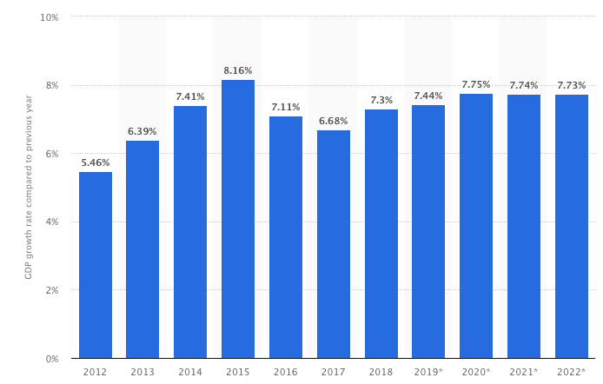

**Currency and Exchange:**

* India's current currency is the Rupee (INR)
* The most popular Rupee exchange rate is USD to INR
* Currently $1 USD = 71 INR
* Inflation for the INR is currently at 3.6%
* Nicknames:
  + Taaka
  + Rupayya
  + Rubai
  + Athanni
* INR currency is made up of coins and banknotes
* India's Central Bank is the Reserve Bank of India
* Other users of the Rupee include:
  + Bhuton
  + Nepal

**Imports, Exports, Good & Volume**

**·         Exports**

**·         India was the United States' 15th largest goods export market in 2017.**

**·         U.S. goods exports to India in 2017 were $25.7 billion, up 18.7% ($4.1 billion) from 2016 and up 71.6% from 2007. U.S. exports to India account for 1.7% of overall U.S. exports in 2017.**

**·         The top export categories (2-digit HS) in 2017 were: precious metal and stone (diamonds) ($7.0 billion), mineral fuels ($2.8 billion), aircraft ($2.2 billion), machinery ($2.1 billion), and optical and medical instruments ($1.4 billion).**

**·         U.S. total exports of agricultural products to India totaled $1.6 billion in 2017. Leading domestic export categories include: tree nuts ($738 million), cotton ($435 million), fresh fruit ($104 million), pulses ($53 million), and dairy products ($43 million).**

**·         U.S. exports of services to India were an estimated $23.7 billion in 2017, 15.2% ($3.1 billion) more than 2016, and 174% greater than 2007 levels.  Leading services exports from the U.S. to India were in the travel, intellectual property (computer software, audio and visual related products), and transport sectors.**

**·         Imports**

* **India was the United States' 11th largest supplier of goods imports in 2017.**

* **U.S. goods imports from India totaled $48.6 billion in 2017, up 5.6% ($2.6 billion) from 2016, and up 101.9% from 2007.  U.S. imports from India account for 2.1% of overall U.S. imports in 2017.**
* **The top import categories (2-digit HS) in 2017 were: precious metal and stone (diamonds) ($10 billion), pharmaceuticals ($6.1 billion), mineral fuels ($2.7 billion), machinery ($2.5 billion), and miscellaneous textile articles ($2.5 billion).**

* **U.S. total imports of agricultural products from India totaled $2.6 billion in 2017.**

* **Leading categories include: spices ($272 million), tree nuts ($236 million), essential oils ($182 million), rice ($178 million), and processed fruit & vegetables ($125 million).**
* **U.S. imports of services from India were an estimated $28.1 billion in 2017, 9.0% ($2.3 billion) more than 2016, and 183% greater than 2007 levels.  Leading services imports from India to the U.S. were in the telecommunications, computer, and information services, research and development, and travel sectors.**

**xtGoods and volume**

|  |  |  |  |  |  |  |  |  |  |
| --- | --- | --- | --- | --- | --- | --- | --- | --- | --- |
| **U.S. Goods Trade with India (in billions of dollars)** | | | | | | | | | |
|  | **1995** | **2000** | **2007** | **2012** | **2013** | **2014** | **2015** | **2016** | **2017** |
| **Total** | **9.0** | **14.4** | **39.0** | **62.6** | **63.6** | **66.9** | **66.2** | **67.7** | **74.3** |
| **Exports** | **3.3** | **3.7** | **15.0** | **22.1** | **21.8** | **21.5** | **21.5** | **21.6** | **25.7** |
| **Imports** | **5.7** | **10.7** | **24.1** | **40.5** | **41.8** | **45.4** | **44.8** | **46.0** | **48.6** |
| **Balance** | **-2.4** | **-7.0** | **-9.1** | **-18.4** | **-20.0** | **-23.9** | **-23.3** | **-24.4** | **-22.9** |
|  | | | | | | | | | |

**Trading Partners**

**India is currently our 9th largest goods trading partner with $74.3 billion in total (two way) goods trade during 2017. Goods exports totaled $25.7 billion; goods imports totaled $48.6 billion. The U.S. goods trade deficit with India was $22.9 billion in 2017.**

**Index of Openness**

* Ratio of India's total trade
  + = (Exports + Imports)/(GDP)
* 2017 Statistics
  + GDP $2.602 trillion
  + Exports $304.1 billion
  + Imports $452.2 billion
* Calculation
  + ($304.1 billion +  $452.2 billion) /($2.602 trillion) ≅ 0.291

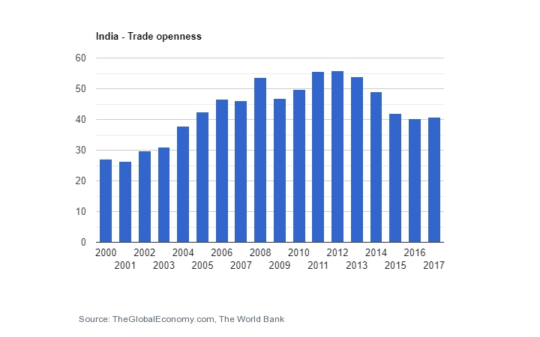

**Trade of Agreements & Trade Policies**