Healthcare Workforce Diversity
The concepts of diversity are rooted in the foundation of the Nation. The demographics of the United States have been trending toward increased diversity since its birth. This trend is viewed not only through the lens of ethnicity, race, culture, and religion but also through age. Cultural competency in healthcare is important and must be achieved while maintaining the quality of care and equity. However, while healthcare organizations strive to achieve cultural competency, a middle ground of reasonable expectations must also be recognized by the healthcare provider and consumer.
Cultural Competency in Healthcare

According to Betancourt, Green, and Carrillo (2002):
Culture has been defined as an integrated pattern of learned beliefs and behaviors that can be shared among groups. It includes thoughts, styles of communicating, ways of interacting, views on roles and relationships, values, practices, and customs. Culture is shaped by multiple influences, including race, ethnicity, nationality, language, and gender, but it also extends to socioeconomic status, physical and mental ability, sexual orientation, and occupation, among other factors. These influences can collectively be described as “sociocultural factors,” which shape our values, form our belief systems, and motivate our behaviors. (p. 1)
The idea of cultural competency transcends the difference of race, ethnicity, nationality, language, or gender. The concept extends to individuals with physical, mental, or emotional difficulties. A person with a hearing deficit struggling to effectively communicate through exhaustive listening techniques or physical challenge of adapting to a prosthetic device is within the spectrum of diversity. All differences are within the dynamic cultural context of requiring understanding and consideration.
Reference:
Betancourt, J. R., Green, A. R., & Carrillo, J. E. (2002). Cultural competence in health care: Emerging frameworks and practical approaches. The commonwealth fund. Retrieved from https://www.commonwealthfund.org/sites/default/files/documents/___media_files_publications_fund_report_2002_oct_cultural_competence_in_health_care__emerging_frameworks_and_practical_approaches_betancourt_culturalcompetence_576_pdf.pdf

The necessity to provide healthcare services to a diverse population under the principles of social justice is the goal. It remains impractical to address every possible variant of diversity, but a focused, reasonable approach to address the diverse demographics of the healthcare organization’s catchment area is a realistic approach.
The challenges of accommodating a diverse workforce can have greater implications regarding the quality of care. Diversity in the workforce can lead to communication and cultural barriers. In recent years, concern arose over the recruitment of nurses from outside the United States to address the nursing shortage. While this practice has proven to be beneficial in addressing the shortage, it has also manifested a number of concerns within and outside the care setting.
Nurses educated abroad must pass board certification exams to practice in the United States and must also adopt the expectations of healthcare delivery in the United States. Many nurses from third-world and Pacific Rim countries have expressed difficulties in matriculating into the United States healthcare delivery system. Some experience an inability to communicate sufficiently with patients, families, and coworkers whose native language is not English.
Diversity in Healthcare
Review the tabs to know more about the challenges of diversity in healthcare.
- Culture Influences in Health Beliefs
- Language Differences
- Difference in Cultural Professionalism
- Racial and Cultural Diversity
- Cultural Differences between East and West
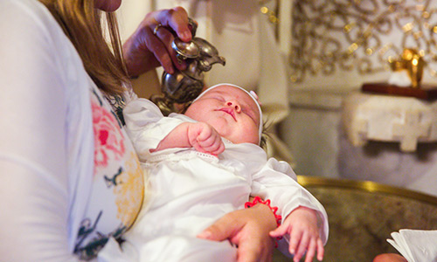
“All cultures have systems of health beliefs to explain what causes illness, how it can be cured or treated, and who should be involved in the process” (EuroMed Info, n.d., para. 1).
Know more by reading the following:
- How Culture influences Health Beliefs
Reference:
EuroMed Info. (n.d.). How culture influences health beliefs. Retrieved from https://www.euromedinfo.eu/how-culture-influences-health-beliefs.html/

Additional Materials
From your course textbook, Human Resources in Healthcare: Managing for Success, read the following chapter:
- Workforce Diversity
From the Internet, read the following:
- Ludwick, R., & Silva, M. C. (2000). Ethics: Nursing around the world: Cultural values and ethical conflicts. Online Journal of Issues in Nursing, 5(3). Retrieved from http://ojin.nursingworld.org/MainMenuCategories/ANAMarketplace/ANAPeriodicals/OJIN/Columns/Ethics/CulturalValuesandEthicalConflicts.aspx

