# CHOKING

hoking is especially common in young children, but a person of any age can choke. Choking occurs when the airway becomes either partially or completely blocked by a foreign object, such as a piece of

food or a small toy; by swelling in the mouth or throat; or by fluids, such as vomit or blood. A person who is choking can quickly become unresponsive and die, so it is important to act quickly.

Risk Factors for Choking

■

■

■

■

Safety pins and hairpins Jewelry

Baby powder Vitamins

Items from the trash (such as eggshells or the pull tabs from soda cans)

Toys meant for older children, which may be small or have small parts*

■

■

■

■

■

■

■

■

■

■

Plastic bags, broken or uninflated balloons, and disposable gloves (the thin material can block the airway)

Coins Buttons

Small “button” batteries (found inside watches, car key fobs, singing greeting cards, hearing aids and other electronics)

Magnets Marbles Beads Pebbles

Pen or marker caps

■

■

■

■

Hard, gooey or sticky candy (such as peppermint candies, fruit strips, marshmallows, gummy bears and chewing gum)

Large foods that break easily into small pieces (such as teething biscuits and cookies)

■

■

Chunks of meat or cheese

Chunks of fruit (such as apples) and whole grapes

Raw vegetables (such as carrots and celery) Popcorn

Peanut butter

■

■

■

Nuts and seeds

Hot dogs and sausages

■

© 2011, 2016 The American National Red Cross. All rights reserved.

Certain behaviors can put a person at risk for choking, such as talking or laughing with the mouth full or eating too fast. Medical conditions (such as a neurological or muscular condition that affects the person’s ability to chew, swallow or both) can increase risk for choking. So can dental problems or poorly fitting dentures that affect the person’s ability to chew food properly.

Children younger than 5 years are at particularly high risk for choking (Box 4-1). Infants and toddlers explore by putting things in their mouths and can easily choke on them. Even some common foods can be choking hazards in young children. For example, a young child can choke on small foods (such as nuts and seeds);



Box 4-1. **Choking Hazards**

In children younger than 4 years, the following foods, household objects and toys may be choking hazards:

Foods

Household Objects and Toys

*For infants and toddlers, no toy should be smaller than 1¾ inches in diameter. If you can fit the toy through a toilet paper tube, then it is too small and not safe for a young child.

round, firm foods (such as grapes, hot dogs and hard candies); and sticky foods (such as peanut butter). This is because young children do not have the skills needed to chew these foods thoroughly, so they often try to just swallow them whole. Laughing, talking or running with the mouth full can also lead to choking.

Signs and Symptoms of Choking

A person who is choking typically has a panicked, confused or surprised facial expression. Some people may place one or both hands on their throat. The person may cough (either forcefully

or weakly), or he or she may not be able to cough at all. You may hear high-pitched squeaking noises as the person tries to breathe, or nothing at all. If the airway is totally blocked, the

person will not be able to speak, cry or cough. The person’s skin may initially appear flushed (red), but will become pale or bluish in color as the body is deprived of oxygen.

## First Aid for Choking

If you are with a person who starts to choke, first ask the person if he or she is choking, or check to see if an infant is crying

or making other noises. If the person can speak or cry and is coughing forcefully, encourage him or her to keep coughing. A person who is getting enough air to speak, cry or cough forcefully is getting enough air to breathe. But be prepared to act if the person’s condition changes.

If the person is making high-pitched noises or coughing weakly, or if the person is unable to speak or cry, the airway is blocked and the person will soon become unresponsive unless the airway is cleared. Have someone call 9-1-1 or the designated emergency number immediately while you begin to give first aid for choking.

#### Caring for an Adult or Child Who Is Choking

© 2011, 2016 The American National Red Cross. All rights reserved.

When an adult or child is choking, give a combination of 5 **back blows** (blows between the shoulder blades) followed by 5 **abdominal thrusts** (inward and upward thrusts just above the navel) (Figure 4-1). The goal of giving back blows and abdominal thrusts is to force the object out of the airway, allowing the person to breathe.

* + **Back blows.** To give back blows, position yourself to the side and slightly behind the person. For a child, you may need to kneel. Place one arm diagonally across the person’s chest (to provide support) and bend the person forward at the waist so that the person’s upper body is as close to parallel to the ground as possible. Firmly strike the person between the shoulder blades with the heel of your other hand. Each back blow should be separate from the others.
  + **Abdominal thrusts.** To give abdominal thrusts, stand behind the person, with one foot in front

of the other for balance and stability. If possible, place your front foot between the person’s feet. Wrap your arms around the person’s waist.

Alternatively, if the person is a child, you can kneel behind the child, wrapping your arms around the child’s waist. Find the person’s navel by placing one finger on the person’s navel, and the adjacent finger above the first. Make a fist with your other hand and place the thumb side just above your fingers. Cover your fist with your other hand and give quick, inward and upward thrusts into the person’s abdomen. Each abdominal thrust should be separate from the others.

Continue giving sets of back blows and abdominal thrusts until the person can cough forcefully, speak, cry, or breathe, or the person becomes unresponsive. After the choking incident is over, even if the person seems fine, he or she should still be evaluated by a healthcare provider to make sure there is no damage to the airway or other internal injuries.

For step-by-step instructions on giving first aid to an adult or child who is choking, see Skill Sheets 4-1 and 4-2. Table 4-1 describes how to troubleshoot special situations when an adult or child is choking.

© 2011, 2016 The American National Red Cross. All rights reserved.

**Figure 4-1.** Use a combination of back blows (A) and abdominal thrusts (B) when an adult or child is choking.

###### TABLE 4-1 Special Situations: Choking in an Adult or Child

© 2011, 2016 The American National Red Cross. All rights reserved.

|  |  |
| --- | --- |
| Special Situation | Solution |
| The person is too large for you to wrap your arms around to give abdominal thrusts. | Give chest thrusts instead of abdominal thrusts. To give chest thrusts, position yourself behind the person as you would for abdominal thrusts. Place  the thumb side of your fist against the center of the person’s breastbone. Then cover your fist with your other hand and pull straight back, giving a quick, inward thrust into the person’s chest. |
| The person is obviously pregnant or known to be pregnant. | Give chest thrusts instead of abdominal thrusts. |
| The person is in a wheelchair. | Give abdominal thrusts in the same way that you would for a person who is standing. It may be necessary to kneel behind the wheelchair. If  features of the wheelchair make it difficult to give abdominal thrusts, give chest thrusts instead. |
| You are alone and choking. | Call 9-1-1 or the designated emergency number using a landline or a GPS-enabled mobile phone. Even if you are not able to speak, the open line will cause the dispatcher to send help. Give yourself abdominal thrusts, using your hands, just as if you were giving abdominal thrusts to another person. Alternatively, bend over and press your abdomen against any firm object, such as the back of a chair or a railing. Do not bend over anything with a sharp edge or corner that might hurt you, and be careful when leaning on a railing that is elevated. |

Caring for an Infant Who Is Choking

When an infant is choking, give a combination of 5 back blows followed by 5 chest thrusts (instead of abdominal thrusts) (Figure 4-2). You can sit, kneel or stand to give first aid care to a choking infant, as long as you are able to support the infant on your thigh with the infant’s head lower than his or her chest. If the infant is large or your hands are small, you may find it easiest to sit or kneel.

**Figure 4-2.** Use a combination of back blows (A) and chest thrusts (B) when an infant is choking.

* **Back blows.** First, get the infant into position for back blows. Place your forearm along the infant’s back, cradling the back of the infant’s head with your hand. Place your other forearm

along the infant’s front, supporting the infant’s jaw with your thumb and fingers. (Be careful not to cover the infant’s mouth with your hand while you are supporting the infant’s jaw.) Turn the infant over so that he or she is face-down along your forearm. Lower your arm onto your thigh so that the infant’s head is lower than his or her chest.

Continue to support the infant’s jaw with the thumb and fingers of one hand while you firmly strike the infant between the shoulder blades with the heel of your other hand. Keep your fingers up to avoid hitting the infant’s head or neck. Each back blow should be separate from the others.

* **Chest thrusts.** Next, place one hand along the infant’s back, cradling the back of the infant’s head with your hand. While continuing to support the infant’s jaw with the thumb and fingers of your other hand, support the infant between your forearms and turn the infant over so that he or she is face-up along your forearm. Lower your arm onto your thigh so that the infant’s head is lower than his or her chest. Place the pads of two fingers in the center of the infant’s chest, on the breastbone just below the nipple line. Press down about 1½ inches and then let the chest return to its normal position, keeping your fingers in contact with the breastbone. Each chest thrust should be separate from the others.

Continue sets of 5 back blows and 5 chest thrusts until the infant can cough forcefully, cry or breathe, or the infant becomes unresponsive. After the choking incident is over, even if the infant seems fine, he or she should still be evaluated by a healthcare provider to make sure there is no damage to the airway or other internal injuries.

© 2011, 2016 The American National Red Cross. All rights reserved.

For step-by-step instructions on giving first aid to an infant who is choking, see Skill Sheet 4-3.

#### If the Person Becomes Unresponsive

© 2011, 2016 The American National Red Cross. All rights reserved.

If a person who is choking becomes unresponsive, carefully lower him or her to the ground and, if you are trained, begin CPR, starting with chest compressions. After each set of chest compressions and before attempting rescue breaths, open the person’s mouth and look for the object. If you see an object in the person’s mouth, remove it using your finger (Figure 4-3). Never put your finger in the person’s mouth unless you actually see the object. If you cannot see the object and you put your finger in the person’s mouth, you might accidentally push the object deeper into the person’s throat.

**Figure 4-3.** If the person becomes unresponsive, look for the object in the person’s mouth (A), and if you see it, use a finger sweep to remove it (B).

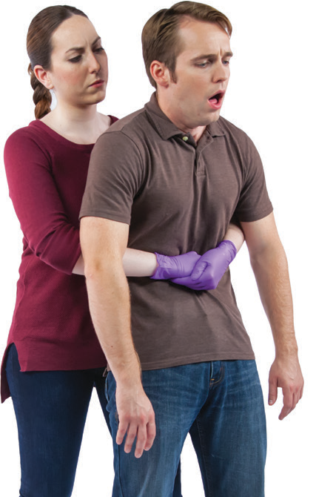Skill Sheet 4-1

© 2011, 2016 The American National Red Cross. All rights reserved.

Caring for an Adult Who Is Choking

1. Verify that the person is choking by asking the person to speak to you.
   * **If the person is able to speak to you or is coughing forcefully:** Encourage the person to keep coughing, but be prepared to give first aid for choking if the person’s condition changes.
   * **If the person is unable to speak to you or is coughing weakly:** Send someone to call 9-1-1 or the designated emergency number and to obtain an AED and first aid kit. Continue to step 2 after obtaining consent.

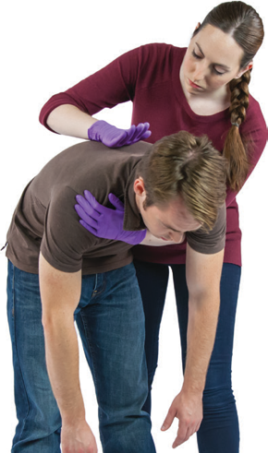

1. Give **5** back blows.
   * Position yourself to the side and slightly behind the person. Place one arm diagonally across the person’s chest (to provide support) and bend the person forward at the waist so that the person’s upper body is as close to parallel to the ground as possible.
   * Firmly strike the person between the shoulder blades with the heel of your hand.

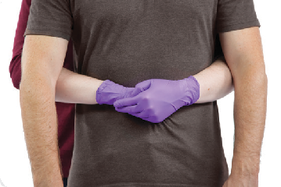

1. Give **5** abdominal thrusts.
   * Have the person stand up straight. Stand behind the person with one foot in front of the other for balance and wrap your arms around the person’s waist.
   * Using two fingers of one hand, find the person’s navel. With your other hand, make a fist and place the thumb side against the person’s stomach, right

above your fingers.

* + Cover the fist with your other hand.
  + Pull inward and upward to give an abdominal thrust.

(*Continued* )

© 2011, 2016 The American National Red Cross. All rights reserved.

1. Continue giving sets of **5** back blows and **5** abdominal thrusts until:
   * The person can cough forcefully, speak, cry or breathe.
   * The person becomes unresponsive.

**Note:** *If the person becomes unresponsive, gently lower him or her to the floor and begin CPR if you are trained, starting with compressions. After each set of compressions and before attempting rescue breaths, open the person’s mouth, look for the object and remove it if seen. Never put your finger in the person’s mouth unless you actually see the object.*

Skill Sheet 4-2

© 2011, 2016 The American National Red Cross. All rights reserved.

Caring for a Child Who Is Choking

1. Verify that the child is choking by asking the child to speak to you.
   * **If the child is able to speak to you or is coughing forcefully:** Encourage the child to keep coughing, but be prepared to give first aid for choking if the child’s condition changes.
   * **If the child is unable to speak to you or is coughing weakly:** Send someone to call 9-1-1 or the designated emergency number and to obtain an AED and first aid kit. Continue to step 2 after obtaining consent.

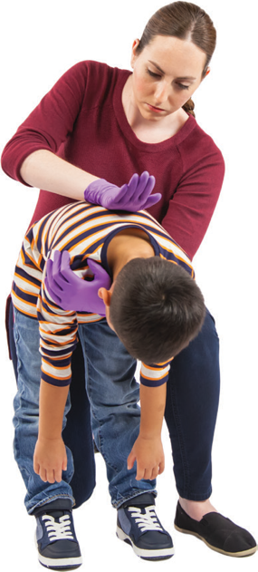

1. Give **5** back blows.
   * Position yourself to the side and slightly behind the child. Place one arm diagonally across the child’s chest (to provide support) and bend the child forward at the waist so that the child’s upper body is as close to parallel to the ground as possible. Depending on the child’s size, you may need to kneel.
   * Firmly strike the child between the shoulder blades with the heel of your hand.

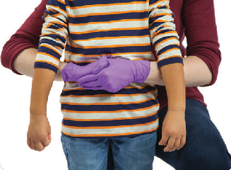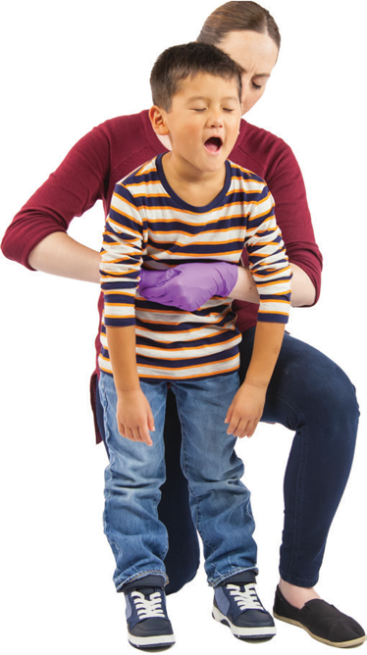

1. Give **5** abdominal thrusts.
   * Have the child stand up straight. Stand behind the child with one foot in front of the other for balance (or kneel) and wrap your arms around the child’s waist.
   * Using two fingers of one hand, find the child’s navel. With your other hand, make a fist and place the thumb side against the child’s stomach, right above your fingers.
   * Cover the fist with your other hand.
   * Pull inward and upward to give an abdominal thrust.

(*Continued* )

© 2011, 2016 The American National Red Cross. All rights reserved.

1. Continue giving sets of **5** back blows and **5** abdominal thrusts until:
   * The child can cough forcefully, speak, cry or breathe.
   * The child becomes unresponsive.

**Note:** *If the child becomes unresponsive, gently lower him or her to the floor and begin CPR if you are trained, starting with compressions. After each set of compressions and before attempting rescue breaths, open the child’s mouth, look for the object and remove it if seen. Never put your finger in the child’s mouth unless you actually see the object.*

Skill Sheet 4-3

© 2011, 2016 The American National Red Cross. All rights reserved.

Caring for an Infant Who Is Choking

1. Verify that the infant is choking by checking to see if the infant is crying or coughing forcefully.
   * **If the infant is crying or coughing forcefully:** Allow the infant to keep coughing, but be prepared to give first aid for choking if the infant’s condition changes.
   * **If the infant is unable to cry or is coughing weakly:** Send someone to call

9-1-1 or the designated emergency number and to obtain an AED and first aid kit. Continue to step 2 after obtaining consent.

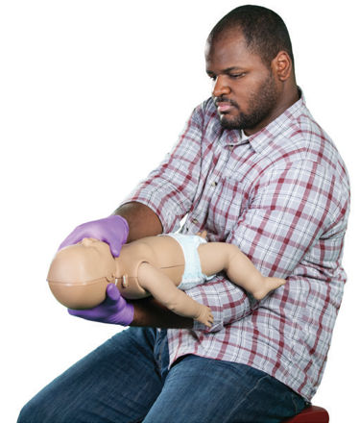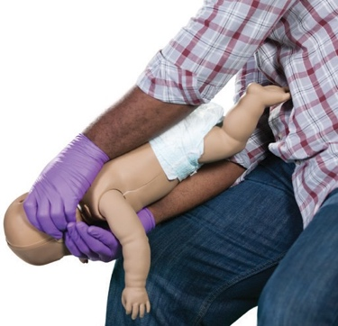

■

Lower your arm onto your thigh so that the infant’s head is lower than his or her chest.

**Note:** *Always support the infant’s head, neck and back while giving back blows and chest thrusts.*

1. Position the infant.
   * Place your forearm along the infant’s back, cradling the back of the infant’s head with your hand.
   * Place your other forearm along the infant’s front, supporting the infant’s jaw with your thumb and fingers.
   * Turn the infant over so that he or she is face-down along your forearm.

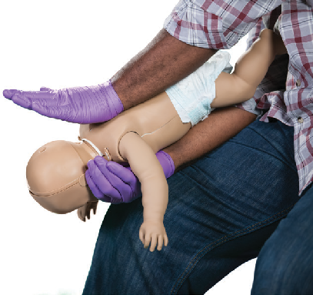

1. Give **5** back blows.
   * Firmly strike the infant between the shoulder blades with the heel of your hand. Keep your fingers up to avoid hitting the infant’s head

or neck.

(*Continued* )

© 2011, 2016 The American National Red Cross. All rights reserved.

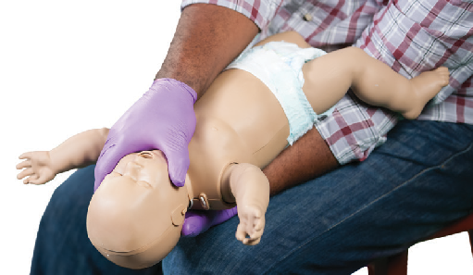

1. Reposition the infant.
   * Place one hand along the infant’s back, cradling the back of the infant’s head with your hand.
   * While continuing to support the infant’s jaw with the thumb and fingers of your other hand, support the infant between your forearms and turn the infant over so that he or she is face-up along your forearm.
   * Lower your arm onto your other thigh so that the infant’s head is lower than his or her chest.

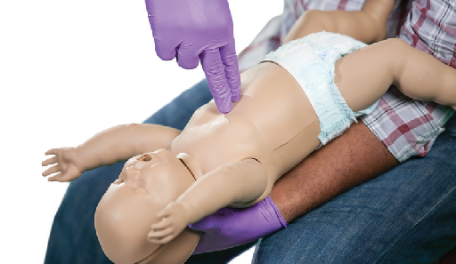

1. Give **5** chest thrusts.
   * Place the pads of two fingers in the center of the infant’s chest on the breastbone, just below the nipple line.
   * Press down about 1½ inches and then let the chest return to its normal position.
2. Continue giving sets of **5** back blows and **5** chest thrusts until:
   * The infant can cough forcefully, cry or breathe.
   * The infant becomes unresponsive.

**Note:** *If the infant becomes unresponsive, lower him or her to a firm, flat surface and begin CPR if you are trained, starting with compressions. After each set of compressions and before attempting rescue breaths, open the infant’s mouth, look for the object and remove it if seen. Never put your finger in the infant’s mouth unless you actually see the object.*