How communication has changed due to technological advances
Since the beginning our existence, humans have been communicating with each other. Some methods of communication are considered quite primitive, and some are now considered to be very advanced. Historically, most types of communication meant that people needed to be in the same place, even if they were not there at the same time. This goes back to the days when individuals would etch drawings into stone or on cave walls. They may or may not have been directly communicating with someone who was with them, but even after they had moved on, people who followed could read their messages. Also, in early generations, people were able to write letters to others using a quill and ink. Letters would have to go through the postal service; and prior to modern transportation such as planes and automobiles. Delivery would sometimes take days, weeks, or longer.
As time went on and inventors began to make equipment that made communication easier, machines were developed such as printing presses and typewriters. These allowed for printed media to be produced, and even mass-produced, as technology evolved. Typewriters allowed for people to write messages and other documents in typed print as opposed to by hand, which was potentially more difficult to read and more laborious for the author.
In the mid-1800s, there was a group of men who invented a method of communication known as the telephone. Alexander Graham Bell is known as the father of the telephone because he designed the concept of a telephone. Telephones have undergone many technological advances over time. The telephone is now one of our most common methods of communication. We have progressed from an expensive service that was only available to some, to party-line systems of calling, to rotary phones plugged into a wall, and now to cellular phones that are portable, battery operable, and can be used anywhere.
Combined with telephone technology, advances in computer technology have helped us to communicate more efficiently. Computers used to be bulky and slow-operating machines that were used for practical business purposes or cryptic games. Eventually, with the addition of the Internet in the late 1900s, computers became an important tool for communication. The Internet offered the opportunity to communicate virtually with people via email. Computers have evolved to be slim, sleek, and portable machines that are used not only for business or educational purposes, but are what many consider to be a critical part of their ability to function daily. Many people store databases of their personal and important information so that it is safe and easily accessible, as opposed to keeping things on paper or in filing cabinets.
Now, we have phones and computers combined. We call them smartphones. These are cellular phones that can access the Internet and allow for information acquisition or communication via various methods at the push of a button. Smartphones have applications that allow face-to-face video calls (Facetime, for example) and they also have access to the Internet. Having instantaneous access to the Internet has helped our society have more immediate access to information. We can Google something and find information about any topic imaginable, whereas in the past, we would have to go to a library and research or look at encyclopedias, etc.
These are just a few of the technological advances that have helped communication change and become more efficient throughout our history. The number of advances that have enhanced our society are virtually countless.
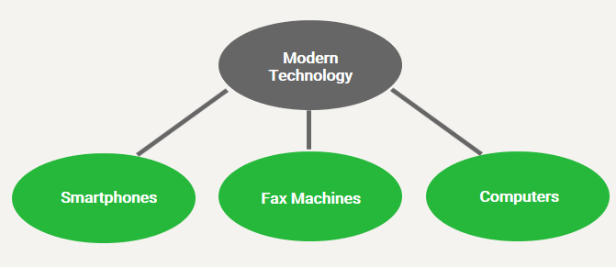
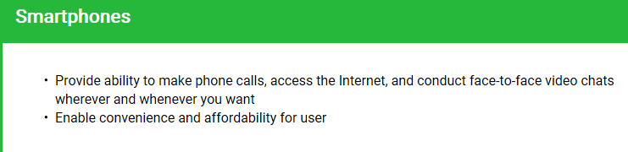

As you can see, as technology has advanced, our methods of communication have not only increased in number but have also become significantly more convenient and user-friendly.
Modern Gaps in Communication
As with many other things in our society, communication styles and methods vary between generations, and between individuals of various socioeconomic status, race, sex, ethnic group, etc. At any given time in society, there are people from multiple different generations and social classes interacting. Due to the technological advances that occur each day, some individuals grow up more familiar with the devices and technologies that are available. People from earlier generations or from underdeveloped societies, for example, have not been exposed to more modern technological advances until later in life, generally making them less familiar and potentially less comfortable using various methods of communication.
As we have discussed in previous modules, communication in previous centuries included either face-to-face communication or writing letters and sending them through the postal service, or what we now today call "snail mail." Eventually, with the creation of the telephone, people were able to communicate with others, near and far, simply by dialing their phone. Over time, this method of communication has become more efficient and significantly cheaper, but when it was brand new, it really opened up opportunities for people to stay connected to others regardless of distance.
The changes in the way that people communicate really arrived in more recent decades with the advances in phones and the movement toward the use of cellular technology and Internet communications. The current trend in society is that people stick with what they are most familiar with. Some individual's adaptation to modern technological advances may be slower than those who are immersed in it from early in life. Some individuals may still have landline phone systems in their home, and many may not have a cellular phone that they use when they are away from home. Individuals who have always had access to Internet and computer technology and have used it since they were born are likely to have smartphones with Internet accessibility. They probably do not even have landline phones in their home. Many rely solely on their cellular phone. Cellular phones are also now equipped with applications that allow for face-to-face communication, such as Facetime and Skype.
When not communicating by phone, people of all generations in today's society are likely to communicate via text messaging on their phone, or via email on their phone or computer. While there continue to be individuals of all ages who prefer landline phones and pen-and-paper communication, they increasingly becoming an exception instead of the norm.
As alluded to a bit earlier in this module, there are several reasons why there may be differences in the way that people communicate. In addition to generational gaps, there are also communication gaps due to socioeconomic status, personal preferences, and available access to technology. One must have access to the technology available, and the ability to acquire it or that individual will not be able to benefit from it. An example of this may be people in underdeveloped societies that do not have knowledge of or access to the technologies available. Also, there are people of all generations and levels of financial resources that simply prefer not to utilize cell phones or modern technologies.
It stands to reason, however, that as the technology of the time is taught to people, regardless of age, social status, etc., they are savvier as compared to those not exposed. If everyone had equal access to the technology enjoyed by today's society, they would likely use it as well. The bottom line is that we are comfortable with what we have always known. Humans are creatures of habit, and this is clearly seen through our methods of communication.
