Case Study 3 Choice Hotels International
Within the hospitality industry, there has traditionally been a division between networks that serve guest functions and those that serve operations and administration, both with respect to data transmission and voice transmission. In recent years, most hotel and motel chains have moved in the direction of consolidating multiple functions on networks that used to be dedicated to one use. Tighter integration of voice and data and of guest and operations/administration networking is a fast-growing trend. Choice Hotels International is a good example of this trend.
Choice Hotels International is the world’s second largest hotel franchise, with enough beds for about a million people. The company franchises more than 5000 hotels, inns, all-suite hotels, and resorts open and under development in 48 countries under the Comfort Inn, Comfort Suites, Quality, Clarion, Sleep Inn, Rodeway Inn, Econo Lodge, and MainStay Suites brands.

In-House Networking Functions
Choice supports two distinct networking functions. A central Web site enables customers to reserve rooms at any Choice franchise accommodation. The central reservation system, known as Profit Manager, automatically finds the most appropriate hotel based on location, price range, or standard. Individual hotels also take bookings, so there needs to be a way for hotels and the central system to remain synchronized.
Choice networks also support its franchisees. Choice is in fact a relatively small company in terms of personnel (about 2000 employees) and does not own or operate any hotels. All of the establishments under its brand names are independently owned and pay Choice licensing fees and a royalty on all sales. In return, they receive a variety of services, including marketing, quality control, and inventory management. Many of these services are offered via network, such as allowing managers to order supplies online and check booking status. This support network is similar to a corporate intranet but has a higher reliability requirement. The 5000 hotel managers are, in effect, Choice’s customers, not employees. Thus, the standards for reliability and performance of the network are high.
In the late 1990s, Choice began to focus on providing a state-of-the-art global reservation system. At this point, the synchronization of local and online reservations was done manually. Each hotel provided Choice with a fixed block of inventory to sell over the central reservation system, with an average of 30% of capacity. Once that 30% was sold, Profit Manager listed the hotel as fully booked, even though there might be plenty of rooms available from the other 70%. The reverse problem also occurred: If the local reservation system had sold all available rooms except those assigned to Choice, the local staff had to refuse additional customers or overbook. Thus, the system was inherently inefficient.
Around this time, Choice moved from a purely telephone-based central reservation system to a Web-based system. Choice found, as did many companies, that letting customers serve themselves online saved time and money. Further, unlike many industries burned in the move to e-commerce, the travel sector is an ideal match for Web-based services. Booking a hotel room has always been done remotely, via telephone. There are none of the fulfillment problems that have plagued the online mail-order business, because there are no shipping costs and no shipping and delivery hassles. And the benefits are striking. Customers can get an instant list of every room available with their chosen criteria. They can also view the hotel and, in some cases, the individual room. In addition, hotel rooms are a typical example of “distressed” products; like airline seats and theater tickets, they can’t be stockpiled if left unsold. Thus, they are ideal for using last-minute special offers and promotions, which can be posted online or e-mailed to interested customers.
But all of these benefits require full integration between local reservation systems and the central reservation system. Choice decided to implement a franchise-wide IP network that provided every American hotel with a permanent connection to the central Profit Manager database. The most important criteria for this network were coverage and reliability. The network needed to reach every franchise and needed to be highly available. Capacity was not a particular concern, because updates and reservations use little capacity.
To meet its needs, Choice decided to go with a satellite network [HARL02, DORN01, UHLA00]. Even within the United States, reliable universal coverage requires expensive leased lines or dependence on switched networks that may not always deliver. The situation is far worse internationally. Satellite networks provide the universal coverage and are in fact more reliable than the competition. Satellites that use fixed dishes are a mature, dependable technology. Downtime averages only minutes each year.
For its initial effort, Choice went to Hughes Network Systems, which set up a dedicated IP network using two geostationary satellites based at separate hubs (Figure VIII.1). The hub is a ground-based control center that includes a number of switches and routers. At the hub, Hughes separates Choice’s traffic from that of its other customers and routes it accordingly. The Los Angeles hub covers the entire United States via a broad-beam satellite service. The Germantown hub controls a number of narrower spot beams that service Alaska and Hawaii and provides extra capacity for major cities. Each hotel is equipped with a VSAT (very small aperture terminal) dish.
The satellite system has worked well, and Choice has gradually transitioned operational and administrative functions to the network. For example, data for settling accounts with travel agents and tracking the Choice Privilege frequent-stayer program are sent on the satellite network.
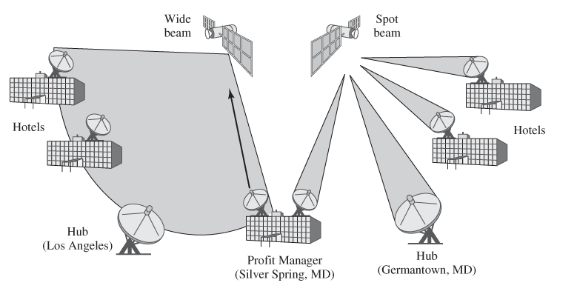

Figure VIII.1 Choice Hotels U.S. Network

Guest Internet Access
In 2004, choice began implementing free high-speed Internet access for all guests in its Clarion Hotels and Comfort Suites, using 3Com equipment. The implementation uses an efficient combination of wireless and wired access within each hotel [3COM04, 3COM06].
To be able to affordably provide Internet service, hotels have traditionally invested in expensive and disruptive construction, including the installation of additional cabling and forcing the closing of income-producing rooms. To recover their costs, hotels normally surcharge by the minute for Internet access—which is exactly the situation Choice Hotels wished to avoid. To allow its franchises to affordably fulfill its mandate, Choice Hotels needed a powerful, low-cost network solution that could be installed quickly and easily.
Access is provided in wireless and wired modes. For wireless access, each hotel implements Wi-Fi that serves all guest rooms. Using the 3Com Wi-Fi network, guests are able to check e-mail, exchange files, and browse the Web at speeds up to 54 Mbps. Built-in encryption and support for multiple security options help safeguard data as they travel over the wireless network. With each access point supporting up to 256 users, setting up conference room connectivity requires no additional wiring or IT assistance to provide ample bandwidth even to large groups.
Users without wireless capabilities will be able to plug their laptops into 3Com wireless LAN workgroup bridges in guest rooms and hotel data centers for immediate connectivity.

Discussion Questions
- 1. Perhaps the major drawback to a satellite-based system is latency. The delays can be noticeable on some online applications. Discuss what issues this might raise for the Choice suite of applications.
- 2. What issues would you expect to arise as Choice moves to expand the network to full global reach?

