Group Research Paper: Solar Irrigation System in Tanzania
Our core argument: We wish to create a solar water pump irrigation system in order to improve the agricultural sector of Tanzania.
- Introduction to Study:
  - Population growth and GDP:
Tanzania is positioned number ten among the 47 countries in the Sub-Saharan Africa region. Its overall score with regards to economic freedom is above the regional average but below the world average. Tanzania, as a country has one of the very lowest world’s levels of income per capita. However, agriculture accounts for most exports and employment opportunities since it offers two-thirds of the jobs. The vast economic growth rate is as a result of its wealth in natural resources and tourism. The country currently faces development challenges especially in the areas of economic distribution, corruption, and population growth. Besides, new economic opportunities are arising and have the potential of making the necessary changes and reforms. Since independence, Tanzania has experienced high growth in population from approximately 11 million in the 1960’s to 45 million in 2012. The population is still high and steady and forecasted to grow to 53 million in the year 2018.
The major cause of the constant poverty level in the country despite its economic growth is the failure of Tanzania not being able to raise its productivity levels in the agriculture sector which contributes to half of the country’s GDP. The country is predominantly agricultural having approximately three-quarters of its population living in the rural areas. Growth, especially in the agricultural sector, is still low at 4% per year. Significant support and resources have been used in the past to improve other sectors of the economy with agriculture been left out. Agricultural production is still low due to lack of adoption of new technology available on the same. The country still depends on rainfall based agriculture since most farmers rely on the annual rainy seasons. The recent changes in the rainfall patterns have lowered the overall agricultural productivity. This has, in turn, created problems in food security and production in most parts of the country. This paper is aimed at discussing a solar irrigation system which is believed to offer a remedy to the current problems in the agricultural sector caused by climate change.
  - Agricultural background of Tanzania:
The United Republic of Tanzania’s populace and economy is profoundly reliant on the agricultural sector for livelihood and income respectively. According to Ronner and Giller (2013), crop production and livestock account for 55 percent and 30 percent of the country’s GDP respectively. The leading crops for export comprise tea, cotton, tobacco, coffee and sugar. Further, there are staple crops such as millet, rice, maize, cassava and sorghum (Logwa, 2010).
However, the agro-ecosystem of Tanzania is characterized by the extreme variability of rainfall and extensive dry lands which become a hindrance to the sector’s productivity. According to Mtega and Msungu (2013), the lack of productivity leads to the degradation of land hence becoming scarcer especially in areas which have a large population. Therefore, the primary factors that the Ministry of Agriculture in Tanzania has identified as constraining the prospective growth and development of the agricultural sector comprise inadequate arable land (25 percent) under cultivation, limited mechanization and inputs, inadequate services of research and extension and last but not the least insufficient irrigation (Logwa, 2010).
According to Mdee et al. (2014), only approximately 1.8 percent of Tanzania’s land is under irrigation, although this varies across regions. The land under irrigation depends on the amount of rainfall in that particular region. However, the irrigation systems used in Tanzania are mostly unreliable. This is because they encounter social and technical challenges hence leading to unworthy returns (Mdee et al., 2014). Therefore, investing in better and reliable systems of irrigation will not only enable the country to be food secure in response to the population growth but also boost the growth of the economy through the increase in agricultural exports.
One way of improving the agricultural sector by enhancing the irrigation systems is the creation of a Solar Irrigation System (Harishankar et al., 2014). The establishment of a solar water pump irrigation system will provide a reliable source of water for the crops especially when the amount of water necessary is high. This will improve the agricultural sector in Tanzania.
- Motivation:
  - Why Tanzania:
There are several reasons as to why we chose to create solar water pump irrigation system in Tanzania. Agriculture land in Tanzania is measured at 396,500 square kilometers which is 65% of the total area. Agriculture sector employs 85% of rural workforce and therefore creates main source of employment opportunities to individuals. Farmers produces both non-farm and farm business crops for export. Two third of the population depends on agriculture as it the main source of income and the larger part of the population depends on agricultural for food (Higgins 2011). The country’s main export cash crops are tobacco, cashew-nuts, coffee, tea, cloves, cotton and sisal. Although there is economic growth and opportunities in agriculture, we find that poverty is the major problem to individuals in the country. Majority of individuals are characterized with BOP factors, i.e. large population with an average of 2$ a month. Since agriculture is a key factor in supporting upward mobility, we found that, introduction to solar pump for irrigation would be the best option to boost agriculture in the area.
Tanzania has also experienced substantial growth over the past decade. GDP growth per annum is dearly 4.1% in 1998 to 7.4% in 2016 (Ministry of Finance and Economic Affairs, 2017) but this has not been accompanied by a significant reduction in poverty, 35.7% of people still living below the poverty line. Main reason is because, most of people depend on agriculture, which depends on the availability of rain. There are no reliable rainy seasons along the region therefore makes it hard for individual to predict reliable outcomes of agricultural production. With the availability of solar pump, will not only reduce over dependence on rain-fed agriculture but will also increase production.
Tanzania is characterized with sunny days throughout the year, the application of solar pump for irrigation will be cheap and easy to use as it is recharged with sun; this will enable individuals to get away with energy challenges from the use of pumps that depends on fuel and power as part of agricultural inputs, hence low cost of production.
Tanzania is also facing dry seasons throughout the year, 65% of season in the year is drought season mostly around coastal shores where there is huge population (Magrath, 2015). Solar pumps will enhance irrigation system as these will be cheap to provide reliable water solution. It will enable accessibility of water throughout the year, and therefore buffer the effects of drought and overcome water stress during dry season.
  - Environmental and existing water systems:
Being a tropical country, Tanzania is entirely experiencing associated climatic conditions such as hot, humid, semi-arid, high rainfall and temperate during various times of the year (Mongi, Majule & Lyimo 21). As a result, agricultural activities are practiced on a seasonal basis as dictated by the prevailing climatic conditions. However, it was noted that Tanzania is comprised of adequate water bodies which can be harnessed to support irrigation through solar powered systems.
This research was developed to implement a solar-powered irrigation system in which the day's sunlight would be harnessed by photovoltaic cells, thus converting them to electric energy. The energy generated is then used to power submersible pumps to water tanks and crop fields. The system is also composed of high voltage batteries for storing excess energy for use during night hours (Kelley et al 2669).
Considering the nature of this installation, it can be concluded that this system is very much affordable to implement. Additionally, it will be useful in supporting full-time agriculture as well as supplying water for multipurpose uses like domestic needs. Lastly, it can be observed that the system is unlikely to be affected by environmental conditions because of its clean renewable energy.
- Nature of the Study:
- Our research will primarily be done using quantitative and qualitative data procured by other researchers. By using online databases we will find reliable sources which outline economic and environmental issues in Tanzania. We will find data from interviews and studies that have been conducted by scientists and researchers on the subject of Tanzania agriculture. Using their data we will explain the needs and limitations of the agricultural sector of Tanzania. We will then conduct more research through online journals and articles to show what strategies have already been put in place to help solve the problem of useful and cost-effective irrigation systems.
We will then research what the social, economic, and environmental limitations in Tanzania are so we can better understand the parameters in which to work in. Using the data from the surveys and from our online research we will then try and outline how to create a solar powered water pump to be used in irrigation systems in Tanzania. This innovation will have to fit within the limitations of Tanzania’s social, economic, and environmental situations, so we must carefully plan and research all areas of our innovation before proposing the finished product or idea.
Part of that research will include examining existing water pumps used in other agricultural sectors to determine what the benefits and fall backs of those existing systems are. We will also have to research how solar power works in both the mechanical sense and how cost-effective it is as a power source. We will also have to research how our finished product would fit in the Tanzania agricultural sector. Will it be affordable? Will it be useful? Can it be multi purposeful? Will any environmental factors inhibit our invention? We must try and create a foolproof, solar, water pump irrigation system for the agricultural sector of Tanzania. And we will be able to accomplish this through the numerous research methods talked about above.

Literary Reviews:
- Theories:
Frugal Innovation Theory:
Frugal innovation is essentially an innovation that is created even when there are financial, technological, or resources constraints. Like, for example, a young man in Africa created a windmill out of scraps from the junkyard to produce electricity for his family’s home and to run a water pump system for their irrigation system. Hossain et al. gives a more elaborate definition;
Frugal innovation as a resource scarce solution (i.e., product, service, process, or business model) that is designed and implemented despite financial, technological, material or other resource constraints, whereby the final outcome is significantly cheaper than competitive offerings (if available) and is good enough to meet the basic needs of customers who would otherwise remain underserved (2016, p. 133).
The most important thing to remember about Frugal Innovation Theory is that the end result (product or service) must be as affordable as possible. Almost all innovations created within BOP markets would be considered frugal innovations because they are created with limited resources and must be affordable because the consumers are from the lowest incomes possible.
This theory applies to our innovation in almost every way. The innovation we are creating is geared towards a BOP market, the agricultural sector of Tanzania, therefore it must be affordable. We must also take into consideration what types of materials and resources we may have available when creating this solar powered water pump for irrigation systems. All materials used to create this pump must be cheap and accessible to the people of Tanzania. Also, by finding cheap material to make the pump it will help us keep the overall price of the product down which makes it more affordable for our consumers. It is also very important that our product meet the basic needs of the consumer, just like the Frugal Innovation Theory requires. The basic need of our consumer, in this case, is to have a more efficient way to water all of their crops, i.e. not manually. We intend for our solar powered water pump to be affordable, accessible, and to meet the needs of the agricultural sector of Tanzania.
References
Hossain, M. (n.d.). Frugal innovation: A review and research agenda. Journal of Cleaner Production, 182, 926-936. https://doi.org/10.1016/j,jclepro.2018.02.091
Disruptive Innovation Theory:
The Disruptive Innovation Theory is a theory which explains the phenomenon through which a new technology transforms an existing market or industry by introducing convenience, simplicity, affordability, and accessibility as coined by Harvard Professor, Mr. Clayton M. Christensen in his book, The Innovator’s Dilemma. Clayton explains that an innovation may at its initial stages of the invention appear to be inconsequential or unattractive to the existing firms in an industry, but at the end, the innovation redefines the market or the industry.
The most important thing to remember is that a disruptive innovation is a positive force which does not make goods and services better; instead, it makes goods and services more accessible and affordable to a wide range of users in the market.
The Disruptive Innovative theory applies to our study in several ways. For instance, since we want to reach many Tanzanian farmers who form two-thirds of our population, the solar-powered irrigation pump will be made available to these people to ease for their usage such that they can improve their agricultural yields. In other words, the new solar irrigation pump should be made cheaper than the existing sources of farm energy. Additionally, in developing the solar irrigation pump, the innovators need to use more affordable and accessible materials to the majority of the Tanzanians. As Clayton suggests in his theory, it is also imperative that our product meets the basic needs of the consumer for it to compete with the current sources of farm energy. In this case, the basic requirement of our consumer is to have a more efficient way to water all of their crops. We intend that our solar-powered water pump will be affordable, accessible, and meet the needs of the agricultural sector of Tanzania.
Uppsala Internationalization Theory by Beckerman (1956):
Internationalization is the process by which businesses or firms focus their core opportunities in a foreign environment. The Uppsala internationalization model (U-model) is a model used by firms in selecting a market and entry mode while going international. The model was developed by watching of four Swedish multinational companies. The theory discusses four main aspects that a firm is supposed to follow while going international. They range from knowledge of the market, market commitment, committing to making decisions, and the establishment of current activities as stated by Sandberg, (2012). The model is founded on the conception that the process of international expansion is driven by knowledge development when doing business in a new market, therefore generating the opportunity to take advantages of the opportunities arising in the market.
The model will be useful for our project since Tanzania is a foreign market and we will require to have a guide on how to explore the market opportunities effectively. The U-model will help us develop a market commitment that will help our solar system irrigation grow and boost the agricultural sector economy of Tanzania. We will need to determine what resources we need to commit for our project since our knowledge will be mainly experiential. The model will help us identify the level of risk linked to entering new markets. Investing in a foreign market might risk losing resources that is why we will need the commitment to decision making and establishing current activities required for the success of the project. The model also gives an insight into the best entry mode based on different variables. Therefore, Uppsala internationalization will be critical in guiding our solar system project in Tanzania (Sandberg, 2012).
Country Similarity Theory by Linder (1961):
Country similarity theory is also called Linder hypothesis. This hypothesis was put forward by economist Staffan Burenstam Linder in 1961. Linder hypothesis explains that countries with similar demand structures are more likely to trade with each other. For instance, Developed countries trade more with developed countries because their demand and user conditions are matched; Countries in same cultural milieu trade more amongst themselves because their family functions, rites, rituals, entertainments, religious ceremonies and so on are similar (Country Similarity Theory of International Trade, N, D). Similarly, in the BOP market, some countries have similar demand structures to some extent. Therefore, based on this theory, we can also explore and develop new markets and strengthen our innovative product.
At present, the target market of innovative Solar Irrigation System is Tanzania. Because of the abundant sunshine and the lack of water resources, we can draw a conclusion that the Solar Irrigation System may be popular in countries and regions around Tanzania due to the similar geographical and climatic conditions. Secondly, according to the industrial structure, many countries in the BOP market are dominated by agriculture. The reason is heavy industry and service-oriented industries are difficult to develop because of underdeveloped economies or technological constraints. However, our products focus on innovation in BOP markets and developing countries/regions, low cost and practicality are advantages, so the demand for agriculture means that the solar irrigation system could be used in other less developed areas outside Africa. Moreover, we can continue to improve and develop different products to meet the needs of other countries/regions. Therefore, this theory is quite applicable to our products. It can help us develop bigger markets and promote product upgrades to ensure that we keep innovating.
3. Methodology:
- Qualitative:
Our main forms of qualitative data will come from interviews, participant observation and individual interviews. Through observation, we will focus to know which products are common in the market and how they can be produced in a simple process. Since many of the agricultural products do not take long to mature, focusing on the products that can be exported will be one of our tasks. This is to ensure that the solar system will not only be of importance to the citizens’ consumption but also for the government’s revenue. Also, in order to make the research more credible, we will involve descriptive, correlational, causal-comparative, and experimental forms of research.
Individual interviews will also be a fruitful way for us to have a clear understanding of how citizens think about the introduction of the new form of irrigation (Harishankar, 2014). By these interviews, we will be able to understand which areas will need more effort and more attention to ensure that the project is fully operational. We will do interview in conjunction with correlational form of research to ensure we compare the previous and current forms of farming.
Another form of qualitative method that we will use is group discussion. This is where we will be able to discuss all the experimental work and other factors coming up in the research. In addition, we will be able to come up with the best option on how to ensure that the solar system application has been affected and it is fully operational (Aly & Pedersen, 2017). Also, we will be able to discuss other possible means that can be used to avoid delays and other complications.
References
Harishankar, S., et al. "Solar powered smart irrigation system." Advance in Electronic and Electric Engineering 4.4 (2014): 341-346.
Aly, A., Jensen, S. S., & Pedersen, A. B. (2017). Solar power potential of Tanzania: Identifying CSP and PV hot spots through a GIS multicriteria decision making analysis. Renewable Energy, 113, 159-175.
- Quantitative:
Quantitative methods emphasize objective measurement, public opinion surveys, questionnaires and data statistics, using mathematical or computational techniques to systematically examine social phenomena (Wienclaw, 2013). According to research, quantitative methods are used to examine the relationship between variables with the primary goal being to analyze and represent that relationship mathematically through statistical analysis (An Overview of Quantitative Research, N, D).
Based on quantitative method, we focus on the analysis of the collected data rather than the means of investigation. We create some questions that can be analyzed by numbers or ranges. For example, first of all, we use public opinion surveys to find out the willingness of local agricultural workers to use the solar-powered irrigation system. This problem can be easily scored into two answers, yes and no. For those who choose "yes", we can continue to investigate and summarize the five factors that affect their wishes. Similarly, for people who choose no, we continue to investigate five factors that influence their refusal to use the irrigation system. This method can help us judge whether the product can get the support of the local people, successfully enter the local market, and analyze advantages of our products in the local market and problems faced by us.
Next, we investigate the degree of affordability of local agricultural workers. We still focus on all the participants above, not just the "yes" participants. Because that way we can see if some of the participants who choose "no" will change their view because of price factors. We estimated the purchase cost, use cost and maintenance cost of the solar irrigation system beforehand. After collecting the survey data, we can observe the mode, that is, the affordability of the product for most people. At the same time, we can compare the number of people who choose"not affordable" and the number of people who choose "not willing". The investigation of this problem can help us judge whether the product can develop well locally.
Reference
Wienclaw, R. A. (2013). Quantitative and Qualitative Analysis. Research Starters: Sociology
(Online Edition). Retrieved from:
http://ezproxy.snhu.edu/login?url=https://search.ebscohost.com/login.aspx?direct=true&d
b=ers&AN=89185655&site=eds-live&scope=site
An Overview of Quantitative Research. (N,D). Center for innovation in research and teaching.
https://cirt.gcu.edu/research/developmentresources/research_ready/quantresearch/overview_quant
- Case Studies:
Case studies are one of several ways of doing research. It includes but is not limited to experiments, surveys, histories and economic etiologic research (Robert Y. Kim, (2009). Case studies are the preferred method when a “how” or “why” question is being posed and where investigators have little control over events. In most cases, this method works better when evidence is gathered on real life context. Case studies are more practical and qualitative and utilizes a particular type of evidence through process tracing, historical or field research. In general, case studies are the studies involved in collecting information through guided questions using several data sources, through interviews and participatory observations, which eventual enable individuals to make decision (Malcon T. 2017).
Since our intention is to introduce affordable water pumps to the agricultural sector of Tanzania, we will develop a “how” or ‘why” question that will be rationale for the case study. We will perform various studies on why and how the use of these pumps are necessary to the population. Since we already know the need for this machine, the key issue here will be to know who are the beneficiary, where and how to make it effective to perform the intended objectives.
On of the advantages of case studies is that they are easy to obtain data from simple designs that we create. Case studies are not complicated as details are gathered based on real life context and so benefits are clearly seen. While performing a case study, other solutions to the problems can be obtained which can be used later for other experiments. Finally, the results can create better solutions to the society. The disadvantages may however be that, if the case studies are not scientific, they may lead to wrong decision making especially where data is bias.
References
Robert Y. Kim (2009) Case Study Research: Design and Methods; 8th Edition
Sage Inc Publications, London EC1Y ISP, United Kingdom
Malcom Tight (2017) Understanding Case Study Research: Small- Scale Research with
Meaning. Sage Publications, Thousand Oaks, California 91320
- Survey:
We have created a simple four question survey to get Tanzanians’ opinions on our possible product. This survey will be done online and sent out through social media, email and texts to as many Tanzanians as we can reach. Our survey will focus on the knowledge that our participants have of the agricultural sector of Tanzania. We are focusing on this because our innovation is going to be vital to the everyday life of those working in the agricultural sector of Tanzania. It is important to understand what the general population of Tanzania thinks about this this product because they will be the first potential buyers.
The first question in our survey is “Do you or have you ever lived in Tanzania?” this is a yes or no question and we ask this because it is important to understand if our survey participants have first hand experience with the region in which we are targeting. Our second question is “What methods are used by Tanzanian farmers to water their crops, that you know of?” this is a checklist question because there may be multiple methods used in Tanzania. This question is asked to get an idea of the products and methods we may be competing with. This knowledge can be used to create the most updated, useful, and affordable product.
The third question we ask participants is “Do you believe a solar powered water pump for irrigation systems would make the day-to-day life of Tanzanian farmers more productive?” this is also a yes or no question. This question is asked to see if the general population believes this product will actually be useful and helpful to Tanzanian farmers.. Our fourth and final question is “If a solar powered water pump for irrigation systems was made affordable and accessible, do you think Tanzanian farmers would purchase one?” and this is a yes or no question. We ask this question because it is important to see how many participants believe a solar powered water pump would be a product purchased and used by this market. If the general population believes this product will not be bought then it may be best to come up with an alternative.
This is the link to our online survey: https://goo.gl/forms/dQdjh5L5yOoDXya33

4. Research Findings and Discussion:
  - Explain the finding of the study

Survey Results:
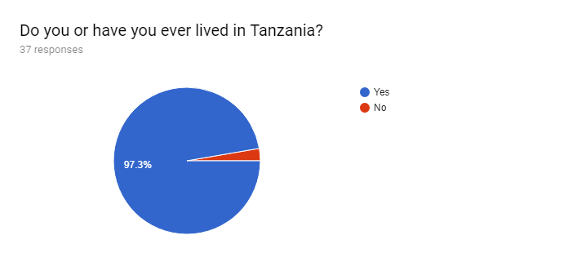
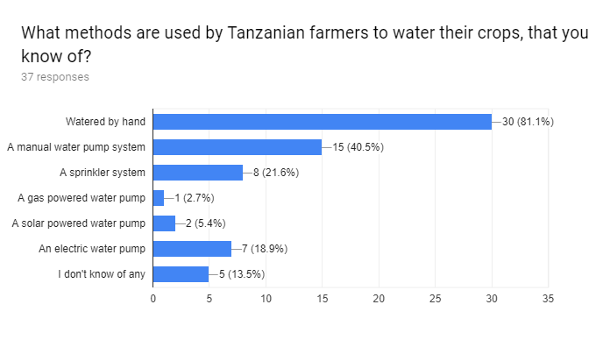
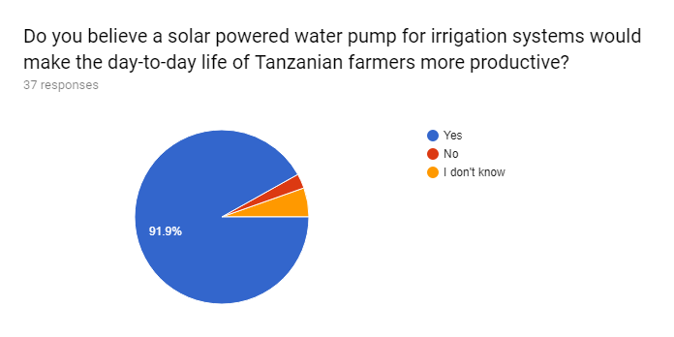
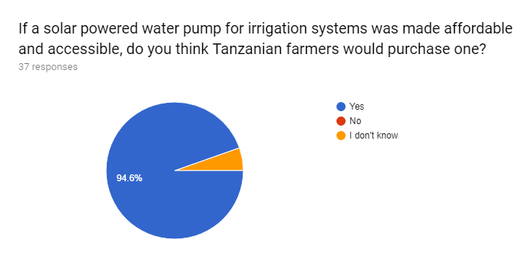
5. Conclusion:
  - Future research recommendation
  - Study limitations
  - Reflection

- Conceptual Framework: consider framework for bop market

