‘Weaponized Ad Technology’: Facebook’s
Moneymaker Gets a Critical Eye
Image
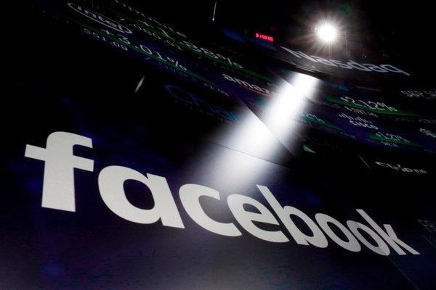
Government officials, researchers and advertising executives have warned that microtargeting tools, like the kind Facebook offers, can be exploited to polarize and manipulate voters.CreditCreditRichard Drew/Associated Press
By Natasha Singer
• Aug. 16, 2018
Facebook has made a mint by enabling advertisers to identify and reach the very people most likely to react to their messages. Ad buyers can select audiences based on details like a user’s location, political leanings and interests as specific as the Museum of the Confederacy or online gambling. And they can aim their ads at as few as 20 of the 1.5 billion daily users of the social network.
Brands love it. So do political campaigns, like those for President Trump and former President Barack Obama, which tailored their messages to narrow subsets of voters.
But microtargeting, as the technique is called, is coming under increased scrutiny in the United
States and Europe. Some government officials, researchers and advertising executives warn that it can be exploited to polarize and manipulate voters. And they are calling for restrictions on its use in politics, even after Facebook, in response to criticism, recently limited some of the targeting categories available to advertisers.
“It has essentially weaponized ad technology designed for consumer products and services,” said
Sarah Golding, the president of the Institute of Practitioners in Advertising, an industry organization in Britain. Her group recently called for a moratorium on political microtargeting. “There is a danger that every single person can get their own concerns played back to them,” she said.
Facebook is just one player among tech giants like Google and Twitter that also offer datamining services to try to influence consumer and voter behavior. But Facebook’s gargantuan reach, vast holdings of user data and easy-to-use self-service advertising system have made it a lightning rod for political microtargeting.
Much of the new attention being paid to microtargeted advertising has emerged from investigations into how Russian groups interfered in elections and how the voter-profiling company Cambridge Analytica harvested the data of millions of Facebook users. Microtargeting, they have found, was a central tool for foreign groups trying to interfere in elections.
In Britain, a report in July on political campaigning from the Information Commissioner’s Office, the government data protection authority, called for an “ethical pause” on the use of personal information in political microtargeting so that regulators and companies could consider the technology’s implications.
“These techniques raise fundamental questions about the relationship between privacy and democracy, as concerns about voter surveillance could lead to disengagement with the political process,” Elizabeth Denham, the British information commissioner, wrote in the report.
Last month, a report from a British Parliament committee investigating fraudulent news criticized the “relentless targeting of hyper-partisan views, which play to the fears and prejudices of people, in order to influence their voting plans and their behavior.” It also called for curbs on some microtargeting.
New research on how groups tied to the Kremlin exploited the technology during the 2016 presidential election in the United States is also raising concerns.
A report this week from Young Mie Kim, a professor at the University of Wisconsin-Madison, described how a Kremlin-linked group, called the Internet Research Agency, used Facebook’s ad system to identify nonwhite voters. Then the group tried to discourage those people from voting.
Image
Young Mie Kim, a professor at the University of Wisconsin-Madison who studies online political advertising.CreditJustin T. Gellerson for The New York Times
A week before the election, for instance, the Russian group paid Facebook to aim an ad at users interested in African-American history, the civil rights movement, Martin Luther King Jr. and Malcolm X with a seemingly benign post. The ad included a photo of Beyoncé’s backup dancers.
“Black girl magic!” the ad said, according to Facebook ads recently released by federal lawmakers.
Then on Election Day, the same Russian group sent the same Facebook user demographic an ad urging them to boycott the presidential election.
“No one represents Black people. Don’t go to vote,” the ad said.
“Russian groups appeared to identify and target nonwhite voters months before the election with benign messages promoting racial identity,” Professor Kim, who studies online political ads, wrote in the report. By singling out the same individuals on Facebook, she added, “these groups later appeared to interfere in the elections with voter suppression messages.” Image
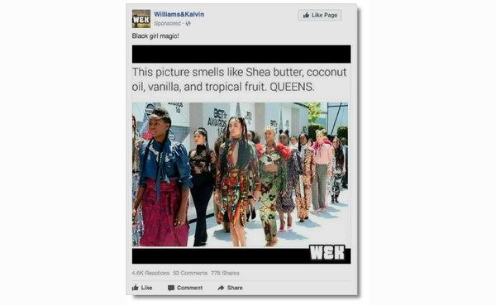
A Russian group first targeted Facebook users interested in Martin Luther King Jr., AfricanAmerican history or Malcolm X with a benign-seeming ad.
Image
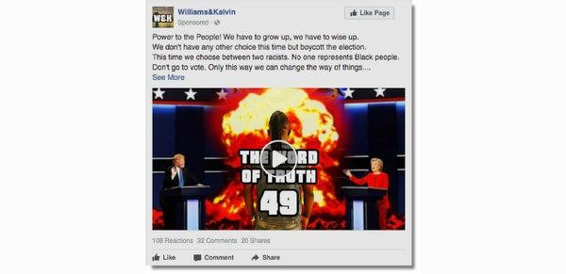
The Russian group then targeted the same users with an ad telling them that they should not vote in the presidential election.
In the wake of Russian interference in the 2016 election, Facebook has made major changes to try to deter subversive groups from exploiting its system.
In May, Facebook said it had removed almost one third of the ad-targeting categories used by the
Russian voter interference group. Those included segments like “Young, Black and
Professional,” “Indigenous People of the Americas” and “Help Disabled Veterans.”
In addition, Facebook has removed the option for advertisers to exclude users in certain sensitive categories — like race, ethnicity, sexual orientation and religion — from seeing ads. Those changes were made after articles by ProPublica, the investigative news organization, criticized Facebook’s ad system.
But there remain many categories available to political and other advertisers, including selecting audiences by their ZIP code, education level, brand of smartphone, and whether they are politically moderate, very conservative or very liberal.
Facebook has also said that it would require anyone seeking to run a political campaign or political issue ad to confirm their identity and location as well as disclose who paid for the ad. In May, Facebook introduced an archive containing political ads shown on Facebook and
Instagram. It includes information on the ad costs, viewership and certain demographics of the ad audience.
“This is by far the best transparency effort that any of the social media platforms have given us,” said Laura Edelson, a doctoral student at New York University who researches political ads on social media.
Rob Leathern, director of product management at Facebook, said the archive and other changes would “help prevent the abuse” of the company’s advertising tools.
“It’s no longer possible to advertise in obscurity on Facebook,” Mr. Leathern said in a statement.
But critics, including some civil rights experts and researchers, say that Facebook’s recent efforts have done little to disable microtargeting as an engine of voter manipulation. The company’s new political ad archive, for instance, does not include details on the criteria used to target voters.
In the United States, a bill introduced in the Senate, called the Honest Ads Act, would require online services to provide descriptions of each audience targeted by a political ad. The bill, introduced by Senators Mark Warner of Virginia and Amy Klobuchar of Minnesota, both Democrats, as well as Senator John McCain, Republican of Arizona, is still in committee.
Some experts warn that curbing microtargeting too much could have negative consequences. They say it could limit the political information received by first-time voters or new immigrants, who are already low priorities for many campaigns.
“If we overcorrect too much and we take away the ability to reach people who might be less intrinsically engaged in politics, then we also lose the capacity to try to make them excited about participating in politics,” said Daniel Kreiss, an associate professor at the University of North Carolina, Chapel Hill, who studies political microtargeting.
The problem, critics of microtargeting say, is that even a small amount of money could potentially have large negative effects.
To stoke anxiety among Latinos last year, for instance, the Internet Research Agency used Facebook to aim an ad at users interested in Mexico, Latin hip-hop and the Chicano Movement.
The ad showed a cartoon of immigrants standing in front of a barbed-wire border with a “No Trespassing” sign. “We didn’t come to steal your jobs,” it said, “we came to make a living.”
The Russian group paid 10.6 rubles — about 16 cents — for the Facebook ad, which was seen 283 times. But the targeting was so successful that the selected group spread the ad, which eventually racked up 16,000 reactions and 95,000 shares.

