Shuk Yan Cho
Dr. Dayna Chatman
J 320
10th October, 2018
A Meme challenging the Heterosexuality Dominance
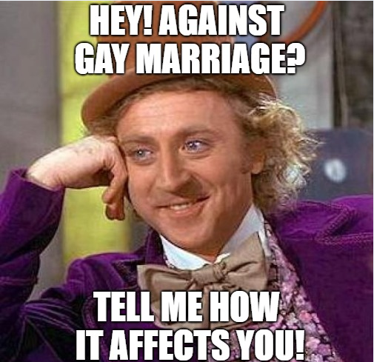
This meme challenges the heterosexual dominance which has been perceived by the society as the accepted and the normal way of sexual relations. In a long period, the society, social institutions as well as the media have contributed much in ensuring that heterosexuality has remained grounded from generations to generations. The society and these social institutions have brought about one assumption that the only way of living is “marriage” which is a mutual link between two people who have attained the maturity age (Dowson 162). According to the norms, the relationship only applies to heterosexuals and carried out by heterosexuals. These perceived “norms” have impacted the lives of gay people leading to some getting laid off, being tortured, denied an opportunity to serve their native countries in a quest to force them to conform to the heterosexual ways. This means that the people who identify themselves as gay are deemed to be deviant to the values of the society. However, from the discussions below drawn from Avila Saavedra’s work show that indeed they are not deviant.
To begin with, the definitions of sexuality are developed by the society to oppress or punish those people who don’t conform to the heterosexual way of living (Foucault, 5). Foucault’s ideas and gay literary studies have led to the development of the queer theory which dismisses the inflexible definitions of sexuality. The word “queer” means something which is deemed odd or even strange and disapprove definitions which it considers emanated from debates of post-structuralism. The theory highlights how power is applied in the modern era society to define what is acceptable and what is not. Brookey (42) states that the main purpose of applying queer theory is to illustrate how culture is central to sexuality in instilling heterosexuality as the normal way of living. Therefore, heterosexuality to be regarded as normality is just dictated by the culture which should not bind everyone.
Besides, queer studies state that sexuality is a broad concept and is not limited to heterosexuality and homosexuality. Since queer is opposed to what is perceived as normal, it may also fight those practices by the gay community which are regarded as normal. This provides queer with a broader sense in dealing with many things which are not limited to sexuality since it involves all that which is perceived as normal. As a result, it can be used as an alternative of domination and use of force to normalize the social structures and cultures. In other studies, Berlant et al. (193) state that normalization of heterosexuality makes it privileged as well as desirable. This means that the domination heterosexuality enjoys is derived from the desirability which has been created by social institutions through power struggles. Since the gay community is the minority, then the power struggle, in this case, will be won by the heterosexuals who enjoy much support from the society.
Moreover, identities of gay as well as lesbians are appearing in media in a conservative way and at times when they have no negativity concerning values of heterosexuals. The gays are presented in media in an acceptable manner by the heterosexuals in that they embrace the values of family, marrying of one partner as well as stability. These are values which are deemed to be traditional and are mostly upheld by the heterosexuals as well as the society (Avila- Saavedra 8). The values of the gay community which were perceived as undesirable have been done away with, and therefore the gay males don’t face challenges when they appear in media. When appearing in media, the focus should be concentrated on assessing whether the individual or the image he or she is representing portray the traits which are acceptable as well as desirable by the heterosexual people instead of focusing on the effeminate character (Avila- Saavedra 8). Assessment should be done to ensure only selected, and a desirable image is revealed. Therefore, as long as the people who identify themselves as gay (s) embrace the values which are welcomed by the heterosexuals, they should enjoy their space without many limitations since their behavior or action doesn’t harm the heterosexuals.
In conclusion, the increase in the gay community doesn’t disrupt or interfere with heterosexual values and norms. According to the queer studies, regarding heterosexual is a narrative which should be considered as relative as the definitions of sexuality don’t refer to either heterosexuality or homogeneity. On the other side, the gay community or the homosexuals have their narrative which should also be given an ear just like heterosexuals’. Consequently, heterosexuality is only imposed by the society through its social institutions. The dominance of the heterosexuality is as a result of power struggles in the society and the homosexuals being the minority they have little space. However, having embraced values desirable as those of heterosexuals such as family, they should find space in the society as well.

Works Cited
Avila-Saavedra, Guillermo. "Nothing queer about queer television: Televized construction of gay masculinities." Media, Culture & Society 31.1 (2009): 5-21.
Berlant, Lauren, Elizabeth Freeman, and Michael Warner. "Fear of a queer planet: Queer politics and social theory." (1993): 193.
Brookey, Robert Alan. "A community like Philadelphia." Western Journal of Communication (includes Communication Reports) 60.1 (1996): 40-56.
Dowson, Thomas A. "Why queer archaeology? An introduction." World Archaeology 32.2 (2000): 161-165.
Foucault, Michel. "TTie History of Sexuality; volume 1: An Introduction." (1978).
Jagose, Annamarie. Queer theory: An introduction. NYU Press, 1996.

