Unit 3

Content
- Project Procurement and Budgeting

Introduction
Unit 3 will focus on articulating the goals of a project, recognizing opportunities, and identifying the direct and indirect costs associated with achieving results.
Most projects start with a capital budget request for a new piece of equipment or a service line. These capital requests include a pro forma or proposed budget that is approved by the project manager. Good estimates are important in the proposed budget because the project manager will be held accountable for accuracy.

Getting Buy-In
In order to achieve stakeholder buy-in, the concept of return on investment (ROI) is used to measure the amount of return on a project relative to its cost. Forecasting the costs from the project, followed by the expected gains and associated expenses determines its profitability. The more profit that can be made from a project leads to a greater chance for stakeholder buy-in.

Learning Activities
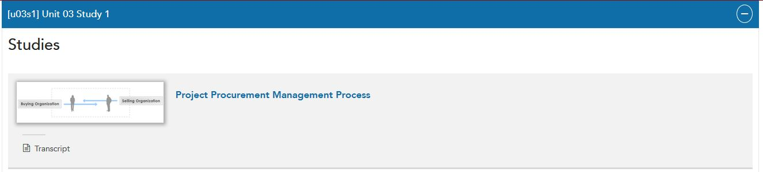

Transcript: Project Cost Estimate
Cost Estimate Template
The cost estimate is a breakdown of the project for each resource. Your cost estimate may include, but is not limited to: manufacturing, marketing, and personnel.
Constraints, Dependencies, and Assumptions
You must identify the project constraints, dependencies, and assumptions that relate directly to the project budget. This is your opportunity to bring these concerns to your project sponsors and stakeholders. This is another place where you have the ability to document your concerns.

Credits
Presenter:
Kris Luopa
Interactive Design:
Marc Ashmore
Instructional Design:
Graeme Braithwaite
Project Management:
David Balthazor

Transcript: Project Cost Estimate
Cost Estimate Template
The cost estimate is a breakdown of the project for each resource. Your cost estimate may include, but is not limited to: manufacturing, marketing, and personnel.
Constraints, Dependencies, and Assumptions
You must identify the project constraints, dependencies, and assumptions that relate directly to the project budget. This is your opportunity to bring these concerns to your project sponsors and stakeholders. This is another place where you have the ability to document your concerns.

Credits
Presenter:
Kris Luopa
Interactive Design:
Marc Ashmore
Instructional Design:
Graeme Braithwaite
Project Management:
David Balthazor

Required

Readings
Use your textbook, Project Management in Practice, to read the following:
- Chapter 4, "Budgeting the Project," pages 109–144.
- Chapter 6, "Allocating Resources to the Project," pages 186–233.
Use the Capella library to complete the following:
- In A Guide to the Project Management Body of Knowledge (PMBOK® Guide).
  - Read Chapter 12, “Project Procurement Management,” pages 147–160.

Multimedia
- Click Project Procurement Management Process to explore the six processes of project procurement management.
- Click Project Cost Estimate to listen to Kris Luopa, PhD, talk briefly about the cost estimate timetables and constraints, dependencies, and assumptions.
  - Running time: 0:36.

Optional
- Project Management Institute Web site.
- Health Administration Masters Research Guide.

Learning Components
This activity will help you achieve the following learning components:
- Learn how to allocate resources to a project.
- Study budgeting and project procurement processes.
- Examine sources of information used for budgeting.

------------------------------------------------------------------------------------------------------

[u03a1] Unit 03 Assignment 1

Getting Commitment and Buy-In

Overview
The intended outcome for this assignment is to get commitment and buy-in from senior leadership/C-suite for your project. Remember this document is one in a series of deliverables that can be used to move a project forward.
Starting with the feedback you received in the discussions in Unit 2, you will be building upon your project scope and charter documents to create a project procurement plan that reflects the goals and objectives for the project.
Start by forecasting the budgetary requirements for the project.

Cost Estimate
Based on the project's objectives, in a workplace setting you would use Microsoft Excel, Microsoft Project, or other appropriate software of your choice to forecast the budgetary requirements for the project. For the purposes of this assignment, use the Project Cost Estimate template as a guide for your forecasting. You will find the template linked in Resources.
- As part of the budget, define the constraints, dependencies, and assumptions. Also, forecast the time and resources required to coordinate the work and meet project objectives.

Project Procurement Plan
Compose your document in the form and style that is expected by senior leadership in the scenario you selected in Unit 1. Note: If your workplace does not have a prescribed format, search the Internet for examples and select a style that best fits this assignment.
Be certain your written plan includes the following elements:
- Creates a project procurement plan that integrates project scope and project charter into the overall plan, and identifies areas of uncertainty or knowledge gaps. A description of the processes for conducting and administering procurement, including how the relevant procurement management tools and techniques will be used.
- Defines the processes for conducting and administering project procurement, and identifies criteria that could be used to evaluate the processes.
- Forecasts project time and resource requirements, and identifies assumptions on which the forecasts are based.
- Forecasts project budgeting requirements, and identifies areas of uncertainty or knowledge gaps.
  - Attach a cost estimate spreadsheet as an addendum to your plan.
- Writes clearly and concisely in a form and style consistent with professional health administration project management communications. Source attributions are correctly formatted. Grammar and mechanics are virtually error free.
- Adheres to APA style and formatting when citing sources with no errors.

Additional Requirements
- Written communication: Your project procurement plan should be professionally written in a form and style appropriate for the intended audience. Consider the purpose of the document, its intended use, and the setting in which your project is being executed.
- Document format: Submit your project procurement plan as a Microsoft Word document. You may embed other Microsoft files, such as Excel files, in your document or submit them as attachments.
- APA formatting: Resources and citations should be formatted according to current APA style and formatting standards.

