Assignment 8.b: Social Influence Field Assignment
For this assignment, you will be responsible for using social influence to change or affirm the view of young adults. There is much information in today's media regarding world leaders that classifies them as either "good" or "bad" depending on one's political views, the groupthink of those in your circles of influence, and the media reports you choose to read or watch.
You should choose two different people (under the age of 25) for this Field Assignment and perform it without the other one watching (don't do this with two people at the same time or in the same room). One example would be a relative at a family gathering. Another would be a coworker, a friend's child, or a stranger in a public setting. We are choosing a young individual to see if their opinion can be changed through conforming or complying (Coon & Mitterer, Chapter 14.5).
Show them these 3 pictures (please use these, pictures chosen for the similar facial expressions and no hints in background) of these world leaders below and ask them two questions: what is their name, and are they bad or good? The first person, make a neutral face during your questions and do not give them any feedback other than recording their answer. The second person, use strong facial expressions and persuasive statements such as, "Are you sure they are good? Have you heard about what they did this week? I don't think you know." You don't have to give specific details, just see if their opinion will waiver at all with your persuasion. You can also influence them towards an answer of a world leader being "good" if they choose a negative response: "Oh come on, they are so much better than what the media says! Think about all they have done for their county!"
Kim Jong-un, Supreme Commander of North Korea (Democratic People's Republic of Korea)
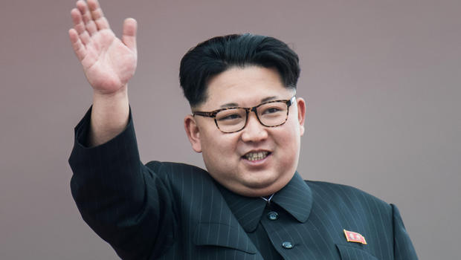
Donald Trump, President of the United
States of America
Vladimir Putin, President of Russia
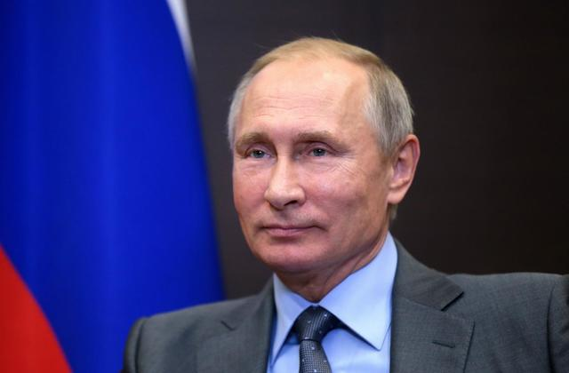
You will then write a paper describing the experience. You should:
- Describe your experience: How did the youth respond to your request to participate? Did you feel uncomfortable performing the Field Assignment? Do not forget to describe the setting in which you attempted influence – were there other people around? Did the physical location influence outcome?
- Describe how each youth responded to your questions: Did both youth know the word leaders names? Did they seem confident in their initial answers of assigning a "good" or "bad" label to each world leader?
- Discuss the influence and persuasion portion of the assignment: did the youth change their views based on your persuasion? Did you feel their original view was strong or easily influenced?
- Connect the experience back to the textbook: Looking at Chapter 14's views on acquiring attitudes from the media or our peer group, how do you believe the youth came to their knowledge and views on world leaders? Do you believe choosing youth from other social settings, circles of influence, or other cultural or geographical groups would have changed your experiment? How does influence and persuasion come into play in how we form our opinions on political and cultural topics?
Your papers should be written in APA format and at least two pages double spaced (you will likely need more to fully address all of the components). Papers will be graded on completeness (did you include of the requested information), quality (how well did you describe the situation, how well did you connect to the material, etc.), and accuracy (did you correctly discuss the psychological factors at play).

