A close up of text on a white background

Description generated with high confidenceA close up of text on a white background

Description generated with high confidence

A close up of a newspaper

Description generated with high confidenceA close up of a newspaper

Description generated with high confidence

A close up of a newspaper

Description generated with high confidenceA close up of text on a white background

Description generated with high confidence

A close up of a newspaper

Description generated with high confidenceA close up of text on a white background

Description generated with high confidence

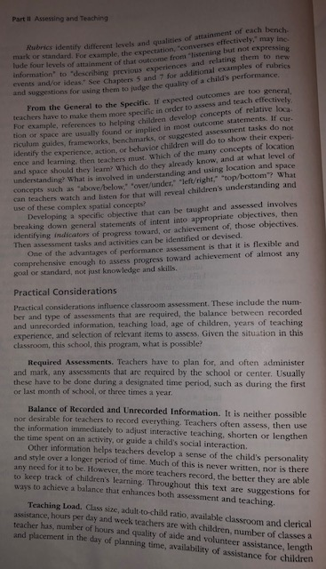A close up of a newspaper

Description generated with high confidence

A close up of text on a white background

Description generated with high confidenceA close up of text on a white background

Description generated with high confidence

A close up of text on a black background

Description generated with high confidenceA close up of text on a black background

Description generated with high confidence