Module 1 Overview
Processes are fundamental to all the activities that produce goods and activities. For example, operations managers make process decisions about the type of work to be done in-house, the extent of automation to use, the technologies to pursue, etc.
Operations management transforms inputs (labor, capital, equipment, land, buildings, materials, and information) into outputs (goods and services) that provide added value to customers. The figure below summarizes the transformation process. The arrow labeled “Transformation System” is the critical element in the model that will determine how well the organization produces goods and services that meet customer needs. It does not matter whether the organization is a for-profit company, a non-profit organization (religious organizations, hospitals, etc.), or a government agency; all organizations must strive to maximize the quality of their transformation processes to meet customer needs.
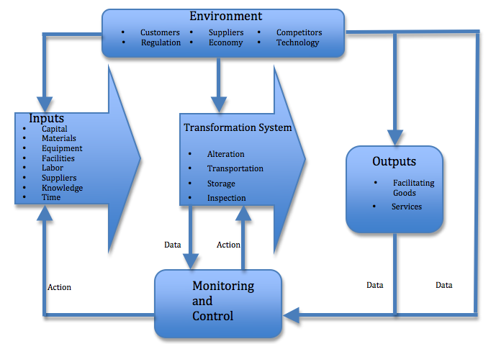
Example of typical transformation process
The 3M Company is a good example of the strategic importance of transforming inputs into outputs that provide competitive advantage in the marketplace. 3M manufactures a top-quality adhesive tape called “Magic Tape”. Magic Tape is used for everyday taping applications, but it offers attractive features that most other tapes do not, including smooth removal from the tape roll, an adhesive that is sticky enough to hold items in place (but not too sticky that it cannot be removed and readjusted if necessary), and a non-reflective surface. For several decades, 3M has enjoyed a substantial profit margin on its Magic Tape product because 3M engineers make the manufacturing equipment and design the manufacturing processes that produce Magic Tape. In other words, 3M enjoys a commanding competitive advantage by controlling the transformation processes that turn raw material inputs into the high value-added Magic Tape product. Controlling the transformation process makes it extremely difficult for competitors to produce tape of the same quality as Magic Tape, allowing 3M to reap significant profits from this superior product.
An opposite example of the strategic implications of the input/output transformation process is 3M’s decision in the 1980s to stop manufacturing VHS tape for video players and recorders. In the VHS tape market, 3M had no proprietary manufacturing advantage, as there were many Asian competitors that could produce high-quality VHS tape at lower cost. Since 3M had no proprietary control over the transformation process for VHS tape that would allow the company to protect its profit margins for this product, it dropped VHS tape from its offerings. The two 3M examples of Magic Tape and VHS tape show how important the transformation process and operations management can be to providing and protecting an organization’s competitive advantage.
A service example of the strategic importance of the transformation process is ING Bank, a banking company that conducts all banking transactions through the Internet, phone, and mail. ING maintains no traditional bank facilities, except for the buildings that house the employees that execute remote transactions with ING’s customers. This strategy results in tremendous cost savings and competitive advantage to ING by not having to spend capital resources on land and buildings that traditional banks must spend. Consequently, ING can offer its customers' higher interest rates on savings accounts and lower interest rates on loans.
A major responsibility of Operations Management is to measure performance and determine ways to improve it. Productivity measurement and process improvement are the focus of this first module.
Productivity is a major concern of most businesses. It is a fundamental basis of competition, to reduce costs and do more with less. Productivity in the U.S. is measured and has been for over 125 years by the U.S. Bureau of Labor Statistics. Labor productivity is a key index that is used to determine how the overall economy is doing year to year.
The basic measurement is the ratio of Output/Input. Or, Productivity = O/I.
But industries and individual businesses also measure productivity. And it is this measurement that is key to productivity and process improvement. Without quantitative measurement, you cannot know if you are improving.
At the business level, there are many ways to count output and input. For example, you could have the output measured as the number of parts produced and the input is the number of hours. Prod = widgets/hour. A key criterion for counting each of these is to make sure you are using the same time period, that you are matching the actual input effort to the outputs generated. You must also use the same process for each. For example, counting widgets, you would look at a specific process and/or group of people for a specific time period, say last week, Monday thru Friday. If this group of people produced 3500 widgets collectively, and spent 200 hours collectively, then you would get, P = 3500 widgets/200 hours. Or, P = 17.5 widgets / hr.
Productivity is measured using simple or complex ratios of outputs/inputs. At the business level, there are many financial ratios that are measures of productivity (e.g., ROS, or Return on Sales). If you consider the amount of Sales as input to generating profit, and profit is the results or the output, then you get ROS = Profit/Sales. Businesses measure their productivity in different ways based on what makes sense to them and what is important. But for Operations Management, the key productivity measures have to do with the inputs and outputs within Operations.
So once a measurement system is in place, an improvement program can be implemented. Improvements come by focusing on PROCESSES. Processes are the repetitive actions in a specific sequence that are intended to produce a specific output. Outputs can be parts and components that make up a finished product, or part of a service or the finished service.
Businesses are always trying to improve productivity and processes in order to be competitive. Indeed, some companies attempt to be the "low-cost leader", which then makes productivity a driving force for the business. Other businesses consider productivity a necessity to keep ahead of inflation, to keep costs down, and to maintain margins.
Process improvement can take several different forms within a business. This can be viewed by the amount of change being made in the process. There is the incremental process improvement, which utilizes small changes. The next amount of change usually considers a wholesale change to the process, called Process Re-engineering. This approach attempts to redo a whole process by looking at it from the view of how this process should be designed from scratch. The third approach is fostered by Lean Thinking, which is to look at the chain of processes, both inside the company and outside, including those of its up-strain supply chain and down-stream supply chain. This kind of change is radical.
Actually, in lean thinking, all three kinds of process change are used. Kaikaku is radical change, which can also include some aspects of process re-engineering. Kaizen is the incremental continuous improvement efforts. And the focus of this change is to eliminate waste, or muda. By eliminating muda, processes become efficient and productivity is improved throughout.

Steps to Improving Productivity
- Identify the process – what are the activities involved in the flow of work – what is the starting point and what is the ending point?
- Identify the outputs – What is the output of the process? What is the end result and how do you count or measure this? What is the basic time frame you are using?
- Identify the inputs – What are the inputs of the process? Labor hours, quantity of materials, energy, etc.? How can you count or measure these inputs?
- Determine the Productivity Measure – What is the Productivity Measure you want to use to calculate, Outputs/Inputs? Which inputs are you concerned about?
- Determine a data collection process – How do you collect the data during the time period? Is there a system or method for counting the outputs and inputs during the same time period?
- Analyze the steps in the process and determine how to modify it to obtain more output with the same inputs, or the same outputs with less inputs, or more outputs with less inputs.

What Are Ways to Generate Labor Productivity?
- Increase the rate of at least one process step.
- Eliminate or combine process steps.
  - Time and motion study
  - Lean engineering
  - Automate – replace the manual process with a machine process.
    - Partial Automation - add the use of tools, jigs, and fixtures to aid the work and speed up the process.
    - Full Automation - completely replace the worker with a machine.
- Reduce non-productive time that is included in the labor input.
  - Setup or changeover time
  - Interruptions
  - Machine or tool breakdowns or problems
  - Stop for quality issues
  - Waiting for material to arrive
References:
Global Text Project (2017), Operations management: The input/output transformation model. OpenStax CNX. ‎Retrieved from https://cnx.org/contents/_yBkSAt4@4/Operations-management-The-inpu
Chew, W. (1988, Jan.-Feb. 1988). No-nonsense guide to measuring productivity. Harvard Business Review, 3-9. Retrieved from https://hbr.org/1988/01/no-nonsense-guide-to-measuring-productivity

