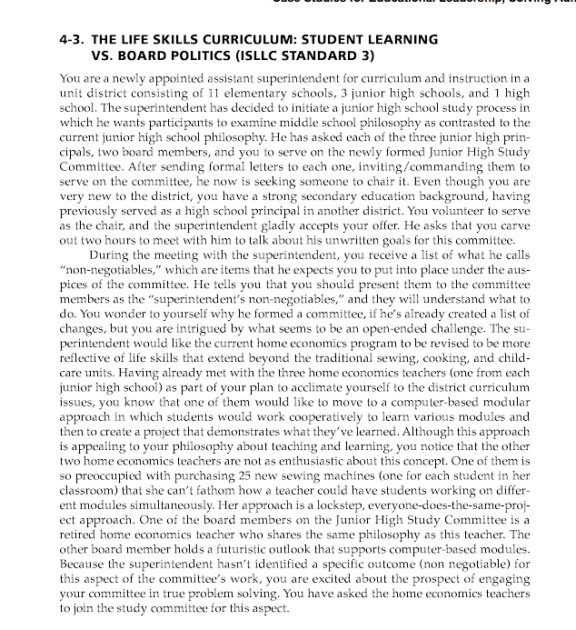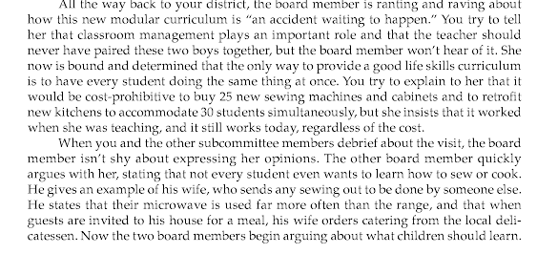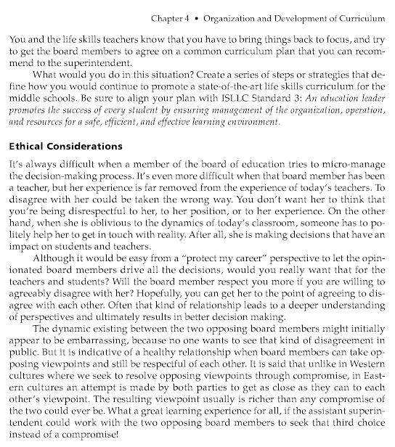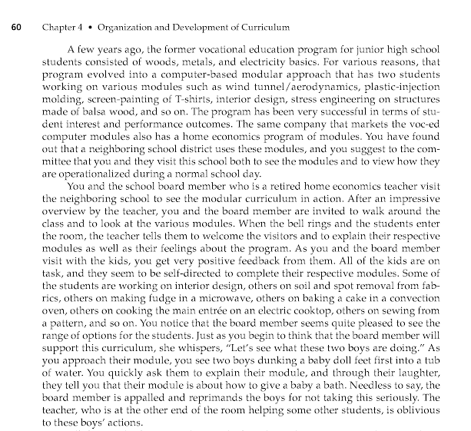

If you are the “lead administrator” a brief summary of the situation, describe the specific action or actions you would take to deal with the situation, and a brief discussion of your rationale for taking the action.

2-





