Unit 8

Content
- Performance Measurement

Introduction
This week we explore measurement and control processes. Measurement tools, such as the balanced scorecard, the risk exposure calculator, and the duration, integrity, commitment, and effort (DICE) model can help health care leaders quantify the outcomes achieved. Four types of control processes will also be reviewed: diagnostic/steering controls, belief systems, boundary systems, and interactive controls. The type of control process can be determined by the phase in the change management plan. Selection of measurement tools and control processes can provide early warning systems for health care leaders and will force change agents to be objective about the success of the outcome (Cawsey, Deszca, & Ingols, 2016).

Reference
Cawsey, T. F., Deszca, G., & Ingols, C. (2016). Organizational change: An action-oriented toolkit (3rd ed.). Thousand Oaks, CA: Sage.

Objectives
To successfully complete this learning unit, you will be expected to:
  - Review the process of designing effective control systems.
  - Identify measures used to determine the success of organizational change.
  - Discuss how change disrupts the psychological contract that exists in an organization.

A Balanced Scorecard for Change

Introduction
Tracking critical success factors is an important component of a balanced scorecard. As discussed in the text, a balanced scorecard consists of four perspectives: financial, customers, internal processes, and learning and growth. Use Figure 10.5 as a template to guide you when generating a balanced scorecard for change. An example can be found in Figure 10.6 to guide you. You will be able to enter your notes within the text fields and generate a pdf when finished.

Financial
To succeed financially with the change, how should we appear to our shareholders?
- Objectives
- Measures
- Targets
- Initiatives

Customer
To achieve our change vision, how should we appear to our customers?
- Objectives
- Measures
- Targets
- Initiatives

Values, Mission, Change Vision, & Change Strategy

Internal Business Processes
To achieve our change vision in ways that satisfy our shareholders and customers, what business processes do we need to excel at?
- Objectives
- Measures
- Targets
- Initiatives

Learning and Growth
To achieve our change vision, how will we sustain our ability to change and improve?
- Objectives
- Measures
- Targets
- Initiatives

References
- Cawsey, T. F., Deszca, G., & Ingols, C. (2012). Organizational change: An action-oriented toolkit (2nd ed.). Fig.10-5, p.360, Thousand Oaks, CA: Sage.
- Adapted from: Kaplan, R.S. & D.P. Norton, "Using the Balanced Scorecard as a Strategic Management System," Harvard Business Review, Vol. 74, #1, 1996, pg. 76.

Credits
Subject Matter Expert:
Dr. Darleen Barnard, DHA, CHFP
Interactive Designer:
Mark Bune
Interactive Developer:
Justin Lee
Instructional Designer:
Marisa Johnson
Project Manager:
Catherine Baumgartner

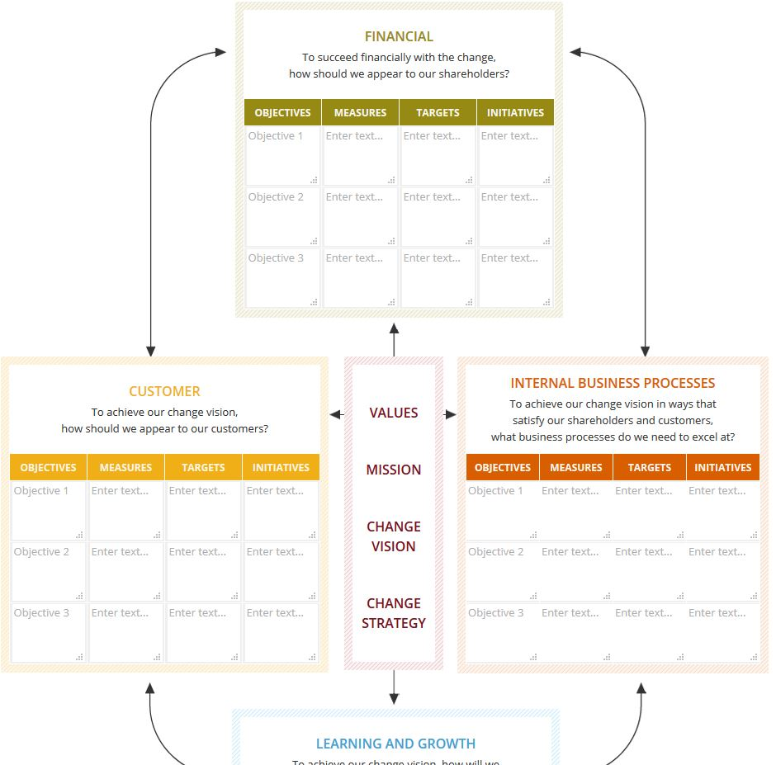

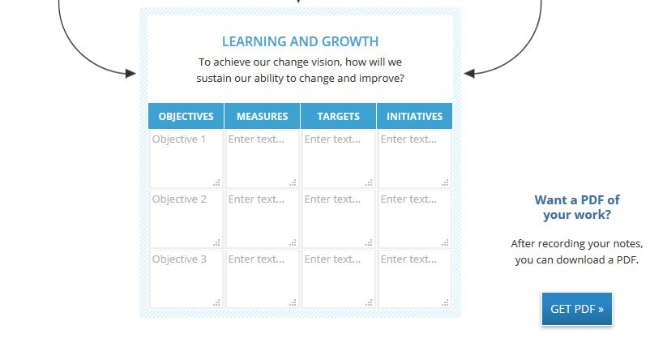

Use your Organizational Change text to complete the following:
- Chapter 10, "Measuring Change: Designing Effective Control Systems," pages 339–372.

Research
- Research the Capella University Library to find a recent journal article (published within the last two years) that discusses a health care organization that has recently experienced a significant change, and that describes the measures the organization is using to determine the success of the change and ensure continuous quality improvement (CQI). Be prepared to share your findings in the second discussion for this unit. Make sure you have a link or citation for your selection that you can post in the discussion for your peers.

Multimedia
- Click Launch Presentation to complete the interactive media piece A Balanced Scorecard for Change. See images above.

I will do DQ #1. It is a peer review of the Week 7 essay.

Discussion Post #2:

Measuring the Impact of Organizational Change
Post a link to the journal article you selected in this unit's studies that discusses a health care organization that recently experienced a significant change. Which measures is that organization using to determine the success of the change and ensure continuous quality improvement (CQI)?
Responses should range from 350-450 words, with APA formatted in-text citations and accompanying, congruent APA formatted references.

INTERNET ARTICLE:
https://hbr.org/2016/11/how-to-get-health-care-employees-onboard-with-change

References:
Centura health corporation. (2018). (). Fort Mill: Mergent. Retrieved from ProQuest Central Retrieved from http://library.capella.edu/login?qurl=https%3A%2F%2Fsearch.proquest.com%2Fdocview%2F1860750027%3Faccountid%3D2796
Dana moore - SVP, CIO and managing director, service center, centura health (2015). San Francisco: Boardroom Insiders, Inc. Retrieved from http://library.capella.edu/login?qurl=https%3A%2F%2Fsearch.proquest.com%2Fdocview%2F1776907863%3Faccountid%3D2796
Levin, S., & Berry, T. B. (2010). Next-generation vendor management: The experience of centura health. Healthcare Financial Management, 64(6), 106-10, 112, 114 passim. Retrieved from http://library.capella.edu/login?qurl=https%3A%2F%2Fsearch.proquest.com%2Fdocview%2F366897764%3Faccountid%3D27965

