The Great Gatsby
Chapter Nine Questions
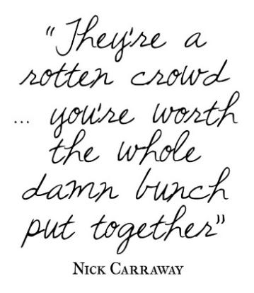
Directions: Choose 2 questions from Chapter Nine. Answer each using E3 format and quoted examples from the text to support your response of 8-15 sentences each.
Chapter 9
- Why does Nick feel he is responsible for taking care of the situation?

- What is the father’s perception of his son and his son’s life?

- Why isn’t Klipspringer going to attend the funeral? Why is it significant that the man with owl-eyed glasses is the only other person to come to Gatsby’s funeral?

- Why does Nick say that Tom and Daisy are “careless people”?

- What does Nick mean by his comment, “I’m thirty…I’m five years too old to lie to myself and call it honor”?

- What is Gatsby’s dream?

- What is the significance of the last line of the novel: “so we beat on, boats against the current, borne back ceaselessly into the past”?

