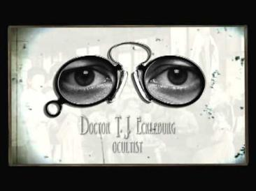
The Great Gatsby
Chapter Eight Questions
Directions: Choose 3 questions from Chapter Eight. Answer each using E3 format and quoted examples from the text to support your response of 8-15 sentences each.
Chapter 8
- How does Gatsby’s house seem to Nick during his visit?

- Why does Gatsby feel “married” to Daisy?

- What attracts Daisy to Tom Buchanan?

- Why does Nick say, “They’re a rotten crowd…You’re worth the whole damn bunch put together”? Why is it good that he chose this moment to say this to Gatsby?

- What ultimately happens to Gatsby? What happens to George Wilson?

- What is the significance of Doctor Eckleburg’s eyes?

- What does it show about Gatsby when he says, “what was the use of doing great things if I could have a better time telling her what I was going to do”?

