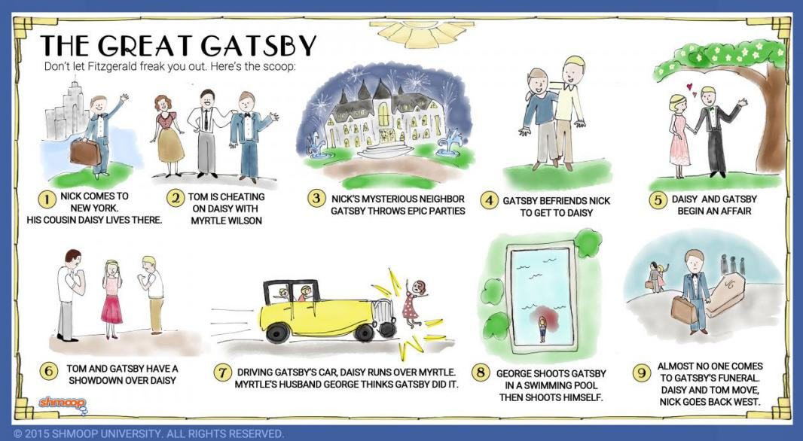
The Great Gatsby
Chapter Seven Questions

Directions: Choose 6 questions from Chapter Seven. Answer each using E3 format and quoted examples from the text to support your response of 8-15 sentences each.
Chapter 7
- What has changed at Gatsby’s house? What reason does Gatsby give for these changes?

- What does Gatsby decide he is going to do the day he goes over to Tom and Daisy’s house?

- Why does Gatsby look at Daisy’s daughter Pammy with surprise?

- Why does George want to move away? What reasons does he give for wanting to move away?

- Who is looking out the window above George’s garage? Why is he/she jealous?

- Why does Fitzgerald insert a wedding into the texture of this scene in the hotel room?

- Why is Gatsby surprised when Daisy says, “I did love him [Tom] once - but I loved you too”?

- Who is killed? How is he/she killed?

- Why does Tom say, “That yellow car I was driving this afternoon wasn’t mine---do you hear? I haven’t seen it all afternoon”? What are his potential motives?

- Whose birthday is it? How old is he/she turning?

- What is the tone/mood of the scene where Daisy and Tom ate at the kitchen table?

- Describe each person’s connection to the yellow car:
  - Daisy
  - Tom
  - Myrtle
  - Gatsby

