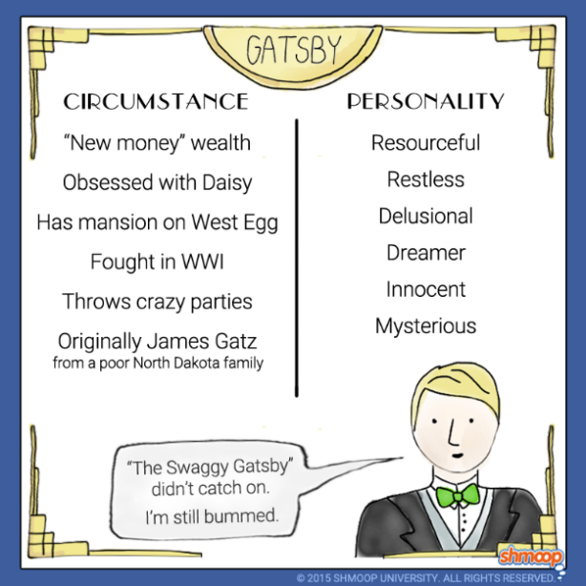

The Great Gatsby
Chapter Six Questions

Directions: Choose 3 questions from Chapter Six. Answer each using E3 format and quoted examples from the text to support your response of 8-15 sentences each.
Chapter 6
- What is Gatsby’s real history? Where is he from and what is his name?

- What did Dan Cody do for Gatsby? What did Gatsby learn from him?

- What is Daisy’s opinion of Gatsby’s party? How does this affect him?

- How does Gatsby act when the visiting trio (including Tom Buchanan) comes to visit? How do they act toward him?

- Why does Tom immediately sense that Gatsby is a bootlegger?

- What does Gatsby want from Daisy?

